INDEX

|  |  |
| --- | --- |
| **Contents** | **Page No** |
| Specification Document | 2 |
| Number and duration of sprints | 3 |
|  |  |
| Spring and Angular Concepts used  Database Design | 6 |
| Screenshots  Conclusion on enhancing the application | **7**  8  15 |
| GitHub repository link | 15 |

**Specification Document:**

Product Name: FoodBox

Product description: Create a dynamic and responsive online food delivery web application for ordering food items of different cuisines from a restaurant

Developer: Madhav Bhat K

## Product’s capabilities:

* Registration
* Login
* Add to Cart
* Display Food Items
* Admin Portal
* View Food Page
* Add Food
* Delete Food
* Update Food
* Add Admin Users
* Delete Users
* Payment Screen

# Number and duration of sprints required:

There will be four sprints each of one week.

Goal achieved in each sprint are provided below:

### In the first sprint we did the following

### 

* + Planning Modular approach to understand what concept can be modularized.
  + Understanding and building system architecture of the application
  + Setting up basic Angular application

### In the Second sprint we improvised our function implementation for each functionality

* + Based on the requirement the basic UI was built using HTML tags and Bootstrap

### In the Third sprint we created Spring Boot Application

### Built Spring boot REST API’s, resolved Cross Origin Errors and Database Design

### In the Fourth sprint we integrated the Rest API and Spring boot application

### Angular Application and Spring boot Rest API’s were integrated and tested for bugs

### 

# Flow of overall application (Life cycle of the project):

### Select and prioritize project

During the first step of the agile software development life cycle, the team scopes out and prioritizes the project. These priorities can be based on client’s requirement

**Diagram requirements for the initial sprint**

Once you have identified the project, work with stakeholders to determine requirements. You might want to use user flow diagrams or high-level UML diagrams to demonstrate how the new feature should function and how it will fit into your existing system.

**Construction/iteration**

Once a team has defined requirements for the initial sprint based on stakeholder feedback and requirements, the work begins

**Release the iteration into production**

You’re nearly ready to release your product into the world. Finish up this software iteration with the following steps:

* Test the Application
* Address any defects
* Finalize the user document
* Release the iteration through documentation

**Production and ongoing support for the software release**

This phase involves ongoing support for the software release. In other words, your team should keep the system running smoothly and show users how to use it. The production phase ends when support has ended or when the release is planned for retirement.

**Retirement**

During the retirement phase, you remove the system release from production, typically when you want to replace a system with a new release or when the system becomes redundant, obsolete, or contrary to your business model.

**Flow Of Application**

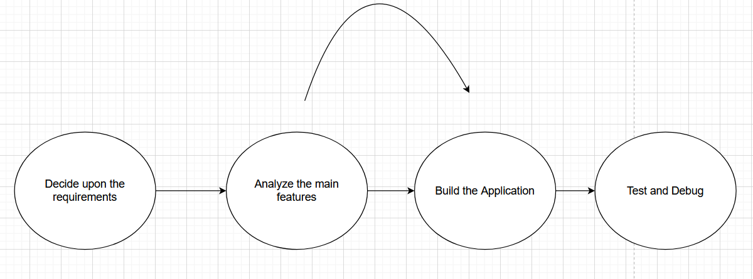

# Spring and Angular Concepts used:

* Angular Routing
* Two-way Binding
* Bootstrap
* Spring Rest API’s
* Spring Security
* MySql
* HTTP Client Service
* Angular Directives
* LocalStorage
* Event Emitters
* Angular Forms and Validation

# Database Design:

### 

`

# ScreenShots:

# Graphical user interface, application Description automatically generatedGraphical user interface, application Description automatically generatedGraphical user interface, text, application Description automatically generatedGraphical user interface, application Description automatically generatedGraphical user interface Description automatically generatedGraphical user interface, application Description automatically generatedGraphical user interface, text, application Description automatically generatedGraphical user interface, text, application Description automatically generatedGraphical user interface, application, website Description automatically generatedGraphical user interface, application Description automatically generatedGraphical user interface Description automatically generatedGraphical user interface, application Description automatically generatedGraphical user interface, application Description automatically generated

# 

# 

# 

# Conclusion on enhancing the application:

# By Enhancing the project, the project can be deployed on the cloud providers so that it can be easily accessible by a client in the world

# GitHub Repository Link:

https://github.com/kmadhav907/Capstone-Project