**Project Manager – Web API is deployed in IIS**

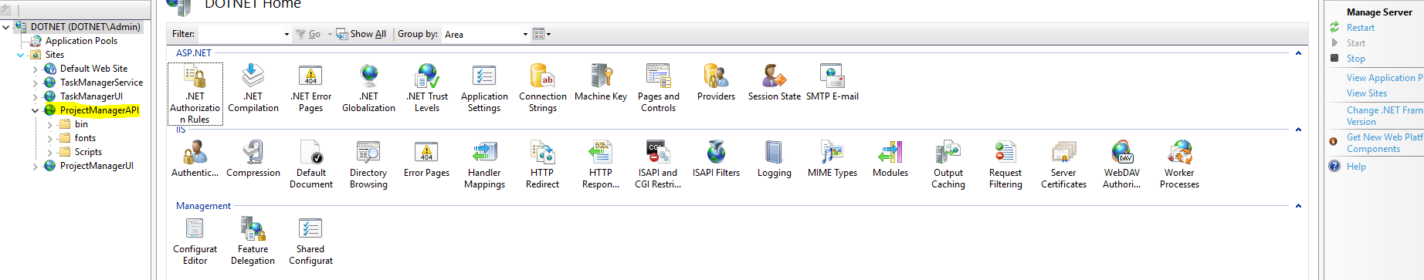

**Task Manager Service is running from IIS 🡪http://localhost:10001/**

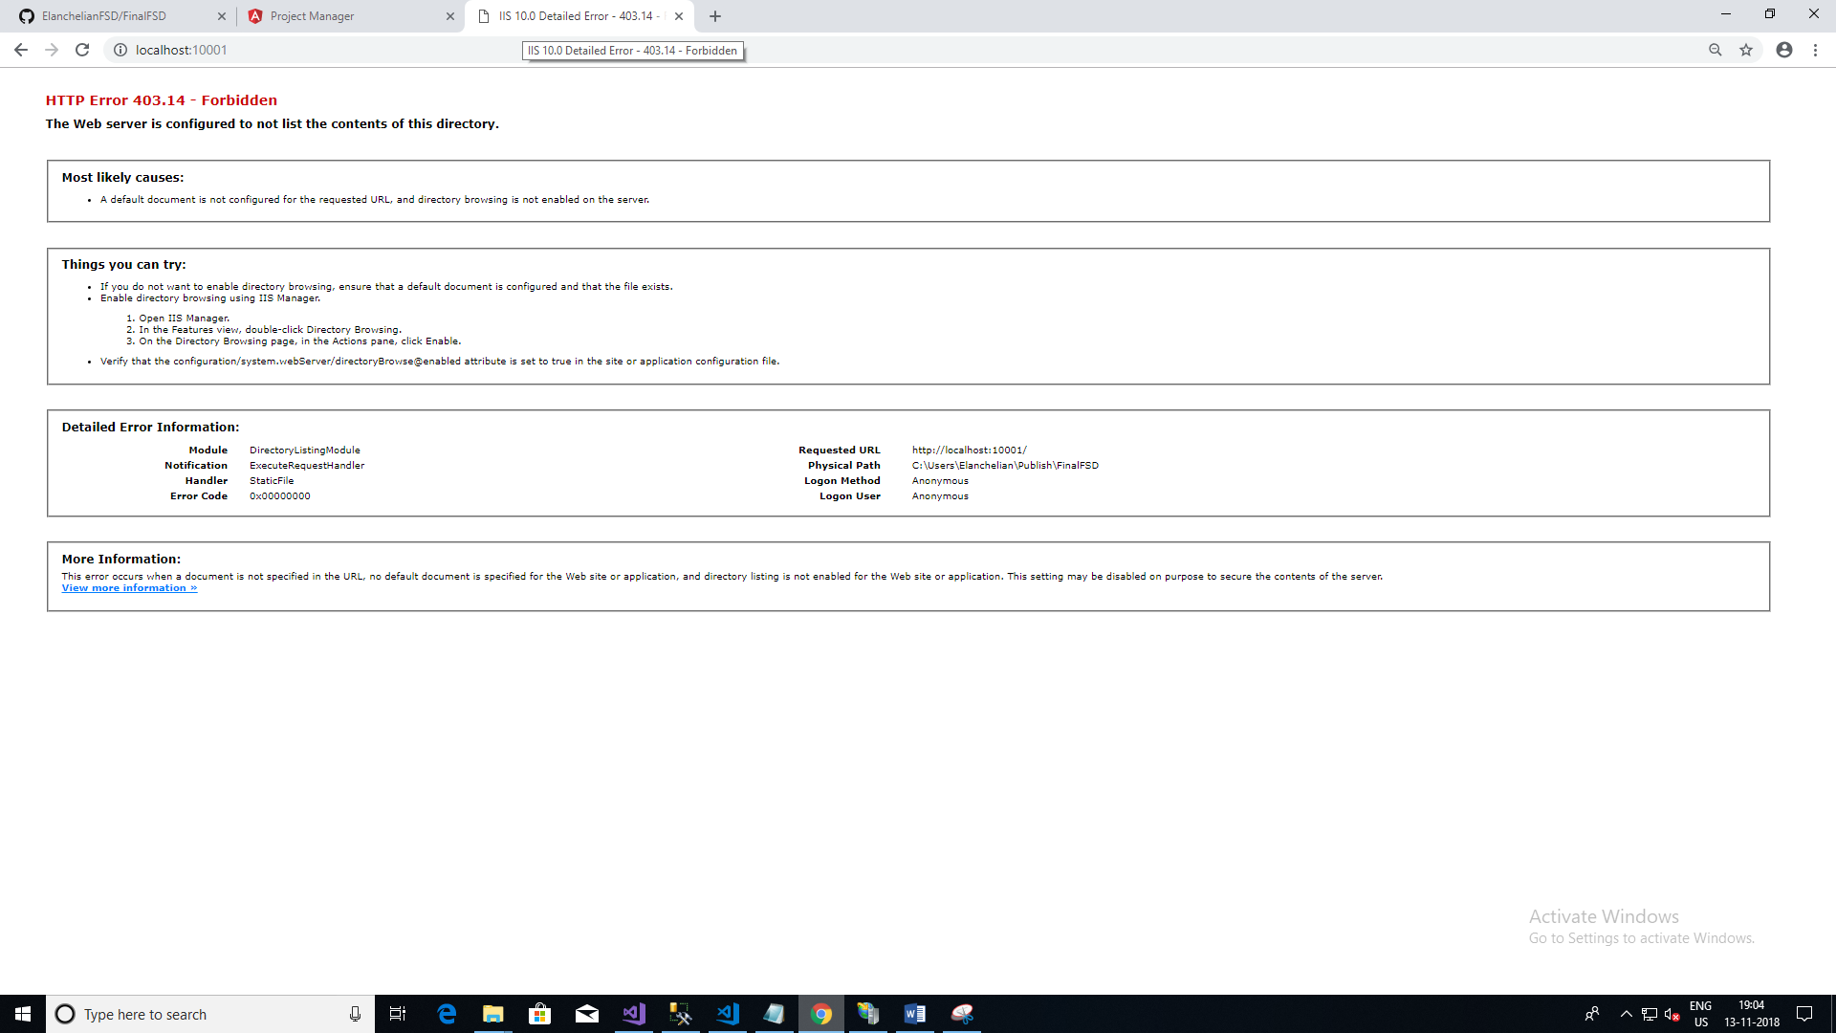

**Project Manager UI – Deployment**

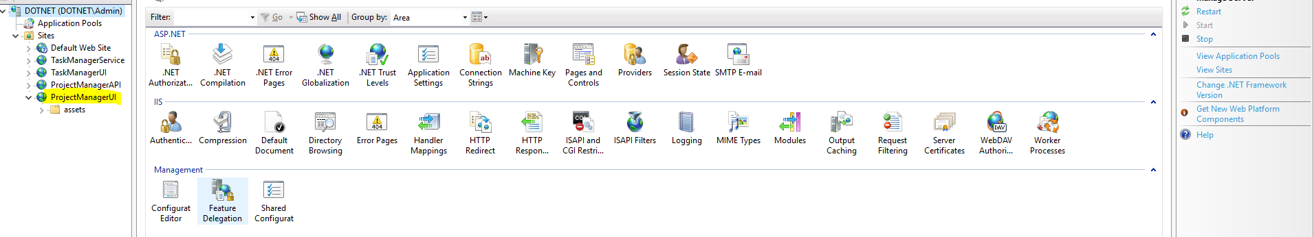

**Project Manager front end is running from IIS**

**Add Project**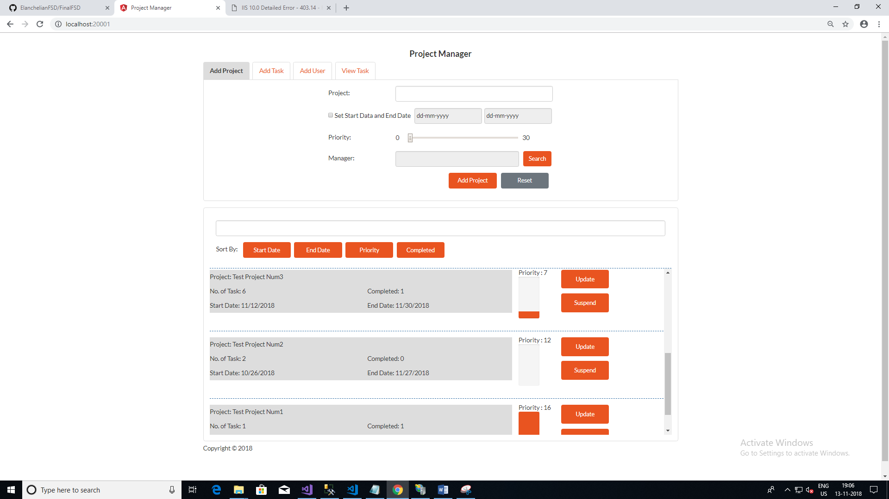

**Search Manager for project allocation**

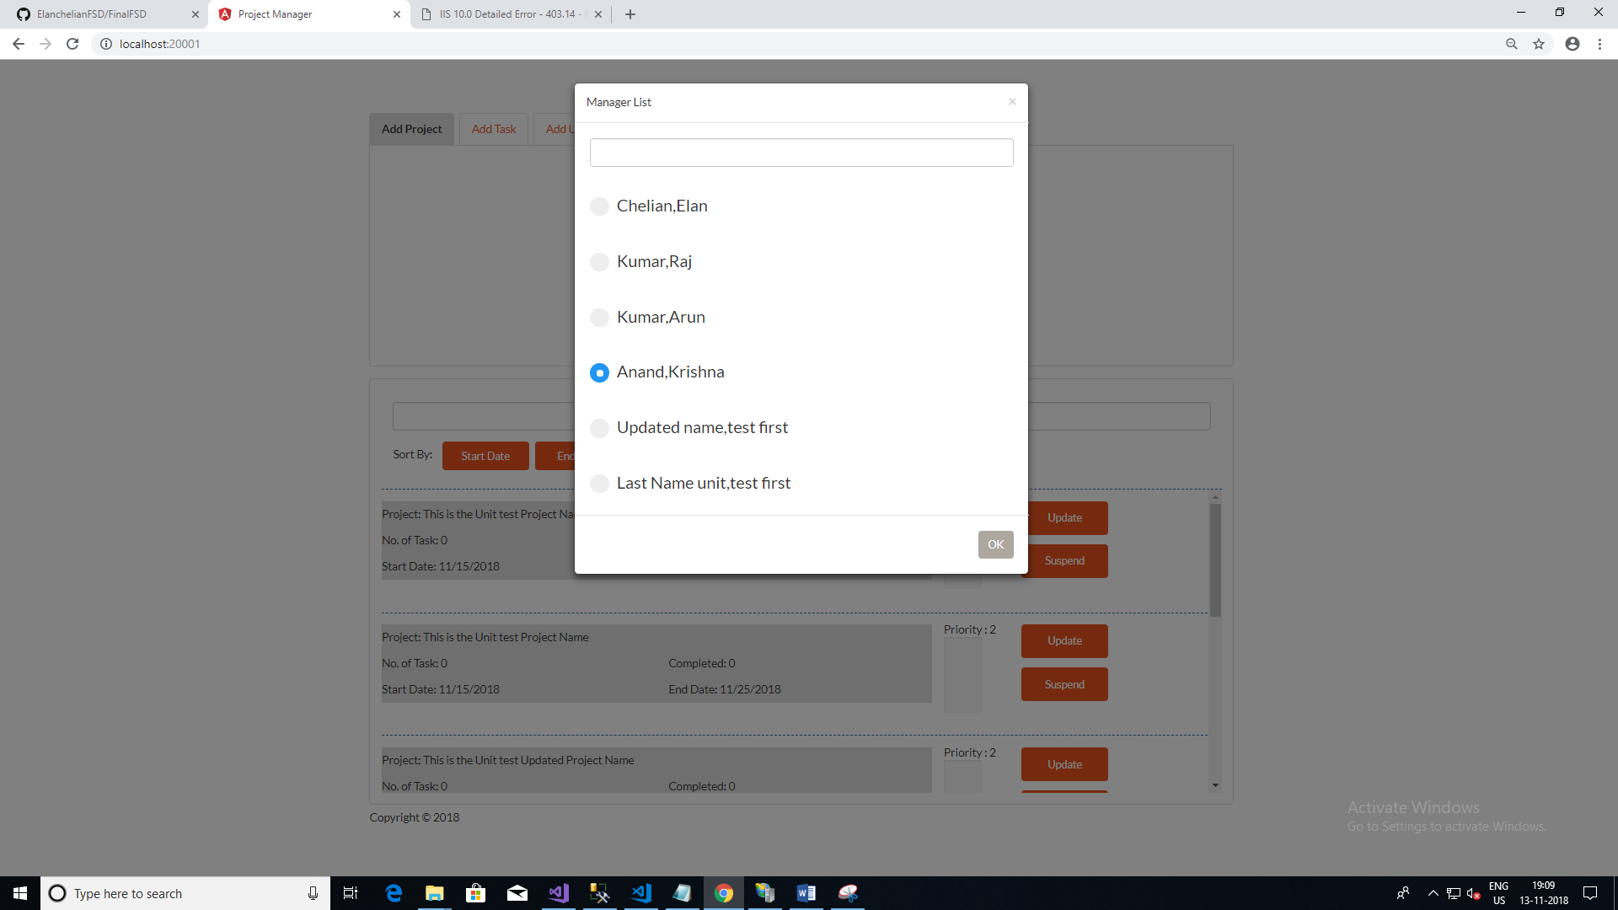

**Add Task**

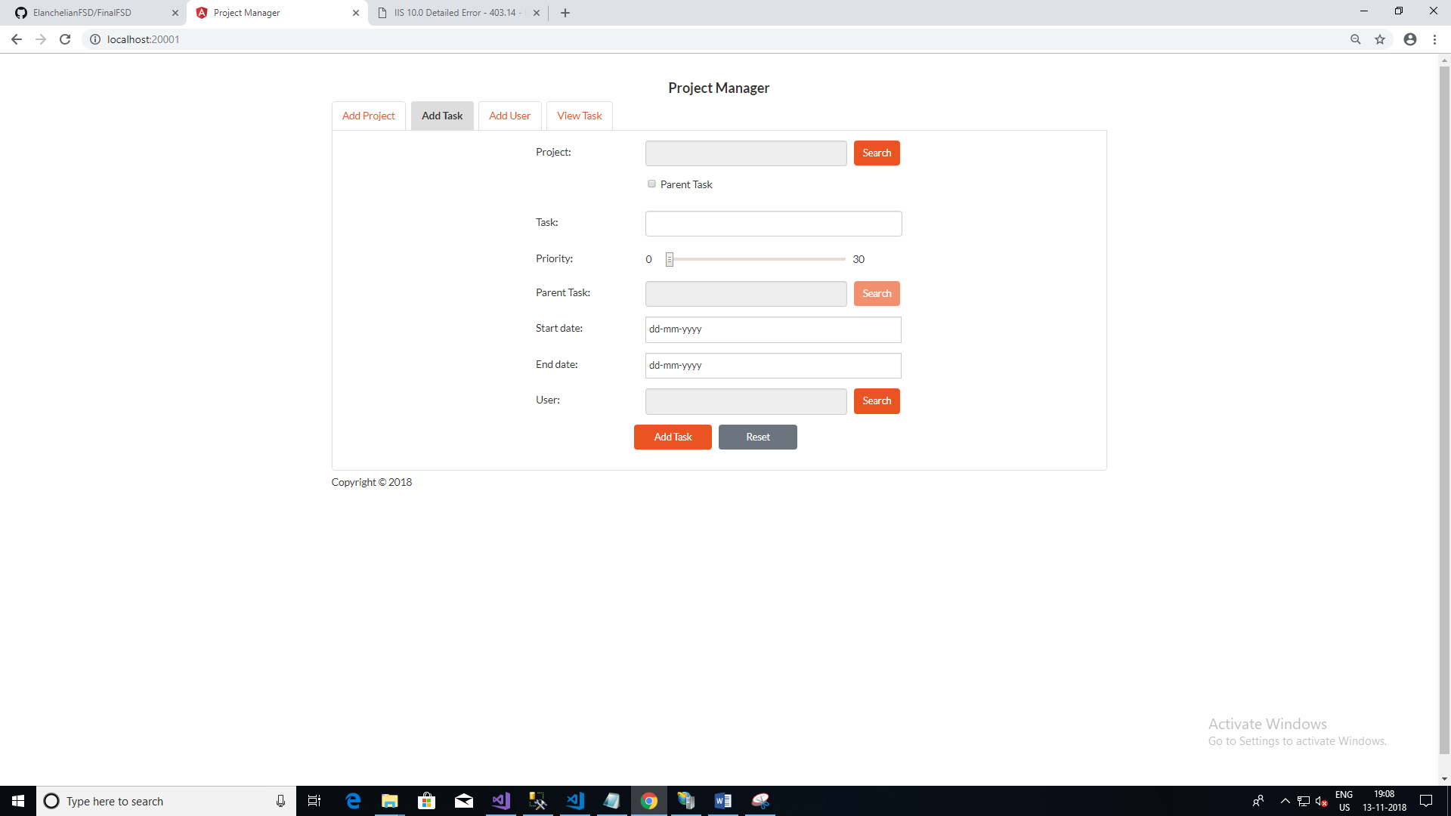

**Project Search List**

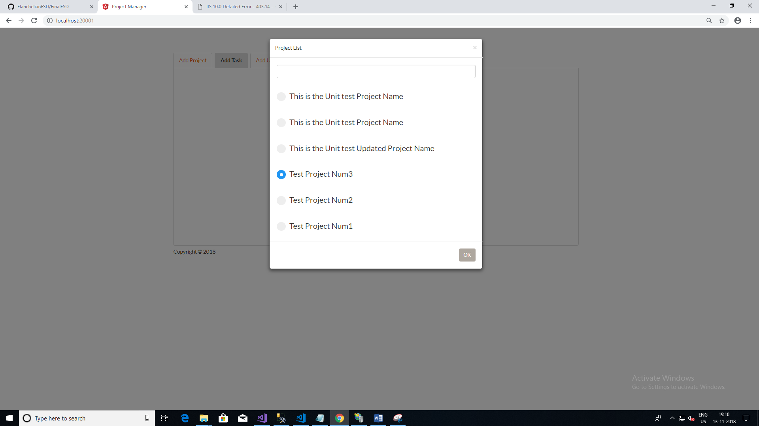

**Parent Task Search List**

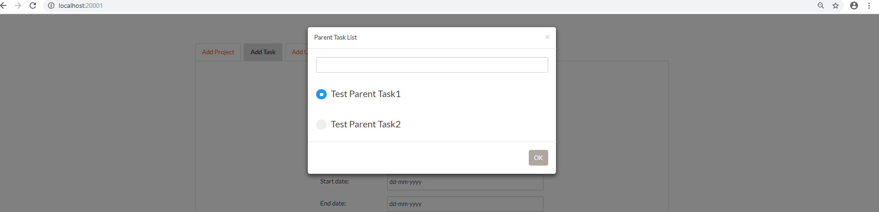

**Search User List**

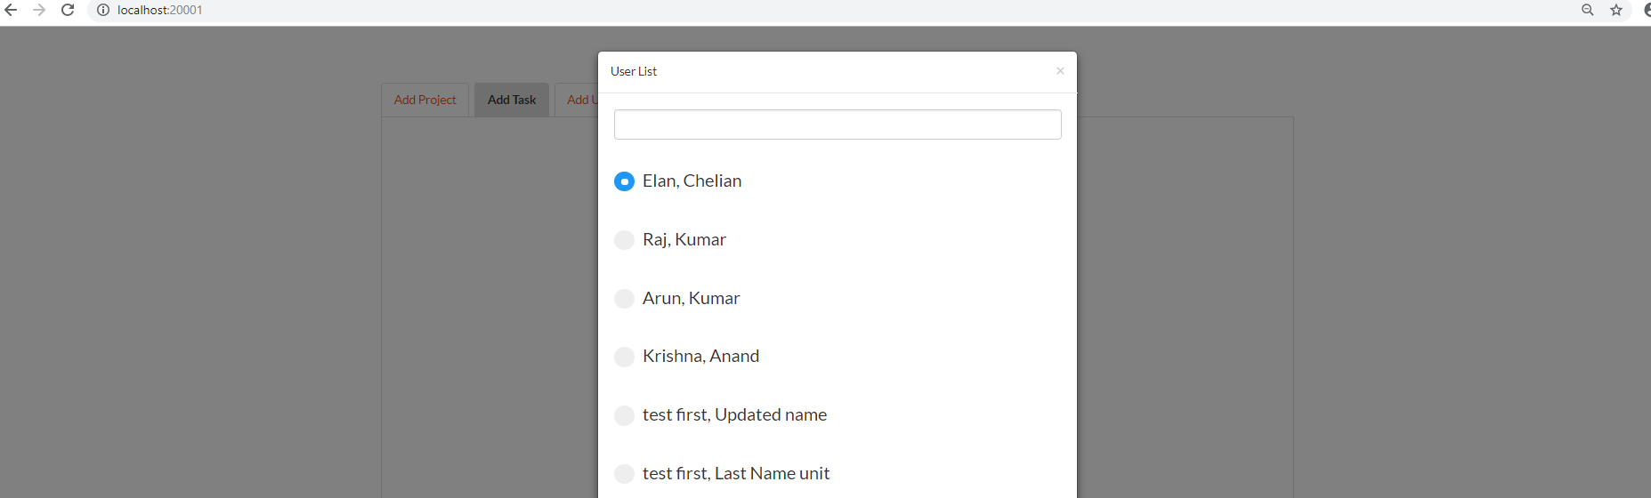

**Add User**

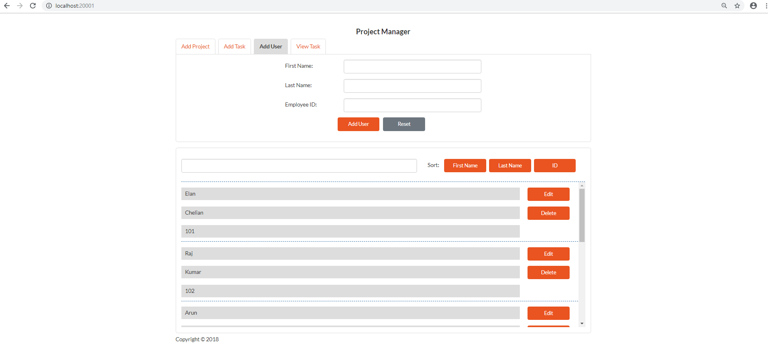

**View Task**

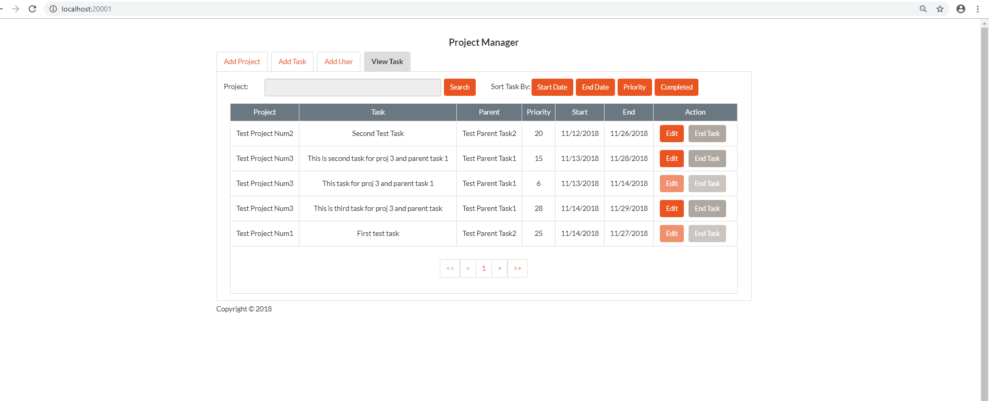

**Front End –Angular JS Project Manager Solution**

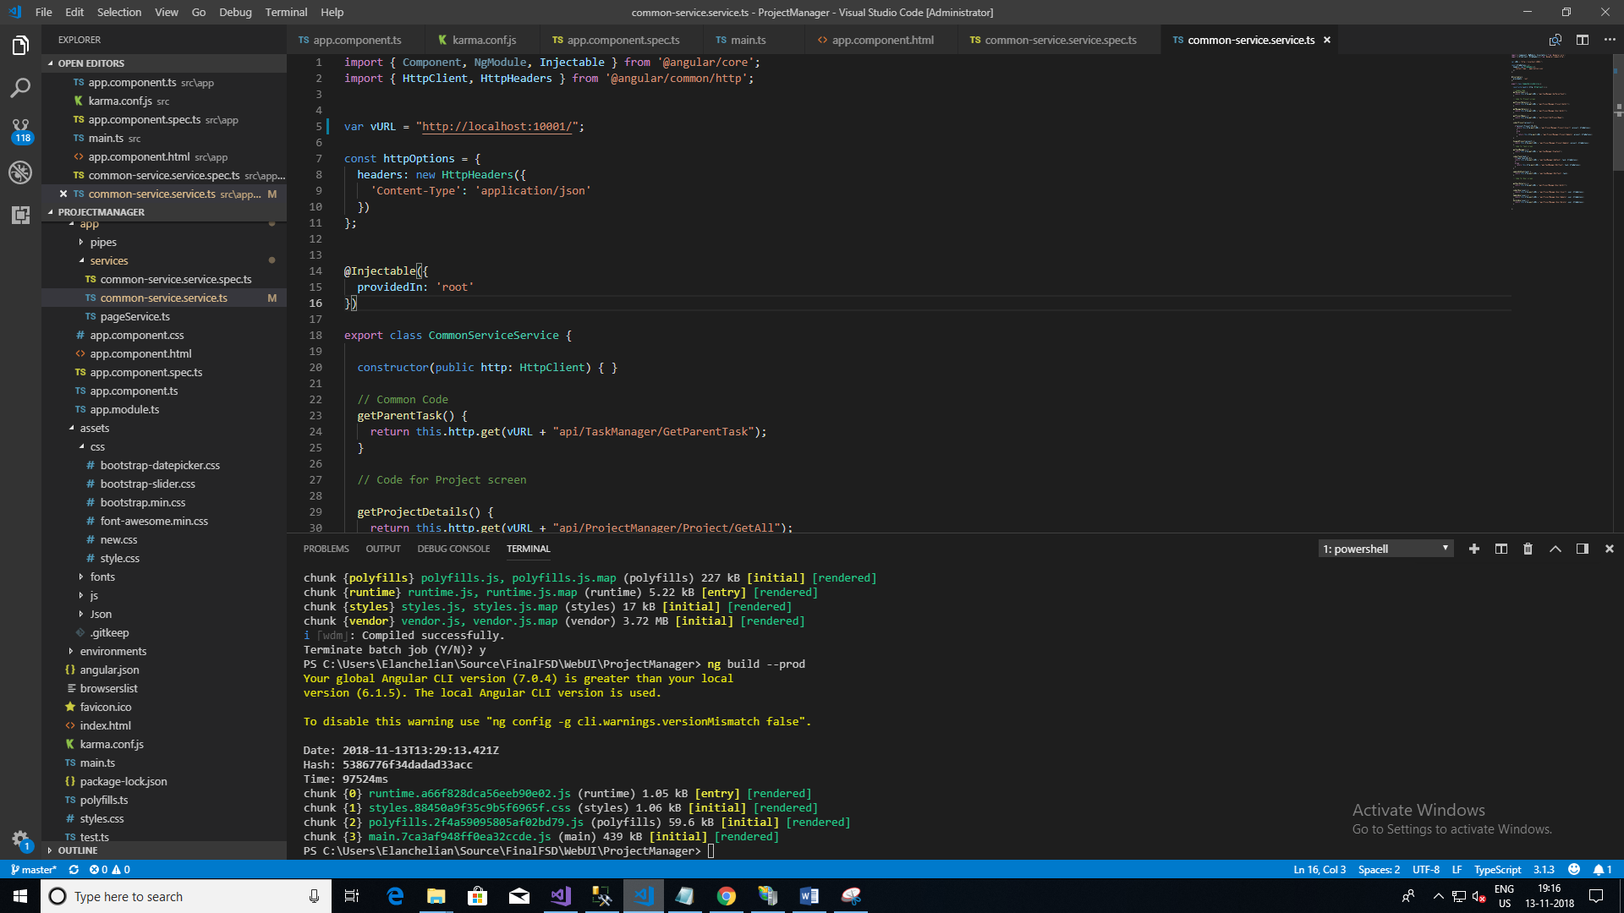

**Karma Test:-**

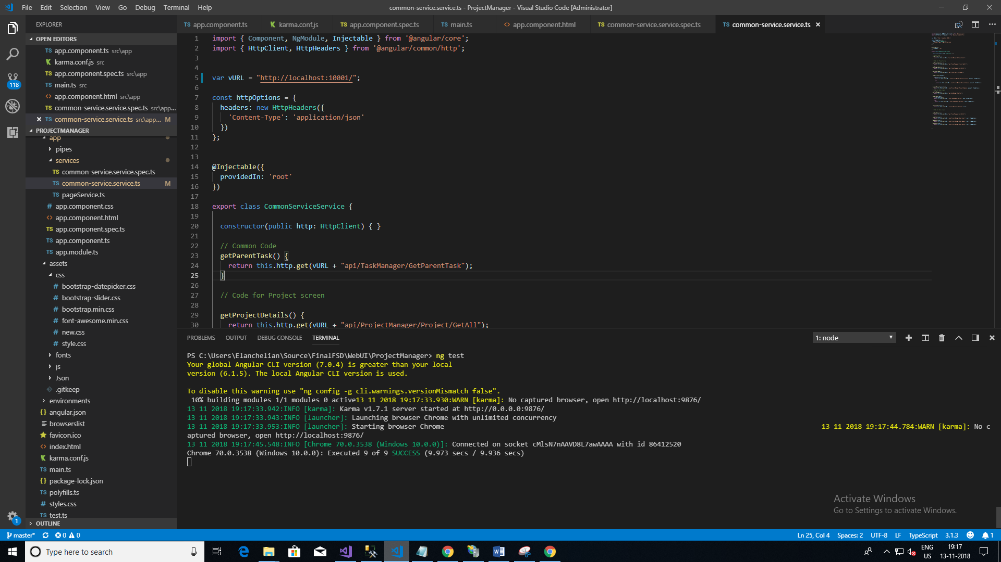

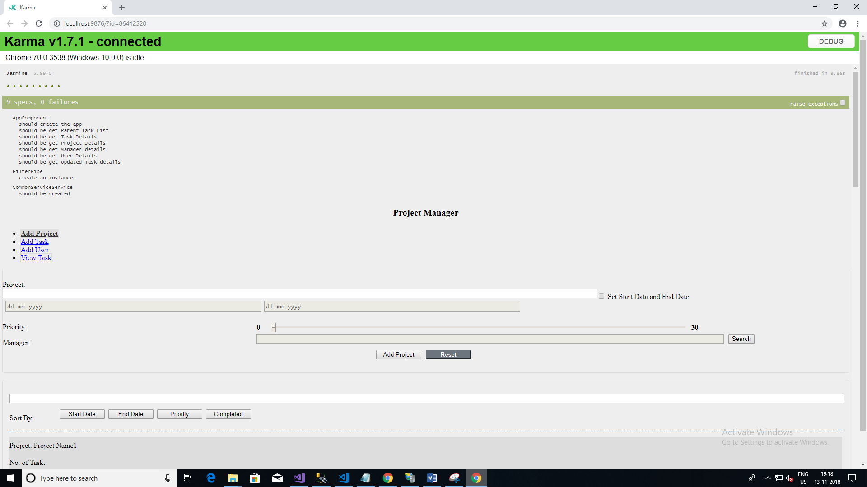

**Web API Service Solution**

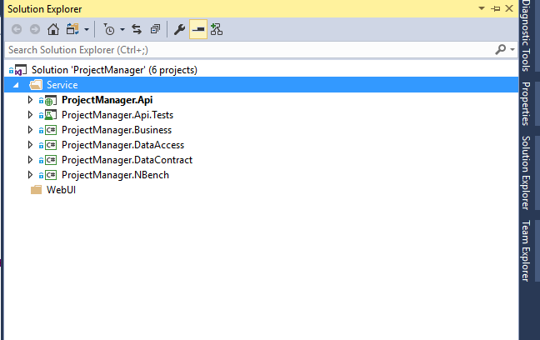

**Web API service Unit testing**

