What is JDBC ? java 2 aplication Enterprice Edition.

It’s a J2AEE API , which is used to connect to any data base from the java code

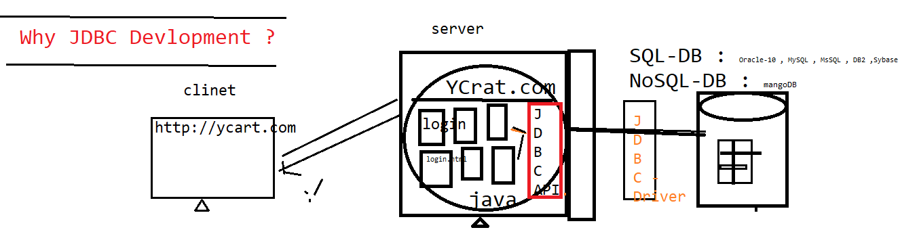



JDBC helps java program to store / retrieve data from the physical database

In Real time, every application required data base to store/retrieve the user information in data base

There are types of database

1. SQL Database

* Data will be stored in form of table

EG : mysql , MsSql , Oracle 11 g , DB2 ,

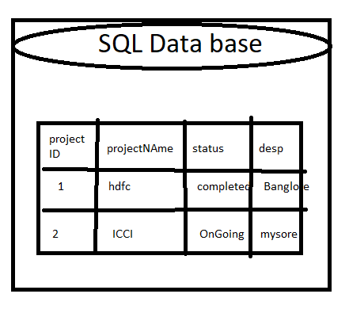

1. No SQL Database

* Data will be stored in the from JSON format

EG : Mango db , Casandra , NoSQL

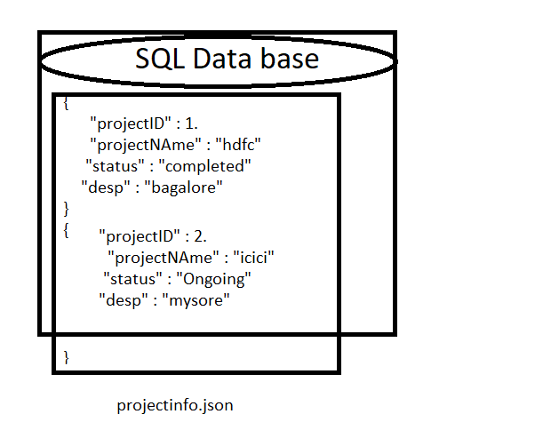

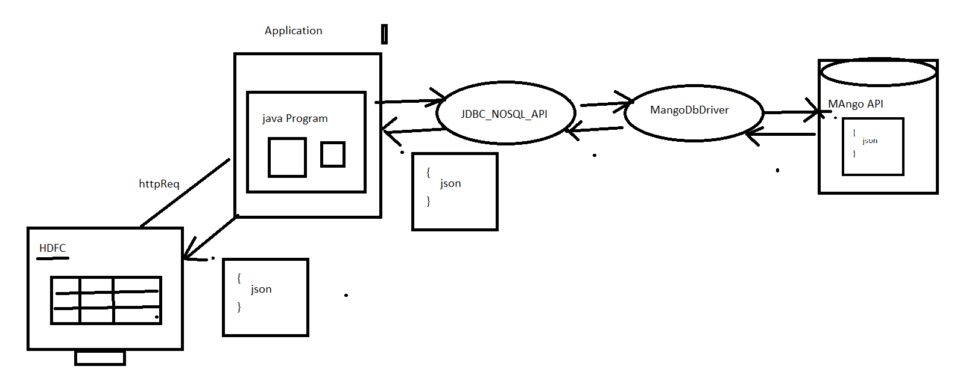

Types of Query

1. Select query
2. Non Select Query
3. **Select Query**

Any query start from select is called select query, it’s always retunes data in the form of table

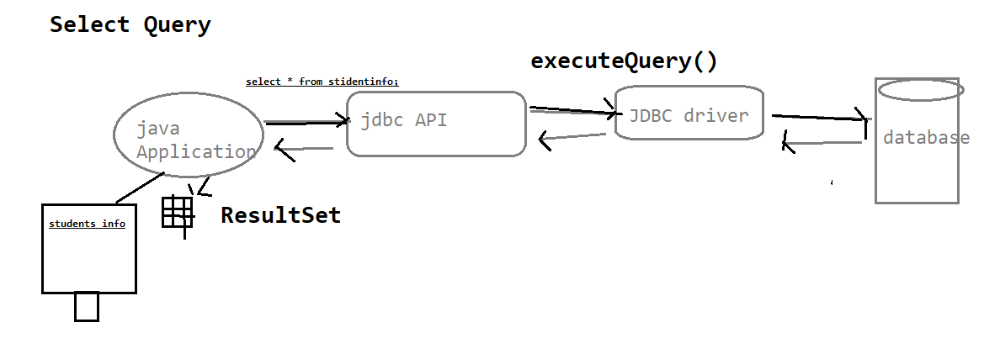

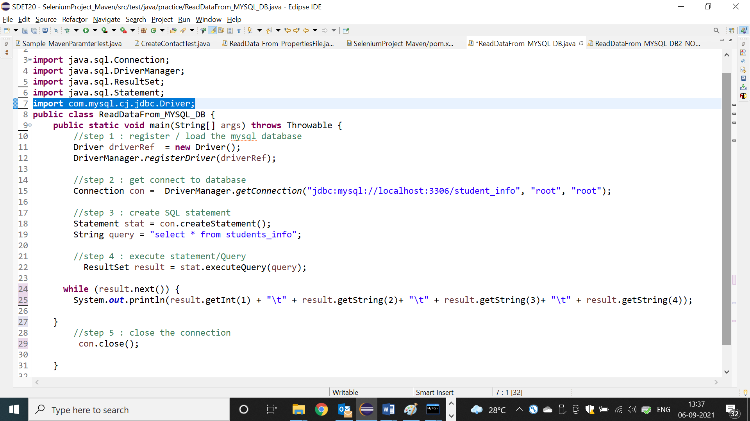

1. Non Select Query

Any query start from other than select is called non select query, it’s always retunes +-integer data

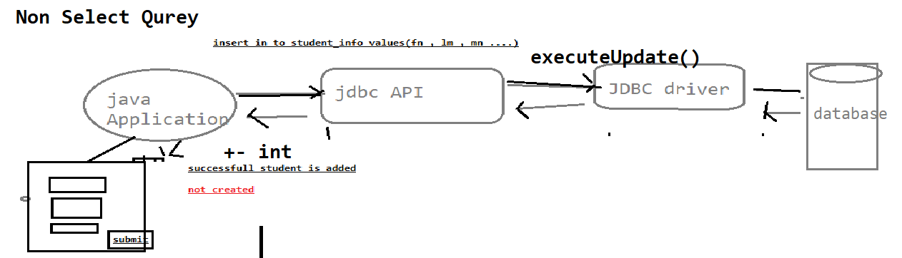

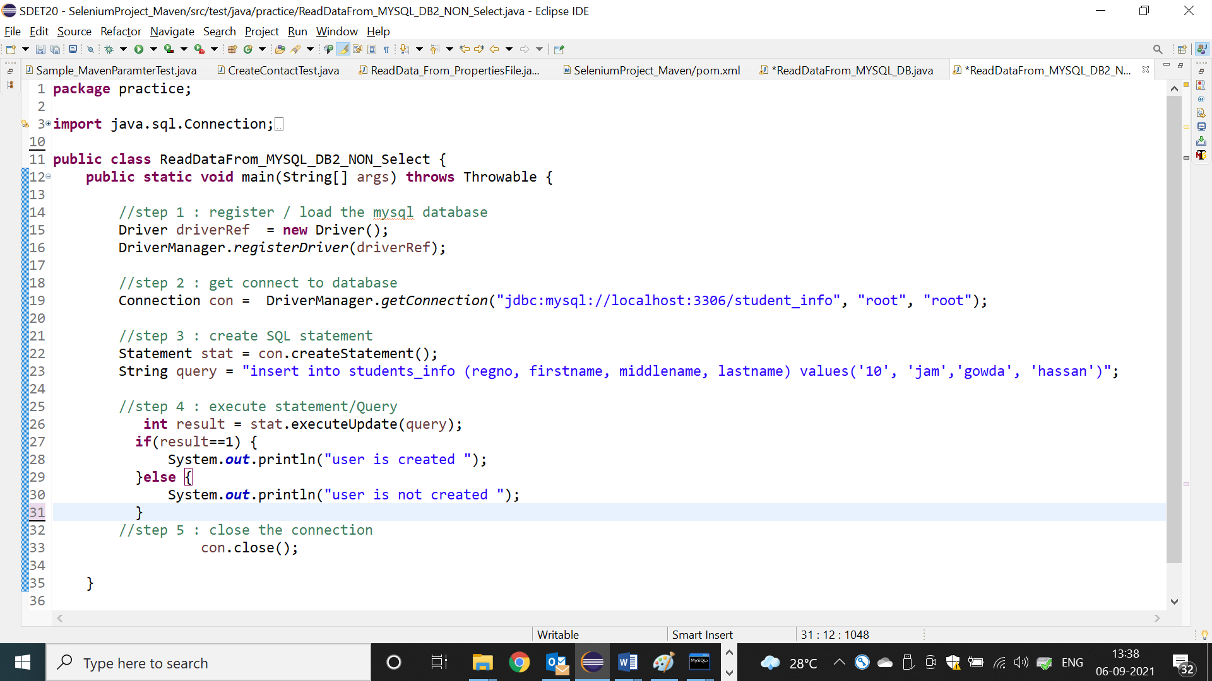

What is JDBC Drivers & JDBC API ?

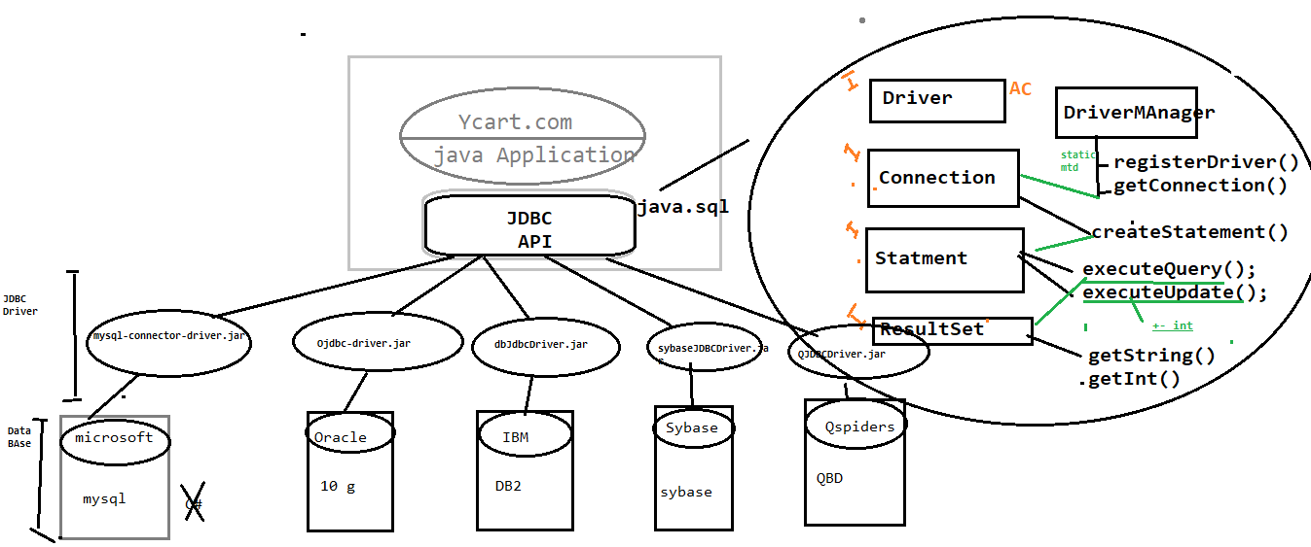

JDBC API : its an API’s available in java.sql package , which is collection interfaces with abstract method & class , & it’s database independent

JDBC Driver : its implementation class of JDBC API provided by data base vender . it’s a db dependent.

Why JDBC in Automation ?

In Automation also required JDBC Connection , Most of the test case Preconditions , required few set of data in Database & also validation GUI WRT Database

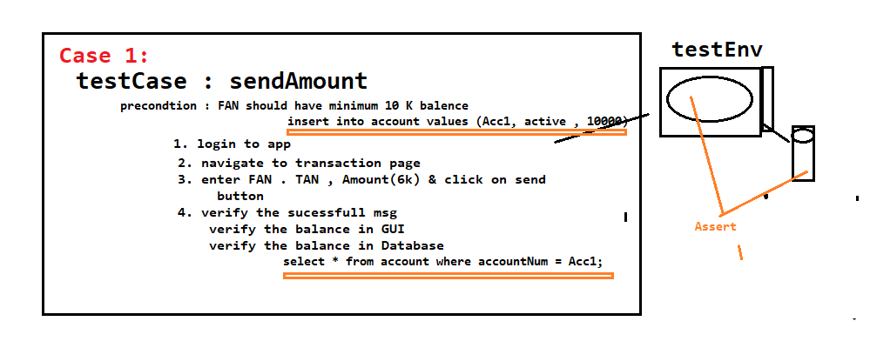

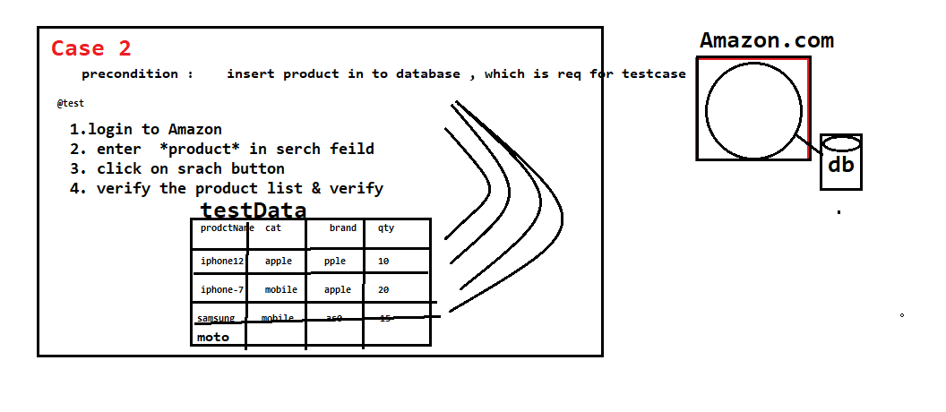

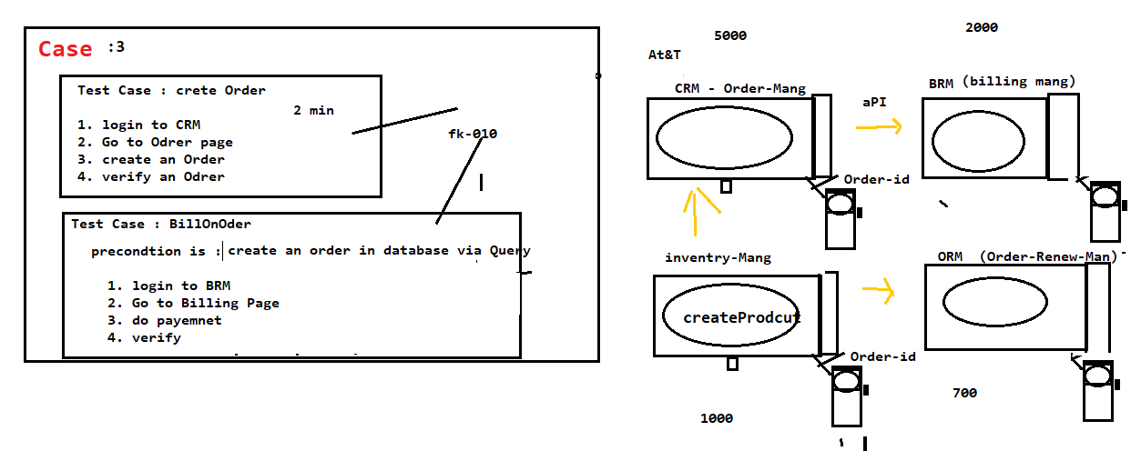

**JDBC usage in UNIT Testing[White box Testing]**

In case unit testing , [jdbc]database code is required to connect to database & get the data then verify the data WRT to business logic

