Nate Marsh, Sarah George and Maggie Kennedy
Final Project Write-Up
POLI 281.004: Data in Politics
9 December 2023
Data Analysis: Does a Voter’s Gender Influence Who They Voted For?

I. Introduction
Using the survey results from the 2016 American National Election Study, also known as ANES, we will be constructing an argument that hypothesizes why Donald Trump won the 2016 Presidential Election. We decided to investigate the impact that gender (of the participants), our independent variable, had on which candidate they voted for, our dependent variable. We believe the appeals each candidate respectively made to male and female demographics during campaigning and their general attitudes towards each gender strongly influenced the outcome of the election results. While our IV (column V161002) only had two answer choices, our DV (column V162034a) had five different options. Given our two-party system in the U.S., we decided to focus solely on Hilary Clinton and Donald Trump as the impact of the candidates from the Democratic and Republican parties considerably outweighed that of Gary Johnson, Jill Stein, and “Other” (third-party candidates). By making our DV a binary variable, we felt that it would be easier to draw conclusions about the influence of a candidate’s perceived views of gender given the prominence of Clinton and Trump in the mainstream media. Conversely, coverage of Jill Stein, Gary Johnson, and “Other” candidates was much less accessible, meaning it is difficult to correlate public knowledge of the candidate’s views with certain demographics. Overall, we believe the distinctive approaches of Hilary Clinton and Donald Trump with regard to their advocacy of women-specific issues (e.g., the wage gap, reproductive rights) greatly affected their endorsements by female versus male demographics, thus shaping the results of the election. More specifically, we think that Hilary Clinton’s championing of women’s rights and her status as the first female presidential nominee of a major political party caused female voters to favor her.

II. Introducing your independent variable and dependent variable
From the dataset, there were two potential dependent variables to consider that gauged the respondents overall feelings on the 2016 election: (1) “Who did you vote for? Hillary Clinton, Donald Trump, Gary Johnson, Jill Stein, or someone else?” or (2) “How would you rate Donald Trump?” The first of the two questions randomized the order of Trump and Clinton for each survey. This was a critical reason for choosing this variable, V162034a, for further investigation because the phrasing of the question, as well as the inclusion of third-party candidates, minimized potential for bias in how respondents answered the survey question. Gender was selected as the primary independent variable for further investigation given its undeniable influence during the 2016 election, the first in U.S. history where a woman was nominated for president and far more attention was placed on Trump’s history of accusations of sexual harassment than the candidates’ policies about taxes or healthcare. The expectation is that there will be a larger proportion of women voting for Hillary Clinton compared to Donald Trump.

III. Prep work: the dependent variable (who you voted for: trump or hilary)
People who had non-standard responses were those who answered with candidates that were not either Hilary Clinton or Donald Trump (i.e., Gary Johnson, Jill Stein, & “Other”). Since we coded this variable as a binary one, we were able to filter out the aforementioned data that did not fit with our experiment. There were some values in this column that included negative negatives – we created an inequality that filtered this out so that our figure wasn’t skewed. These non-standard responses may have been a product of incorrect data entry.

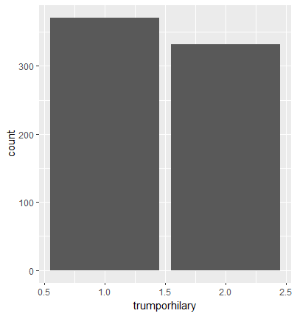
Caption: This figure shows us that participants in the survey voted for Hilary Clinton more than Donald Trump; the margin is less than 100. There is less of a concern with an item nonresponse here since the survey is conducted anonymously, so participants are more likely to answer more honestly and experience less shame in doing so.

IV. Prep work: the independent variable (gender: male or female)
The survey only allowed for either male, 1, or female, 2, to be selected for gender. Because this response was recorded as a binary variable initially, this variable did not require any additional cleaning to ensure this variable could be used for analysis. With that being said, we did decide to code male respondents to “0” and female respondents to “1” for easier interpretation of results.

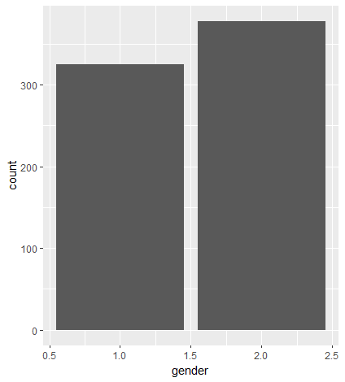
Caption: The figure for the independent variable, gender, is depicted with a bar graph where male voters are represented by the variable 1 and female voters are represented by 2. The graph shows that female voters outnumbered male voters by nearly 100 observations in this dataset. Item non-response does not appear to be a concern here, but typically a question regarding gender may result in non-response bias because due to the lack of inclusive options for gender identity, or respondents simply not feeling that their gender is relevant in the study.

V. Initial analysis: data visualization
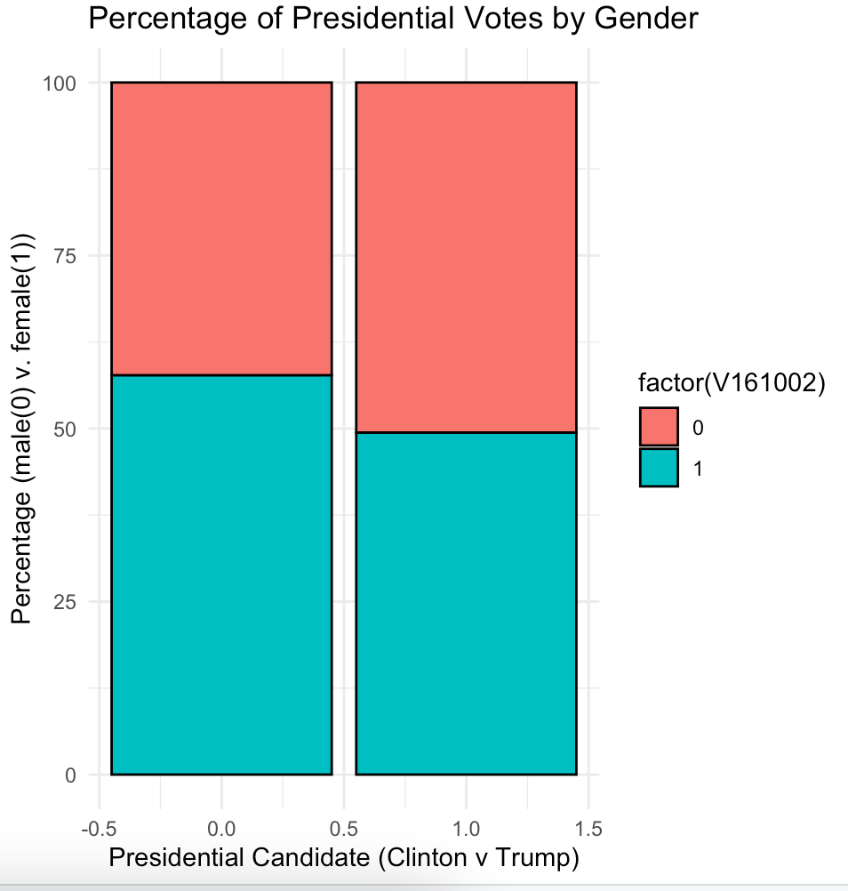
Caption: This figure represents the distribution of male v female voters for each candidate. Clinton is represented by the left bar, and Trump is represented by the right. Male respondents were coded as 0, and thus 0 in the legend represents males, while 1 represents females.

The figure above represents the percentage of male and female voters for candidates Clinton and Trump. The left bar represents all the respondents who indicated they voted for Clinton in the survey, while the right bar showcases all the respondents that voted for Trump. Looking at the legend, 0 represents male voters and 1 represents female voters. It is evident that female voters outweighed male voters for Clinton, with nearly 60% of her total votes coming from female surveyors. Conversely, when looking at Trump’s total votes, male respondents were the majority. From this bar graph, it appears that there is some relationship between the gender of the respondent and who they voted for. This figure also supports the hypothesis that females would be more likely to vote for Clinton.

VI. Initial regression analysis
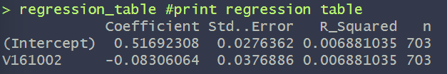
The initial regression analysis describes the estimated linear relationship between our IV, the vote result, and our DV, the gender of the voter. Looking at the table, we see that the analysis has 703 observations, the same number of observations in our dataset given the initial dataset was cleaned to only include the respondents who had voted for Hillary Clinton or Donald Trump.

Looking at the slope and intercept, we can better understand the relationship between our independent and dependent variables. Because the dependent variable (V162034a) is binary, with a response of 1 being a vote for Donald Trump, we can interpret the intercept as the likelihood a respondent voted for Donald Trump, keeping other variables as 0. A response of 0 for the independent variable, gender, is Male. Therefore, the intercept can be interpreted as the likelihood that a male voter voted for Trump, with that being 5169.%. The slope of the model can be interpreted as the change in likelihood a respondent voted for Trump when increasing V161002 (gender) by one unit. A one unit increase takes the binary gender variable from 0 to 1, with 1 being the code for female respondents. The slope in the model means that females have an 8.306% lower chance of voting for Donald Trump over Hillary Clinton. Altogether this model predicts that males have a 51.69% chance of having voted for Donald Trump, and a 48.31% having voted for Hilary Clinton, while females have a 43.66% chance of voting for Donald Trump and a 56.34% chance of voting for Hillary Clinton. So far, the ANES data set has confirmed our theories that female voters favor Hillary Clinton and male voters favor Donald Trump, as the results of the initial regression analysis are consistent with the aforementioned hypothesis.

VII. Introducing: confounders
Confounders, or omitted variables, pose an issue to any statistical analysis because they produce bias in observational studies especially. Identifying and considering any possible confounder is key to ensuring the accuracy in a study and discouraging misleading interpretations of the results. A confounder is a variable that is associated with both the independent variable and the dependent variable. The best way to identify potential confounders in a study is to consider the following criteria: (1) is the variable in question correlated to the independent variable, resulting in potential bias? (2) is the variable associated with the dependent variable independently, possibly disrupting the observable relationship between the IV and DV. By not isolating the independent and dependent variables and examining their relationship separately makes it impossible to draw meaningful conclusions about the data. Not thoughtfully considering the confounders would ultimately lead to bias and misleading interpretations.

In this analysis, four potential confounders are religion(V161244), age (V161267), education(V161270) and views on the economy (V161140). We suspect religion and age are unlikely to be confounding variables because while they may impact the dependent variable (i.e. religious people and older individuals are more likely to vote conservative), neither variable correlates with the dependent variable, gender. Conversely, education and views on the economy are far more likely to confound. For education, there are studies that show women are more likely to pursue higher education, and that those with higher level degrees tend to vote liberal leaning. As for perspectives on the economy, men tend to feel more confident discussing the economy and show a particular interest in the matter, and those who express concern about the economic state are more likely to vote conservatively. Both of these variables show a specific relationship with the independent and dependent variable, however further investigation via multivariate regression analysis is required to determine which of the variables produce the most bias in the results.

VIII: Prep work: confounders
We chose to make religion (V161244) a binary variable because there were initially only 4 answer choices (yes, no, don’t know, or refused), and we noticed there were only one or two data points that had a response of “don’t know” or “refused”. So, for the sake of concision, we decided to narrow it down to the “yes” and “no” data points knowing that it would minimally affect the overall interpretation. We made age (V161267) a continuous variable because of the range of values within this vector; the sole alteration we made was coding the variable as an inequality so that the data points that had an answer of -9 (= refused to answer) were removed. Once again, this would only slightly affect the distribution as there were less than a handful of these answers. We had a similar thought process for the views on the economy variable (V161140) as we singularly focused on the data points with the 1, 2, or 3 answer choices and disregarded the negative values. -8 and -9, which translated to don’t know and refused to answer, respectively, were almost nonexistent in the data set, with -9 only showing up once. We made views on the economy a categorical variable and did the same for education. However, with education, we greatly condensed the categories from the initial answer choices to create the following categories: high school or less, some college, college degree, post-bac education. We changed it as such because external research studies we referenced had split up education this way, and we thought it would be easier to draw conclusions from these categories.

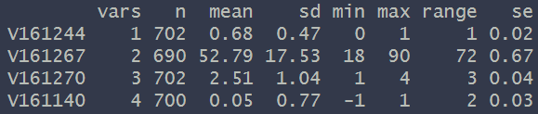
Caption: This figure shows the summary variable statistics for each of the four possible confounders.

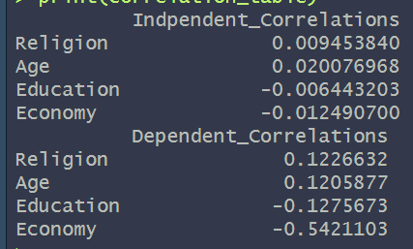
Caption: This figure shows the correlation coefficients for each of the four possible confounders against the independent and dependent variables.

After looking at each of the correlation coefficients in the table, it appears that the variable economy is most likely to be a confounding variable of the four possible choices. This is because it has the strongest correlation with the independent and dependent variables, compared to religion, age and education. The correlation between economy and the independent variable is considerably weak at 0.01, and moderate with the dependent variable at -0.54. While this correlation is not very strong overall, it is the strongest correlation amongst the potential confounding variables. This slightly changes the discussion we wrote above in part VII, as we had hypothesized that both education and views on the economy would confound (whereas only views on the economy ended up slightly confounding).

IX. Multivariate regression
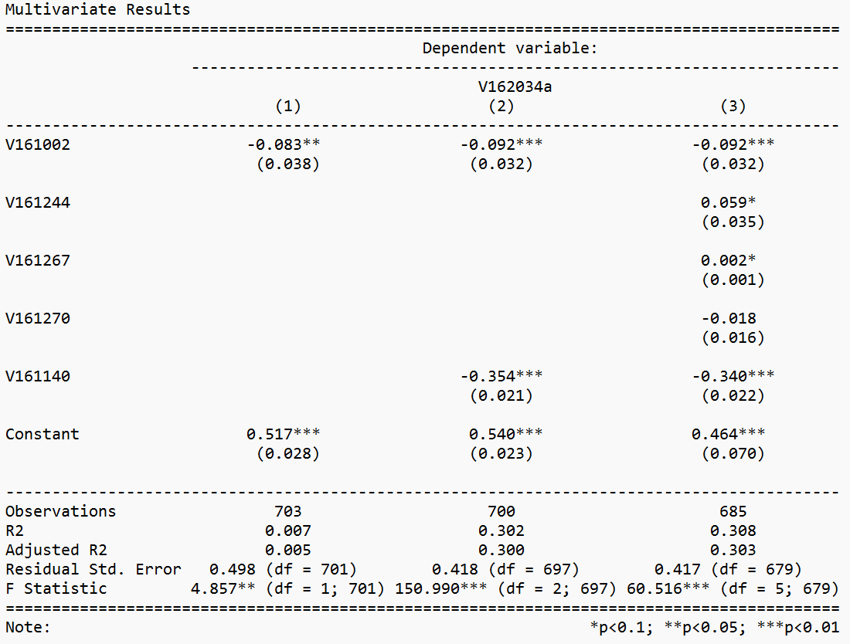
Caption: This figure shows the results for the multivariate regression, where the first column is the same as the bivariate regression, the second represents variables gender and views on economy, and the third includes gender and all four possible confounders.
The first column of the multivariate regression table reiterates the same results from the initial regression analysis. It shows the direct relationship between the dependent variable, if the respondent voted for Clinton or Trump, against the initial independent variable, whether the respondent is male or female. The initial intercept is 0.517 with a standard error 0.028, indicating the likelihood that a male voter voted for Trump is 51.7%. The second column represents gender as well as the variable that represents the respondent’s views on the economy, recorded 1 for “the economy has gotten better,” 0 for “the economy has stayed about the same,” and -1 for “the economy has gotten worse.” In this column, the intercept is 0.540, with a standard error of 0.023. It represents the likelihood of a male respondent who believes the economy has stayed the same voting for Trump is 54%. The intercept in column 3 is 0.582, with a standard error of 0.086, which is interpreted as the probability of a young, uneducated male who believes the economy is the same voting for Trump is 58.2%.

The initial variable (V161002) is -0.092 in both column 2 and column 3. This stability across columns suggests that despite adding the four additional variables, there is no substantial impact on the relationship between the initial independent variable and the dependent variable. With that being said, the absolute value of the coefficient is larger in columns 2 and 3 (0.092) compared to column 1 (0.083), indicating that the confounding variable in column 2 may have contributed to an underestimation of the main variable's effect. The remaining variables in column three are not confounders, however, it appears that by including them in the regression analysis, the estimate of the initial independent variable's impact on the dependent variable is refined allowing for a more accurate portrayal of their relationship. Therefore, these adjustments enhance the model and contribute to a more reliable interpretation of the main independent variable's effect on the dependent variable.

X. Conclusion
Through analyzing the 2016 ANES Election data set in this exercise, we have been able to confirm our initial hypothesis that women would be more likely to vote for Hilary Clinton than men. We considered other factors like the age of the voters, their educational backgrounds, religious identity, and views on the economy in our interpretation of the data.
To further elaborate on our hypothesis about the influence of potential confounders, we had expected a notable correlation between the independent and dependent variables and views on economy. According to a study conducted by the London School of Economics, women are generally less confident than men when it comes to discussing issues relating to the economy (Sarsons & Xu). As we discussed earlier in this report, this gender disparity is somewhat evident in the data we analyzed given it had the highest correlation values relative to the other variables. Moreover, our research from before we ran the multivariate regression had suggested that age might have been an influential factor. When contemplating the 2016 Presidential Election, it is imperative to consider the social climate and cultural context. While the #MeToo movement didn’t officially begin until 2017, the attitudes toward exposing sexual predators in positions of power had been shifting and becoming more visible up until that point. This premise is reinforced by the rhetoric surrounding Trump’s history of accusations of sexual assault around the time of his election. An intolerance of behavior like Trump’s was becoming less culturally tolerated, with many wanting to change this status quo. Furthermore, given the rise of young activists and changemakers in the last several decades, young women would have likely tolerated Trump’s behavior less than older women and young men. It is for these reasons, as well as the fact that women are becoming more politically active than men, that we had hypothesized that age would have been a formidable confounder (Cox). The final confounder we thought would have a considerable impact was education. Because education is known to correlate positively with liberalism, we had hypothesized that individuals that are more highly educated would be more likely to vote for Clinton (Pew Research Center). Additionally, given the increasing dominance of women in higher education, we had thought there would have been a higher correlation between education and the independent and dependent variables (Fry).
There are a couple of important caveats we wanted to make, most importantly the fact that we didn’t consider the “did you vote” column (V162034). Though we likely eliminated the respondents in our coding of the dependent variable, the answer choice of “did not register” may have been another factor to consider. Additionally, while theorizing about the inclination of women towards Clinton and men towards Trump, we realized that the general dislike of both candidates likely influenced this distinction. During the 2016 election, there was a large portion of the population that had a dissatisfaction with both candidates, which led to a lot of voters being forced to choose the “lesser evil”. This widespread dislike may have led to a lower turnout but also may have caused people to focus on the gender of each presidential candidate over all else. If a voter did not agree with the views of a candidate on a variety of issues, they may just disregard these factors and choose the candidate whose gender they also identify with. Hilary Clinton being the first female Presidential nominee of a prominent political party also likely pushed some voters to choose her in order to align themselves with this revolutionary change.
In conclusion, our analysis of the 2016 ANES Presidential Election data set showed us that women are more likely to vote for Hilary Clinton over Trump. The only potential confounder that emerged was the participants' views on the economy. We found there was a slight correlation between respondents feeling like the economy is in a good place or improving and voting for Hilary Clinton over Donald Trump. This is likely explained by the fact that Donald Trump had more stringent fiscal policies than his Democratic counterpart. Based upon these conclusions, we propose two recommendations. Firstly, while campaigning in the time preceding the election, it is imperative that a candidate minimize inflammatory comments directed at women and misogynistic language. This (somewhat obvious) campaign strategy is essential to avoiding alienating female voters, as Donald Trump has done time and time again through his misogynistic rhetoric. With regards to a policy recommendation, we suggest that candidates ensure that their language in discussions of fiscal issues is inclusive towards women. A candidate could also propose the implementation of financial literacy programs geared towards women to increase women’s confidence in these issues and general accessibility. As seen in the slight impact of views on the economy, fiscal policies are just as relevant to women’s favorability towards a candidate.
Finally, we believe the measures for our independent and dependent variables are sufficient. Recoding both of these variables as binary made our interpretations much clearer. We are confident in our methods and results as the p-values of the main variables are close to zero, indicating a statistical significance. Overall, we learned how many variables can interact with each other to produce a likelihood of a specific result and recognized the importance of considering confounders. Our assumptions at the beginning of this project were confirmed, though we were able to develop a more nuanced understanding of the 2016 Election results and the significance of gender in voting in the process.

XI: Individual contributions
Each group member contributed significantly. Nate completed all prep work and multivariate regression in the r script, as well as the paragraphs for the bivariate regression in the write-up. Sarah wrote the introduction, parts III, VIII, and conclusion in the write-up. Maggie completed the bivariate regression and data visualization in the r script and the paragraphs for the multivariate regression and parts II, IV, V and VII in the write up.

Works Cited
Cox, D. A. (2023, May 16). The growing political divide between young men and women. The Survey Center on American Life. https://www.americansurveycenter.org/featured_data/the-growing-political-divide-between-young-men-and-women/
Fry, R. (2022, September 26). Women now outnumber men in the U.S. college-educated Labor Force. Pew Research Center. https://www.pewresearch.org/short-reads/2022/09/26/women-now-outnumber-men-in-the-u-s-college-educated-labor-force/
Pew Research Center. (2016, April 26). A wider ideological gap between more and less educated adults. Pew Research Center - U.S. Politics & Policy. https://www.pewresearch.org/politics/2016/04/26/a-wider-ideological-gap-between-more-and-less-educated-adults/
Sarsons, H., & Xu, G. (2015, July 17). Confidence gap? women economists tend to be less confident than men when speaking outside their area of expertise. British Politics and Policy at LSE. https://blogs.lse.ac.uk/politicsandpolicy/confidence-gap-women-economists-tend-to-be-less-confident-than-men-when-speaking-outside-their-area-of-expertise/#:~:text=We%20find%20that%20top%20female,that%20is%20lower%20(right).

