This is an odfWeave document demonstration of the Cross-correlation map simulation study.

Here is the code that sets up the timeseries:

> library(lattice)
> t = seq(0, 520, 1)
> Sinuswave_expl <- ts(1 * sin(2 * pi * 1/52 * t))
> Random_expl <- ts(rnorm(length(t)))
> Random_resp <- ts(rnorm(length(t)))
> Sinuswave_resp_lag = Sinuswave_expl[(length(Sinuswave_expl) -
+ 3):length(Sinuswave_expl)]
> Sinuswave_resp_lag <- c(Sinuswave_resp_lag, Sinuswave_expl[1:(length(Sinuswave_expl) -
+ 4)])
> Sinuswave_resp_lag <- ts(Sinuswave_resp_lag)

Here's the plot showing the timeseries:

> plot(t/52, Sinuswave_expl, type = "l")
> lines(t/52, Sinuswave_resp_lag)
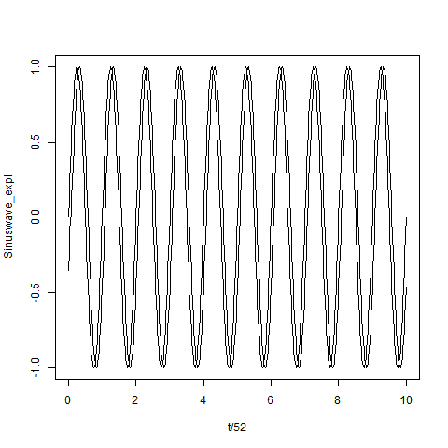

> plot(t/52, Random_expl, type = "l")
> lines(t/52, Random_resp)
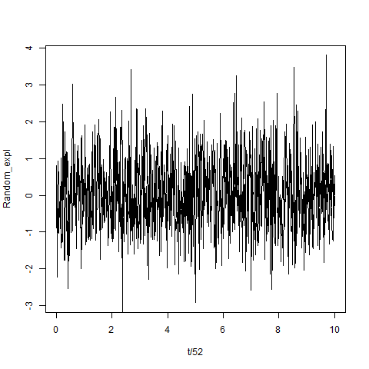

Here's the cross-correlation plot between the true lagged sinusoidal timeseries:

> Sinuswave_resp_lag_Sinuswave_expl_ccf <- ccf(Sinuswave_expl,
+ Sinuswave_resp_lag, lag.max = 40)
> plot(Sinuswave_resp_lag_Sinuswave_expl_ccf)
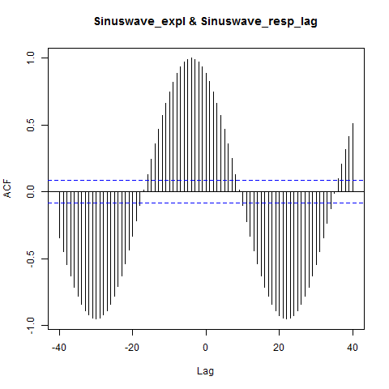

Here's the cross-correlation plot between the lagged sinusoidal and the random timeseries:

> Sinuswave_resp_lag_Random_expl_ccf <- ccf(Random_expl, Sinuswave_resp_lag,
+ lag.max = 40)
> plot(Sinuswave_resp_lag_Random_expl_ccf)
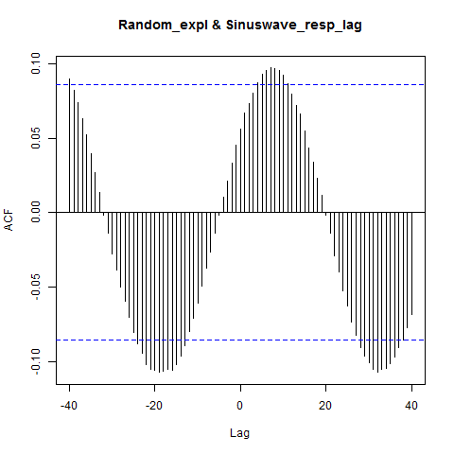

Here's the cross-correlation plot between the random and the sinusoidal timeseries:

> Random_resp_Sinuswave_expl_ccf <- ccf(Sinuswave_expl, Random_resp,
+ lag.max = 40)
> plot(Random_resp_Sinuswave_expl_ccf)
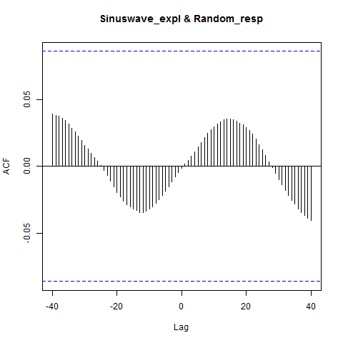

Here's the cross-correlation plot between the random timeseries:

> Random_resp_Random_expl_ccf <- ccf(Random_expl, Random_resp,
+ lag.max = 40)
> plot(Random_resp_Random_expl_ccf)
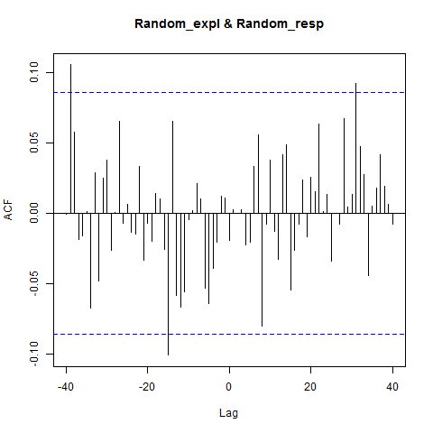

Create mixed timeseries with sinusoidal timeseries and random noise added with 1/5th weight:

> Mixed_expl = Sinuswave_expl + Random_expl/5
> Mixed_resp_lag = Sinuswave_resp_lag + Random_resp/5
> plot(Mixed_expl, type = "l")
> lines(Mixed_resp_lag, cl = "red")
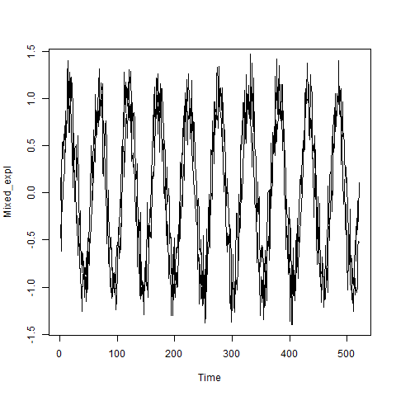

Here's the cross-correlation plot between mixed and lagged sinusoidal timeseries:

> Sinuswave_resp_lag_Mixed_expl_ccf <- ccf(Mixed_expl, Sinuswave_resp_lag,
+ lag.max = 40)
> plot(Sinuswave_resp_lag_Mixed_expl_ccf)
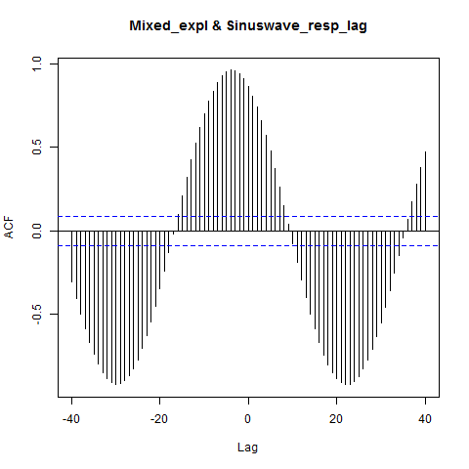

Here's the cross-correlation plot between sinusoidal and lagged mixed timeseries:

> Mixed_resp_lag_Sinuswave_expl_ccf <- ccf(Sinuswave_expl, Mixed_resp_lag,
+ lag.max = 40)
> plot(Mixed_resp_lag_Sinuswave_expl_ccf)
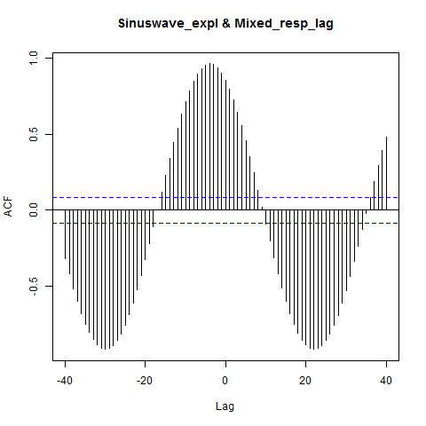

Here's the cross-correlation plot between mixed and lagged mixed timeseries:

> Mixed_resp_lag_Mixed_expl_ccf <- ccf(Mixed_expl, Mixed_resp_lag,
+ lag.max = 40)
> plot(Mixed_resp_lag_Mixed_expl_ccf)
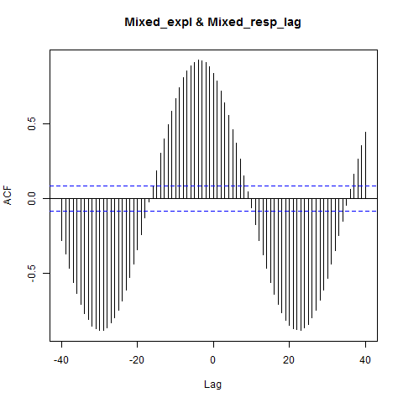

We difference the sinusoidal timeseries and the lagged sinusoidal timeseries:

> diff_Sinuswave_expl <- diff(Sinuswave_expl)
> diff_Sinuswave_resp_lag <- diff(Sinuswave_resp_lag)
> plot(diff_Sinuswave_expl)
> lines(diff_Sinuswave_resp_lag, col = "red")
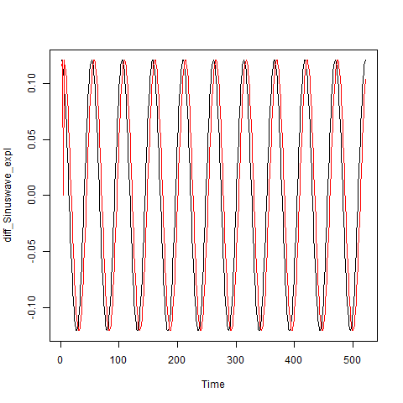

Here's the cross-correlation plot between the differenced sinusoidal lagged timeseries:

> diff_Sinuswave_resp_lag_diff_Sinuswave_expl_ccf <- ccf(diff_Sinuswave_expl,
+ diff_Sinuswave_resp_lag, lag.max = 40)
> plot(diff_Sinuswave_resp_lag_diff_Sinuswave_expl_ccf)
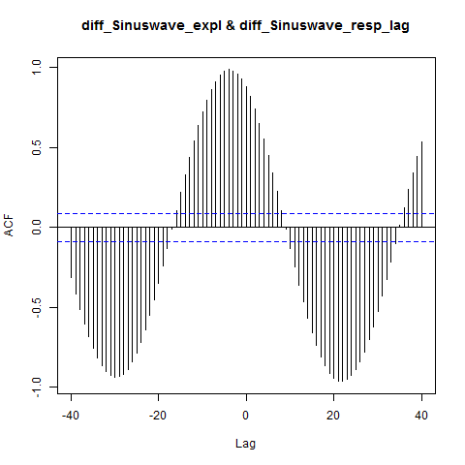

We difference the mixed timeseries:

> diff_Mixed_expl <- diff(Mixed_expl)
> diff_Mixed_resp_lag <- diff(Mixed_resp_lag)
> plot(diff_Mixed_expl)
> lines(diff_Mixed_resp_lag, col = "red")
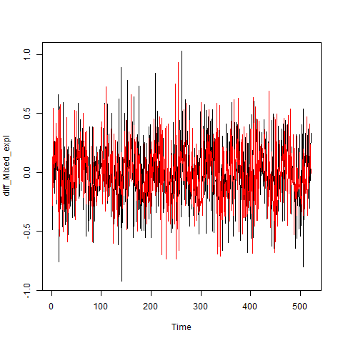

Here's the cross-correlation plot of the differenced mixed time-series:

> diff_Mixed_resp_lag_diff_Mixed_expl_ccf <- ccf(diff_Mixed_expl,
+ diff_Mixed_resp_lag, lag.max = 40)
> plot(diff_Mixed_resp_lag_diff_Mixed_expl_ccf)
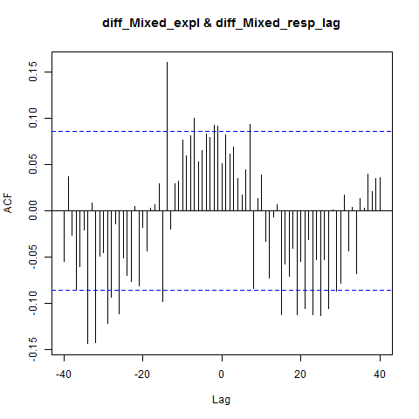

Now we will create the cross-correlation map of the sinusoidal timeseries:

Here's the Cross-Correlation Map of the sinusoidal timeseries based on Pearson's correlation:

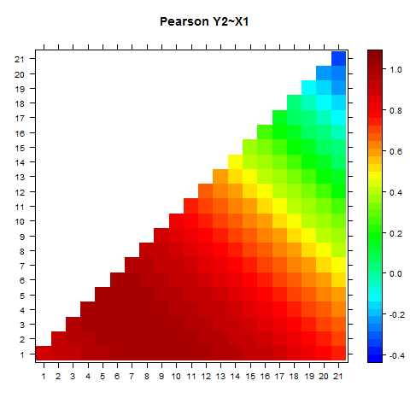

Here's the Cross-Correlation Map of the sinusoidal timeseries based on Spearman's correlation:

> Spearman_corr_matrix <- matrix(CCM_corr_matrix[, 4], nrow = 21,
+ ncol = 21, dimnames = list(c(1:21), c(1:21)))
> print(levelplot(Spearman_corr_matrix, xlab = "", ylab = "", main = "Spearman Y2~X1",
+ col.regions = rgb.palette(100), cuts = 40))
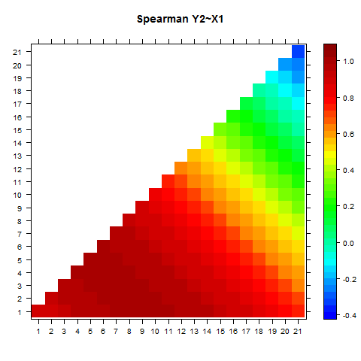

Let's compare Pearson's and Spearman's correlations:

> plot(CCM_corr_matrix[, 3], CCM_corr_matrix[, 4], xlab = "Pearson's",
+ ylab = "Spearman's")
> lm_comparison <- lm(CCM_corr_matrix[, 3] ~ CCM_corr_matrix[,
+ 4])
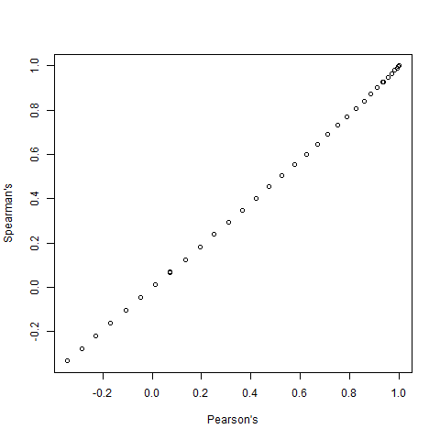

Cross-correlation map correctly identifies the lag 4 as the highest correlation:

cor rho
4 4 1 1
cor rho
[1,] 0 8 1 0.9999371
[2,] 2 6 1 0.9999342
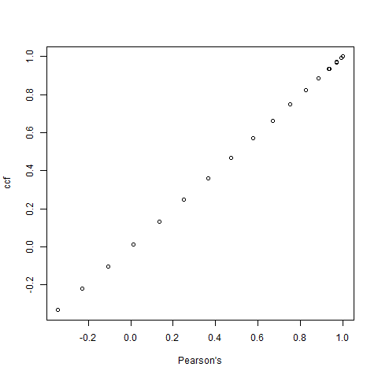

Now we create the cross-correlation map for the mixed timeseries:

Here's the cross-correlation map of the mixed timeseries based on Pearson's correlation:

> Pearson_corr_matrix <- matrix(CCM_corr_matrix[, 3], nrow = 21,
+ ncol = 21, dimnames = list(c(1:21), c(1:21)))
> print(levelplot(Pearson_corr_matrix, xlab = "", ylab = "", main = "Pearson Y3~X4",
+ col.regions = rgb.palette(100), cuts = 40))
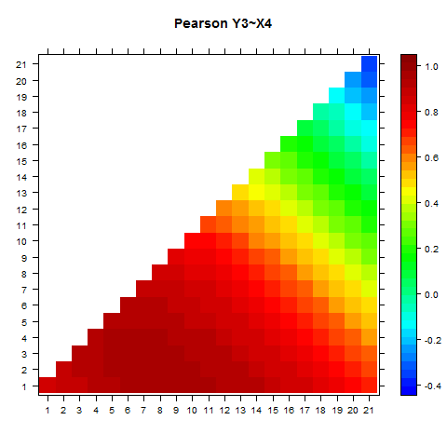

Here's the cross-correlation map of the mixed timeseries based on Spearman's correlation:

> Spearman_corr_matrix <- matrix(CCM_corr_matrix[, 4], nrow = 21,
+ ncol = 21, dimnames = list(c(1:21), c(1:21)))
> print(levelplot(Spearman_corr_matrix, xlab = "", ylab = "", main = "Spearman Y3~X4",
+ col.regions = rgb.palette(100), cuts = 40))
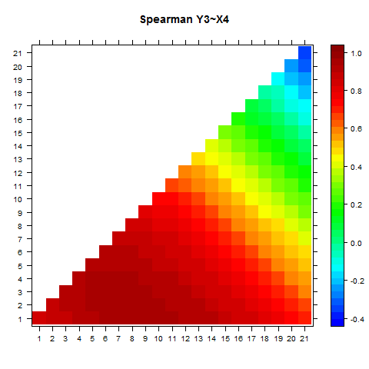

Let's compare the Pearson's and the Spearman's correlation:

> plot(CCM_corr_matrix[, 3], CCM_corr_matrix[, 4], xlab = "Pearson's",
+ ylab = "Spearman's")
> lm_comparison <- lm(CCM_corr_matrix[, 3] ~ CCM_corr_matrix[,
+ 4])
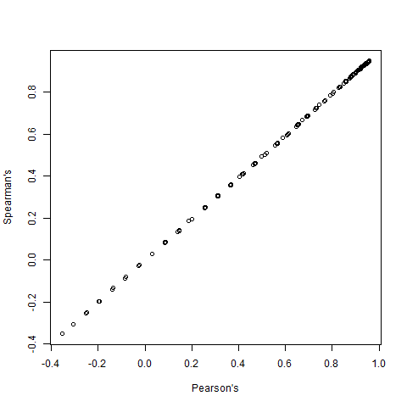

We check Pearson's correlation against the cross-correlation function:

> diag_Pearson <- Pearson_corr_matrix[seq(1, length(Pearson_corr_matrix),
+ 22)]
> ccf_estimates <- Mixed_resp_lag_Mixed_expl_ccf$acf[41:21]
> plot(diag_Pearson, ccf_estimates, xlab = "Pearson's", ylab = "ccf")
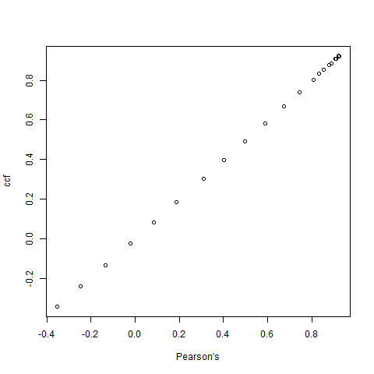

Cross-correlation plot correctly identifies the lag of the sinusoidal component of the mixed timeseries:

cor rho
0.0000000 8.0000000 0.9574599 0.9478863
cor rho
0.0000000 8.0000000 0.9574599 0.9478863

