IT481 M2 Part 2

Kevin Maher

Screen Shots

Part 2

// Build

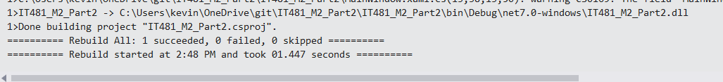

// At startup

// login as User_CEO

// login as User_HR

// login as User_Sales

// failed login

