Measure of Central Tendency

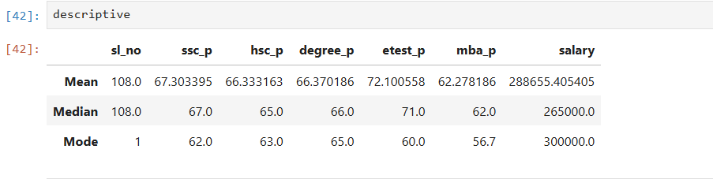
ssc_p

-> Mean = All arrived pass mark percentage around 67.3033
-> Median = All arrived pass mark percentage around 67
-> Mode = Most of them arrived 62 percentage in class room

hsc_p

-> Mean = All arrived pass mark percentage around 66.3331
-> Median = All arrived pass mark percentage around 65
-> Mode = Most of them arrived 63 percentage in class room

degree_p

-> Mean = All arrived pass mark percentage around 66.3701
-> Median = All arrived pass mark percentage around 66
-> Mode = Most of them arrived 65 percentage in class room

etest_p

-> Mean = All arrived pass mark percentage around 72.10
-> Median = All arrived pass mark percentage around 71
-> Mode = Most of them arrived 60 percentage in class room

mba_p

-> Mean = All arrived pass mark percentage around 62.278
-> Median = All arrived pass mark percentage around 62
-> Mode = Most of them arrived 56.7 percentage in class room

Salary:

-> Mean and Median has more difference and Mean and Mode are approx same, hence there is outlier present in dataset

