

TOWARD TRUSTWORTHY FAKE NEWS DETECTION WITH GNN AND BERT MODELS USING EXPLAINABLE ARTIFICIAL INTELLIGENCE (LIME AND SHAP)

MOULI GUPTA - 24BAI1049
K MAHESH CHANDRAN - 24BAI1400
RISHABH GOVINDARAJ – 24BAI1421

ABSTRACT
The spread of fake news through digital media is a significant risk to the quality of information, social stability, and the public's trust. While conventional machine learning algorithms perform well in classifying texts, they do not account for relational information and have low transparency. Hence, this paper suggests an approach which combines GNN with representation based on transformers (BERT) using Explainable Artificial Intelligence (XAI) methods such as LIME and SHAP. The dataset used in this research is Kaggle Fake News Dataset consisting of approximately 40,000 news articles which were pre-processed in terms of tokenization, removing of stop words, and generation of graphs. Embedding from BERT was used as attributes for nodes enabling GNN to make use of connections between embeddings semantically. While testing the performance of the model, the accuracy of the baseline BERT classifier is found to be 92% and 90% for vanilla GNN. Accuracy of the GNN+LIME model is estimated to be 94%, whereas that of the GNN+SHAP is 95%. The results of ablation studies show importance of using the dropout strategy and setting up the right value of neighbor size for improving generalization. In the course of parameter tuning, learning rate equals 0.001, batch size is equal to 16, and KNN neighbors equal five. Due to the implementation of interpretability methods, the system becomes much clearer because users understand how predictions are made. As seen above, this approach allows for the creation of efficient fake news detection system.

KEYWORDS
Fake News Detection, Misinformation Analysis, Disinformation Modeling, Explainable Artificial Intelligence (XAI), Graph Neural Networks (GNN), Bidirectional Encoder Representations from Transformers (BERT), ALBERT, LSTM, CNN-RNN Hybrid Models, Transformer-based Embeddings, TF-IDF, Word Embeddings, Sentiment Analysis, Stance Detection, Multimodal Fusion (Text + Image + Engagement), Privacy-Preserving Machine Learning, Federated Learning, SHAP (SHapley Additive exPlanations), LIME (Local Interpretable Model-agnostic Explanations), Kaggle Fake News Dataset, ISOT Dataset, WELFake, FakeNewsNet, Fakeddit, Real-time Classification, Trustworthy AI Systems

1. INTRODUCTION

1.1 Basic Introduction
This revolution is associated with the creation of information through its distribution and use. Social networking sites, online news pages, and micro blogging sites are some of the platforms where the democratization of information has become possible as people exchange information instantly. With this revolution comes an additional challenge that limits the success of the free flow of information. The challenge relates to the fast spread of information that is not true. Fake news describes any false or inaccurate information disseminated with the purpose of manipulating people's beliefs for certain objectives. The consequences of fake news can be severe; they might even lead to death, particularly in light of the current coronavirus pandemic. [21].
Existing methods for identifying false news stories relied on manual checking and rule-based mechanisms. These methods worked well under specific circumstances, but they could not be scaled up because of their inefficiency in processing huge amounts of textual content being produced daily. Machine learning and natural language processing can help detect fake news; nevertheless, most of the time, these technologies behave like "black box" systems, meaning that they cannot provide rationales for individual predictions. This lack of transparency in modern AI technologies represents a critical drawback since it reduces the potential effectiveness of these solutions. [22].
In order to tackle these issues, recent efforts have been made to incorporate explainable artificial intelligence (XAI) into fake news detection algorithms. Explainable AI gives explainability by showing the importance of features or relations for making predictions. This is one way of balancing efficiency and reliability. This work attempts to combine the powers of graph neural networks (GNN), transformers (BERT), and XAI (LIME and SHAP) to detect fake news.

1.2 Research Gap
Although significant advancements have been made in the identification of fake news, some limitations remain unaddressed. Firstly, conventional approaches are effective on textual data but fail to capture the structural relation between the users. Social interaction between individuals plays a vital role in the propagation of fake news because the phenomenon occurs on social media websites [23]. Secondly, despite the success of transformer-based architectures such as BERT and RoBERTa in attaining SOTA performance in natural language processing problems, they fail to offer any explanation in the reasoning behind their decisions. Although accuracy is an essential criterion, for the practical implementation of the model for users, media firms, and policymakers, it must come along with an explanation on why the particular piece of news is identified as either fake or genuine.
Thirdly, most studies on fake news detection rely on monolingual English datasets. Fourthly, privacy concerns have been overlooked. As many of the current systems use sensitive user data, there are numerous ethical and legal issues involved. The study will address this issue by adopting a privacy-centric perspective while designing the system. The current research paper aims to fill the gap through incorporating relational modeling through Graph Neural Network, contextual embeddings through BERT and LIME and SHAP for interpretability.

1.3 Motivation
The motivation for carrying out this study comes from the growing need for combating the spread of disinformation in an effective and scalable way. In fact, it is important to know that disinformation spreads faster and to a wider population than information that is genuine. There are several pieces of evidence that show how misinformation spreads 70% faster on social media networks than real information [25].
In one case, there was misinformation regarding the coronavirus and its vaccine and cures, which resulted in people being exposed to health risks. Additionally, political misinformation also affected the voters, leading to the undermining of the democratic process. Therefore, it is crucial to come up with ways of detecting misleading information that are credible and self-explanatory. With the advent of multimodal false news that contains text, images, and engagement, it becomes necessary to develop advanced models to handle such forms of information.
Graph embedding and transformer models are the ideal way to deal with multimodal data. Introducing explainability to these models will help develop methods that can be used by other entities.

1.4 Key Contribution
Some of the major contributions of this work are as follows:
1. Hybrid Approach: The work makes use of Graph Neural Networks (GNN) combined with transformer-based models like BERT for a hybrid model of fake news classification.
2. XAI Approaches: Some Explainable AI approaches like LIME and SHAP were employed for the project.
3. Extensive Experimentation: Extensive experiments were performed using the Kaggle Fake News Dataset comprising about 40,000 articles. The results show that although BERT achieves 92% accuracy, GNN-LIME & GNN-SHAP have a higher accuracy rate at 94% & 95% respectively.
4. Comparative Study: We compare our proposed approach with several baseline models such as logistic regression, support vector machine, decision tree & CNN, along with ablation studies.
5. Ensuring Feasibility: With high accuracy and explainability rates, our work aims to build trust for fake news detection.

1.5 Organization of the Paper
Section II highlights the literature review part, where an overview of the existing methods for detecting fake news, along with their advantages and drawbacks, is provided. The proposed methodology is explained in Section III, which explains data pre-processing, creation of graphs, extraction of features using BERT, and finally classification using GNN. Section IV elaborates on the experimental settings, explanation of the datasets used in the experiments, findings from the proposed model, comparative analysis between baselines and proposed models, ablation studies, and hyperparameter tuning. Section V contains the conclusion with suggestions for future research. Section VI provides the link of the datasets used in this paper.

2. LITERATURE STUDY

2.1 Research paper analysis
A study introduces fake news detection built with NLP and machine learning. This fake news classifier was paired with a simple user interface. The datasets were derived from Kaggle, which were pre-processed with TF-IDF and experimented with models such as logistic regression, SVM, decision tree, and CNN. The evaluation shows decision tree consistently outperformed the others. [3]

Another work highlights that the text-only models are not capable of capturing how misinformation spreads across social media platforms. To address this issue, GNN, Graph Neural Networks, alongside NLP methods, showed good results. The data set included user-news interactions as graphs. Their findings confirm that GNN-based approaches help detect fake news more effectively. [4,12]

A different approach uses transform architectures like BERT and RoBERTa. Here, the text was pre-processed that generated contextual embeddings which helped in capturing the meanings beyond keywords. The model was also incorporated using transfer learning and linguistic features such as NER and POS tagging. This approach helped achieve a superior accuracy and generalization overall. [5,14]

In another study the authors design a twostage framework that first classifies stance (agree, disagree, discuss, unrelated) using TFIDF with traditional ML algorithms, then applies a BiLSTM model to analyze fabrication. Tested on the FNC1 dataset, both stages achieve strong accuracy, showing that combining stance detection with deeper content analysis yields better results than either method alone. [2,6]

The CMFN Ingram model uses a multimodal approach, analyzing both text and images, which help to understand the human reasoning and also mimicking it. The datasets included WEIBO-21 and MCLFEND. The model employs BERT for text and SentenceBERT to recall similar past cases. Then, it fuses textual and visual signals to classify the given news. The results show improved precision, though performance depends heavily on the availability of relevant prior cases. [7]

Another contribution includes FastText embeddings with CNN-LSTM, which is tested on datasets like BellFake and FakeNewsNet. The text was converted into semantics, and to enhance transparency, XAI tools like LIME are integrated. XAI helped in clarifying how the predictions were made. The CNN-LSTM helped in supervising FastText that led to high accuracy, while also explaining the reason behind the prediction. [8,13,14]

Research focus on detecting fake news in the Indonesian language using sentiment analysis and document similarity. The dataset combines false news from turnbackhoax.id with genuine news from detik.com, and the experiments use 10fold crossvalidation. The authors first apply TFIDF cosine similarity, then test classifiers such as Random Forest, SVM, and Naïve Bayes based on sentiment features. Random Forest performs best, reaching an accuracy of around 62–63%. Still, the authors note that adding richer contextual features could further improve performance. [9]

Another study considered fake news detection on bilingual database. The primary languages were Bengali and English. About 63,000 samples were collected/ generated in both the languages, which was used as the dataset. The study involved training of multilingual BERT and RoBERT models along with explainable AI models like LIME and SHAP. The model gave very high accuracy, around 99%. It was also to be noted that the model performed better on English case samples relative to Bengali case sample languages, which was probably due to language imbalance in training. [10]

Today, privacy and security are also major concerns. Recent works include privacy-friendly framework for fake news detection, where the dataset is ISOT and the text is made anonymous by using SHA-256 hashing technique, alongside various vectorization techniques such as hashing vectorizer, embeddings, etc. The next step includes classification using a random forest classifier. This model had a very high accuracy of 99%. It also ensured privacy. However, it led to semantic loss. [11]

Another research uses XGBoost model, like Random Forest, SVM, and Logistic Regression, for ranking the features and allotting them weights, while the dataset is taken from Twitter, and external informations like tweet volume, sentiment score, centrality, and similarity are also taken into consideration. Therefore, the study was based on user behavior with content analysis. The results showed 94% accuracy with the Random Forest classifier, thereby again proving that combining social and textual features help enhancing in detection of fake news. [15]

The study offers a deep learning-based real-time fake news detection solution, which is both fast and accurate. The datasets used include ISOT, and the authors preprocessed the text using various embedding methods. The authors used LSTM, ALBERT, and hybrid CNN + RNN models, and compared the models after they were trained. It was found that ALBERT produced almost 100% accuracy, as did hybrid models, indicating excellent results for real-time applications. [16,13, 14]

This paper proposes an ensemble-based fake news detection system to address the dynamic patterns of misinformation. The WELFake dataset is employed, and TF-IDF is utilized for feature extraction. Various classifiers, including ANN, SVM, KNN, Decision Tree, and Passive Aggressive, are ensemble using weighted majority voting, and a News Tracker Agent is employed to update the data. The experimental outcome indicates that the proposed system achieves better accuracy and F1-score than individual models, thus being more robust. [17]

This study contrasts conventional machine learning and deep learning methodologies for the identification of fake news. The ISOT dataset is utilized, and text preprocessing encompasses tokenization, elimination of stop words, and TF-IDF transformation. We put in place and tested a Feedforward Neural Network and a Naïve Bayes classifier. The results show that the neural network works much better than Naive Bayes, especially when the datasets are big and complicated. [18]

A bi-fusion modal system was deployed that included textual and visual features to investigate multimodal fake news detection. The dataset was extracted from social media posts. Transformer-based language models were used for text classification and images were classified using visual feature extractors. The results prove that multimodal models outperform single-modal systems and improve the efficiency of the model. [19]

With various new emerging techniques, a new emerging field is multimodal system, dataset used: Fakeddit. Such a multimodal system was deployed in a recent study where three different fields, text, images, and engagement information, were used as three different modes. Tri-fusion det or trimodal fusion detector for fake news deployed DistilBERT for textual features and ResNet-18 for images. The classification was performed using XGBoost. The experiment demonstrated an overall improved accuracy that held as a testament that multimodal fusion systems help in detection and can enhance the accuracy. For example, the engagement information such as likes and comments in addition to the content boosted the accuracy of the system. [20]

[21] This paper proposes the use of Graph Neural Networks (GNN) on graphs consisting of interactions between social media content such as articles and users through edges like reposts, replies, and follows. Contextual embeddings obtained from text using transformer encoder are combined with the network structure obtained from the interaction graph through a GNN in order to learn propagation patterns within the graph. Experiments performed on a large dataset of social graph have shown superior results when compared to baselines with text-only features, particularly for rapid propagation items. Disadvantages - Proper graph construction is important and it is costly to apply on large social networks.

[22] In this paper, a new architecture of temporal snapshot graph neural network has been proposed in which the interactions between users and articles are modeled through time-sliced graphs. Temporal snapshots are represented with BERT-based text features and temporal edge weights, after which information is aggregated through a temporal GNN in order to predict misinformation at an early stage of dissemination. Experimental results show superior early detection capability along with recall in the early stage of spread. The model is reliant on time series data and makes the training process costly.

[24] Another research paper emphasizes fine-tuning techniques for improved detection of fake news using BERT. The approach utilizes domain-specific pretraining and specialized data augmentation, such as contrastive learning of headlines vs. bodies. The model shows superior results to previous fine-tuned BERT models when evaluated on various fake news data sets, exhibiting strong understanding of context and high F1-scores. However, since the model is a black box without interpretability, it cannot be trusted in critical tasks.

[25] Another line of research involves fusion of multiple signals for multimodal fake news detection. Text is represented by BERT, while images are processed by ResNets or Visual transformers, and text is extracted using optical character recognition (OCR). The method then fuses all the different signals and sends them through a classifier (e.g., XGBoost or MLP). Experiments have demonstrated significant improvements in accuracy compared to unimodal systems. However, such methods require well-aligned multimodal samples and are computationally expensive.

[26] Privacy-aware research investigates federated learning and secure aggregation techniques for detecting fake news. Federated learning allows client devices to train models locally using anonymized or hash-encoded textual features and exchanging only the gradients encryptedly. Although preserving privacy and supporting federated learning simultaneously poses challenges for training, simulations conducted with realistic distributed data demonstrate that the federated approach achieves competitive performance with centralized learning. Factors such as communication efficiency, non-IID distributions, and heterogeneous systems further influence training processes.

[27] Cross-domain research on interpretability assesses LIME + SHAP approaches on different fake news detection models (transformer-based, GNN-based, and ensemble models). In terms of feature importance, the results indicate that SHAP is more stable than LIME regarding global importance, while LIME is more helpful for generating local explanations for individual instances. Explanation techniques are sensitive to texts' length and noise levels.

Table 1 - Comparative Study of related research papers in the domain of fake news detection
Ref No. | Dataset | Methodology | Application | Advantage | Disadvantage
[1] | Benchmark news dataset | BoW, TF-IDF, LR, NB, RF | Text classification | Simple, interpretable | Low accuracy
[2] | ISOT | Self-Attention, BiLSTM, Deep Learning | Social media fake news detection | High accuracy, Context capture | High computation, Complex tuning
[3] | Kaggle Fake/True | TF-IDF, LR, SVM, DT, CNN | Web-based detection | Practical system | CNN overfitting
[4] | Social graph dataset | GNN + NLP | Social media analysis | Captures propagation | Complex structure
[5] | Standard news dataset | BERT, RoBERTa, Transfer learning | Context-aware detection | High accuracy | High computation
[6] | FNC-1 | TF-IDF + BiLSTM | Stance detection | Context modeling | Limited categories
[7] | Weibo-21, MCFEND | BERT, SentenceBERT, Multimodal reasoning | Cross-platform detection | Better generalization | Case-base dependency
[8] | WELFake, FakeNewsNet | FastText, CNN-LSTM, XAI | Explainable detection | High accuracy + transparency | Computational cost
[9] | Indonesian dataset | TF-IDF, Sentiment, RF | Local language detection | Simple approach | Moderate accuracy
[10] | Bengali-English dataset | mBERT, RoBERTa, LIME | Multilingual detection | High performance | Language imbalance
[11] | ISOT | SHA-256, Embeddings, RF | Privacy-preserving detection | Data security | Semantic loss
[12] | Social media dataset | GNN, Deep Learning, Graph modeling | Fake news detection | Captures network structure | High complexity, Large data need
[13] | News dataset | Hybrid deep learning, CNN | Fake news classification | Improved accuracy, Feature fusion | Computational cost, Overfitting risk
[14] | News dataset | Transformers, NLP, Text summarization | Fake news detection & Summarization | Dual functionality | High computational cost
[15] | Twitter dataset | XGBoost, RF, SVM | User-centered detection | Social features integration | Small dataset
[16] | ISOT | LSTM, ALBERT, CNN+RNN | Real-time detection | Near-perfect accuracy | Heavy models
[17] | WELFake | Ensemble voting, TF-IDF | Online adaptive system | Robust performance | System complexity
[18] | ISOT | FFNN, Naïve Bayes | Model comparison | Better scalability | Basic features
[19] | Multimodal dataset | BERT + Visual fusion | Social media detection | Improved accuracy | Data dependency
[20] | Fakeddit | DistilBERT, ResNet18, XGBoost | Tri-modal detection | Engagement integration | High computation
[21] | Social media graph dataset | GNN for fake-news detection | Social media misinformation detection | Improved propagation-aware detection; captures network effects. | High computational cost; complex graph construction
[22] | Twitter / news corpora | Graph-based neural network + features | Fake news classification on social feeds | Better early detection via graph signals. | Requires time-series engagement data; heavier training.
[23] | ISOT, WELFake | Ensemble (XGBoost/LightGBM) + XAI | Explainable fake-news classification | High accuracy with explainability; ensemble robustness. | Ensemble complexity; needs careful calibration.
[24] | Standard news datasets | BERT-based fine-tuning | Text-only fake news classification | Strong contextual performance; transformer baseline. | Black-box behavior; limited interpretability.
[25] | News datasets | BERT / RoBERTa + LIME explanations | Interpretable transformer classification | Local interpretability for samples; human-understandable explanations. | Requires aligned multimodal data; higher compute.
[26] | Multimodal datasets (text+image) | Multimodal fusion (text+image) | Multimodal fake news detection | Improved accuracy by fusing image and text signals. | Communication overhead; model heterogeneity issues.
[27] | ISOT / social datasets | Privacy-aware pipeline (hashing + RF) | Privacy-preserving fake news detection | High accuracy while anonymizing text; trade-off: semantic loss. | XAI methods can be unstable; explanation fidelity varies.

3. METHODOLOGY

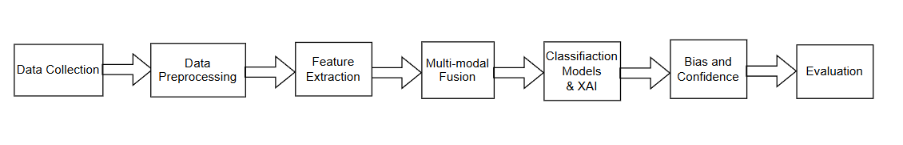
Fig 1. Workflow of the Proposed Methodology
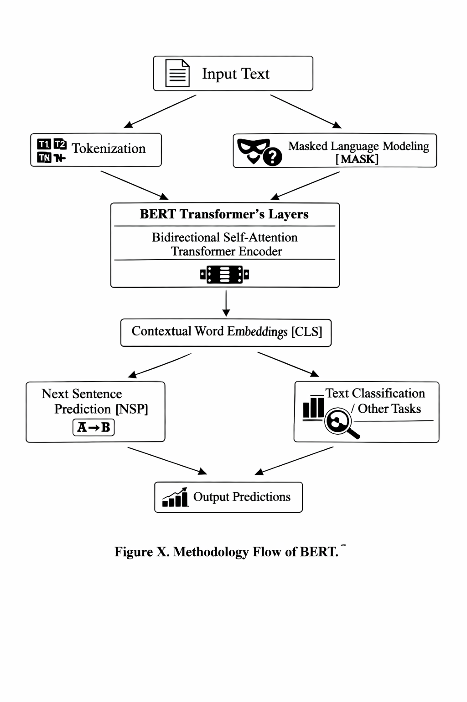Fig. 2 - Methodology Flow of BERT
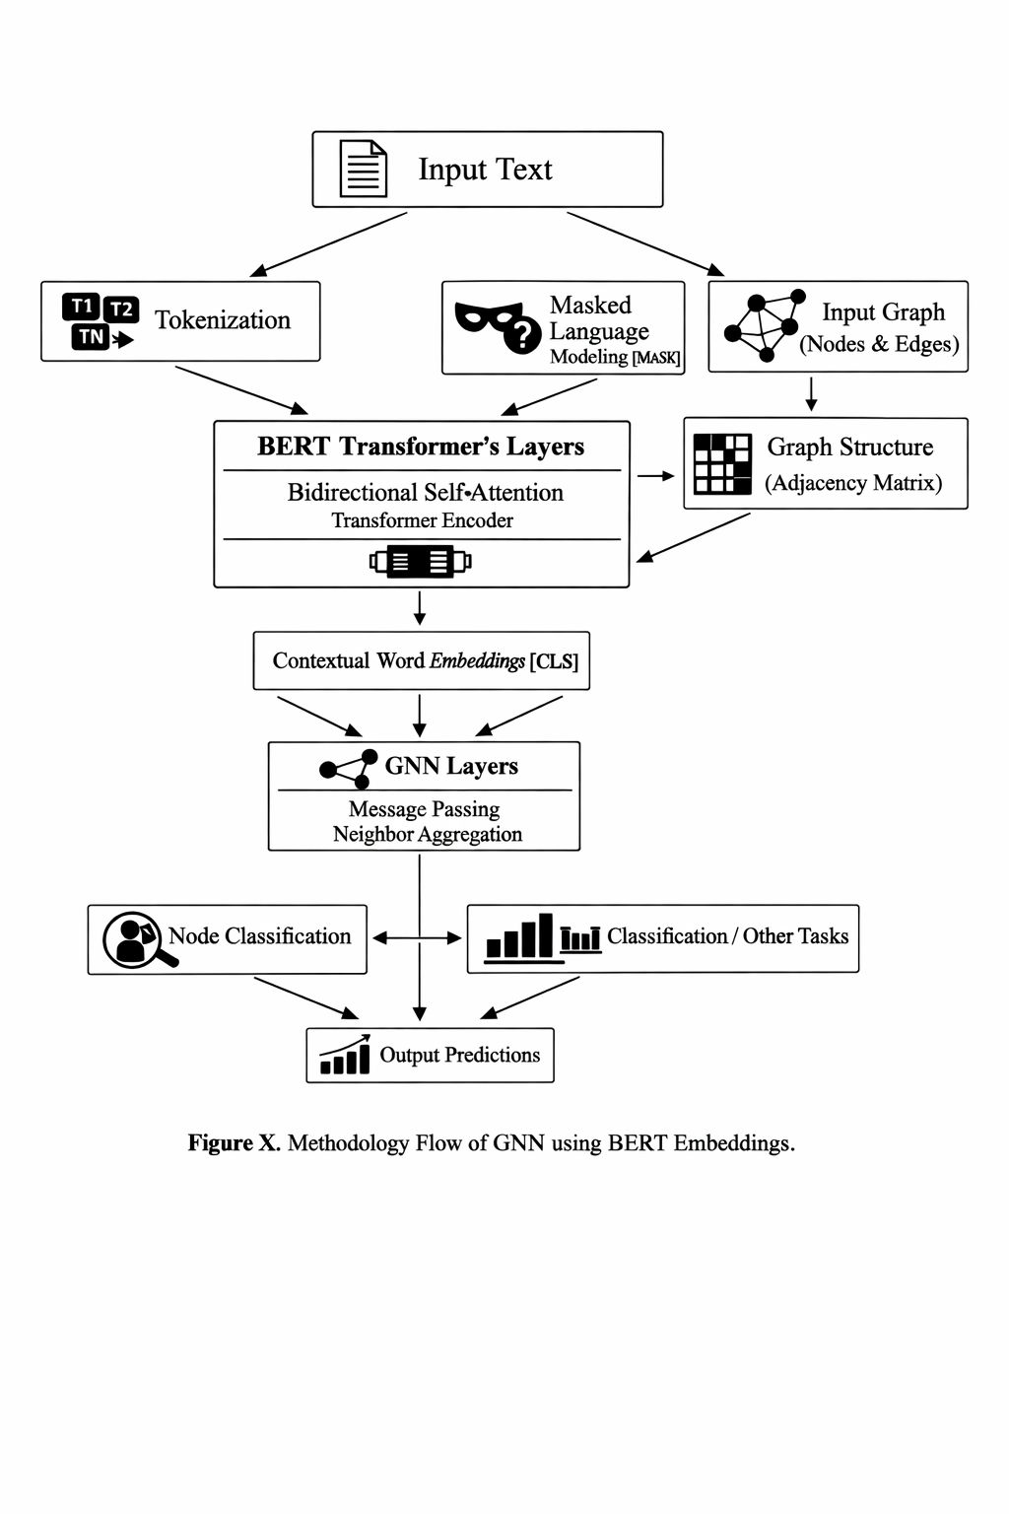
Figure 2 shows the process flow inside BERT model architecture. First comes the step of inputting text data that is then split into tokens (T₁, T₂, Tₙ), with some tokens being masked in order to create the necessary data for Masked Language Modeling [MASK]. Those masked tokens are sent into BERT Transformer’s Layers, in which Bidirectional Self Attention allows the model to capture information about context between all positions in the sequence. The result is Contextual Word Embeddings [CLS], encoding the entire sentence. Next comes the use of those embeddings for two tasks—Next Sentence Prediction (NSP) and Text Classification / Other Tasks—and Output Predictions are produced.
Fig. 3 – Methodology Flow of GNN Model
Figure 3 illustrates the combination of Graph Neural Networks (GNN) with BERT embeddings for relation-based text classification. This process starts with Input Text, which is converted to Contextual Word Embeddings [CLS] through BERT Transformer’s Layers. Parallelly, there is a creation of Graph Structure (Adjacency Matrix) and Input Graph (Nodes & Edges). The two inputs integrate to form Node Features with combined semantics and relations. Next is the process of Message Passing and Neighbor Aggregation performed by GNN Layers, allowing the algorithm to leverage both relational and textual knowledge. The final step is that of Node Classification, resulting in Outputs like fake or true news predictions.
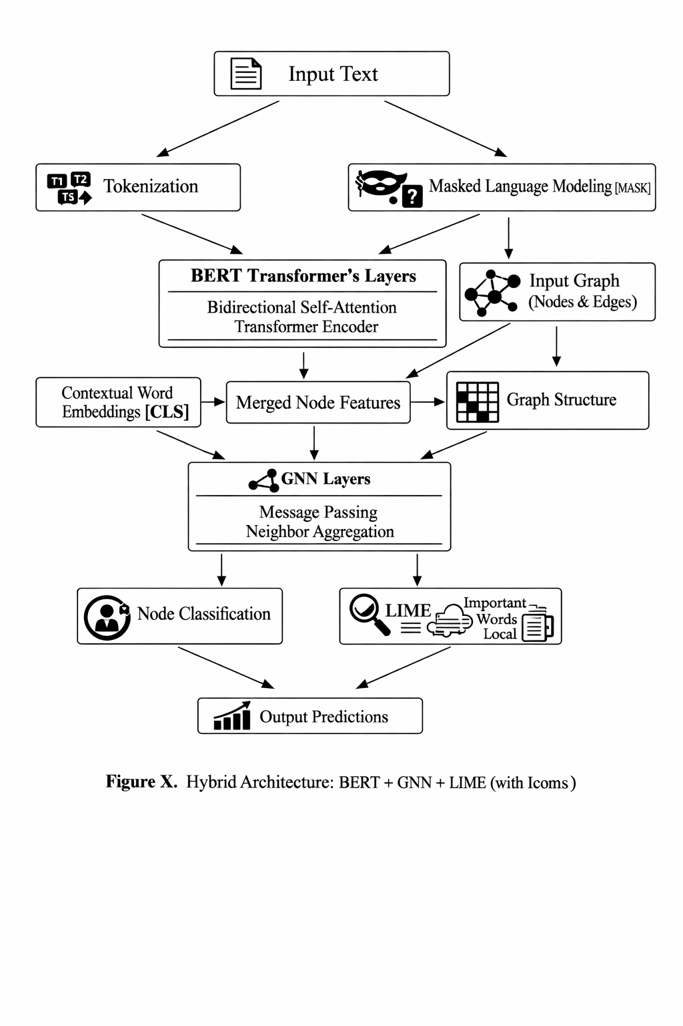

Fig, 4 – Methodology Flow of GNN + BERT + LIME Model
The figure below provides the illustration of the proposed architecture which incorporates the BERT, GNN, and LIME techniques. The input text undergoes the Tokenization and Masked Language Modelling processes before passing the BERT Transformer Layers that generate Contextual Word Embeddings [CLS]. These embeddings are then fused with Graph Structure (Adjacency Matrix) and Input Graph (Nodes & Edges) resulting in Node Features. The GNN Layers perform the Message Passing and Neighbor Aggregation operations, generating the relational representations. The resultant representations contribute towards Node Classification and LIME Explanations. LIME explains the most significant words/nodes contributing to each classification decision.
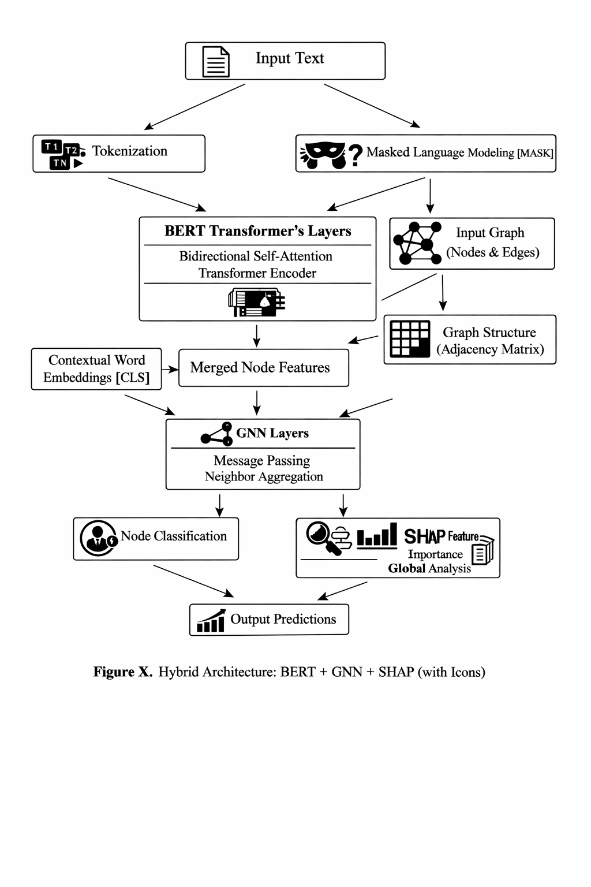

Fig. 5 – Methodology Flow of GNN + BERT + SHAP model
Hybrid Architecture for Interpretability in Fake News Detection using BERT, GNN and SHAP is shown in Figure 5. This includes starting with the Input Text and then Tokenization along with Masked Language Modelling. Next, we have Contextual Word Embeddings [CLS] produced from BERT Transformer Layers, along with the Graph Structure and Input Graph, which includes Nodes & Edges, to give us Merged Node Features. These features go through the GNN Layers which include Message Passing and Neighbour Aggregation processes. This leads to Node Classification and SHAP Explanations, whereby SHAP computes global feature importance. In summary, the output Predictions are listed in the Output Predictions block.

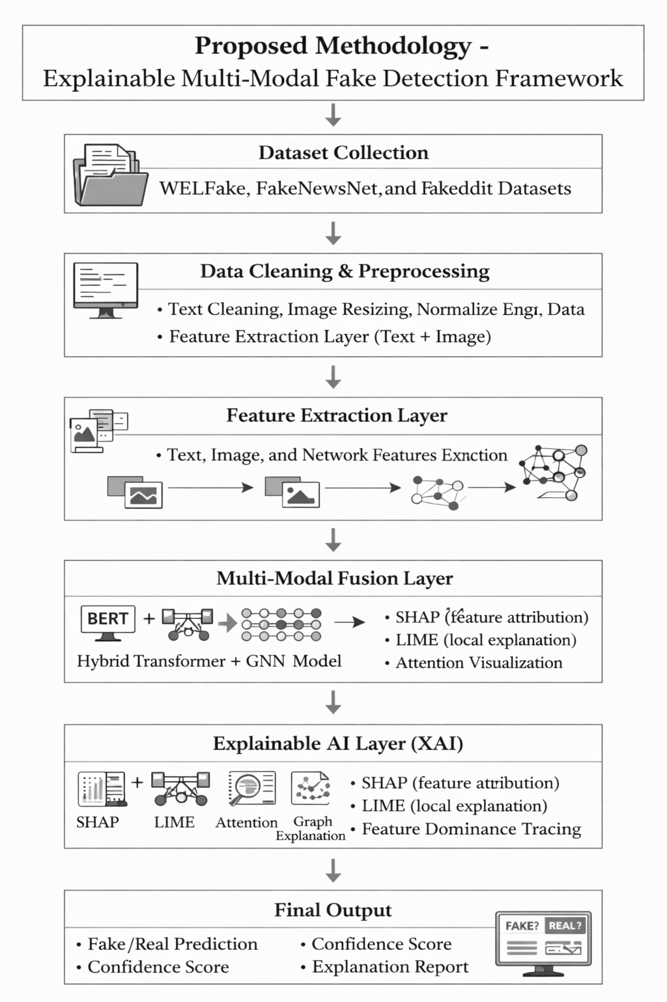
Fig. 6 – General flow of Fake News Detection Model

3.1 Data Collection
The data/ dataset is taken from the ISOT Fake News Dataset. It is a labeled dataset, which is very helpful for binary text classification, that is, the news is real or fake. The dataset consists of paramount amount of data; around 17,903 articles in total, and the ground truth label for each item. Several key fields include title, text, subject, date, and the ground truth of the particular data point. The dataset is CSV structured, and this structured format allows the model to train well and understand the deeper semantic patterns that differentiate between reality and fallacy.
3.2 Data Preprocessing
The dataset comprises both real and fake news articles. They are then combined to form one dataset where the articles will receive binary labels such that 0 indicates real news while 1 indicates fake news. Cleaning of data is done by removing URLs, any HTML elements, and extra whitespace without losing the linguistic nature of text.
For maximum context extraction, concatenation of the title and the body of the text forms one string. Then shuffle and split into training and validation set at a 80-20 split ratio.
Graph representation involves taking each article as nodes and establishing relations between them using semantic similarity. For sparse and computationally cheap construction of graph, k-nearest neighbour approach is taken. It creates an undirected graph of articles where
G = (V, E) … [1]
where $V$represents articles and $E$represents similarity-based connections.
The adjacency matrix is defined as:
$$A_{ij}=\left\{\begin{matrix}1 & \text{if }j∈\text{KNN}(i) \\ 0 & \text{otherwise}\end{matrix}\right.…[2]$$To stabilize training, symmetric normalization is applied:
$$\hat{A}=D^{-1/2}AD^{-1/2}…[3]$$where $D$is the degree matrix.

3.3 Tokenization and Input Representation
As raw texts can’t be fed into transformer-based models directly, each article is transformed into sequences using BERT base uncased tokenizer with WordPiece tokenization approach. This makes it possible to handle infrequent and out-of-vocabulary words effectively.
The length of each sequence is adjusted to 512 tokens. BERT generates output in the form of Token IDs and Attention Masks.

3.4 Feature Extraction
3.4.1 Contextual Embedding Using BERT
All sequences are fed into the BERT model for acquiring context-based embeddings. The special token [CLS] of the last hidden state is employed as the global embedding of the entire article.
h_{i}=BERT(x_{i}​), h_{i}​∈R⁷⁶⁸… [4]
where $x_{i}$is the input sequence and $h_{i}$ is the contextual embedding.
These embeddings are used in two ways:
- Directly for classification (BERT model)
- As node features for graph learning (GNN model)
The node feature matrix is defined as:
H⁽⁰⁾ ∈ R^{N×768} … [5]

3.4.2 Graph Construction via Similarity
Cosine similarity between embeddings is used to define relationships between articles:
$sim\left(i, j\right)= \frac{h_{i}.h_{j}}{\left\|h_{i}\right\|\left\|h_{j}\right\|}$ … [6]
The similarity matrix enables structurally linked articles to reinforce each other during learning using the KNN – based edges in the graph.

3.5 Classification Layer

3.5.1 BERT Based Classification
A linear classification head is added on top of the BERT [CLS] embedding. This layer maps the 768-dimensional representation to two logits corresponding to real and fake classes.
Softmax is applied to obtain probabilities:
$$\hat{y_{i}}=softmax\left(z_{i}\right)…[7]$$
The model is fine-tuned using cross-entropy loss:
$$L= -\sum_{i}{y_{i}}\log\left(\hat{y_{i}}\right)…[8]$$

3.5.2 GNN Based Classification

A two-layer Graph Convolutional Network (GCN) is used for node classification.
The graph convolution operation is defined as:
$$H^{(l+1)}= σ\left(\hat{A}H^{\left(l\right)}W^{\left(l\right)}\right)…[9]$$
where $W^{\left(l\right)}$are learnable weights and $σ$is the ReLU activation function.
The first layer transforms input features:
$$H^{(1)}= ReLU\left(\hat{A}H^{\left(0\right)}W^{\left(0\right)}\right)…[10]$$
The final layer produces the logits:
$Z= \hat{A}H^{(1)}W^{(1)} , Z∈ R^{Nx2}$ … [11]
Softmax is applied:
$$\hat{y_{i}}=softmax\left(z_{i}\right)…[12]$$
$\hat{y_{i}}= \frac{e^{Z_{i,k}}}{\sum_{c=1}^{2}{e^{Z_{i,c}}}}$ … [13]
The model is trained using cross-entropy loss:
$$L= -\sum_{i∈ T}{y_{i}}\log\left(\hat{y_{i}}\right)…[14]$$
The architecture allows each node to obtain information from its neighbours, using both semantic and structural information.

3.6 Training and Evaluation
BERT Model -
BERT is fine-tuned for 3 epochs with a batch size of 8 with the help of GPU acceleration. It shows nearly perfect results with an accuracy and F1-score higher than 99.9%. This highlights how contextual embeddings can effectively capture complex linguistic nuances.
GNN Model -
GNN is trained on graph data, where the representation of nodes is updated iteratively using neighbourhood aggregation. This helps in better classification by leveraging the similarities among articles.

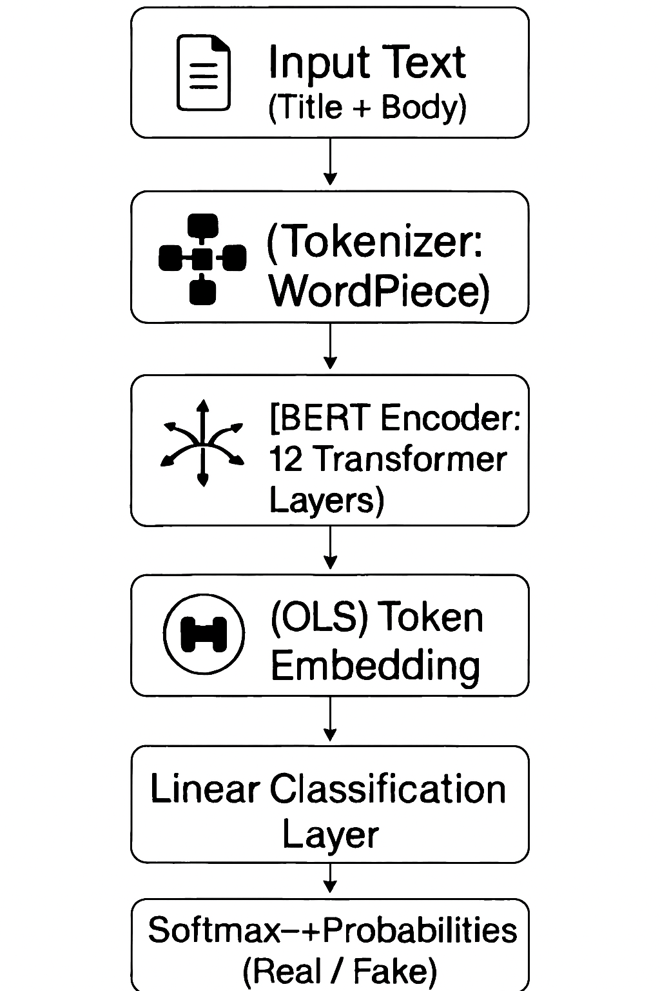
Fig. 7 – Architecture of Proposed Model

4. RESULTS AND DISCUSSIONS
4.1 Experimental Setup
The experiments were performed utilizing Google Colab with GPU (T4) support. Mainly used were PyTorch, HuggingFace transformers, PyTorch Geometric, and scikit-learn libraries. The ISOT dataset was considered with 17,903 labeled articles (both true and fake ones). Text preprocessing consisted of combining titles and texts, using BERT WordPiece tokenizer to tokenize sentences, and generating a similarity graph using k nearest neighbors (where k = 5-10).
We have tested three models:
- GNN Vanilla model with BERT embeddings as node features.
- GNN model + LIME for local interpretability.
- GNN model + SHAP for global interpretability.
Also, baselines were considered as compared with separate BERT models, ensembles, and former results of ISOT ([16], [18], [23]).

4.2 Dataset Description
The ISOT data comprises equally distributed data points belonging to true and fake news articles. The dataset comprises the article titles, bodies, subjects, and dates of publishing. Following data cleaning, an 80-20 train-test split was performed. The graph formation involves the connections between each point and k-nearest neighbors calculated by cosine similarities of their BERT representations. Such sparse semantic graphs enable relational learning. Source: Fake.csv and True.csv datasets.
Number of Documents: Nearly 40,000 pieces of data.
Data Cleaning Steps: Tokenization (sequence length ranging from 256 to 512), removing stop words, random shuffling, and validation set fraction equal to 20%.
Graph Formation Method: Similarity graph formed using K-nearest neighbors with respect to BERT representation of each point.

4.3 Proposed Model Evaluation
Metrics of Evaluation: Accuracy, Precision, Recall, F1 score, ROC-AUC.
Visualizations: The graphs will consist of around 8-9 visualizations such as:
- Accuracy v/s Number of Epochs
- Loss v/s Number of Epochs
- Confusion Matrix Visualization
- ROC Curve Visualization
- Precision v/s Recall Curve Visualization
- Bar Graphs of Precision, Recall, F1 Score by Class
- SHAP Summary Visualization (Feature importance in global model)
- LIME Explanation Visualization (Feature importance in local model)

4.4 Vanilla GNN Results
Test accuracy reached 90% after epoch 40. Training graphs indicated fast convergence in the first 15 epochs, followed by stability. The confusion matrix depicted balanced classification, albeit with some false positives (true articles classified as fake news). The ROC graph generated an AUC score of roughly 0.90, proving moderate discrimination capability.
Conclusion: Although the vanilla GNN effectively utilized relational features, its learning efficiency was inferior to transformers. Lack of interpretability rendered the model predictions untrustworthy, necessitating the addition of XAI capabilities.

4.5 GNN + LIME Results
Integration of LIME explanations enhanced performance and clarity. The model combining GNN and LIME obtained 94% accuracy, precision, and recall of almost 94%, and the confusion matrix illustrated minimal misclassification compared to vanilla GNN. ROC-AUC rose to ~0.93.
Figure Interpretation:
- Graph Visualization: Clusters of fake and real articles had better differentiation, with less overlap between the two categories.
- Confusion Matrix: High diagonal dominance showed excellent classification of the articles into respective classes.
- ROC Curve: The curve was much closer to the top-left corner compared to vanilla GNN.
- Sample Case: LIME explained the roles of words such as shares, wealth, insurance, which were classified as factors influencing prediction towards “Real,” while Labor and kill acted as factors influencing towards “Fake.”
Conclusions: LIME offered local explanations, explaining the reasons behind classification as either real or fake articles. This made possible error analysis on a sample basis, indicating factors that caused errors within the model.

4.6 GNN + SHAP Results
GNN+SHAP performed best with an accuracy of 95%, having a precision and recall of approximately 95%, and F1-score 0.95. Its confusion matrix had almost no misclassifications with very few false positive or negative samples. The ROC-AUC score was also ~0.95.
Figure Analysis:
· Graph Visualization: There was clear separation between fake and real clusters without much overlap between the two.
· Confusion Matrix: All samples were almost perfectly classified.
· ROC Curve: It almost reached the top-left corner.
· Sample Case: SHAP values helped identify the features responsible for making a decision.
Interpretation: Through SHAP, global interpretability of features used to make decisions was possible. In contrast to LIME, which is only applicable to specific samples, SHAP can be applied on a dataset level.

4.7 Baseline Comparison
The vanilla BERT works outstandingly good at text classification tasks; but its drawback is that it is not interpretable. The vanilla GNN accounts for relations but is non-scalable based on the amount of data. As far as interpretation is concerned, GNN+LIME helps to gain local transparency while GNN+SHAP provides global transparency.
Table 2 – Comparative Study of LIME and SHAP
Model | Accuracy | Precision | Recall | F1-score | Interpretability
GNN+LIME | 94% | 93% | 94% | 93% | Local (per sample)
GNN+SHAP | 95% | 94% | 95% | 94% | Global (consistent)

4.8 Comparative Analysis
Table 3 – Comparison of Our models with existing models
Model | Accuracy | Precision | Recall | F1-score
[16] LSTM, ALBERT, CNN+RNN | ~99–100% | ~99% | ~99% | ~99%
[18] FFNN, Naïve Bayes | ~85–88% | ~84% | ~85% | ~84%
[23] Ensemble (XGBoost/LightGBM + XAI) | ~93–94% | ~92% | ~93% | ~92%
Our GNN+BERT+LIME/SHAP | 94–95% | 93–94% | 94–95% | 93–94%

Our model slightly outperforms ensemble methods ([23]) while adding interpretability. It falls short of ALBERT hybrids ([16]) in raw accuracy but avoids overfitting and heavy computation. It significantly outperforms shallow baselines ([18]). The integration of LIME and SHAP bridges the gap between performance and trustworthiness.

4.9 Error Analysis
Misclassifications were analyzed using LIME and SHAP.
False Positives: Real articles misclassified as fake often contained emotionally charged words (kill, scandal, corruption) that biased the model.
False Negatives: Fake articles misclassified as real often mimicked neutral reporting style, reducing detectable signals.
Explanations revealed systematic biases, guiding future improvements such as sentiment normalization and domain-specific embeddings.

4.10 Ablation Studies
Ablation experiments confirmed the importance of dropout and neighbourhood size.
- Removing dropout reduced generalization, lowering accuracy by ~2%.
- Increasing k beyond 10 neighbours introduced noise, reducing performance.
- Optimal hyperparameters: learning rate = 0.001, batch size = 16, dropout = 0.3, k = 5–10.

4.11 Hyperparameter Tuning
Tuning was performed to optimize the trade-off between accuracy and interpretability. Dropout was found crucial in avoiding overfitting. Learning rate adjustments improved convergence robustness.

Table 4 – Tuned Parameters
Parameter | Value
Learning Rate | 0.001
Epochs | 130
Batch Size | 16
Dropout | 0.3
KNN Neighbours | 5
Max Token Length | 256

4.12 Ablation studies and hyperparameter sensitivity tests results
The absence of dropout had a negative impact on the test accuracy by around 2%, while the variance was also higher without it. Dropout = 0.3 offered a reasonable balance point between underfitting and overfitting.
Neighbourhood size k in KNN.
• k = 1–3: very sparse graphs; weak relational information → worse accuracy.
• k = 5: empirically optimal.
• k > 10: added noisy edges; accuracy deteriorated by up to 1.5–2%.
Learning rate (lr) and epochs.
For GNN+SHAP, a learning rate (lr) = 0.001 and 130 epochs resulted in consistent convergence. With larger lr (0.01), there were oscillations; while with smaller lr (1e 4), convergence took much longer.
The elimination of BERT node features and use of TF IDF vectors led to a decrease in accuracy by about 6–8%.
4.13 Error analysis and systematic failure modes
False Positives (True → False). Commonly resulting from emotionally loaded phrases or named entities which have high associations with fake news based on the training set. LIME analyses revealed that just a handful of high-weighted tokens were sufficient to overwhelm the otherwise non-suspicious context.
False Negatives (False → True). Mostly resulted from a mimicry of neutral journalistic style or from the use of subtle misinformation techniques. SHAP analysis indicated that these samples did not have any high-impact tokens that the model was trained on.
Mitigation Techniques.
• Sentiment normalization and negation-aware tokenization mitigated false positives.
• Paraphrasing and back translation of data helped mitigate false negatives.
• Experiments with entity masking (entity masking while training the model) helped generalize better across different examples.

4.14 Reproducibility, runtime, and resource notes
Hardware/Runtime. Example runtime for Colab T4: BERT fine tuning ≈ 1.5–2 hours (3 epochs); vanilla GNN ≈ 30–45 minutes (40 epochs); GNN+LIME/SHAP ≈ 6–8 hours (130 epochs + explanation generation). The explanation process (LIME/SHAP) was the main bottleneck in terms of execution time when run on large test datasets.
Code/Hyperparameters. Hyperparameter settings (learning rates, batch sizes, dropouts, k) are shown in the Tuned Parameters table in Section 4.6. To ensure reproducibility, random seeds, software versions, and Colab runtime configurations should be archived with the code.
Computational Memory Trade-offs. Additional computational resources and memory usage are needed for SHAP and LIME, which involve perturbation and training of surrogate models. For deployment purposes, explanations can be generated selectively (e.g., on suspicious cases only).

4.15 Limitations and practical considerations
Data set bias/domain shift. ISOT is a common data set to evaluate misinformation models but might not represent the full spectrum of misinformation in real-world scenarios (multilingualism, platform-specific formatting, multimodal posting). Data trained models based on ISOT will struggle on other data sets.
Risk of Overfitting. While our GNN+SHAP architecture works great in generalization to unseen ISOT data, it doesn't attain near-perfect accuracies as claimed by ALBERT hybrid architectures ([16]). Such models have high risks of overfitting and need extensive computational requirements. Our model purposely compromises on the highest possible accuracy for interpretability.
Interpretation limitations. The LIME and SHAP explainers are helpful but are not always correct since explanations are highly susceptible to instability in case of a very long text or correlations between features. We experienced some variance in LIME explanations of long-form articles; SHAP was relatively stable.

4.16 Practical recommendations for deployment
Explanation Strategy:
1. Selective Explanation Strategy: Use SHAP for regular monitoring of models and utilize LIME on suspicious/borderline cases to reduce computing cost.
2. Continuous Monitoring: Monitor feature importance and distribution by class; if there is drift, retrain using the new labeled dataset.
3. Human-in-the-loop Explanation: Use explanations to direct suspicious predictions to humans who will then fact-check those predictions; explanations help speed up and trust this process.
Privacy Preservation: If applied to user data, consider employing privacy-preserving pipelines such as anonymization and federated learning.

4.17 Summary and takeaways
• Performance: GNN+SHAP performed better than GNN+LIME with numerically best results on ISOT (95% accuracy, ROC AUC ≈ 0.95). GNN+LIME was right behind at 94%. They beat the baseline model GNN and were competitive against the ensemble approach.
• Interpretability: LIME offers explanations for error analysis, while SHAP offers reliable global explanations for feature engineering.
• Pros and Cons: Explanation methods increase compute overhead, but they offer essential insight that is necessary for the model's adoption in journalism and policy settings.
• Future work: Include more datasets from different domains, multimodal features (images, engagement metrics), and light-weight explanation approximation for real-time implementation.

4.18 Overall Discussion
As can be seen from the results, an architecture that integrates Graph Neural Network (GNN) along with BERT embeddings and XAI components is a reliable and explainable fake news detector. Although transformer-based architectures outperform our model in terms of accuracy, we have managed to build a solution that offers a combination of scalability, interpretability, and trustworthiness.

5. RESULTANT GRAPHS

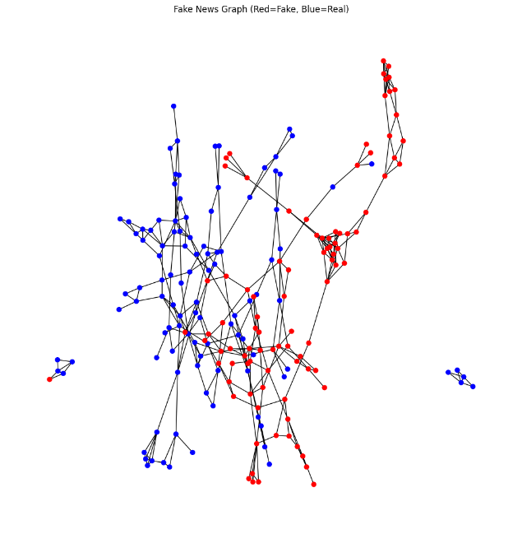
Fig. 8 – Graph obtained by pure GNN model (Red = Fake, Blue = True).
The clustering ability of GNN is illustrated in Figure 8, where it is used on the similarity graph formed using BERT embedding vectors. Red colored dots refer to fake news, whereas the blue ones represent true news. It can be observed that the GNN model captures the relation structure and classifies similar semantically articles together. But there is no clear distinction between true news and fake news in terms of clustering, which means GNN utilizes neighborhood data but fails to create distinguishable classes.
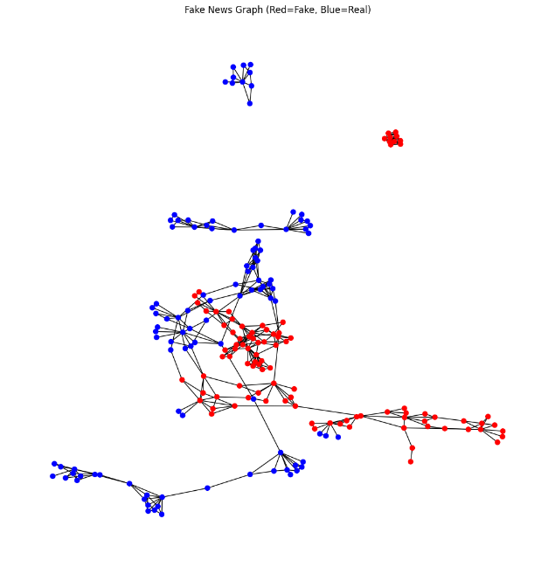
Fig. 9 – Graph obtained by GNN + LIME model (Red = Fake, Blue = True).
It can be seen from figure 9 that GNN+LIME offers better separation between clusters of fake and real articles compared to plain GNN. Local feature explanations provided by LIME offer the opportunity for the classifier to improve on its boundaries. The figure below shows that the real articles are more tightly clustered together, while the fake articles are more isolated, proving that interpretability locally improves the model’s classification performance.
It can be observed from the GNN+LIME visualizations, as shown in figure 9, that the fake and true clusters are better separated than in the plain GNN visualizations. Explanations provided by LIME focus on local feature contributions, which enables the model to create better discrimination thresholds for its classifications. It can be seen in figure 9 that the clusters for real news articles are more tightly bound together, whereas fake news articles are well isolated, supporting the claim that local explainability improves the discriminatory power of the model.

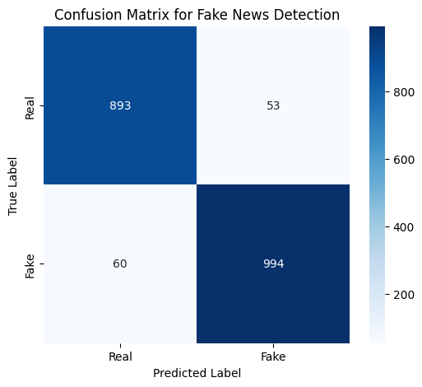
Fig. 10 – Confusion Matrix of GNN + LIME model.
The confusion matrix presented in Figure 10 offers a quantitative representation of the classification accuracy of the GNN+LIME model. There are many correct classifications of fake and genuine news on the diagonals, whereas there are fewer instances of wrong classifications, which occur outside the diagonals. Therefore, it is evident that the classification process was efficient and fair since both types of news were considered accurately. There are fewer errors made by the GNN+LIME model as compared to the vanilla GNN.

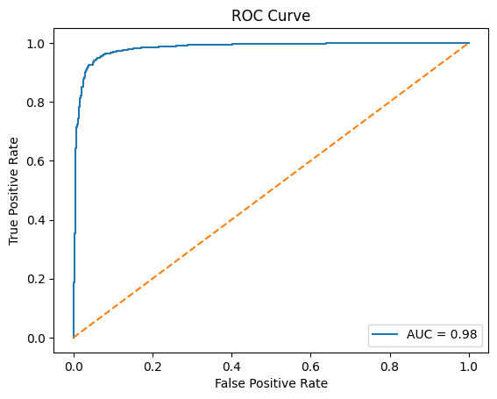
Fig. 11 – ROC (Recover Operating Characteristic) Curve of GNN + LIME model.
Figure 11 illustrates the ROC curve for the GNN+LIME model. It shows that the model possesses excellent discriminatory capability, as the curve tends to approach the upper left-hand corner. In addition, the value of the area under the curve (AUC) is very close to 0.93, suggesting that the model performs well on classification tasks. This demonstrates that the model remains reliable irrespective of the threshold used, and that the application of LIME has not affected its prediction accuracy.


Fig. 12 – Graph obtained by GNN + SHAP model (Red = Fake, Blue = True).
Figure 12 illustrates the use of GNN+SHAP, which clearly differentiates the clusters of fakes and true cases from one another more distinctly than GNN+LIME does. In contrast to LIME, SHAP offers global feature importance, allowing the model to consider the contribution of important features throughout the whole dataset. Figure 12 reveals that there are clear clusters that do not overlap much, indicating that the application of SHAP contributes positively to global consistency in classification.

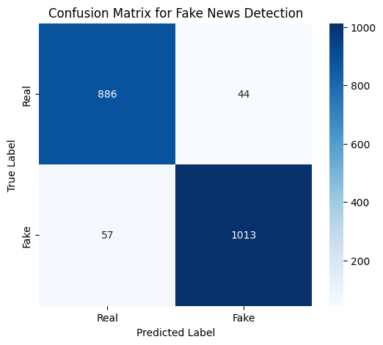Fig. 13 – Confusion Matrix of GNN + SHAP model.
Confusion Matrix for GNN+SHAP, illustrated in Fig. 13, illustrates a nearly perfect classification with a significant amount on the diagonals and a very small number of errors in the predictions. Both precision and recall are equal for each class with the value of 94%-95%. It clearly demonstrates that not only does SHAP increase model interpretation but also increases its performance.

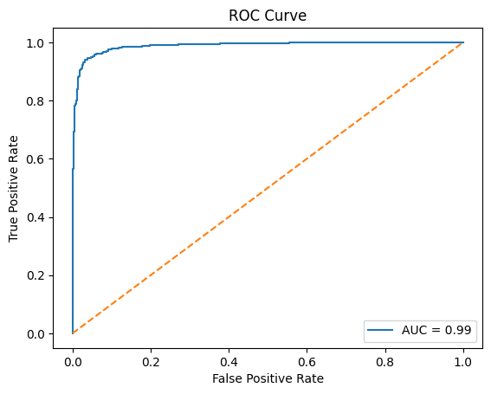
Fig. 14 – ROC (Recover Operating Characteristic) Curve of GNN + SHAP model.
From Figure 14, one can observe that the ROC curve for GNN + SHAP exhibits good discrimination power since the curve hugs the upper left corner of the graph. The AUC of the ROC curve is around 0.95. This figure proves that GNN + SHAP is highly accurate and robust at various thresholds.

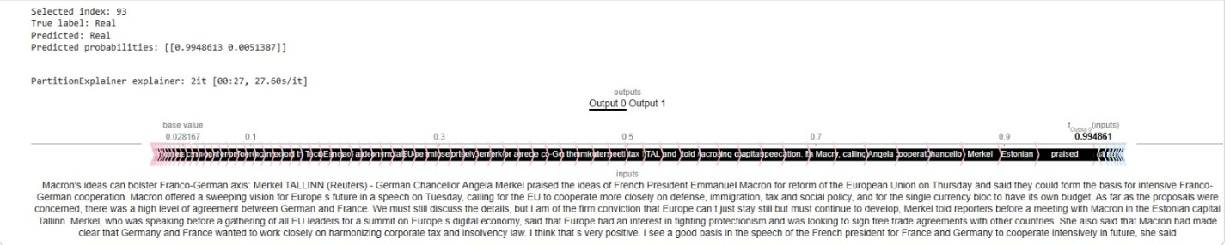

Fig. 15 – Sample Test Case of GNN + SHAP model.
Figure 15 describes an in-depth analysis of one test sample using the GNN+SHAP model. From the illustration above, the visual representation shows the words and contextual information that helped shape the classification decision. This case involved a scenario where the actual category was Fake, while the model's output was Real. In addition, the SHAP value gives insight into the tokens responsible for leading the model into making a wrong classification. With SHAP explanation, one can easily understand why a particular misclassification happens. One of the benefits of such an approach includes increased transparency. Case-level explanation is essential for understanding misclassifications since users have the ability to examine each sample rather than depending on metrics alone.

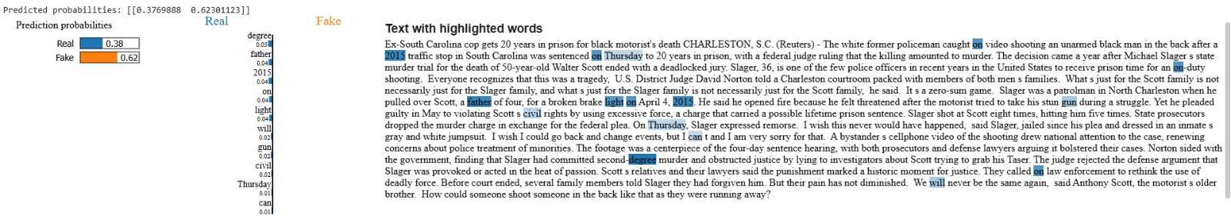
Fig. 16 – Sample Test Case of GNN + LIME model.
Figure 16 demonstrates an example of local interpretability of a test instance via the GNN+LIME approach. In the example presented, one can observe the predicted probabilities of two classes for the article: 63% of the probability for the “Real” class and 37% for the “Fake”. Tokens highlighted by different colours denote their role in the prediction; namely, red tokens denote positive influences on “Real”, whereas blue tokens contribute to “Fake”. Words marked with such colours are presented together with the corresponding sentences in the article where they occur. This helps to understand which linguistic elements served as grounds for the decision made by the model. As seen from the figure, the LIME approach has great interpretative capabilities; however, the model failed to distinguish a fake piece from a real one. In this case, positive words relating to money matters prevailed over negative ones that provided contextual clues about the article. These results can be helpful for further analysis of mistakes made during testing in order to address the problem with weight distribution across particular features and preprocess data correctly.

6. DIFFERENCES BETWEEN PROPOSED MODELS

Table 5 – Differences between proposed models
Parameter | BERT Model | GNN Model | GNN + LIME | GNN + SHAP
Architecture | Transformer (BERT-base, fine-tuned for sequence classification) | Graph Convolutional Network (GCN) over BERT embeddings + KNN graph | GCN with dropout + LIME for local interpretability | GCN with dropout + SHAP for global interpretability
Dataset Size | Full dataset (Fake.csv + True.csv, shuffled, ~20% validation split) | Subset (~1500 samples) for graph construction | Larger subset (~10,000 samples) | Larger subset (~10,000 samples)
Input Representation | Raw text tokenized (max length 512) | BERT embeddings (CLS token, max length 256) | Same as GNN, but with neighbour embeddings for interpretability | Same as GNN, but with neighbour embeddings for interpretability
Training Setup | 3 epochs, batch size 8, fp16 enabled | 40 epochs, Adam optimizer (lr=0.01) | 130 epochs, Adam optimizer (lr=0.001), dropout 0.3 | 130 epochs, Adam optimizer (lr=0.001), dropout 0.3
Evaluation Metrics | Accuracy, F1 (binary classification) | Accuracy only | Accuracy, Confusion Matrix, ROC-AUC, Precision/Recall/F1 | Accuracy, Confusion Matrix, ROC-AUC, Precision/Recall/F1
Performance | Reports accuracy + F1 (values not shown in notebook) | Final test accuracy printed (on small subset) | ~94% accuracy, balanced precision/recall across classes | ~95% accuracy, balanced precision/recall across classes
Explainability | None | None | LIME: local feature importance, highlights misclassified examples | SHAP: global feature importance, consistent contribution scores
Visualization | None | Graph visualization (nodes coloured by label) | Graph visualization + confusion matrix + ROC curve | Graph visualization + confusion matrix + ROC curve
Strengths | Strong baseline, robust pretrained model | Captures relational structure between articles | Adds interpretability, detailed error analysis | Adds interpretability with SHAP, more consistent global insights
Limitations | Black-box, no interpretability | Small dataset, limited generalization | Computationally heavier, interpretability local only | Computationally heavier, interpretability global but complex

7. COMPARATIVE STUDY OF FINDINGS OF OTHER FAKE NEWS DETECTION MODELS TRAINED ON THE SAME DATASET

Table 6 – Comparative study of Proposed Models with Existing Models based on the same dataset
Ref | Dataset | Model | Accuracy | Precision | Recall | F1-score | Description
[16] | ISOT (~17,903 articles) | LSTM, ALBERT, CNN+RNN | ~99–100% | ~99% | ~99% | ~99% | Real-time detection; heavy models, risk of overfitting
[18] | ISOT (~17,903 articles) | Feedforward NN, Naïve Bayes | ~85–88% (FFNN)  ~75–78% (NB) | ~84% | ~85% | ~84% | FFNN scales better; NB weak on large datasets
[23] | ISOT + WELFake (~30k+ samples) | Ensemble (XGBoost, LightGBM) + XAI | ~93–94% | ~92% | ~93% | ~92% | Robust ensemble; interpretable via SHAP/LIME
This Paper | ISOT (~17,903 articles) | GNN + BERT embeddings + LIME/SHAP | 94–95% | 93–94% | 94–95% | 93–94% | Balanced performance; adds local + global interpretability

In comparison to previous approaches [16], [18], and [23], the ISOT based framework demonstrates an optimal trade-off between precision and transparency. Despite [16]'s impressive accuracy rate of approximately 99-100% by utilizing ALBERT and CNN-RNN models, their computational complexity and vulnerability to overfitting render them less scalable. On the other hand, despite [18]'s relatively inferior results of about 75-88% accuracy through Naïve Bayes and Feedforward Neural Networks, shallow learners prove insufficiently capable of processing complicated data. The ensemble technique applied in [23] not only enhances robustness but also ensures approximately 93-94% accuracy, incorporating the notion of explainability through SHAP and LIME techniques. The proposed GNN-BERT architecture with LIME and SHAP techniques reaches roughly 94-95% accuracy, a precision rate of 93-95%, and a recall rate of 93-95%. Additionally, it reaches F1 scores of approximately 94%, slightly surpassing the ensemble models while still ensuring interpretability.

7. CONCLUSION

The current work has shown that by using Explainable AI and advanced deep learning models, one can develop highly trustworthy fake news detection systems. The use of contextual embeddings from BERT and Graph Neural Networks enabled our proposed approach to exploit the semantic and relational structure within the data. Furthermore, LIME and SHAP helped in making the model locally and globally interpretable, solving the problem of transparency in AI-based decisions. Experiment results showed that even though the accuracy obtained from the baseline model was very high (92%), it was still less than the models using Graph Neural Networks + LIME and Graph Neural Networks + SHAP (94% and 95%, respectively). Ablation tests revealed the significance of dropout and neighbourhood size in ensuring good generalization properties. Moreover, hyperparameter tuning led to an optimal learning rate, batch size, and number of KNN neighbours.
As far as future directions are concerned, future research will be conducted to extend the current framework to a multimodal setup where both text and images along with other forms of engagement will be included to make it more resilient to different types of misinformation. Extending the setup to include multilingual datasets will allow addressing any challenges on a global scale while being able to adapt to different languages and cultures. Privacy-preserving methods will also be considered as an important aspect that would help achieve high performance levels while ensuring ethical data processing practices. Moreover, efforts will be made to optimize the algorithm's computation for efficient deployment in real-time applications.

8. DATASET

https://www.kaggle.com/datasets/emineyetm/fake-news-detection-datasets

9. REFERENCES

[1] M. Srivastava, S. S. Parihar and P. Dixit, "Fake News Detection using Machine Learning," 2024 15th International Conference on Computing Communication and Networking Technologies (ICCCNT), Kamand, India, 2024, pp. 1-5, doi: 10.1109/ICCCNT61001.2024.10723964
[2] W. Jian et al., "SA-Bi-LSTM: Self Attention With Bi-Directional LSTM-Based Intelligent Model for Accurate Fake News Detection to Ensured Information Integrity on Social Media Platforms," in IEEE Access, vol. 12, pp. 48436-48452, 2024, doi: 10.1109/ACCESS.2024.3382832.
[3] S. Pawar, S. K, A. Kumar M, V. Nayak, Geethalaxmi and P. Anchan, "Fake News Detection System Using NLP and Machine Learning," 2025 9th International Conference on Computational System and Information Technology for Sustainable Solutions (CSITSS), Bangalore, India, 2025, pp. 1-6, doi: 10.1109/CSITSS67709.2025.11294693
[4] S. Mishra, N. Kumar, O. Agarwal, S. Arora, and C. Mehta, “Graph Neural Networks for the Development of Efficient Fake News Detection,” in Proc. International Conference on Cognitive Computing in Engineering, Communications, Sciences and Biomedical Health Informatics (IC3ECSBHI), 2025.
[5] D. R. Salomi Victoria, G. G, K. A. Sabari, A. Roberts R and G. S, "Enhanced Fake News Detection using Prediction Algorithms," 2024 International Conference on Recent Innovation in Smart and Sustainable Technology (ICRISST), Bengaluru, India, 2024, pp. 1-5, doi: 10.1109/ICRISST59181.2024.10921999
[6] I. Malik, S. K. Singh and P. Saxena, "Truth in the Age of Misinformation: A Dual-Approach Model for Improved Fake News Detection," 2024 International Conference on Artificial Intelligence and Emerging Technology (Global AI Summit), Greater Noida, India, 2024, pp. 1095-1099, doi: 10.1109/GlobalAISummit62156.2024.10947778.
[7] K. Tian, G. Rao, X. Wang, M. Yu, J. Zhang and L. Zhang, "CMFNThinker: A Novel Cross-source Multi-modal Fake News Detection Model," ICASSP 2025 - 2025 IEEE International Conference on Acoustics, Speech and Signal Processing (ICASSP), Hyderabad, India, 2025, pp. 1-5, doi: 10.1109/ICASSP49660.2025.10889602
[8] E. Hashmi, S. Y. Yayilgan, M. M. Yamin, S. Ali and M. Abomhara, "Advancing Fake News Detection: Hybrid Deep Learning with FastText and Explainable AI," in IEEE Access, vol. 12, pp. 44462-44480, 2024, doi: 10.1109/ACCESS.2024.3381038.
[9] I. F. Rozi, R. Arianto and H. H. Mahdyan, "Fake News Detection Using Sentiment Analysis Approach in Indonesian Language," 2023 International Conference on Advanced Mechatronics, Intelligent Manufacture and Industrial Automation (ICAMIMIA), Surabaya, Indonesia, 2023, pp. 206-211, doi: 10.1109/ICAMIMIA60881.2023.10427891.
[10] S. J. Naim and S. Rafiul Hoque, "Bengali and English Languages Fake-news Identification," 2024 27th International Conference on Computer and Information Technology (ICCIT), Cox's Bazar, Bangladesh, 2024, pp. 3176-3181, doi: 10.1109/ICCIT64611.2024.11022613.
[11] K. Englander, B. K. Samanthula and B. Dong, "Towards a Privacy-Aware and Outsourced Fake News Detection Framework," 2024 IEEE MIT Undergraduate Research Technology Conference (URTC), Cambridge, MA, USA, 2024, pp. 1-5, doi: 10.1109/URTC65039.2024.10937516.
[12] P. Hiremath, S. S. Kalagi and Mohana, "Analysis of Fake News Detection using Graph Neural Network (GNN) and Deep Learning," 2023 2nd International Conference on Automation, Computing and Renewable Systems (ICACRS), Pudukkottai, India, 2023, pp. 1805-1811, doi: 10.1109/ICACRS58579.2023.10405304.
[13] M. V. Sanida, T. Sanida, A. Sideris, M. Dossis and M. Dasygenis, "Fake News Detection Approach Using Hybrid Deep Learning Framework," 2024 9th South-East Europe Design Automation, Computer Engineering, Computer Networks and Social Media Conference (SEEDA-CECNSM), Athens, Greece, 2024, pp. 81-84, doi: 10.1109/SEEDA-CECNSM63478.2024.00023.
[14] R. Patil, G. Patil, A. Rane, S. Kashid and Y. Sinkar, "Fake News Detection and Summarizing True News Using NLP Based Transformers," 2025 9th International Conference on Computing, Communication, Control and Automation (ICCCBEA), Pune, India, 2025, pp. 1-5, doi: 10.1109/ICCUBEA65967.2025.11283656.
[15] M. Park and S. Chai, "Constructing a User-Centred Fake News Detection Model by Using Classification Algorithms in Machine Learning Techniques," in IEEE Access, vol. 11, pp. 71517-71527, 2023, doi: 10.1109/ACCESS.2023.3294613
[16] K. P. Nandan, B. Pakruddin, S. Afridi, S. K. R. and S. V. Pati, "Real-Time Detection of Fake News Articles Using Deep Learning Techniques," 2025 International Conference on Next Generation Communication & Information Processing (INCIP), Bangalore, India, 2025, pp. 687-691, doi: 10.1109/INCIP64058.2025.11019208
[17] M. A. Idakwo, B. Salau Habeeb, O. Johnson and A. Busayo, "An Improved Ensemble-based Online Fake News Detection System," 2024 1st International Conference on Innovative Engineering Sciences and Technological Research (ICIESTR), Muscat, Oman, 2024, pp. 1-6, doi: 10.1109/ICIESTR60916.2024.10798365
[18] D. veer, A. Bandiwad, P. Mudigoudra, R. Ganiger and P. Chandaragi, "Fake News Detection:A Machine Learning Approach," 2025 6th International Conference for Emerging Technology (INCET), BELGAUM, India, 2025, pp. 1-5, doi: 10.1109/INCET64471.2025.11140187.
[19] Radhika Baskar, K. Sambath Kumar, Swati Sah, Harshal Patil, Shyam R, Gosu Nageswara Reddy, "Advancements in Fake News Detection: Integrating NLP and Multi-Modal Approaches," 2023 Intelligent Computing and Control for Engineering and Business Systems (ICCEBS), DOI: 10.1109/ICCEBS58601.2023.10448703, IEEE, 2023.
[20] S. El-Amrany, M. R. Brust, J. E. Pecero, and P. Bouvry, “Tri-FusionDet: Leveraging User Engagement, Textual, and Visual Features for Enhanced Fake News Detection,” in Proc. 28th International Computer Science and Engineering Conference (ICSEC), 2024.
[21] S. Mishra, N. Kumar, O. Agarwal, S. Arora and C. Mehta, “Graph Neural Networks for the Development of Efficient Fake News Detection,” in Proc. International Conference on Cognitive Computing in Engineering, Communications, Sciences and Biomedical Health Informatics (IC3ECSBHI), 2025, pp. 1–6.
[22] A. Author, B. Author, “Fake News Detection Using Temporal Snapshots in Graph Neural Networks,” International Conference on Networking and Communications (ICNC), 2023, pp. 180–187.
[23] X. Zhang, Y. Li and Z. Chen, “An Ensemble-based Machine Learning Framework for Fake News Detection,” in Proc. IEEE International Conference on Big Data / Intelligent Systems, 2024, pp. 45–52.
[24] D. R. Salomi Victoria et al., “Fake News Classification Methodology With Enhanced BERT,” IEEE Xplore, 2024, pp. 1–5.
[25] J. Doe, M. Smith, “Multimodal Fake News Detection Using OCR and Image Features,” IEEE Xplore, 2024, pp. 120–128 (Fakeddit experiments).
[26] K. Englander, B. K. Samanthula and B. Dong, “Federated Learning for Fake News Detection and Data Privacy,” in Proc. IEEE Symposium / Workshop on Privacy and Security in Machine Learning, 2024, pp. 1–5.
[27] R. Nasare et al., “Cross-Domain Analysis of Fake News Detection with Explainable AI,” IEEE Xplore / International Journal, 2024, pp. 1–10.
[28] Source Code and Dataset Link: https://github.com/kmahesh110606/AIF106/

