Menu

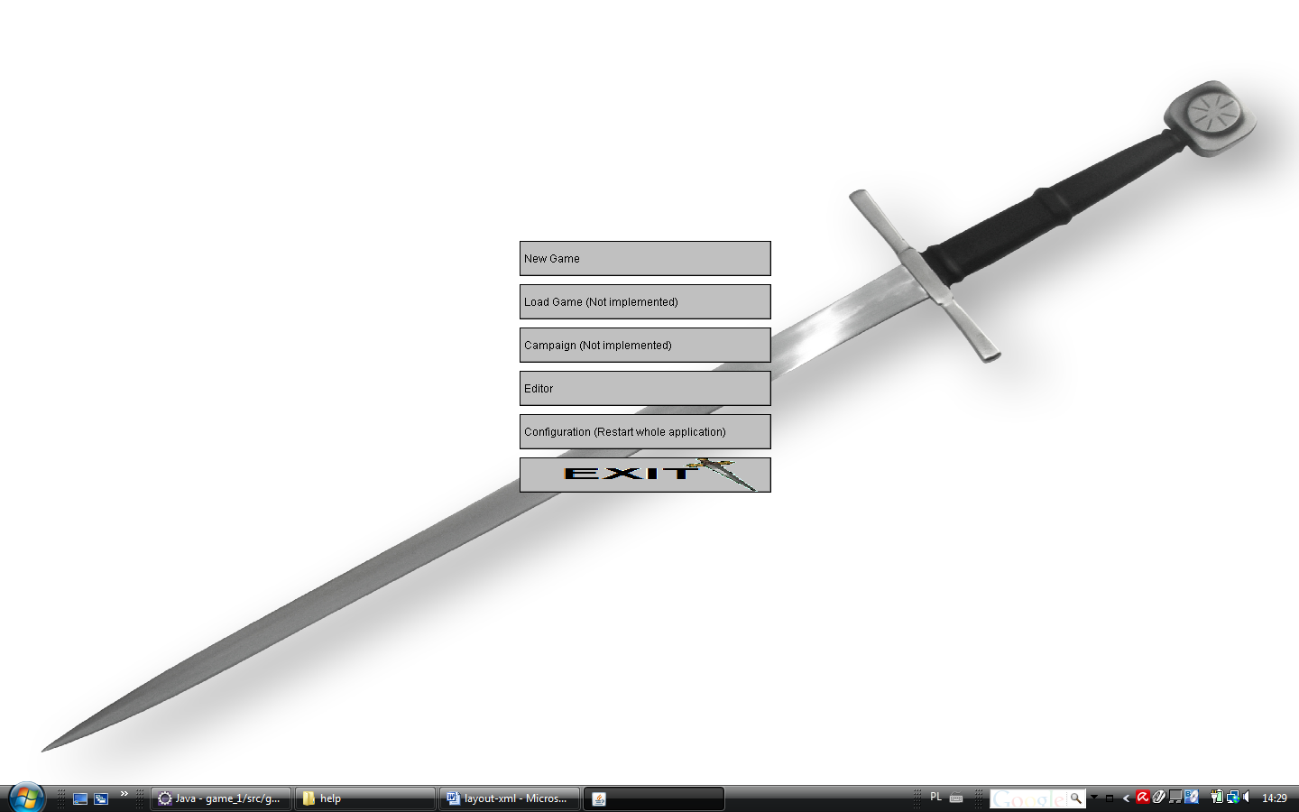

<?xml version="1.0"?>
<main>
<!-- Main Panels -->
<div figure="Panel" tag="PANEL_TOP" dock="top" height="20%"
background_color="default" foreground_color="default" visible="Y" backgroundColor="RGB(108,108,108)" />
<div figure="Panel" tag="PANEL_LEFT" dock="left" width="0%" visible="Y" backgroundColor="RGB(108,108,108)" />
<div figure="Panel" tag="PANEL_BOTTOM" dock="bottom" height="100%"
visible="Y" backgroundColor="RGB(108,108,108)" inside_direction="right" >
</div>
<div figure="Panel" tag="PANEL_RIGHT" dock="right" height="100%" image="l_miecz_kuty.jpg"
width="100%" visible="Y" backgroundColor="RGB(108,108,108)" inside_direction="DOWN" >
<table figure="FramePanel" tag="panelEmpty" height="2%" width="100%" visible="Y" group="empty"/>
<table figure="FramePanel" tag="panel.1.1" height="100%" width="100%"
number_columns="10" visible="Y" number_rows="18" group="one">
<cell figure="Button" tag="NEW_GAME_BUTTON" text="New Game"
position_column="4" position_row="5" extension_cell_row="1"
extension_cell_column="2" margin="10px" margin_left="0px" border="Y" />
<cell figure="Button" tag="LOAD_GAME_BUTTON" text="Load Game (Not implemented)"
position_column="4" position_row="6" extension_cell_row="1"
extension_cell_column="2" margin="10px" margin_left="0px" border="Y" />
<cell figure="Button" tag="CAMPAIGN_GAME_BUTTON" text="Campaign (Not implemented)"
position_column="4" position_row="7" extension_cell_row="1"
extension_cell_column="2" margin="10px" margin_left="0px" border="Y" />
<cell figure="Button" tag="EDITOR_GAME_BUTTON" text="Editor"
position_column="4" position_row="8" extension_cell_row="1"
extension_cell_column="2" margin="10px" margin_left="0px" border="Y" />
<cell figure="Button" tag="CONFIGURATION_BUTTON" text="Configuration (Restart whole application)"
position_column="4" position_row="9" extension_cell_row="1"
extension_cell_column="2" margin="10px" margin_left="0px" border="Y" />
<cell figure="Button" tag="EXIT_APPLICATION_BUTTON" text=""
position_column="4" position_row="10" extension_cell_row="1"
extension_cell_column="2" margin="10px" margin_left="0px" visible="Y"
image="l_exit.png" />
</table>
</div>
</main>

dock="top" | "left"
height="2%" width="100%" - extension in the controls relative to the free zone
position_column="4" position_row="6 – start position for control
extension_cell_row="1" extension_cell_column="2" - extension in the controls for row/column
margin="10px" – margin for left,right,top,bottom in pixel
margin_left="0px" – left margin in pixel
image="l_exit.png" – image for cell or div
text="New Game" – decribed text for control
visible="Y" – visibe for control
border="Y" – border div
group="one" – name of group, we can join e.g. tables in one control
tag="panelEmpty" – unique tag for element - it cannot be the same for two elements
figure="Panel", “List”, “Button”, “Map” … – area for element with own properties
backgroundColor="RGB(108,108,108)" – color for background
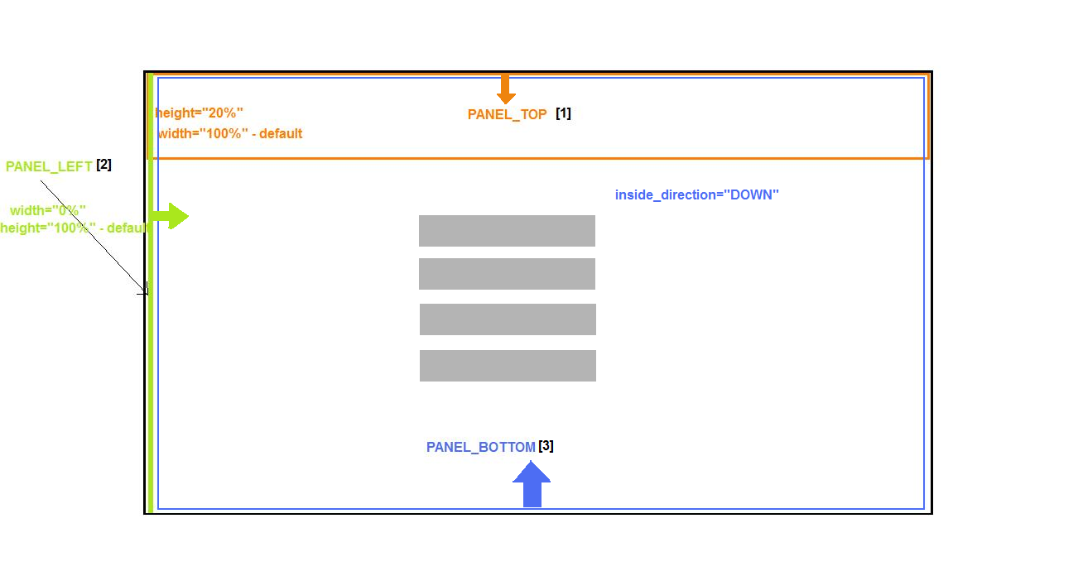

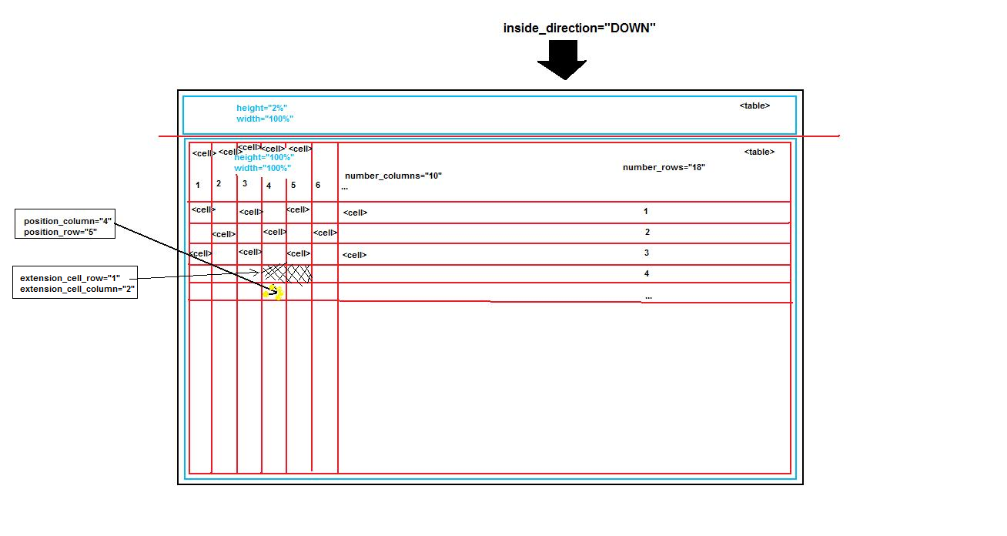

Game

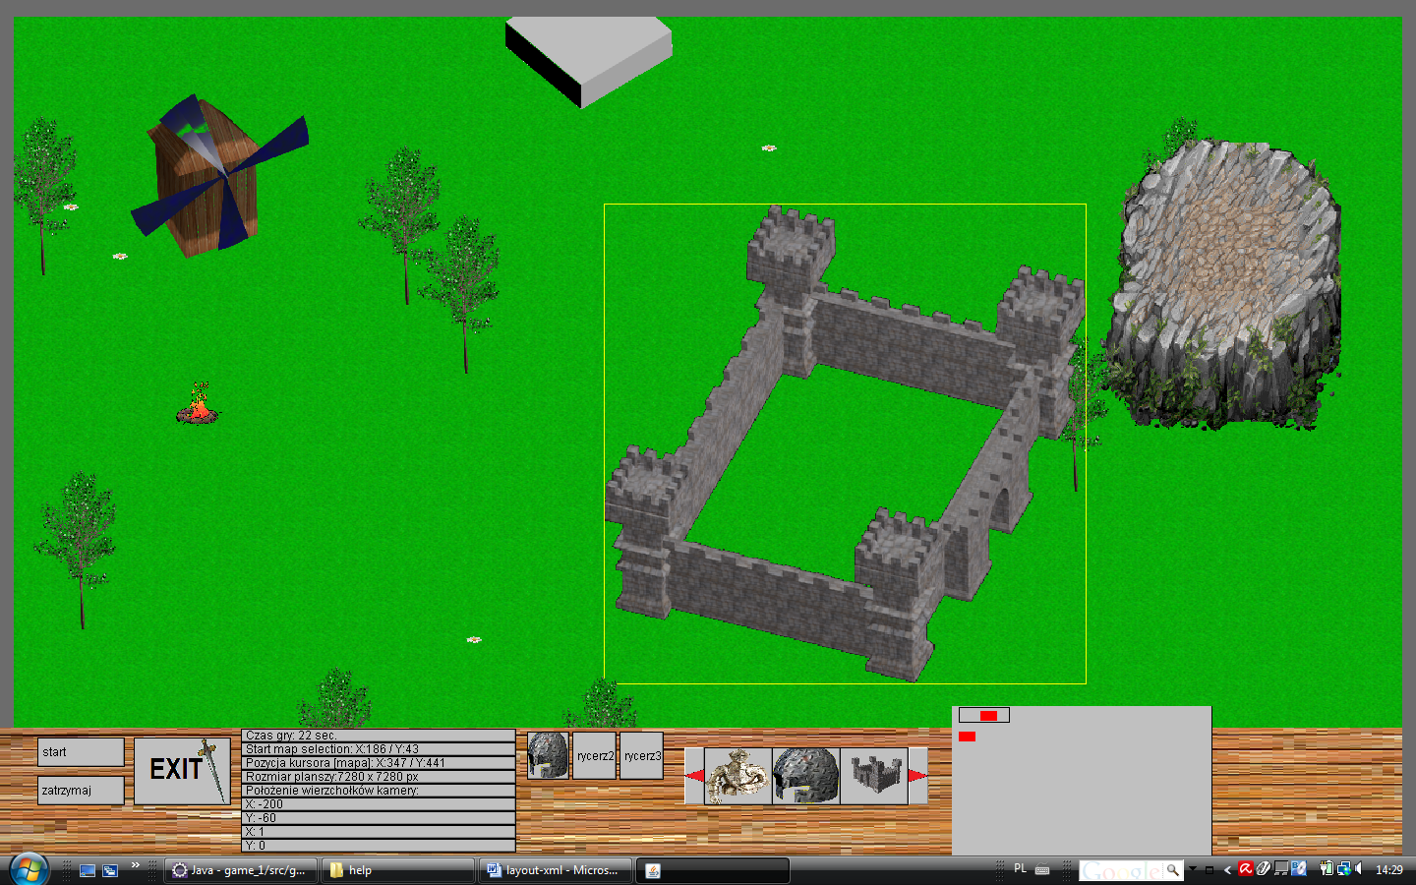

<?xml version="1.0"?>
<main>
<!-- Main Panels -->
<div figure="Panel" tag="PANEL_TOP" dock="top" height="2%"
background_color="default" foreground_color="default" visible="Y" backgroundColor="RGB(108,108,108)" />
<div figure="Panel" tag="PANEL_LEFT" dock="left" width="1%" visible="Y" backgroundColor="RGB(108,108,108)" />
<div figure="Panel" tag="PANEL_BOTTOM" dock="bottom" height="15%" visible="Y" inside_direction="RIGHT" image="stone.png" backgroundColor="RGB(108,108,108)" >
<table figure="FramePanel" tag="panelEmpty1" height="10%" width="2%" visible="Y" group="empty1"/>
<table figure="FramePanel" tag="panel.1.1" height="60%" width="15%"
number_columns="2" visible="Y" number_rows="2" group="one" >
<cell figure="Button" tag="START_BUTTON" text="start"
position_column="0" position_row="0" margin="10px" border="Y" selectedBackgroundColor = "RGB(255,0,0)" />
<cell figure="Button" tag="PAUSE_BUTTON" text="zatrzymaj"
position_column="0" position_row="1" margin="10px" border="Y" selectedBackgroundColor = "RGB(0,0,255)" />
<cell figure="Button" tag="EXIT_MENU_BUTTON" text=""
position_column="1" position_row="0" extension_cell_row="2"
extension_cell_column="1" margin="10px" margin_left="0px" border="Y"
image="l_exit.png" />
</table>
<table figure="FramePanel" tag="sth" height="100%" width="20%"
number_columns="1" number_rows="9" visible="Y" group="three">
<cell figure="TextField" tag="CZAS_GRY" text="czas gry"
position_column="0" position_row="0" margin="1px" border="Y" margin_right="8px" />
<cell figure="TextField" tag="POZYCJA_KURSORA_EKRAN_GRY"
text="pozycja kursora [ekran gr]:" position_column="0" position_row="1"
margin="1px" border="Y" margin_right="8px" />
<cell figure="TextField" tag="POZYCJA_KURSORA_MAPA" text="pozycja kursora [mapa]:"
position_column="0" position_row="2" margin="1px" border="Y" margin_right="8px" />
<cell figure="TextField" tag="ROZMIAR_PLANSZY" text="rozmiar planszy:"
position_column="0" position_row="3" margin="1px" border="Y" margin_right="8px" />
<cell figure="TextField" tag="POLOZENIE_WIERZCHOKOW" text="polozenie wierzchokow mapy"
position_column="0" position_row="4" margin="1px" border="Y" margin_right="8px" />
<cell figure="TextField" tag="POLOZENIE_WIERZCHOKOW_X1Y1"
text="X1,Y1:" position_column="0" position_row="5" margin="1px"
border="Y" margin_right="8px" />
<cell figure="TextField" tag="POLOZENIE_WIERZCHOKOW_X2Y1"
text="X2,Y1:" position_column="0" position_row="6" margin="1px"
border="Y" margin_right="8px" />
<cell figure="TextField" tag="POLOZENIE_WIERZCHOKOW_X1Y2"
text="X1,Y2:" position_column="0" position_row="7" margin="1px"
border="Y" margin_right="8px" />
<cell figure="TextField" tag="POLOZENIE_WIERZCHOKOW_X2Y2"
text="X2,Y2:" position_column="0" position_row="8" margin="1px"
border="Y" margin_right="8px" />
</table>
<table figure="FramePanel" tag="panel.1.4.Empty" height="40%" width="10%"
number_columns="2" number_rows="1" visible="Y" group="four" border="Y" >
</table>
<table figure="FramePanel" tag="panel.1.4" height="40%" width="10%"
number_columns="3" number_rows="1" visible="N" group="four" >
<cell figure="Button" tag="KNIGHT_BUTTON" text=""
position_column="0" position_row="0" margin="4px" margin_left="4px"
margin_right="2px" border="Y" image="l_chelm.png" />
<cell figure="Button" tag="RYCERZ_2" text="rycerz2"
position_column="1" position_row="0" margin="4px" margin_left="2px"
margin_right="2px" border="Y" />
<cell figure="Button" tag="RYCERZ_3" text="rycerz3"
position_column="2" position_row="0" margin="4px" margin_left="2px"
margin_right="2px" border="Y" />
</table>
<table figure="FramePanel" tag="panel.1.7" height="60%" width="20%"
number_columns="1" number_rows="1" visible="Y" group="six">
<table figure="list" tag="drawList" position_column="0"
position_row="0" number_columns="3" number_rows="1" margin="20px"
arrangement="horizontal">
<cell figure="Button" tag="KNIGHT_BUTTON" text="" position_column="0" position_row="0" border="Y" image="l_zbroja.png" />
<cell figure="Button" tag="RYCERZ_2" text="" position_column="1" position_row="0" border="Y" image="l_chelm.png"/>
<cell figure="Button" tag="RYCERZ_3" text="" position_column="2" position_row="0" border="Y" image="l_castle.png" />
<cell figure="Button" tag="RYCERZ_4" text="rycerz4" position_column="3" position_row="0" border="Y" />
<cell figure="Button" tag="RYCERZ_5" text="rycerz5" position_column="4" position_row="0" border="Y" />
<cell figure="Button" tag="RYCERZ_6" text="rycerz6" position_column="5" position_row="0" border="Y" />
<cell figure="Button" tag="RYCERZ_7" text="rycerz7" position_column="6" position_row="0" border="Y" />
<cell figure="Button" tag="RYCERZ_8" text="rycerz8" position_column="7" position_row="0" border="Y" />
<cell figure="Button" tag="RYCERZ_9" text="rycerz9" position_column="8" position_row="0" border="Y" />
<cell figure="Button" tag="RYCERZ_10" text="rycerz10" position_column="9" position_row="0" border="Y" />
</table>
</table>
<table figure="FramePanel" tag="panel.1.map" height="120%" width="20%" number_columns="1" number_rows="1" visible="Y" group="map">
<cell figure="Map" tag="MAP_VIEW" text="" position_column="0" position_row="0" margin="4px" margin_right="20px" border="Y" />
</table>
</div>
<div figure="Panel" tag="PANEL_RIGHT" dock="right" width="1%"
background_color="default" foreground_color="default" visible="Y" backgroundColor="RGB(108,108,108)" />
</main>

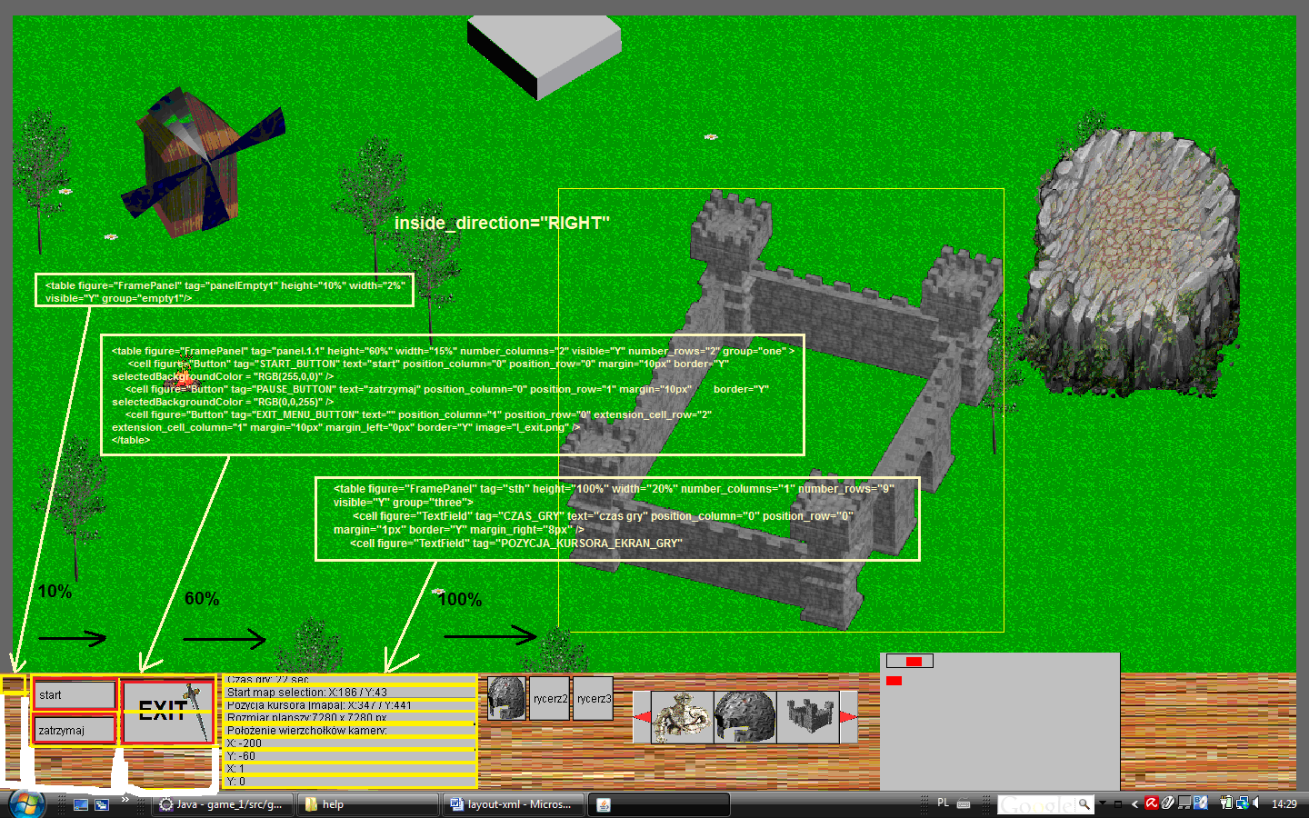

Editor

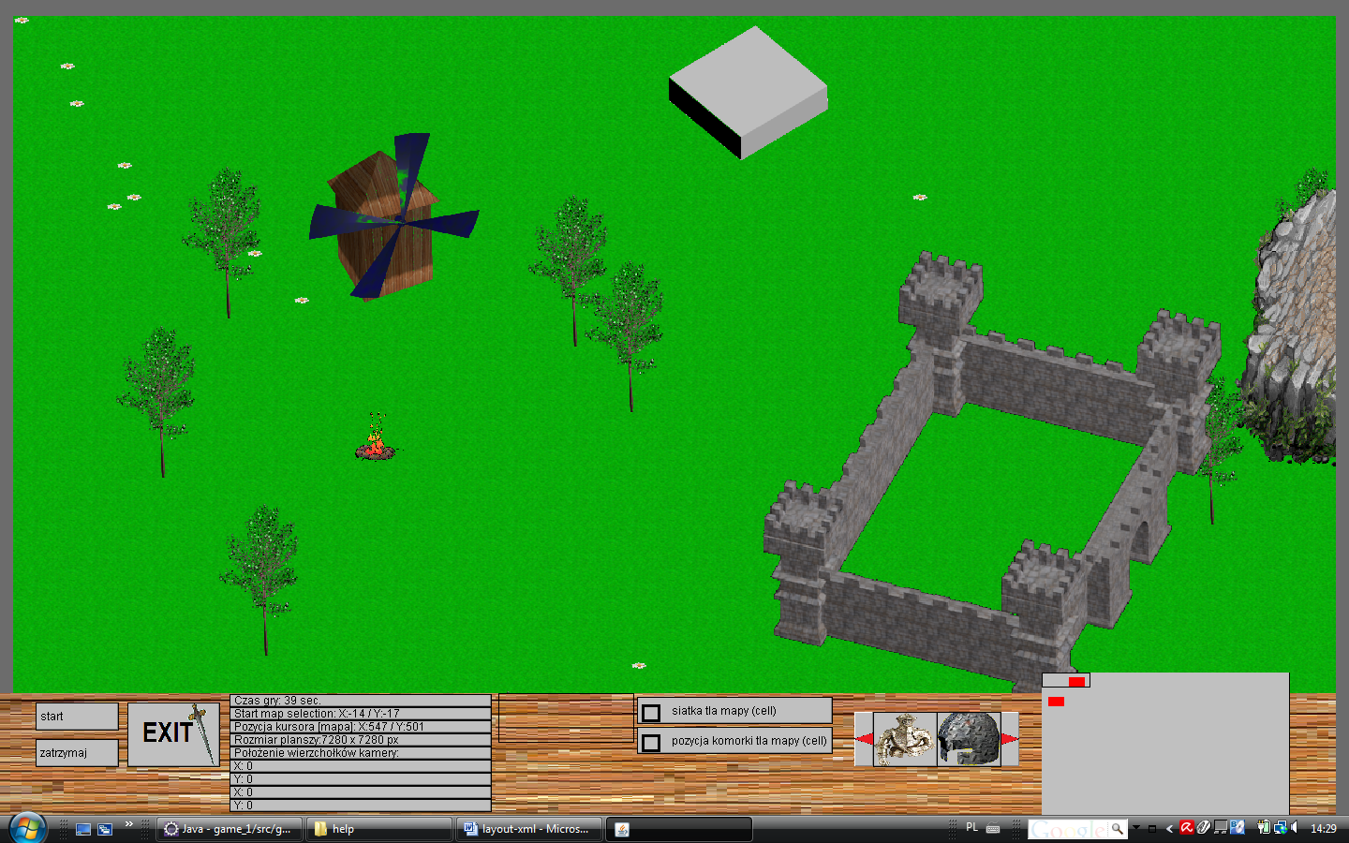

<?xml version="1.0"?>
<main>
<!-- Main Panels -->
<div figure="Panel" tag="PANEL_TOP" dock="top" height="2%"
background_color="default" foreground_color="default" visible="Y" backgroundColor="RGB(108,108,108)" />
<div figure="Panel" tag="PANEL_LEFT" dock="left" width="1%" visible="Y" backgroundColor="RGB(108,108,108)" />
<div figure="Panel" tag="PANEL_BOTTOM" dock="bottom" height="15%" visible="Y" inside_direction="RIGHT" image="stone.png" backgroundColor="RGB(108,108,108)" >
<table figure="FramePanel" tag="panelEmpty1" height="10%" width="2%" visible="Y" group="empty1"/>
<table figure="FramePanel" tag="panel.1.1" height="60%" width="15%"
number_columns="2" visible="Y" number_rows="2" group="one" >
<cell figure="Button" tag="START_BUTTON" text="start"
position_column="0" position_row="0" margin="10px" border="Y" selectedBackgroundColor = "RGB(255,0,0)" />
<cell figure="Button" tag="PAUSE_BUTTON" text="zatrzymaj"
position_column="0" position_row="1" margin="10px" border="Y" selectedBackgroundColor = "RGB(0,0,255)" />
<cell figure="Button" tag="EXIT_MENU_BUTTON" text=""
position_column="1" position_row="0" extension_cell_row="2"
extension_cell_column="1" margin="10px" margin_left="0px" border="Y"
image="l_exit.png" />
</table>
<table figure="FramePanel" tag="sth" height="100%" width="20%"
number_columns="1" number_rows="9" visible="Y" group="three">
<cell figure="TextField" tag="CZAS_GRY" text="czas gry"
position_column="0" position_row="0" margin="1px" border="Y" margin_right="8px" />
<cell figure="TextField" tag="POZYCJA_KURSORA_EKRAN_GRY"
text="pozycja kursora [ekran gr]:" position_column="0" position_row="1"
margin="1px" border="Y" margin_right="8px" />
<cell figure="TextField" tag="POZYCJA_KURSORA_MAPA" text="pozycja kursora [mapa]:"
position_column="0" position_row="2" margin="1px" border="Y" margin_right="8px" />
<cell figure="TextField" tag="ROZMIAR_PLANSZY" text="rozmiar planszy:"
position_column="0" position_row="3" margin="1px" border="Y" margin_right="8px" />
<cell figure="TextField" tag="POLOZENIE_WIERZCHOKOW" text="polozenie wierzchokow mapy"
position_column="0" position_row="4" margin="1px" border="Y" margin_right="8px" />
<cell figure="TextField" tag="POLOZENIE_WIERZCHOKOW_X1Y1"
text="X1,Y1:" position_column="0" position_row="5" margin="1px"
border="Y" margin_right="8px" />
<cell figure="TextField" tag="POLOZENIE_WIERZCHOKOW_X2Y1"
text="X2,Y1:" position_column="0" position_row="6" margin="1px"
border="Y" margin_right="8px" />
<cell figure="TextField" tag="POLOZENIE_WIERZCHOKOW_X1Y2"
text="X1,Y2:" position_column="0" position_row="7" margin="1px"
border="Y" margin_right="8px" />
<cell figure="TextField" tag="POLOZENIE_WIERZCHOKOW_X2Y2"
text="X2,Y2:" position_column="0" position_row="8" margin="1px"
border="Y" margin_right="8px" />
</table>
<table figure="FramePanel" tag="panel.1.4.Empty" height="40%" width="10%"
number_columns="2" number_rows="1" visible="Y" group="four" border="Y" >
</table>
<table figure="FramePanel" tag="panel.1.6" height="50%" width="15%"
number_columns="1" number_rows="2" visible="Y" group="five2">
<cell figure="checkbox" tag="DISPLAY_CELL_BACKGROUND_CHECKBOX"
text="siatka tla mapy (cell)" position_column="0" position_row="0"
margin="4px" border="Y" />
<cell figure="checkbox" tag="DISPLAY_CELL_POSITION_CHECKBOX"
text="pozycja komorki tla mapy (cell)" position_column="0"
position_row="1" margin="4px" border="Y" />
</table>
<table figure="FramePanel" tag="panel.1.4" height="40%" width="10%"
number_columns="3" number_rows="1" visible="N" group="four" >
<cell figure="Button" tag="KNIGHT_BUTTON" text=""
position_column="0" position_row="0" margin="4px" margin_left="4px"
margin_right="2px" border="Y" image="l_chelm.png" />
<cell figure="Button" tag="RYCERZ_2" text="rycerz2"
position_column="1" position_row="0" margin="4px" margin_left="2px"
margin_right="2px" border="Y" />
<cell figure="Button" tag="RYCERZ_3" text="rycerz3"
position_column="2" position_row="0" margin="4px" margin_left="2px"
margin_right="2px" border="Y" />
</table>
<table figure="FramePanel" tag="panel.1.7" height="60%" width="15%"
number_columns="1" number_rows="1" visible="Y" group="six">
<table figure="list" tag="drawList" position_column="0"
position_row="0" number_columns="2" number_rows="1" margin="20px"
arrangement="horizontal">
<cell figure="Button" tag="KNIGHT_BUTTON" text="" position_column="0" position_row="0" border="Y" image="l_zbroja.png" />
<cell figure="Button" tag="RYCERZ_2" text="" position_column="1" position_row="0" border="Y" image="l_chelm.png"/>
<cell figure="Button" tag="RYCERZ_3" text="" position_column="2" position_row="0" border="Y" image="l_castle.png" />
<cell figure="Button" tag="RYCERZ_4" text="rycerz4" position_column="3" position_row="0" border="Y" />
<cell figure="Button" tag="RYCERZ_5" text="rycerz5" position_column="4" position_row="0" border="Y" />
<cell figure="Button" tag="RYCERZ_6" text="rycerz6" position_column="5" position_row="0" border="Y" />
<cell figure="Button" tag="RYCERZ_7" text="rycerz7" position_column="6" position_row="0" border="Y" />
<cell figure="Button" tag="RYCERZ_8" text="rycerz8" position_column="7" position_row="0" border="Y" />
<cell figure="Button" tag="RYCERZ_9" text="rycerz9" position_column="8" position_row="0" border="Y" />
<cell figure="Button" tag="RYCERZ_10" text="rycerz10" position_column="9" position_row="0" border="Y" />
</table>
</table>
<table figure="FramePanel" tag="panel.1.map" height="120%" width="20%" number_columns="1" number_rows="1" visible="Y" group="map">
<cell figure="Map" tag="MAP_VIEW" text="" position_column="0" position_row="0" margin="4px" margin_right="20px" border="Y" />
</table>
</div>
<div figure="Panel" tag="PANEL_RIGHT" dock="right" width="1%"
background_color="default" foreground_color="default" visible="Y" backgroundColor="RGB(108,108,108)" />
</main>

