/game_1/data/layout/dialog/Editor_MainMenu_Dialog.xml

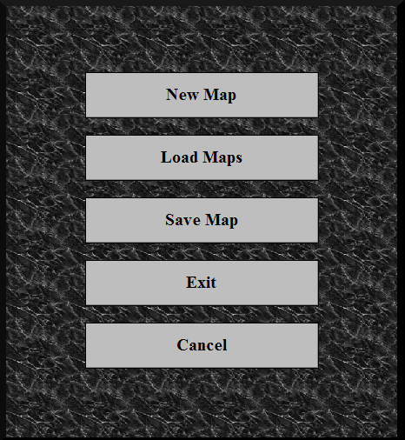

figure_type="editor_menu"
tag="NEW_USER_MAP_BUTTON" text="New Map"
tag="LOAD_LIST_OF_USER_MAPS_BUTTON" text="Load Maps"
tag="SAVE_USER_MAP_BUTTON" text="Save Map"
tag="EXIT_USER_MAP_BUTTON" text="Exit"
tag="CANCEL_USER_MAP_BUTTON" text="Cancel"

client\game_1\data\layout\EditorView.xml

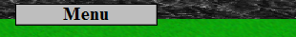

figure_type="editor_view" tag="TOOLBAR_MENU_USER_MAP_BUTTON" text="Menu"

client\game_1\data\layout\dialog\Game_MainMenu_Dialog.xml

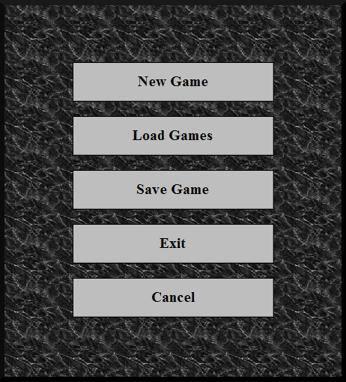
figure_type="game_view"

tag="NEW_USER_GAME_BUTTON" text="New Game"
tag="LOAD_USER_GAME_BUTTON" text="Load Games"
tag="SAVE_USER_GAME_BUTTON" text="Save Game"
tag="EXIT_USER_GAME_BUTTON" text="Exit"
tag="CANCEL_USER_GAME_BUTTON" text="Cancel"

client\game_1\data\layout\GameView.xml

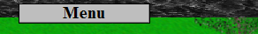
figure_type="game_view" tag="TOOLBAR_MENU_USER_GAME_BUTTON" text="Menu"

/game_1/data/layout/menu/Game_Menu.xml

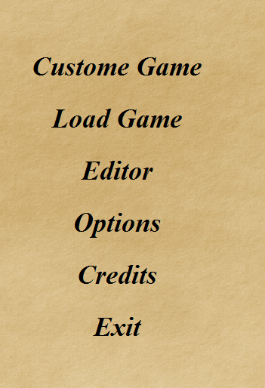
figure_type="main_menu"

tag="CUSTOM_GAME_BUTTON" text="Custome Game"
tag="LOAD_SAVED_GAMES_BUTTON" text="Load Game"
tag="EDITOR_GAME_BUTTON" text="Editor"
tag="CONFIGURATION_BUTTON" text="Options"
tag="CREDITS_BUTTON" text="Credits"
tag="EXIT_APPLICATION_BUTTON" text="Exit"

/game_1/data/layout/menu/CustomGame_Menu.xml

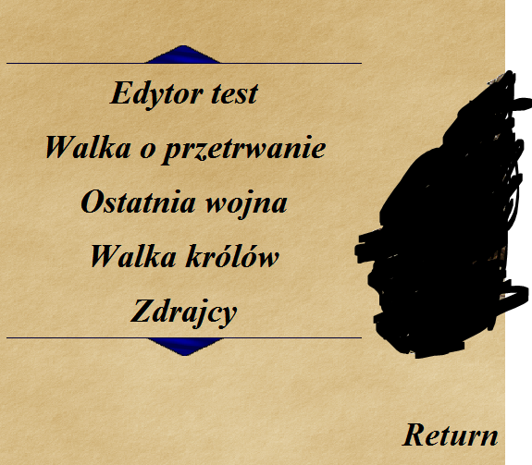

figure_type="main_menu"
tag="OPEN_CUSTOM_GAME_BUTTON" path_data="/data/maps"
tag="RETURN_TO_MAIN_MENU_GAME_BUTTON" text="Return"

/game_1/data/layout/menu/Editor_Menu.xml

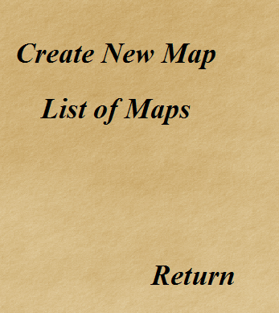

figure_type="main_menu"
tag="NEW_USER_MAP_BUTTON" text="Create New Map"
tag="LOAD_LIST_OF_USER_MAPS_BUTTON" text="List of Maps"
tag="RETURN_TO_MAIN_MENU_GAME_BUTTON" text="Return"

/game_1/data/layout/menu/Editor_New_Map_Menu.xml

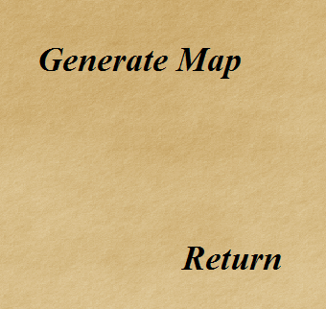
figure_type="main_menu"
tag="GENERATE_USER_MAP_BUTTON" text="Generate Map"
tag="RETURN_TO_MAIN_MENU_GAME_BUTTON" text="Return"

/game_1/data/layout/menu/LoadGame_Menu.xml

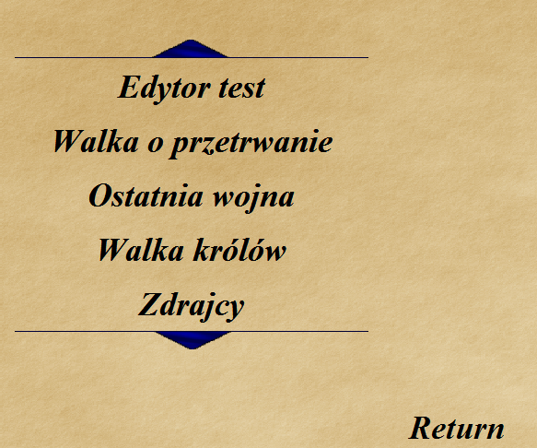

tag="OPEN_CUSTOM_GAME_BUTTON" path_data="/maps"
tag="RETURN_TO_MAIN_MENU_GAME_BUTTON" text="Return"

/game_1/data/layout/menu/Load_Saved_Game_Menu.xml

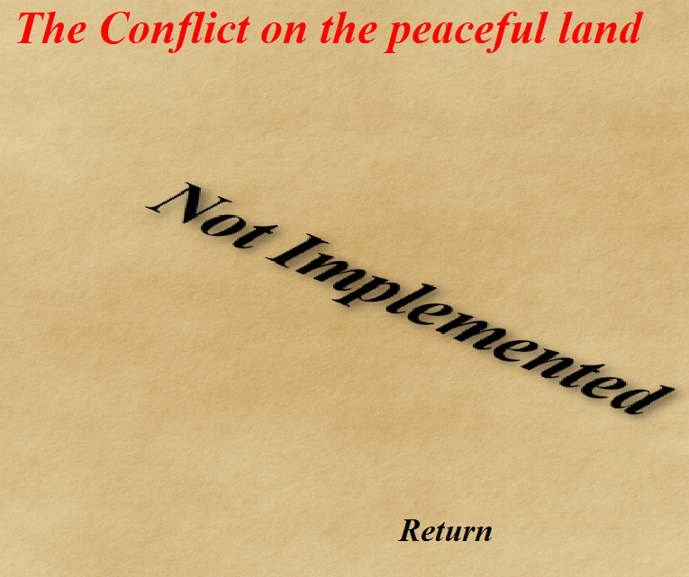

figure_type="main_menu"

figure_type="main_menu" tag="RETURN_TO_MAIN_MENU_GAME_BUTTON" text="Return"

/game_1/data/layout/menu/ConfigurationGame_Menu.xml

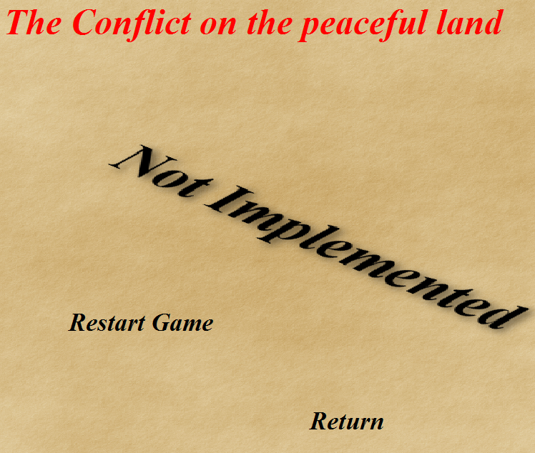

figure_type="main_menu"

tag="REOPEN_APPLICATION_BUTTON" text="Restart Game"
tag="RETURN_TO_MAIN_MENU_GAME_BUTTON" text="Return"

/game_1/data/layout/menu/CreditsGame_Menu.xml

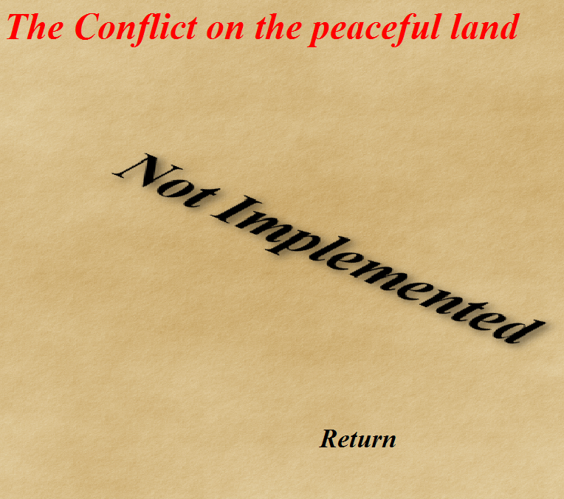

figure_type="main_menu"

figure_type="main_menu" tag="RETURN_TO_MAIN_MENU_GAME_BUTTON" text="Return"

