Configuration for IntelliJ

1.Install Tortoise SVN

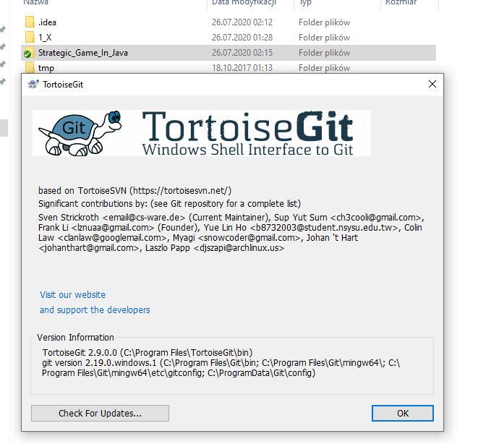

2.Install jdk1.8.0_202

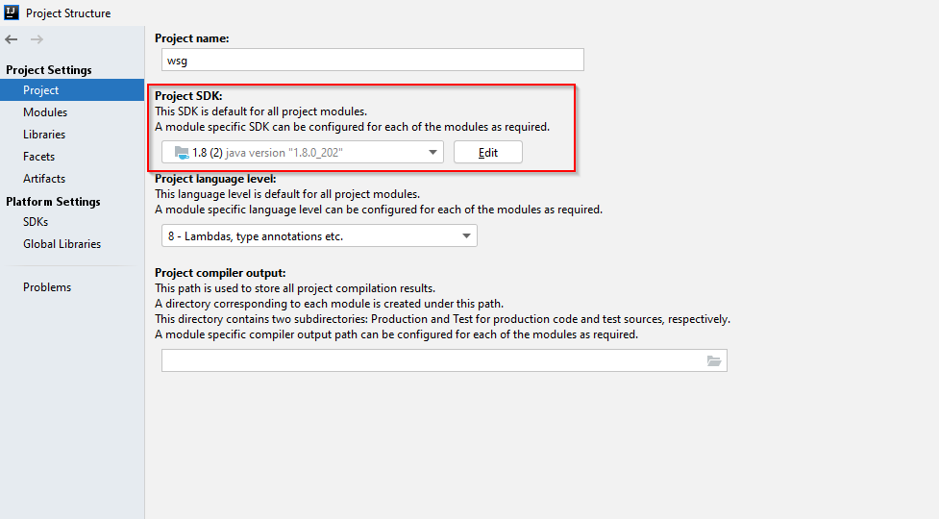

3. install Maven

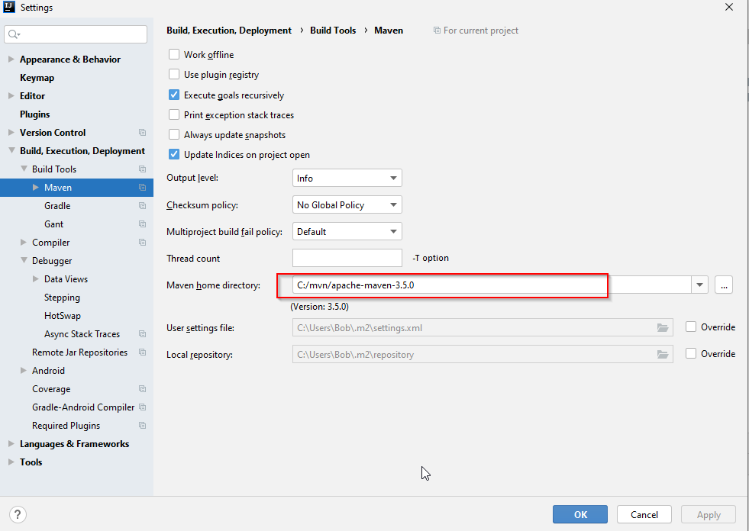

1. Open url

<https://github.com/kmajka/Strategic_Game_In_Java>

2. Copy link for repository

https://github.com/kmajka/Strategic_Game_In_Java.git

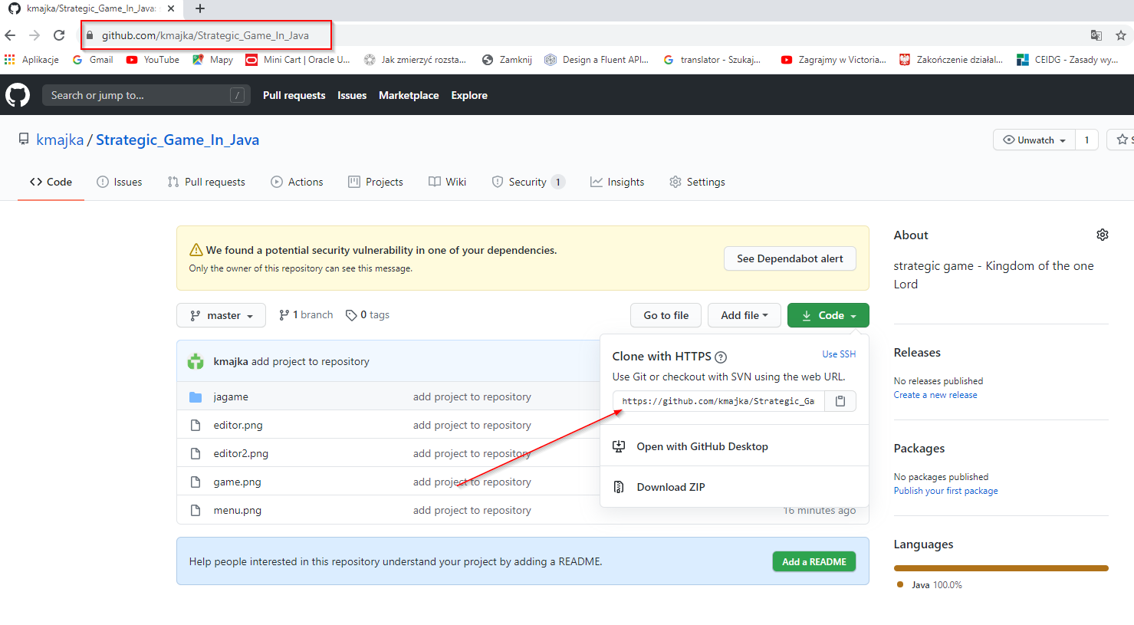

3. Create Git clone on disk



4. Fill URL and Directory

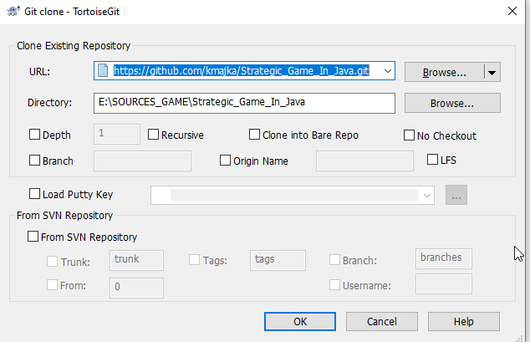

5. Press [OK] button

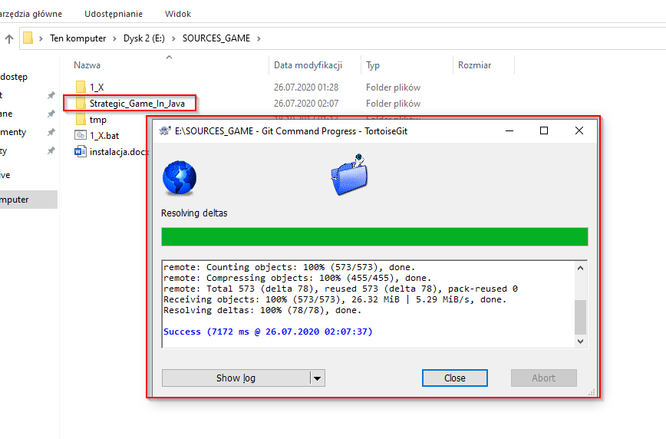

6. Open IntelliJ



7. Open File -> New -> Project from Existing Sources

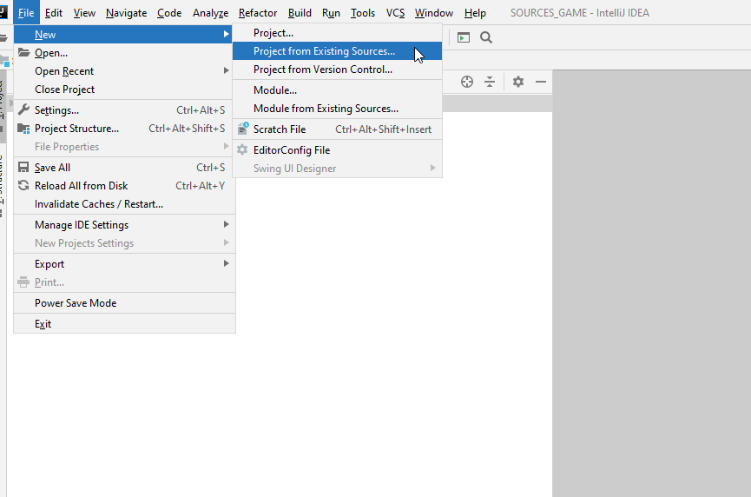

8. select **WSG**

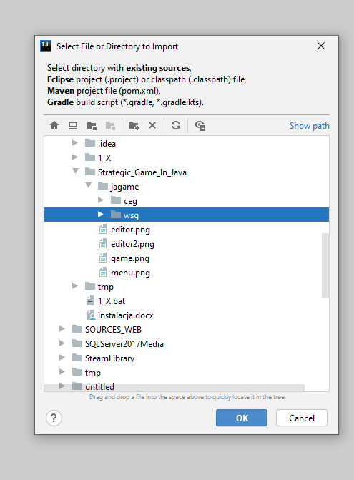

9. Import Maven

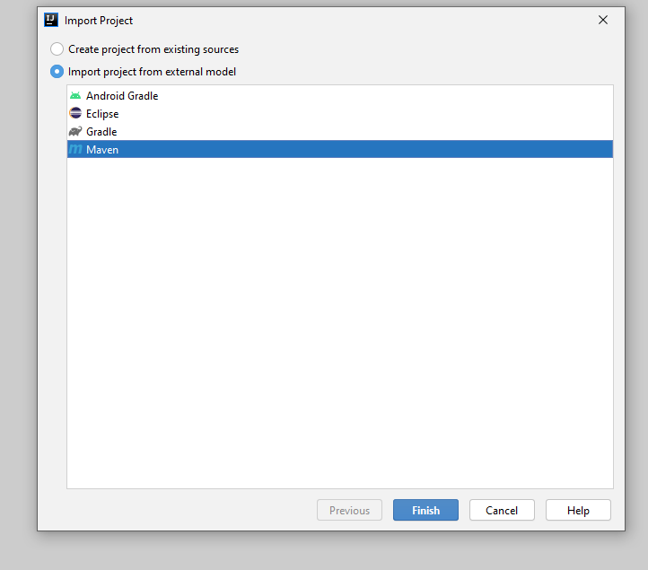

10. Open File -> Project Structure

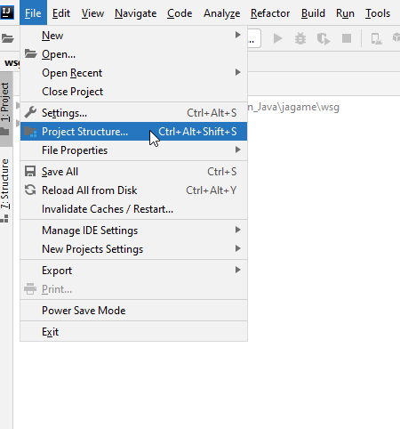

11. Select Module

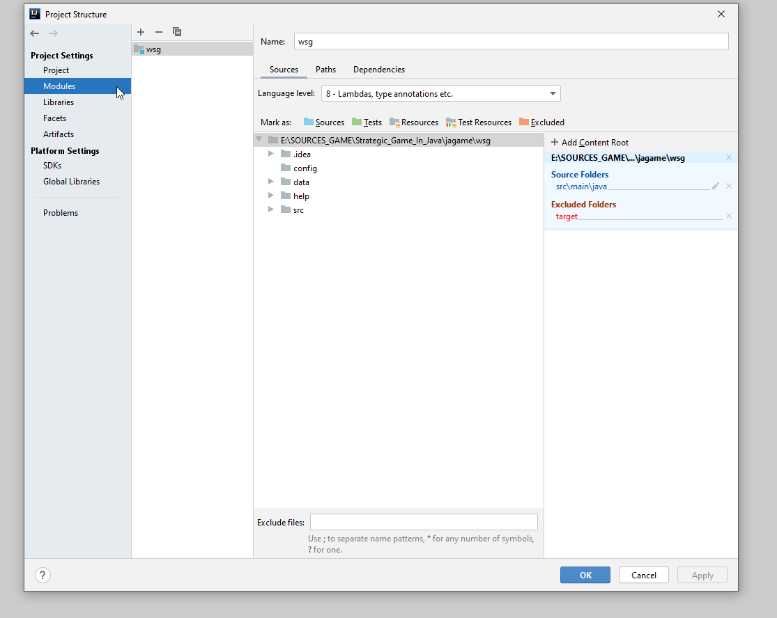

12. import module

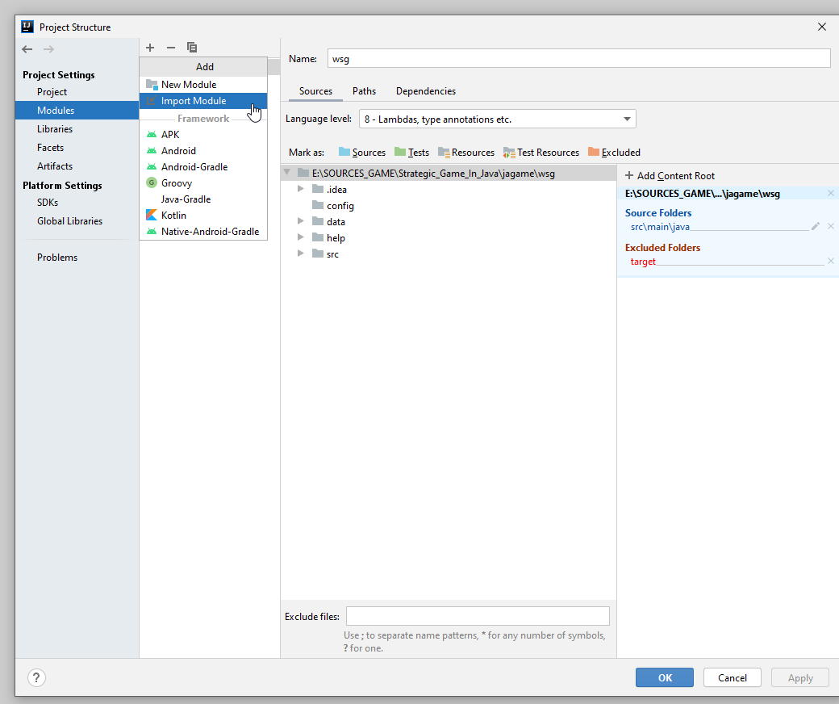

13. Import Maven for **ceg** directory

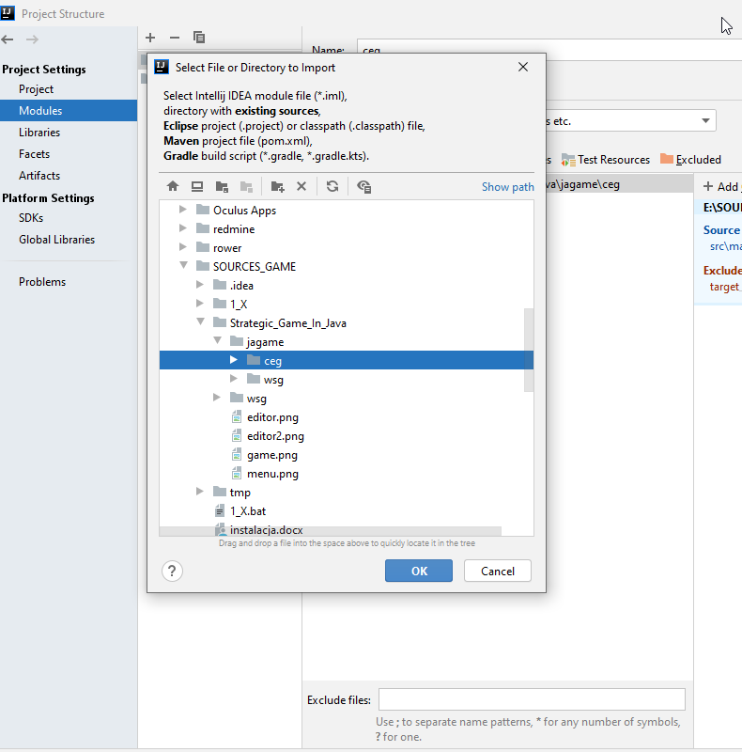

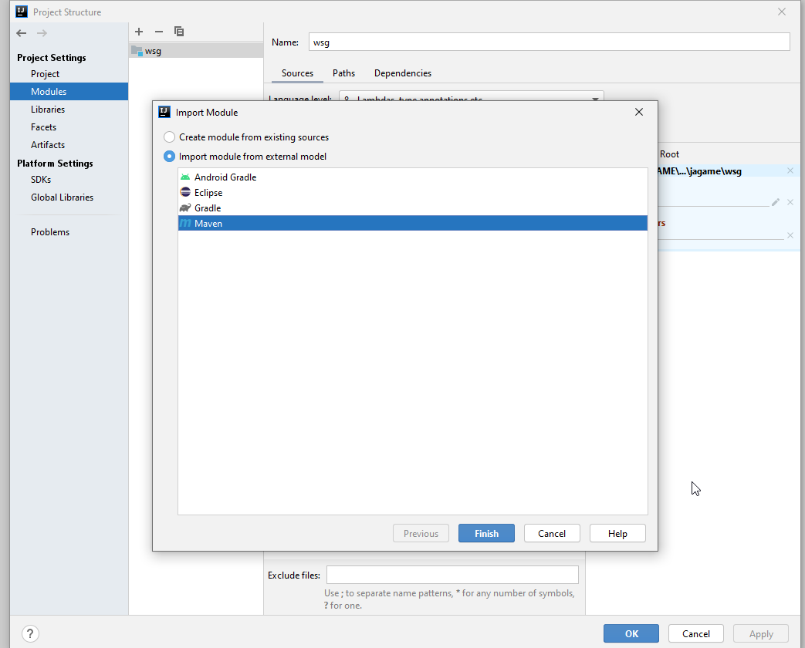

14. mark [Source] for **ceg** and **wsg**

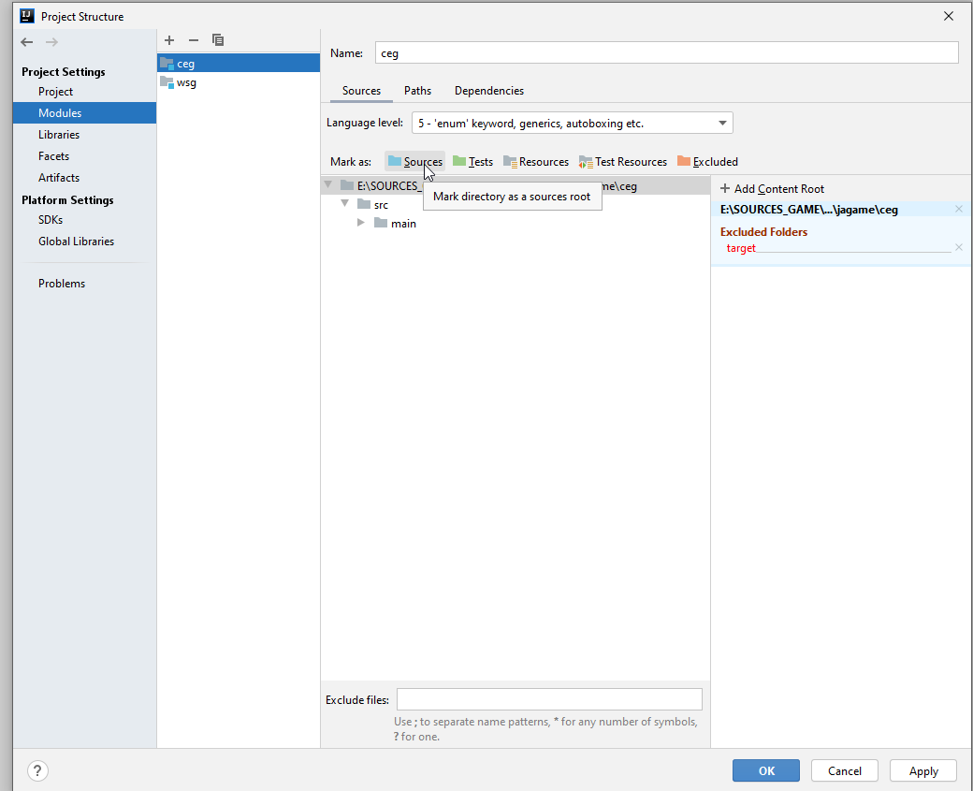

15. Project should looks like this:

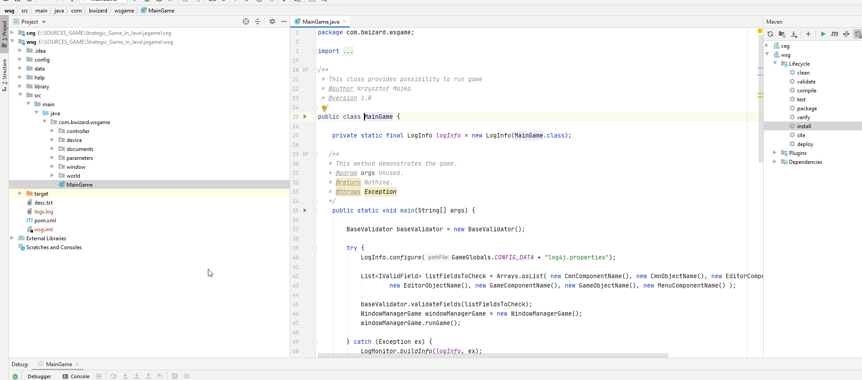

15. For **wsg** project press “Clean” for tab Maven

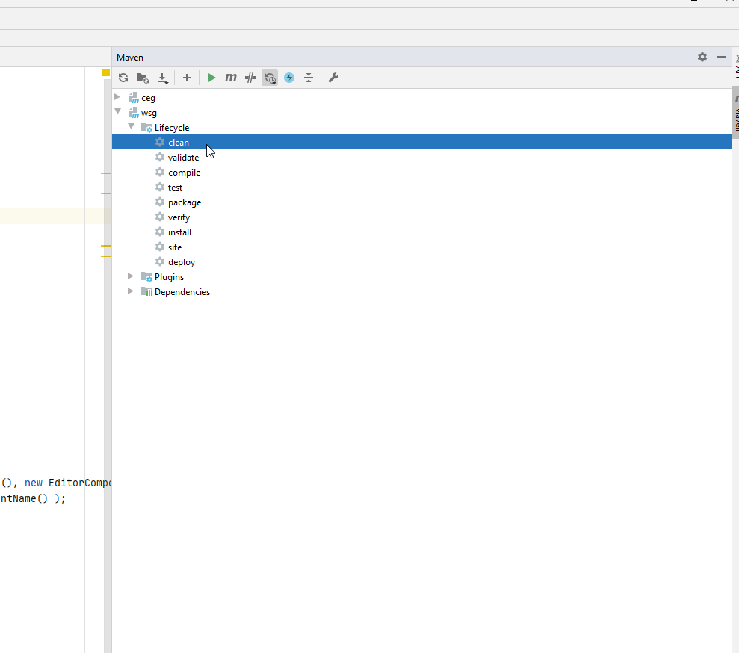

16. For **wsg** project press “install” for tab Maven

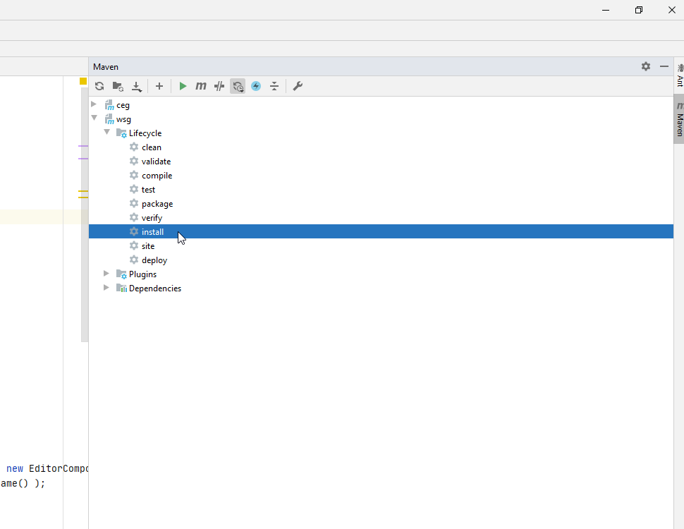

17. Start debug

