|  |  |  |
| --- | --- | --- |
| *@author*  *Kmakise* | Modbus Protocol  Weight Transmitter | *Ver.1.0.3*  *Date：21/3/9* |



This Device is able to support the MODBUS RTU communication protocol on 2 wires RS485 serial line. With the MODBUS communication protocol you can read the data state on multiple online device and check them through software,standards supervisory software provided by third parties or through interface with equipment such as MODBUS PLC terminals and data processing. The MODBUS protocol is based on a Master-Slave architecture, where requests for interrogating are unidirectional and executed only by the master (usually a PC) to the Slave . Indeed, if the Slave does not questioned by the Master, do not send any signal. The Slave when interviewed by the Master meet on predefined rules (defined by the MODBUS protocol) and not ever generate messages on its own initiative while remaining in the passive state pending Master request. All slave devices must have a different address in order to be recognized by the Master, if not, the whole system may still have some problems during operation. RTU protocol is a binary code and is the most common, besides being fast, having a message length below by almost 50% compared to the ASCII protocol.To be able to converse with each other, the master and all slaves should have the same protocol (RTU), speed, stop bits and parity. For more information you can contact us.

1 MODBUS structure Protocol  
The MODBUS protocol common structure that is independent of the communication type (serial, TCP/  
IP) is characterized by 2 communication fields which are: data and function code.  
On serial line, however, the command string consists of 4 communication fields:  
• Device address;  
• Function code;  
• Data;  
• CRC.

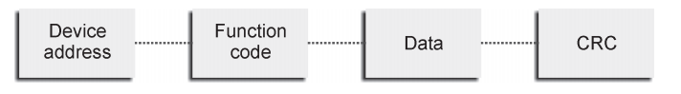

1.1 Slave Address  
The field address (Slave Address) serves to indicate what Slave is called by Master. The valid slave address can be between 1 and 128. Please, note that the Slaves must have different addresses. To communicate with a slave, the Master into the address field the value of the slave address, which in turn will use in the reply message. The values that the Master may enter inside the string are:  
• 0 = address 0, or "Broadcasting", was sent to all slave who must not be answered;  
• 1÷128 = free addresses for the Slave devices addressing;

1.2 Function Code  
The function code used to indicate to the slave the request of the master, and then the operation type to be performed, if the slave could not make this request will send an error code. The codes that can be sent must be between 1 and 83.  
To determine which functions are manageable refer to maps on the next page.

1.3 Data  
The data field contains data sent from master to slave, or sent in response from Slave to Master. The data fields are multiples of 16-bit registers (1WORD = 2byte, 1byte = 8bit). Each WORD is always transmitted from the most significant byte. Depending on how the Slave records are set, you can view or change values in sequence, and it’s possible if the records in question are adjacent to each other.

1.4 CRC  
This field is used to verify the integrity of the received message. Is calculated and attached to the message by the transmitting station. The receiving station, as a first step, recalculate this field and compare it with that received. Is generated in the case of RTU (CRC Cyclic Redundancy Checking).

2 Introduction to MODBUS RTU  
2.1 MODBUS RTU protocol  
The string of communication consists of:  
• T1 T2 T3 T4  
• device address (1 byte)  
• data (N x 2 byte; N = contiguous registers numbers to read or send)  
• CRC (2 byte)  
• T1 T2 T3 T4  
“T1 T2 T3 T4”  
indicates the time that must elapse before a subsequent communication to avoid collisions of messages,  
the overall structure of the byte is composed of:  
• 1 start bit;  
• 8 data bits (transmitted from the least significant bit);  
• 1 parity bit + 1 stop bit, if there is no parity bit using 2 stop bits.

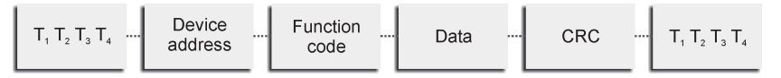

2.2 EXAMPLE

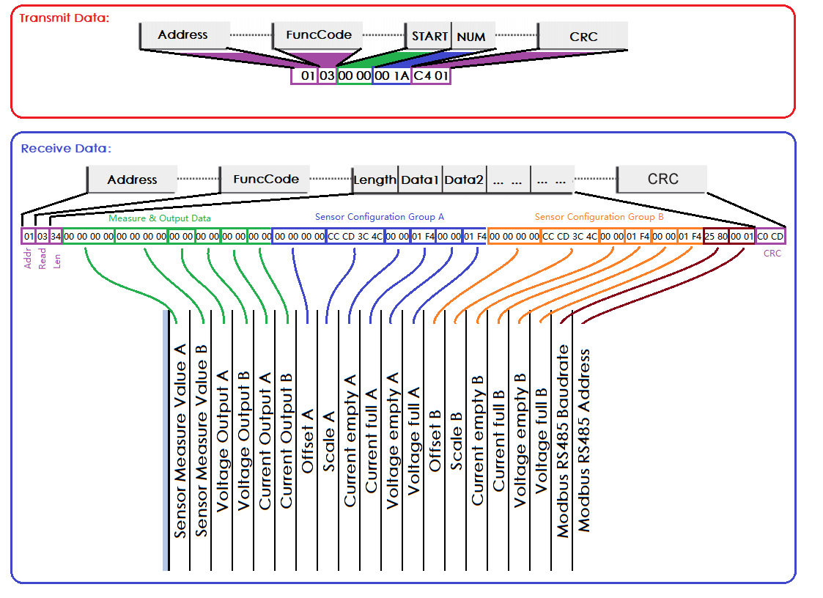•Read register：

Address： 01h

Function code： 03h

Start Address： 0000h

Read number： 001Ah

CRC： CRC16

**01 30 00 00 00 1A C4 01**

•Write single register：

Address： 01h

Function code： 06h

Data Address： 00F1h

Data Value： 0001h

CRC： CRC16

**01 06 00 F1 00 01 19 F9**

•Write multiple register：

Address： 01h

Function code： 10h

Data Address： 0000h

Register number：0002h

Bytes number： 04h

Data Value： 0000 4348h(200f)

CRC： CRC16

**01 10 00 00 00 02 04 00 00 43 48 C2 A9**

3 Mappings  
To enable the "system integrator" to develop a levels management software, following the mapping is  
represented in the device series.  
3.1 MODBUS possible functions  
Modality: RTU  
Parity: none (bit not sent)  
Times: minimum waiting time between two successive transmissions: time of 1 character multiplied by 3.5  
Read / write:  
03, 04 – “read register”  
06 – “write single register”

**10** – “write multiple register”  
Diagnostics: unmanaged  
Information Management: field data up to 100 bytes

|  |  |  |  |  |  |  |
| --- | --- | --- | --- | --- | --- | --- |
| DATA MAPPINGS | | | | | | |
| *Register Dec.* | *Address Hex.* | *Dim.word （16bit）* | *Description* | *unit* | *type* | *Function* |
| 01 | *00* | 2 | Sensor Measure Value A | kg | float | 03h 10h |
| 03 | *02* | 2 | Sensor Measure Value B | kg | float | 03h 10h |
| 05 | *04* | 1 | Voltage Output A | mV | float | 03h |
| 06 | *05* | 1 | Voltage Output B | mV | float | 03h |
| 07 | *06* | 1 | Current Output A | uA | float | 03h |
| 08 | *07* | 1 | Current Output B | uA | float | 03h |
| 09 | *08* | 2 | Offset A | Cnt | float | 03h 10h |
| 11 | *A* | 2 | Scale A | kg/cnt | float | 03h 10h |
| 13 | *C* | 1 | Current empty A | kg | uint16_t | 03h 06h |
| 14 | *D* | 1 | Current full A | kg | uint16_t | 03h 06h |
| 15 | *E* | 1 | Voltage empty A | kg | uint16_t | 03h 06h |
| 16 | *F* | 1 | Voltage full A | kg | uint16_t | 03h 06h |
| 17 | *10* | 2 | Offset B | Cnt | float | 03h 10h |
| 19 | *12* | 2 | Scale B | kg/cnt | float | 03h 10h |
| 21 | *14* | 1 | Current empty B | kg | uint16_t | 03h 06h |
| 22 | *15* | 1 | Current full B | kg | uint16_t | 03h 06h |
| 23 | *16* | 1 | Voltage empty B | kg | uint16_t | 03h 06h |
| 24 | *17* | 1 | Voltage full B | kg | uint16_t | 03h 06h |
| 25 | *18* | 1 | Modbus RS485 Baudrate | bps | uint16_t | 03h 06h |
| 26 | *19* | 1 | Modbus RS485 Address |  | uint16_t | 03h 06h |
| 242 | *F1* | 1 | ChA Zero cmd |  | uint16_t | 06h |
| 243 | *F2* | 1 | ChB Zero cmd |  | uint16_t | 06h |

1. Combination

4.1 Data feature

In receive array the data distribution follows the following characteristics：

•mode **LH**

•uint16_t **21**

•float **2143**

4.2 function demo

•float data

float Char_To_Float(void *p)

{

float f;

char *ch = (char *)p;

char *pf = (char *)&f;

pf[0] = ch[1];

pf[1] = ch[0];

pf[2] = ch[3];

pf[3] = ch[2];

return f;

}

•integer data

int16_t Char_To_int16(void *p)

{

char *ch = p;

return ((int16_t)ch[0]<<8)+ch[1];

}

1. Command

To calibration device data base and measure value in linear transformation command.

* 1. Calibration

•Zero-scale calibration

To eliminate static bias D-value after cleared pressure.

Write register command：

Address： Device Address

Function code： 06h

Data Address： 00F1h(**CHA:00F1 CHB:00F2**)

Data Value： 0001h

CRC： CRC16

**Example：01 06 00 F1 00 01 19 F9**

•Measure value calibration

To measure value linear transformation after set standard pressure(ex: 200kg).

Write register command：

Address： 01h

Function code： 10h

Data Address： 0000h

Register number：0002h

Bytes number： 04h

Data Value： 0000 4348h(200f)

CRC： CRC16

**Example：01 10 00 00 00 02 04 00 00 43 48 C2 A9**