Assignment 3 – CSE536, Summer 2016

**Due: 11:55PM June 20 Monday, 2016**

**GPU/CUDA Implementation of Dense Matrix Multiplication**

In this assignment, you will implement the square matrix multiplication algorithms (A[N][N] * B[N][N] = C[N][N]) on GPU using CUDA and CUBLAS library, and study their performance. The implementation should include three different versions of the kernels: 1) input matrix A and B are all stored in global memory and kernel computation access data directly from global memory, 2) input matrix A and B are read into shared memory of thread blocks and computation access data from shared memory, 3) implementation directly calls sgemm procedure of CUBLAS library to perform the computation.

The implementation will need to include two CUDA kernels for version 1 and 2 and codes for memory allocation and data movement. For version 3, the implementation is mainly codes for memory allocation/data movement and call to the sgemm procedure. For version 2 and 3, you can leverage code in NVIDIA_CUDA-6.5_Samples/0_Simple (matrixMul and matrixMulCUBLAS), which literately are the solutions for the two kernels. You may also refer to the CUDA programming guide for the implementation (<http://docs.nvidia.com/cuda/cuda-c-programming-guide/#shared-memory>). The algorithms of the three kernels will need a 2-dimension topology of both threads of a block and blocks of the grid, and please choose 16x16 for the block size. Each thread will compute one element of the matrix C. Kernels 2 and 3 already use this configuration. To simplify, we will assume the matrix size N to be a number of power of 2 (64, 128, 256, 512, …).

The matmul.cu file provided includes helper functions, matmul_base function for the sequential implementation, matmul_openmp function that is the openmp-parallelized version for CPU. You should put the three versions along with the two CUDA kernels in the matmul.cu file. The main functions need to be modified to include code to drive and time the three implementation, and reports timing and error information. Arrays A, B and C are all now allocated on the heap on the host using malloc so we can run the experiments with bigger input.

The matmul.cu should be compiled using nvcc compiler with “-Xcompiler –fopenmp” to enable the compilation of the OpenMP version, e.g. nvcc –Xcompiler -fopenmp matmul.cu -lpthread -lcublas -o matmul. Your executable should be able to run with two arguments: the first required argument is for the matrix size: N for NxN square matrix; the second optional argument is the # of OpenMP threads for parallelization on CPU, with default value 5 if not provided.

The output of your program should include both the error of computation, time(ms) and FLOP/s performance. Below is a screenshot of the output for running assignment 2’S code (matmul_openmp is not parallelized yet) so you get idea of what normally we can put in the output.

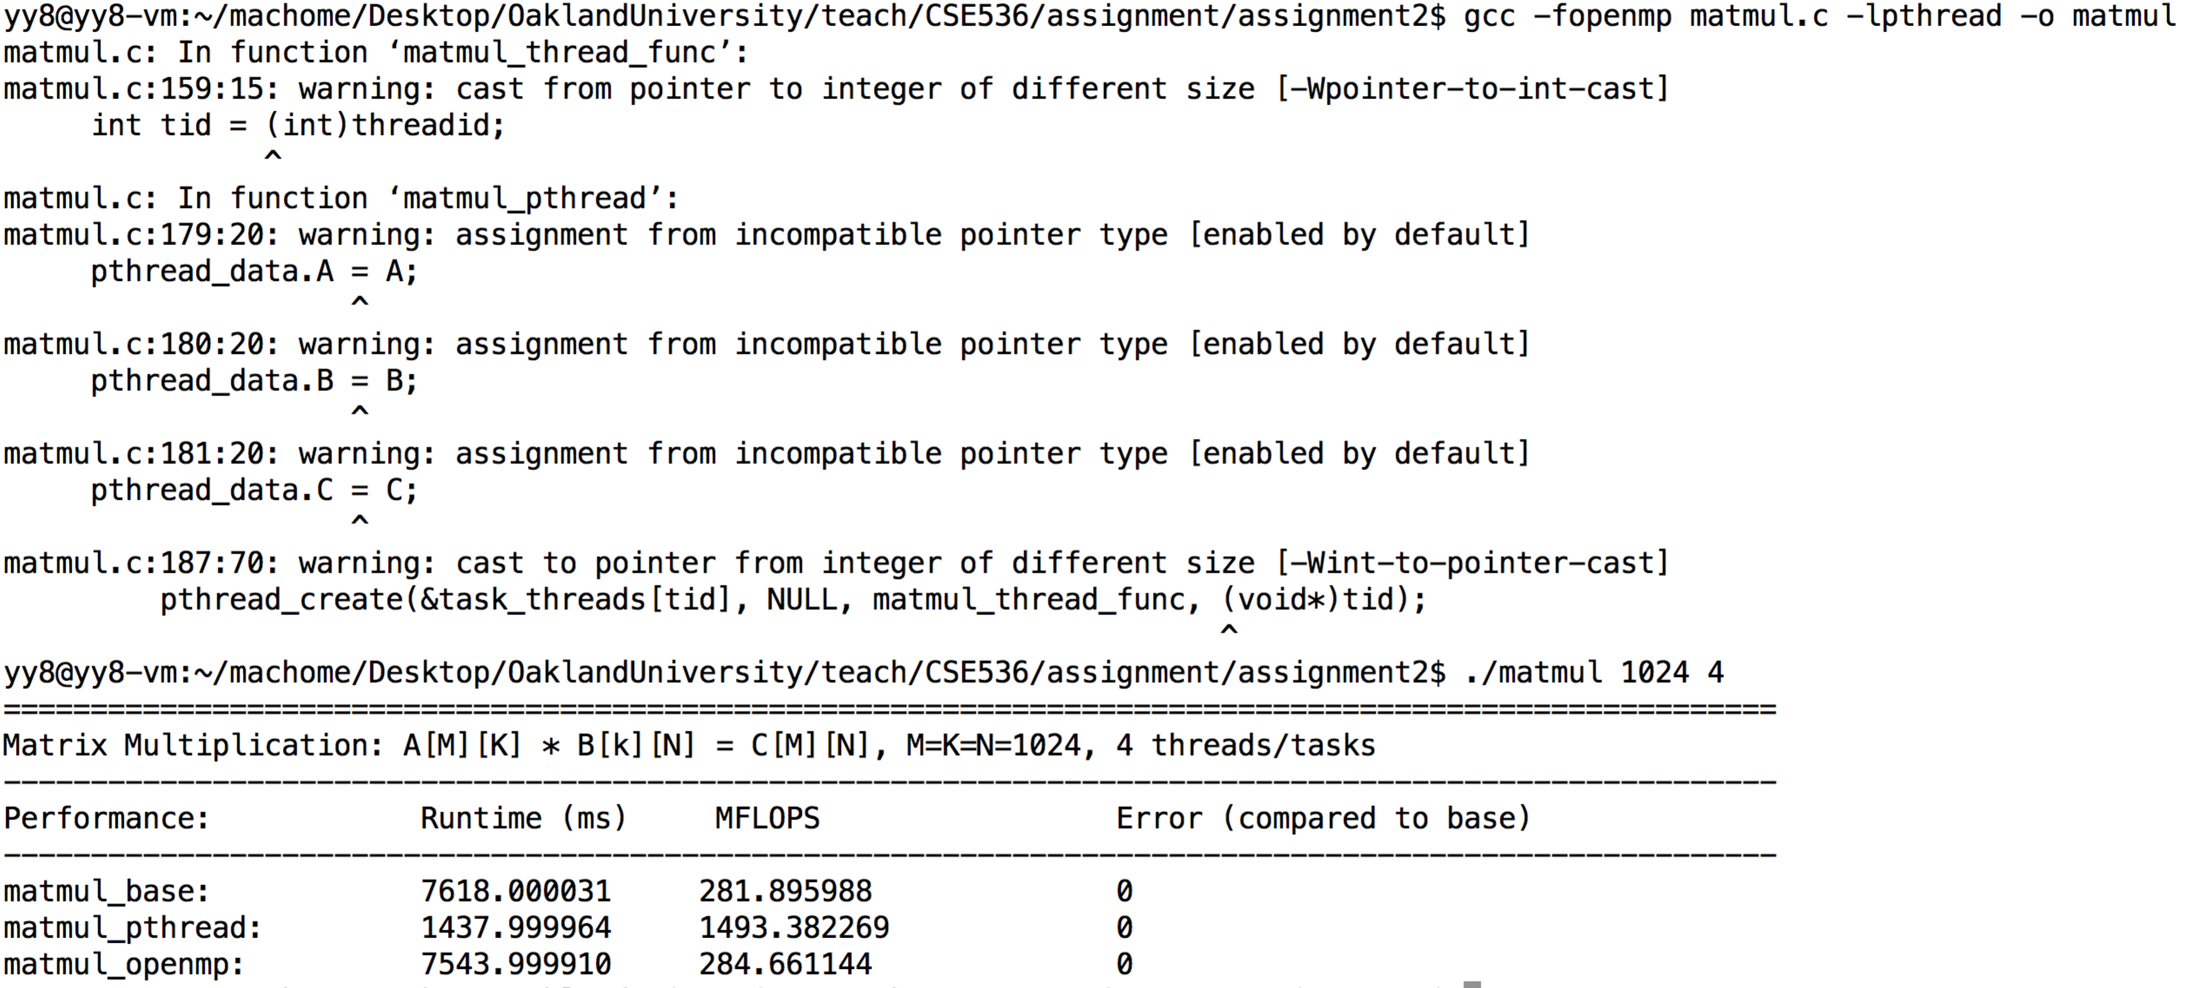

To study the performance, you will need to use the nvprof tool and please refer to the documentation page (<http://docs.nvidia.com/cuda/profiler-users-guide/index.html#nvprof-overview>) for how to use this profiler. You can also use nvvp that can produce visualized output of execution profile. However, to use nvvp on a remote machine (e.g. gpu.secs.oakland.edu), you will need to have a local X-windows system installed and started. Linux desktop by default has it. For Mac OS X, please use XQuartz (<http://xquartz.macosforge.org/landing/>), and For Windows, you can download and install Xmin X server (<http://sourceforge.net/projects/xming/>). You will then need to enable X forwarding in SSH connection. In Linux and OS X terminal, puting –X in ssh command will do it. For windows, it depends on the connection client you are using. For putty, refer to <https://wiki.utdallas.edu/wiki/display/FAQ/X11+Forwarding+using+Xming+and+PuTTY> for how to enable X forwarding.

To profile a specific CUDA implementation, you may need to comment off other kernels calls in the main program.

The performance results collected for the report should be done on lennon.secs.oakland.edu. There are two GPUs that you can use with device id 0, 1. By default, you all will use GPU 0 and you can use cudaSetDevice(1) call to select a different GPU to use. Please random choose a GPU to use so we do not all work on the same device.

**Submission:** The submission should include two files: the matmul.cu file that contains your implementations and a max 3-page report. The report should include:

1. Description on your implementation of the three versions.
2. One performance figure that reports the results for running the code with N=512, 1024, and 2048 matrix on gpu.secs.oakland.edu. The figure should show the execution time for the openmp version (matmul_openmp) that uses all the CPU cores of the machine (use lscpu command to check the total number of CPUs), and the execution time (both the kernel time and memory allocation/data movement time) of the three GPU versions.
3. One performance figure that shows the breakdown of the execution time for N=2048 of the three versions of the GPU kernels. The breakdown figure will show at least three timing information, the execution time for data movement from host to the GPU, kernel execution time, and time for data copy back. Ideally, the percentage of each of the breakdown over the total execution time will give more information, but I hope the absolute value together will show that. You should collect that information using nvprof (or nvvp).
4. Explanation of the performance results shown in the two figures. You report should include a detailed specification of the machine/GPU and software environment you are using, e.g. CPU vendor/model, the number of CPU cores, CPU memory size, GPU model/vendor, memory size, # of SM/cores, CUDA SDK (nvcc) version, gcc version (since nvcc use it) and the compiler flags used to build the executable. “cat /proc/cpuinfo” and “cat /proc/meminfo” commands will give you CPU/mem info and deviceQuery executable from NVIDIA_CUDA-6.5_Samples/1_Utilities/deviceQuery will print out the GPU information. The purpose of this information is for people who may want to do the same experiment as you.

The assignment3-plot.xlsx file will help you to generate the figures from the results you will collect. While the development can be done from your laptop or any other computers, the results in the report should be collected from gpu.secs.oakland.edu (access info from <http://cto.secs.oakland.edu/docs/pdf/linuxServers.pdf>, and <http://secs.oakland.edu/docs/pdf/vpn.pdf>). Please be noted that the machine is shared resource, overloaded use of the machine may cause incorrect performance results. For the CUBLAS sgemm implementation, the following paper discussed in details the optimization applied to the library: “Vasily Volkov and James W. Demmel. 2008. Benchmarking GPUs to tune dense linear algebra. In Proceedings of the 2008 ACM/IEEE conference on Supercomputing (SC '08). IEEE Press, Piscataway, NJ, USA, , Article 31 , 11 pages.

**Grading:**

**Functions implementations**

1. **40 points for implementation.**
2. **Report: 60 points.**

**For non-compliable code, you only receive max 60% of function implementations points. For compliable, but with execution errors and incorrectness, you receive max 70% of function implementation points. Please refer to the next page for the policy of academic conduct.**

**More info for the assignment:**

The GPU needs to be warmed up to collect realistic performance data. The way of doing it is simple: for each version, call the function first without timing it, and then call it with timer turned on. See below:

matmul_cuda_v1_vanilla (...); /* warm up the GPU */

elapsed_v1 = read_timer();

matmul_cuda_v1_vanilla( ... )

elapsed_v1 = (read_timer() - elapsed_v1);

matmul_cuda_v2_shmem (...); /* warm up the GPU */

elapsed_v2 = read_timer();

matmul_cuda_v2_shmem( ... )

elapsed_v2 = (read_timer() - elapsed_v2);

matmul_cuda_v3_cublas (...); /* warm up the GPU */

elapsed_v3 = read_timer();

matmul_cuda_v3_shmem( ... )

elapsed_v3 = (read_timer() - elapsed_v3);

To produce second figures using nvprof, for each version, you need to comment the other two versions in your code (both the warm call and the call to be timed), but leave the warm up call for this version, rebuild it and run it with "nvprof ./matmul 2048". It should produce something similar to the following. You will collect the "time" column of the first three rows (kernel time, HtoD time and DtoH time, and put them in the sheet provided to produce the breakdown timing figures.

==28987== Profiling result:

Time(%)      Time     Calls       Avg       Min       Max  Name

 95.30%  8.1613ms        31  263.27us  259.57us  267.76us  void magma_lds128_sgemm_kernel<bool=0, bool=0, int=6, int=5, int=3, int=3, int=3>(int, int, int, float const *, int, float const *, int, float*, int, int, int, float const *, float const *, float, float, int)

  3.21%  275.17us         3  91.722us  1.5360us  137.15us  [CUDA memcpy HtoD]

  1.49%  127.58us         1  127.58us  127.58us  127.58us  [CUDA memcpy DtoH]

==28987== API calls:

Time(%)      Time     Calls       Avg       Min       Max  Name

 46.87%  169.19ms         7  24.170ms  15.572us  168.45ms  cudaFree

 25.98%  93.788ms         1  93.788ms  93.788ms  93.788ms  cudaDeviceReset

Assignment policy:

Programming assignments are to be done individually. You may discuss assignments with others, but you must code your own solutions and submit them with a write-up in your own words. Indicate clearly the name(s) of student(s) you collaborated with, if any. Although homework assignments will not be pledged, per se, the submitted solutions must be your work and not copied from other students' assignments or other sources.

You may not transmit or receive code from anyone in the class in any way--visually (by showing someone your code), electronically (by emailing, posting, or otherwise sending someone your code), verbally (by reading your code to someone), or in any other way.

You may not collaborate with people who are not your classmates, TAs, or instructor in any way. For example, you may not post questions to programming forums.

You may search the web and use any information that you find. However, you cannot take more than two lines of code from an external resource and actually include it in one of your assignments. Changing variable names or rewriting code you find does not void the "two line rule."

Any violations of these rules will be reported to the honor council. Check the syllabus for the late policy and academic conduct.