3 April 2020 Tyler Starr – Yeast Display Titrations

Example protocols for yeast display inductions and binding experiments. General notes on page 1. Protocol for a panel of isogenic binding experiments is on page 2-5. Protocol for a library expression sorting experiment is on page 6-9. Protocol for a library binding experiment is on page 10-13. Example worksheets that I use to prep ligand stocks, plate layouts, sample volumes etc. for these experiments are included as additional files.

The general principle is to have yeast express a protein of interest on their cell surface (what I will call “receptor”). The most common platform for this is encoded in the pETcon vector (empty vector plasmid log # 2323 – with some extra bells and whistles in place for barcoded library experiments in plasmid log # 2439). This plasmid encodes a protein of interest fused to the Aga2 yeast protein under a galactose-inducible promoter. This fusion targets the protein to the membrane secretion apparatus, where Aga2 forms disulfides with the membrane-bound Aga1 protein, thereby tethering our protein of interest to the yeast cell surface. Yeast display experiments are typically conducted in the strain EBY100, which has galactose-inducible Aga1 and I believe other features to facilitate yeast display; we use a derivative strain, AWY101, which upregulates disulfide isomerases in the ER, which has previously shown to help the expression of some Fabs, and presumably, other proteins with multiple disulfides. The pETcon vector encodes amp resistance for bacterial cloning, and it contains a low copy centromeric origin for low-copy maintenance in yeast populations, along with a TRP auxotrophic marker – the EBY100 or AWY101 yeast strain can grow on rich media such as YPD, but can only grow on selective media lacking exogenous tryptophan (e.g. SD-CAA) if it has been transformed with plasmid.

To conduct binding experiments, we induce expression of our receptor, incubate yeast with varying concentrations of a biotinylated ligand of interest, label the yeast for receptor surface expression using fluorescent detection of a C-terminal Myc tag, and label for bound ligand using fluorescently labeled streptavidin. We can then measure the amount of bound ligand at each concentration using flow cytometry for isogenic titrations, or FACS coupled to deep sequencing for a library of variants.

Using flow cytometry or FACS, we determine a metric of relative binding across a range of ligand concentrations, allowing us to fit a 1:1 binding curve from which we can infer the dissociation constant, *K*D (and additional fit parameters *a* and *b*):

Where *y* is the relative binding metric determined via flow cytometry (‘mean bin’, more on this below), *b* is the baseline signal (typically ~1 in the mean bin metric), *a* is the difference between the minimum and maximum binding value (typically ~3 in the mean bin metric, though unstable variants with low surface expression might plateau at lower values), and [*L*]free is the free ligand concentration of each measurement.

Note, there are several assumptions to this method that are worth remembering:

* We are not actually measuring equilibrium binding constants, so depending on how physics-y an audience you are working with, acknowledge this caveat as needed. A true binding curve such as the ones we want to fit requires that you measure the fraction of your receptor that is bound *at equilibrium*, whereas we have distanced the equilibrated binding (the primary labeling) from the measurement (the flow cytometry, or more convoluted FACS-seq readout). Some people will really die on this hill, trying to call out “non-equilibrium” assays that report a *K*D at face value.
* When we fit these curves, for the x-axis variable ([*L*]free), we simply use the ligand concentration at which we incubated each sample, which is *not* [*L*]free but rather [*L*]tot, which includes [*L*]free as well as [RL] (ligand complexed with receptor). There is a crucial assumption here that is common to many methods for determining *K*D – we assume there is enough *total* molecules of ligand relative to total molecules of yeast-displayed receptor such that the amount of ligand titrated up into [RL] does not substantially alter the concentration of ligand free in solution, such that [*L*]free is more or less the same [*L*]tot at which we set up the binding reaction. To make this assumption, per the simplest rule-of-thumb typically used, we must incubate yeast in a solution of ligand of sufficient volume such that there greater than 10x more raw molecules of ligand than receptor (estimates are that each yeast cell expresses 104-105 receptors on its surface). This can become pretty large volumes at the lowest ligand concentrations, so in some of these worksheets I factor in the known *K*D and other features (e.g. fraction of library that is neutral) to continue to ensure that moles of RL is low relative to moles of Ltot

Example protocol: isogenic titrations using 96 well plates. Note, if full titrations are not needed, similar volumes (or ~2x scaled up) can be accommodated in a small number of Eppendorfs for a relatively easy binding experiment.

Day 1: Dex back-dilutions

* Start yeast overnights in SD-CAA media. Note, if you want to shave a day off the protocol: you can start SD-CAA cultures in the morning, and ~8 hours later they have grown a bit and can be back-diluted into SG-CAA+0.1%D as currently outlined on “day 2”. I like growing all cultures to saturation with an overnight because then there’s better consistency across inductions, since with an 8-hour growth, depending on freshness of the colony and inoculating density, different inductions could be at different stages of growth when back-diluted into induction media.
  + Prepare SD-CAA media, 1.5mL per culture in the plastic blue-capped culture tubes
    - 1.35mL SX-CAA media (no carbon media) per culture
    - 150uL 20% dextrose
  + Inoculate each culture with single colony of yeast from an SD-CAA agar plate. Can also back-dilute a few uLs from a previous liquid culture stored RT or 4oC
  + Incubate 30oC shaker – the one we use is the Stoddard lab shaker in the equipment corridor. It is outfitted with a 50mL conical rack where we insert the culture tube in and at a 45 degree angle (in “through the side” of the rack at an angle through the bottom level of the rack tube position) to prevent cells falling out of suspension, which yeast do more easily than bacteria

Day 2: Gal induction back-dilutions

* Check overnight ODs with 1:50 dilution (typically around 15 OD)
* Spin down 1OD*mL per culture in 1.5mL eppie, 13k rpm 1 min, pipette off sup
* Wash with 500uL Sx-CAA (no carbon) media, spin 13k rpm 1min, pipette off sup
* Resuspend each culture into 1.5mL SG-CAA+0.1%D media (galactose induces expression of construct, small amount of dextrose keeps the yeast happy as they adjust to induction)
  + 1.35mL SX-CAA per culture
  + 150uL 20% galactose
  + 7.5uL 20% dextrose
* Lay culture tubes sideways at RT (I use the 15mL conical racks to hold the cap of each tube so they’re just elevated from horizontal and don’t roll around). I aim for a 16-18 hour induction.
* Prep 1x PBS and PBS-BSA solutions:
  + Filter sterilized 1x PBS – need 1.2mL per titration
  + Filter-sterilized PBS-BSA (1x PBS + 0.2 mg/mL BSA): need xx volume for primary bindings, given at the bottom of the ligand dilutions worksheet described below. Beyond dilutions, you will need approximately 12.5mL per titration for washes and secondary incubation (+1 for the row of unstained and single-stained controls).

Day 3: Primary ligand labeling (Note: I used to do the primary ligand-binding reaction for one hour at room temperature. To achieve better equilibrium binding, it might be better to let the ligand binding reaction proceed overnight—and this would also make the one-day labeling and flow/FACS protocol that I’ve previously been doing a lot less hectic. I have written the protocol with overnight incubation here because that’s how I think it would be nice to try things out when starting a new experimental system. But this can be combined with the Day 4 protocol into one day with a one-hour primary ligand incubation.)

* Prep ligand dilutions spanning desired concentration range, diluting protein stocks into PBS-BSA. See attached worksheet “yeast-display-experiments_example-isogenic-titration-worksheet.xlsx) for example calculations and plate layout:
  + Tab 1 (“plate”) shows the plate layout.
    - This layout is for 10 concentration points per titration in each row, plus a zero concentration sample in columns 1 and 12 -- there is a very small amount of bleedover due to incomplete washing on the plate autosampler for flow, so I like to do a dead sample in column 12 before resetting for the 0M ligand reading for the next titration in the subsequent row.
    - One row is devoted to the unstained and single-stained control samples. It is easiest to fit these in the plate (and just be careful to skip when using the double secondary label, etc.), and pool these into FACS tubes after sample prep is complete to run controls and set flow cytometer settings. If you have a full plate, these can be done in tubes, you just have to deal simultaneously with tubes and plates.
    - Volumes are given for the primary labeling volume (see tab 2, below) – ones that are labeled as “large” are done at a larger volume than the maximum well volume (300uL) – as you’ll see in the protocol below, we set these up in Eppies or Falcon tubes, and spin down to concentrate cells to volume <300uL to transfer to plate for subsequent wash and secondary labeling steps
  + Tab 2 (“volume calc”) shows a worksheet by which I decide on the primary labeling volumes for the low concentration samples to avoid the ligand depletion issue discussed on page 1
  + Tab 3 (“protein dilutions”) gives the volumes for prepping primary labeling solutions.
    - Note, in this experiment I was trying to characterize a bunch of mutants which had very different *K*D so I was trying to span a larger concentration range than normal. I often pick 10 concentrations at half-log10 intervals (i.e. 10-12, 10-11.5, 10-11, …) spanning the expected *K*D of the variant of interest
    - As stated above, binding reactions that are conducted at <300uL scale will take place within the 96-well plate cells, so we prep one master batch of each ligand concentration which we will use to resuspend down a column of our plates. For primary labeling at >300uL, I prep each solution *x* number of times for each titration in larger tube volumes (leaving out volume for cell addition), to which we will add cells directly at a later step. I find it helpful to label each of these *x* tube caps with a) the protein solution label they contain, and b) the well the reaction will ultimately end up in. This helps a lot when doing the transfer to plate step below.
* Check induction culture ODs using 1:20 dilution. (Typical ODs are in the 2-4 range or so)
* In 1.5mL Eppies, spin down 1.067 OD*mL cells per titration/plate row (we will be using approximately 250,000 cells per well) 13k rpm, 1min. (2min if volumes >500uL or so). Pipette off sup
* Resuspend in 800uL PBS-BSA, spin 13k rpm 2min, pipette off sup
* Repeat: resuspend in 800uL PBS-BSA, spin 13k rpm 2min, pipette off sup
* Resuspend in 800uL PBS-BSA: ready for primary labeling (use at 50uL per binding reaction)
* Set up primary labeling reactions for large sample volumes (non-plate volumes >300uL, eventual columns 2-6 in the example worksheet except for the row of controls (1H)):
  + Resuspend 50uL of the appropriate cells directly into large primary binding volume
* Set up primary labeling reactions for small (<300uL) sample volumes in 96-well V-bottom plates (clear plastic – if I am not around, I believe Rachel also knows which plates these are. They are on the ~3rd shelf up in the bulk supplies area, toward the right side of the shelf, in a long narrow box.)
  + For each titration, go across the row aliquoting 50uL cells per well in just the small-volume incubation wells (for the example worksheet, this is columns 1, 7-12, and all columns for controls row 1H – the other columns remain empty for now)
  + Spin 4k rpm 2min in tabletop centrifuge. Shake off sup through a “shake and smack” motion – place a few paper towels right next to the sink. Give a moderately hard shake of the sample volume out into the sink, then quickly smack the inverted plate on the paper towels. Do in one sort of fluid motion, so you don’t disturb the pellet too much by e.g. turning the plate back right-side up before smacking and letting the residual volume resuspend the pellet.
  + Resuspend in appropriate primary binding solution and volume per plate setup, giving a few good pipettes up and down to resuspend pellet
* Leave reactions to equilibrate overnight. It might be worth finding a way to gently agitate to reduce yeast settling? I didn’t worry about this for my 1-hour primaries…
  + Tubes could be set on our rotating shaker thing in the gel room. (Ideally sideways if a way to jerry-rig, but perhaps not a good way to achieve this). For the plate, there’s a plate shaker that belongs to the Buck lab in the cold room, which I use when incubating secondaries (setting ~5, pretty gentle). We could move this out to RT for overnight incubations, at least in this interim period when I doubt they’re using it…
* Move additional PBS and PBS-BSA to 4oC to chill overnight since all subsequent steps are done cold

Day 4: Secondary labeling and flow

* Move PBS and PBS-BSA to ice bucket to further chill. Set tabletop centrifuge to chill to 4oC
* Prepare secondary labeling solutions, store on ice: 200uL plus void for the single-label controls. For the double label, make 660uL solution per titration row, plus an extra ~100uL dead volume for the multichannel reservoir. For 15 titrations (2 plates minus one row of controls) I make 10mL

|  |  |  |  |
| --- | --- | --- | --- |
| Secondary | Vol SA-PE (1:200) | Vol Myc-FITC (1:200) | Vol buffer (PBS-BSA) |
| SA-PE only (for control) | 1.125uL | -- | 223.9uL |
| Myc-FITC only (for control) | -- | 1.125uL | 223.9uL |
| SA-PE/Myc-FITC |  |  |  |

* Spin down large-volume incubations to concentrate <300uL, and transfer to appropriate wells:
  + Spin Falcon tubes 4k rpm 5min in tabletop centrifuge, spin Eppies 13k rpm 2min.
  + For Falcon tubes, pour out sup and give a mild/moderate “shake” off of the remaining supernatant. I find that this leaves ~200uL of residual volume left in the tube
  + For Eppies, pipette off a volume of supernatant that leaves ~200uL of volume behind
  + In the residual volume left in tubes, resuspend pellet and transfer to appropriate well in the 96-well plate. If >300uL volume remains, re-spin and pipette off appropriate volume.
* Once all wells are into place in the 96-well plate, we can begin the washing and secondary labeling. It’s all multichannel from here on out! After we spin down these primaries, we want to keep everything cold to prevent dissociation of bound ligand. Keep plates on ice bucket, centrifuge 4oC, PBS-BSA chilled, etc.
* Spin plates 4k rpm 2 min. Shake and smack out supernatant
* Resuspend 200uL/well ice-cold PBS-BSA with a few up/down pipettes
* Spin 4k rpm 2min, shake and smack
* Resuspend in ice-cold secondary binding solution, 50uL/well ***be careful to not double label the controls row***
* Incubate 1 hour (30 min if time pressed) in cold room on plate agitator, setting ~5
* Spin 4k rpm 2min, shake and smack
* Resuspend 200uL/well PBS-BSA, spin 4k rpm 2min, shake and smack
* Repeat: resuspend 200uL/well PBS-BSA, spin 4k rpm 2min, shake and smack
* Resuspend in final volume 100uL 1x PBS per well, store on ice
* Combine and pool control samples into 400uL in FACS tubes

Flow cytometry;

* Set up experiment to collect PE, FITC, FSC, SSC signals. We’ll do the analysis post-flow in Flowjo, but it’s helpful to have scatter plots like the ones I show from Flowjo below just to make sure voltages are set to make the appropriate plots we’ll want as below
* Use unstained and single-stain controls to set voltages. Collect data from 10,000 cells on these control samples to do post-processing compensation of FITC and PE signals
* Collect data for 10,000 cells from plates on flow cytometer with HTS sampler (I was using Fortessa X50)
  + 3.0uL/s sample flow rate
  + 20uL sample volume
  + 30uL mixing volume at 60uL/s, 3 mixes
  + Wash Volume 400uL
* I usually book a two hour appointment for two plates, which gives time for setup and cleaning afterwards, and I usually still end ~20 minutes early.

FlowJo data analysis:

* Set compensation. From the Fortessa, at least, compensation was pretty minor – a small %age was taken from one channel out of the other (I believe PE signal bled a small bit into FITC but it might have been the other direction)
* Make Cells gate that captures most cells on the FSC/SSC plot (left plot below)
* Nesting within each other (Cells > Singles > Singles, v2) Make gates that capture majority population on FSC-W/FSC-H and SSC-W/SSC-H plots. Note, sometimes on these plots there are two distinct but partially overlapping populations. These, I believe, correspond to partially budded and unbudded cells, and we keep both. The reason I think it is this, is that when doing pilot experiments I have kept an induced culture at 4oC and run flow a day or two later, and these resolve to a single population – I presume because growth stopped but partial buds probably completed their division.

* Though we don’t use this in the data anlaysis, for visualizing binding/troubleshooting by eye, I like to see a plot on the Singles, v2 population that gives PE versus FITC for all cells (e.g. for a bound sample, below):

* For analysis, make a FITC+ subset of the Singles, v2 population. Below is shown an example gate from an unstained (left) versus Myc-FITC single stained control (right):

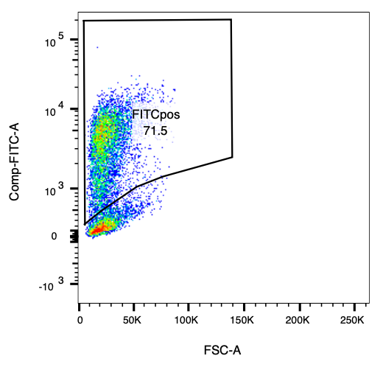

* On the FITC+ subset, make a histogram of PE. Draw bin1 through bin4 boundaries, typically using the wildtype variant titration samples and then applied to all titrations. However, if you have other variants that saturate at a total higher level of binding than wildtype, you will probably want to use this titration to define your bin1-bin4 gates for all titrations:
  + Bin1 captures 99% of cells in the 0M concentration sample (left)
  + Bin4 captures 99% of cells in the highest/saturated sample (right)
  + Bin2 and Bin3 are equally wide gates that span the range between bin1 and bin4.

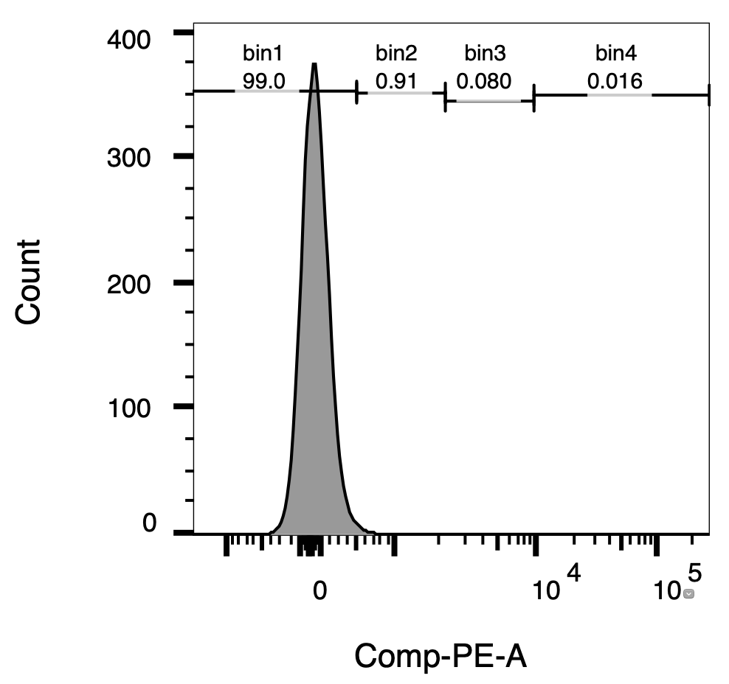

* Output a table containing the following statistics for each sample:
  + Percentage of Singles, v2 population that fall in bin1-bin4
  + Percentage of Singles, v2 population population that are FITC+
  + Geometric mean of FITC fluorescence among FITC+ cells
  + Geometric mean of PE fluorescence among FITC+ cells
* Output the plots described above in a global worksheet, batch report across all wells and save to pdf
* From the table, calculate “mean bin” for each well, as the weighted mean of the integer bin numbers. (Geometric mean fluorescence of cells that fall into each bin are evenly spaced on a log scale, so these integer bin numbers could be replaced by the mean fluorescence of cells in the bin to calculate a simple weighted mean fluorescence for each sample, but that’s an extra step to calculate and the actual fluorescence changes day to day with cytometer threshold setting, so I like this mean bin metric because it’s an internal relative metric that is stable, and this method matches what we will ultimately be doing in the FACS-seq assay below where we don’t have the benefit of knowing the per-cell fluorescence of each cell that falls into a bin.)

Where *f*1 is the fraction (or percentage) of FITC+ cells in bin 1, f2 fraction in bin2, etc.

* Fit 1:1 binding equation for mean bin versus [L] given on p. 1 to determine *K*D

Example sorting experiment: library Sort-seq for expression and FITC+ enrichment

Broad overview:

* Induce expression, sort library into four bins of FITC fluorescence to determine mutation effects on expression
* Sort FITC+ subset of library to improve efficiency of subsequent titration sorting experiment

Day 1: Dex backdilution (If wanting to shave a day off the protocol, we could try making this an AM backdilution into Dex media, and back-dilute into Galactose induction same-day PM)

* Thaw aliquot of yeast cells transformed with library (18.5 OD*mL in 1.5mL aliquot, ~1e8 cfu)
* Dilute into 180mL SD-CAA in 1L baffled flask
* Start a 1.5mL SD-CAA overnight of wildtype transformed yeast for controls
* Incubate overnight 30oC 225 rpm, starting afternoon

Day 2: Galactose Induction

* Check library and wildtype control O/N ODs with 1:50 dilutions
* For library:
  + Spin 20 OD*mL 4k rpm 3 min, pour sup
  + Wash with 5mL SX-CAA (no carbon media), spin 4k rpm 3min, aspirate sup
  + Resuspend to 30mL in SG-CAA+0.1%D in 250mL baffled flask
    - 27mL SX-CAA, 3mL 20% Galactose, 150uL 20% Dextrose
  + Incubate RT 16-18 hours, with gentle shaking – I use the agitator in the gel room, set to ~70 rpm
* For control:
  + Spin 1 OD*mL, 13kg 1min, pipette off sup
  + Resuspend 500uL SX-CAA, spin 13kg 1min, pipette off sup
  + Resuspend to 1.5mL in SG-CAA+0.1%D
  + Lay sideways RT as per isogenic titrations, 16-18hr induction
* If needed, prep ~10mL filtered 1x PBS, ~75mL filtered PBS-BSA (1x PBS with 0.2mg/mL BSA), 50mL 2xYPAD+1% BSA for FACS collection media (from the 7.5% BSA stock solution you use in TC – I have one bottle already used for yeast in the deli fridge, top right rack with my initials. Put all solutions in deli fridge O/N to cool to 4oC

Day 3: Cell prep and FACS

* Cool table top centrifuge to 4oC
* Prepare labeling solution: 3.07mL PBS-BSA + 31uL anti-Myc-FITC, store on ice
* Library sample prep:
  + Read OD with 1:20 dilution
  + Spin 45 OD*mL in 15 or 50mL conical, 4k rpm 3min, pour sup
  + Wash twice with 10mL ice-cold PBS-BSA, spinning and aspirating sup
  + Resuspend 3mL Myc-FITC solution
  + Incubate 1 hour 4oC, gently swirling tube every ~15 minutes
  + Spin 4k rm 3min, aspirate sup
  + Wash twice with 10mL ice-cold PBS-BSA, spinning and aspirating sup
  + Resuspend to final 5mL PBS, pass through mesh filter into 2 FACS tubes, store on ice until sort
* Wildtype control sample prep
  + Read OD with 1:20 dilution
  + Aliquot two eppies with 0.55 OD*mL, which will be the unstained and Myc-FITC stained controls, spin 13k rpm 1min, pipette sup
  + Wash twice with 500uL ice-cold PBS-BSA, pipetting off sup
  + Resuspend in primary binding solutions:
    - (1) 100uL PBS-BSA (unstained)
    - (2) 100uL Myc-FITC solution
  + Incubate 1 hour 4oC, gently flicking every ~15 minutes
  + Wash twice with 500uL ice-cold PBS-BSA, pipetting off sup
  + Resuspend to final 500uL PBS, pass through mesh filter into FACS tubes, store on ice until sort
* Bring to sort:
  + ~40 FACS tubes with 1mL 2xYPAD+1% BSA, extra media and tubes, sharpie…
* Sorting strategy:
  + I usually book a 4.5 hour sort for one set of expression sorts (usually when you sort yeast, they ask that you finish 30 min before your reservation ends so they can decontaminate sorter for the next user).
  + My general setup instructions for a sorter are scrolled on a sheet of paper on my desk :/ I can add this later on if needed…
  + Use unstained and wildtype controls to set parameter thresholds.
  + Use unstained and wildtype inductions to set Cells > Singles > Singles, v2 > FITC+ nested gates as shown for example in the FlowJo plots on page 4 or worksheet below p. 7
  + Collect data for ~20,000 cells for the two controls and the library for re-plotting figures post-sort
  + When aiming collection streams (set up all four – we only collect 1 stream for the first part of the sort but we’ll collect four streams later on): try to aim the stream to hit the liquid at the bottom of the tube – this means you’re *not* aiming the stream to enter through the middle of the top of the tube, but rather to enter at an angle so that it hits the middle of the meniscus at the starting 1mL media volume in the tube. This avoids slamming the cells into the plastic side of the tube, which causes cell death/sticking and poor recovery post-sort
  + Prior to loading sample collection tubes, vortex or invert the collection tube to coat the entire side with the media/BSA solution. This has a huge impact on sample pelleting/recovery post-sort
  + Collect at least 1e7, up to 2e7 cells in the FITC+ gate over the course of ~1-1.5 hour. Run samples at a reasonably high rate, aim for ~15000 events/sec
    - Collection tube fills up every ~2.5 million cells and need to be switched.
    - After pulling a tube off, hold the cap tight and invert a couple of times to mix the sorter media and the recovery media, and store on ice
    - Be sure to “resume” sort after switching tubes and not re-“start”, otherwise sort counter will reset and you will lose values! The exact value for this FITC+ enrichment sort is not very important if it gets reset, but we really want the actual sorter counts for the expression Sort-seq bins (and it’s even more vital for the binding titration experiments downstream), so it’s good to practice this here! If the count does reset, just write down the order of magnitude it was at before and keep a rough addition going
  + After collecting FITC+ population, we do another set of sorts where we partition cells into four bins across FITC fluorescence levels, which we will sequence and use to determine mutational effects on expression level (expression “Sort-seq” experiment):
    - Make a histogram view of FITC fluorescence from the Cells > Singles > Singles, v2 population (so, includes the FITC- population)
    - Make bin1-bin4 gates:
      * Bin1 captures 99% of cells in the FITC histogram of the unstained control
        + In the positive control/library samples, you’ll notice the FITC histogram is bimodal – the FITC- population in the wildtype (if well expressed) is largely due to cells that spontaneous lose plasmid – when you sort these out, you get way fewer cfus growing on a selective plate than on a non-selective plate. In the library, the FITC- proportion is a combination of plasmid loss but also live cells containing variants with reduced or ablated expression. Therefore, many fewer cells will grow out from bin1 than are putatively sorted into it – we will plate dilutions of cells post-sort to estimate the actual number of cells in this expression bin, which is an important number that we use in the per-variant Sort-seq expression calculation
      * Bins2-4 split the remaining FITC+ portion of the library histogram into tertiles of equal proportion.
    - An example of the FACS software worksheet used for one of my Ab libraries is shown below for reference
    - Collect cells from these four bins for ~2 hours, switching out tubes when they start to fill up every ~2.5e6 collected cells. As with the FITC+ sort, prewet the collection tubes, and invert tubes post collection and store on ice.
    - Record the exact fluorescence boundaries of the bin1-4 sort gates. I use a table like the one in the worksheet below, where I report the minimum and maximum FITC value in each bin. These will reset at the sorter’s data vis reset rate. Any individual view usually doesn’t give you the exact boundaries (see the table below – no cell was sampled in this set of 10,000 cells with a fluorescence of 1419, so we don’t know yet whether that falls into P2 or P3). I will watch this table for a few minutes until I see how each bin resolves over the resets, and then record the boundaries. For example, with this sort, the fluorescence boundaries turned out to be: (-212, 1418); (1419, 4178); (4179, 9766); (9767, max ~200,000). It’s ok if two of your bins report overlapping values or you end up with a small gap between bin boundaries, record the average anyway. **We need these fluorescence boundary values for the maximum likelihood calculation we use to reconstruct each variant’s mean expression.**
    - Record the final sort counters.

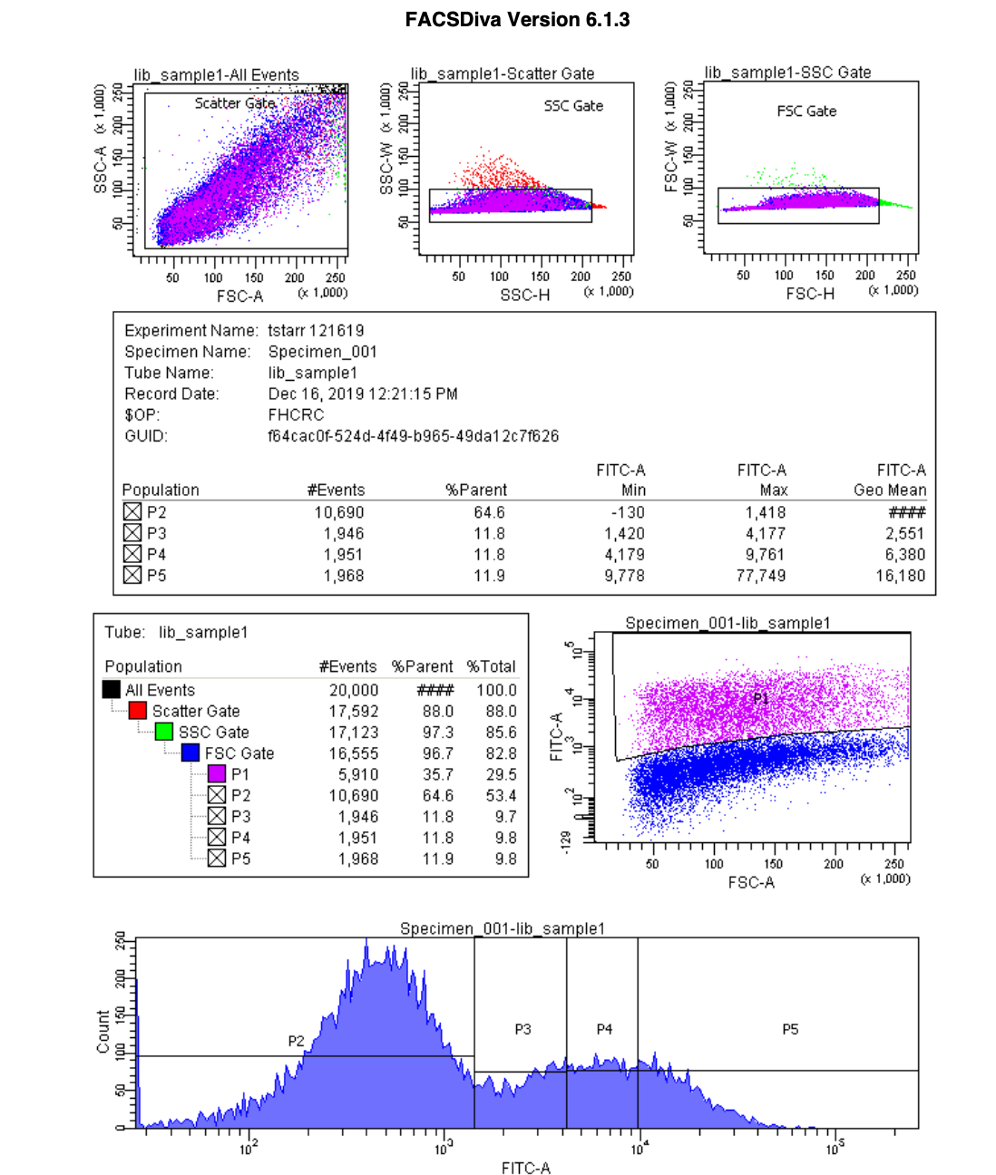

Post-sort processing:

* Spin FACS tubes 4k rpm 5min. Aspirate supernatant, being careful to not disturb pellet, so leave a little residual volume carryover
* Pool all FITC+ collected cells into a recovery volume of SD-CAA media with 1:100 diluted pen-strep. Pick a volume that yields ~500,000 cells (as estimated by the sort counter) per mL media. Put the recovery in a baffled flask where it occupies no more than 1/5 the quoted flask volume
  + I’ll usually pipette media through the series of FITC+ collection tubes 5mL at a time – the first time just aim to recover each pellet, with the subsequent rounds of 5mL try to wash down the sides a little bit – but don’t try to do this too rigorously, otherwise cell recovery will take forever with all of the sort tubes!
* Through the same method, pool all collected cells for each of the FITC.binX samples, but pool to a culture volume of ~2e6 cells/mL (perhaps higher than 2e6/mL for bin1, since we know that the actual cell count for bin1 is lower than the sort cell counter due to plasmid loss)
* Dilute 5uL of each pooled recovery outgrowth into 495uL SX-CAA (10-2 dilution), and further dilute 100uL of 10-2 into 900uL SX-CAA to make 10-3 dilution. Plate 100uL of 10-2 and 10-3 dilutions onto SD-CAA plates, grow 30oC 2-3 days to estimate actual post-sort cell recovery. (Optional, plate 100uL of 10-3 dilution on nonselective YPD plate)
* Incubate post-sort cultures at 30oC 225rpm to grow out overnight

Example table showing FACS counts, outgrowth volumes, and plating efficiencies from a typical “good” (/great) sort. Note, the 10-3 plating on YPD is not necessary for any downstream calculations but is a nice figure to have for troubleshooting from sort to sort. The SD-CAA colony counts are necessary for the Sort-seq calculation of variant effect.

|  |  |  |  |  |  |  |  |  |
| --- | --- | --- | --- | --- | --- | --- | --- | --- |
|  | FACS counter # cells | Vol outgrowth | cfu, 10-2 SD-CAA | cfu, 10-3 SD-CAA | cfu, 10-3 YPD | cfus sorted from SD-CAA | SD/YPD efficiency | YPD/sorted efficiency |
| FITC.bin1 | 45,079,424 | 15mL, 250mL flask | 213 | 19 | 224 | 3,195,000 | 9.5% | 74.5% |
| FITC.bin2 | 7,086,112 | 3mL, blue capped tube | TMTC | 51 | 175 | 1,530,000 | 29.1% | 74.1% |
| FITC.bin3 | 5,868,331 | 3mL, blue capped tube | TMTC | 70 | 151 | 2,100,000 | 46.4% | 77.2% |
| FITC.bin4 | 4,694,218 | 2.5mL, blue capped tube | TMTC | 82 | 131 | 2,050,000 | 62.6% | 69.7% |
| FITC+ | 15,023,720 | 30mL, 250mL flask | 143 | 14 | 36 | 4,290,000 | 39.7% | 71.8% |

Day 4: Post-sort outgrowths: storage and minipreps

* Read ODs with 1:50 dilution
* For FITC+ outgrowth:
  + Store as many 1e8 (18.5 OD*mL) aliquots as possible (well, maybe limit at 30 if you have more cells than that): spin down volume for x*18.5 OD*mL, pour sup, resuspend in x*1.5mL SD-CAA+1:100 pen-strep with 25% glycerol, aliquot 1.5mL per cryotube. Flash freeze in dry ice/ethanol or liquid nitrogen, store -80oC
* For FITC.binX samples:
  + Spin down pellets of 7.5 OD*mL (~4e7 cells) per Miniprep. I typically miniprep 4 pellets for the bin1 sample, and 2 each from bins 2-4.
  + Use Zymo Miniprep II miniprep kit to prep plasmid, but with some tweaks in the protocol:
    - Resuspend each pellet in 200uL Solution1+Zymo (make master mix, 200uL Solution1 + 7.5uL Zymolyase per reaction plus extra dead volume)
    - Incubate 37oC for at least two hours (up to four hours if timing works for the day), gently flicking tube to mix every ~20-30 minutes.
    - Perform one freeze-thaw cycle – put tubes at -80oC to freeze. (This can be a great stopping point for a night/weekend/vacation/however long makes sense!). Thaw tubes on 42oC block
    - Add 200uL Solution 2, mix well via inverting. Let sit between 3-5 minutes to lyse
    - Add 400uL Solution 3, mix well via inverting.
    - Centrifuge max speed for 10 minutes. Note, the pellets are a lot messier than typical bacterial minipreps due to large amount of cell debris! If you’re unable to get out the 700uL sample without tons of debris, transfer to a new Eppendorf and spin again. I typically get some crap into my column loading and just roll with it and haven’t had problems.
    - Transfer up to 700uL to Zymo spin column, centrifuge 13k rpm 1min
    - Do 3x 550uL wash buffer 30s spins (can use Qiagen wash buffer if run out from Zymo kit), empty tube after final wash and do another 1 min dry spin
    - Place column into fresh tube. Add 10uL EB, incubate 5min, spin 13k rpm 1 min. Repeat elution with another 10uL.
    - Pool all plasmid preps from the same samples. Can take nanodrop volume, but this is largely determined by genomic DNA contamination and is not actually an accurate quantification of the plasmid yield, which is low as these are low-copy plasmids and yeast minipreps are notoriously bad
      * (I previously transformed yeast minipreps into bacteria and compared to diluted bacterial-purified plasmid of known concentration to estimate actual plasmid yield, which was routinely >1e6 plasmids/uL)
  + Plasmids are ready for sample index PCR of barcodes for Illumina sequencing. (If I am doing a subsequent library titration experiment, I will typically do these PCRs at the same time as the binding bin PCRs. I will eventually add my PCR protocols to this document, but not now…)

Data analysis (broad overview):

* We normalize Illumina read counts by the estimated number of cfus we recovered from each bin as given in the table above (i.e. if we sequenced 1e7 reads for bin2 but we know we only recovered 1e6 cells from that bin’s sort, every 10 reads of a barcode represents 1 “cell” sorted into that bin)
* For each barcode, we then have an observation of counts of “cells” observed in each of the four bins
* For each library variant, given its observed distribution of counts across bins, and the known fluorescence boundaries of those bins that we recorded above, we calculate the variant’s maximum likelihood mean fluorescence

Example “Tite-seq” (library ligand-binding) experiment

Day 1: Dex backdilution (As before -- if wanting to shave a day off the protocol, we could try making this an AM backdilution into Dex media, and back-dilute into Galactose induction same-day PM)

* Thaw aliquot of FITC+ sorted library (18.5 OD*mL in 1.5mL aliquot, ~1e8 cfu)
* Dilute into 180mL SD-CAA in 1L baffled flask
* Start a 1.5mL SD-CAA overnight of wildtype transformed yeast for controls
* Incubate overnight 30oC 225 rpm, starting afternoon

Day 2: Galactose Induction

* Check library and wildtype control O/N ODs with 1:50 dilutions
* For library:
  + Spin 133.3 OD*mL 4k rpm 3 min, pour sup
  + Wash with 5mL SX-CAA (no carbon media), spin 4k rpm 3min, aspirate sup
  + Resuspend to 200mL in SG-CAA+0.1%D in 1L baffled flask
  + Incubate RT 16-18 hours, with gentle shaking – I use the agitator in the gel room, set to ~70 rpm
* For wildtype control:
  + In duplicate (to have enough induced for 5 controls), spin 1 OD*mL, 13kg 1min, pipette off sup
  + Resuspend 500uL SX-CAA, spin 13kg 1min, pipette off sup
  + Resuspend to 1.5mL in SG-CAA+0.1%D
  + Lay sideways RT as per isogenic titrations, 16-18hr induction
* If needed, prep filtered 1x PBS (~50mL) and filtered PBS-BSA (1x PBS with 0.2mg/mL BSA) (51mL per titration concentration, plus ~25mL for controls and amount for primary labeling given in worksheet).

Day 3: Primary labeling (as above, I used to do a one-hour primary incubation which combined days 3 and 4 together, but I think transitioning to overnight binding is good for equilibration’s sake, as well as making the sorting day slightly less hectic)

* Library:
  + Prep ligand dilutions spanning desired concentration range, diluting protein stocks into PBS-BSA. See attached worksheet “yeast-display-experiments_example-Tite-seq-worksheet.xlsx) for example calculations:
    - Tab 1 (“primary solution calculations”) shows an example calculation of sample volumes to avoid ligand depletion, and recipes for making the ligand concentration solutions
    - Tab 2 (“Sorting counts and plate layout”) gives the table I fill out as I set up the FACS samples, and the plate layout I use to set up post-sort cultures
    - Tab 3 (“illumina prep”) was my PCR quant and pooling worksheet for this set of experiments, though that is not currently described here
  + Read library induction OD using 1:20 dilution
  + For each concentration sample, spin 8 OD*mL cells in a 15mL conical, 4k rpm 3 min, pour sup
    - Empirically from previous sorts, this results in about 3e7 labeled cells per concentration
  + Resuspend each sample in 10mL PBS-BSA, spin 4k rpm 3min, aspirate sup
  + Repeat: resuspend 10mL PBS-BSA, spin 4k rpm 3min, aspirate sup
  + Resuspend each sample in appropriate primary binding solution and volume per attached worksheet.
    - Small volumes can be done within the same 15mL conical, but some volumes will need to be resuspended and transferred to 50mL conical or 100+ mL glass bottles with the full volume of the ligand solution
  + Incubate overnight at RT. Worth finding a way to set samples e.g. on agitator in the gel room to keep solution mixed overnight? Might be too complicated…
* Wildtype controls:
  + Need to make samples (1) unstained, (2) Myc-FITC only, (3) SA-PE only, 100nM ligand, (4) double labeled, 0M ligand, (5) double labeled, 100nM ligand
    - Note, for samples (3) and (5), to use higher than 100nM ligand if needed – these samples should be saturated binding, it’s just not worth the amount of protein used to use an e.g. 1uM labeling concentration if it binds tightly enough to be fully saturated at lower concentration
  + Read OD with 1:20 dilution
  + Aliquot 5 tubes with 0.55 OD*mL induced culture, spin 13k rpm 1 min, pipette sup
  + Resuspend 500uL PBS-BSA, spin 13k rpm 1 min, pipette sup
  + Repeat: resuspend 500uL PBS-BSA, spin 13k rpm 1 min, pipette sup
  + Resuspend in primary binding solution:
    - (1) 400uL PBS-BSA
    - (2) 400uL PBS-BSA
    - (3) 400uL 100nM ligand (or whatever concentration)
    - (4) 400uL PBS-BSA
    - (5) 400uL 100nM ligand
  + Incubate RT overnight
* Move remaining PBS and PBS-BSA to 4oC to chill overnight

Day 4: Wash and secondary labeling, FACS

* Chill PBS, PBS-BSA on ice
* Cool tabletop centrifuge to 4oC
* Prep 100mL collection media (86.67mL 2x YPAD, 13.3mL 7.5% BSA solution)
* Prep 100mL SD-CAA + 1:100 pen-strep
* Take ~6 SD-CAA and YPD plates out to RT
* Prep secondary labeling: 400uL of each single-stain control, 1mL/concentration sample of double label plus 2*400uL for wildtype controls

|  |  |  |  |
| --- | --- | --- | --- |
|  | Vol SA-PE (1:200) | Vol Myc-FITC (1:200) | Vol buffer (PBS-BSA) |
| SA-PE only (450uL) | 2.25uL | -- | 447.75uL |
| Myc-FITC only (450uL) | -- | 2.25uL | 447.75uL |
| SA-PE/Myc-FITC (x*1mL + 2*400uL) |  |  |  |

* Library sample prep (after this spin down, keep everything cold to prevent dissociation: chill solutions on ice, keep cells on ice, etc.):
  + Spin down primary binding solutions 4k rpm 5 min, pour sup:
    - For ligand binding volumes > 50mL, aliquot out 50mL portions in separate conicals to spin
  + Resuspend each sample in 10mL ice-cold PBS-BSA – for samples either in a 50mL conical, or split across multiple 50mL conicals, use this 10mL to (pool and) transfer to fresh 15mL conicals
  + Spin 4k rpm 5 min, pour sup
  + Resuspend in 1mL secondary labeling SA-PE/Myc-FITC
  + Incubate >30 min (up to 1 hour) 4oC and/or on ice, gently swirling tube every ~10 minutes
  + Spin 4k rpm 5 min, pipette sup
  + Resuspend 10mL PBS-BSA, spin 4k rpm 5 min, pour sup
  + Repeat: resuspend 10mL PBS-BSA, spin 4k rpm 5 min, pour sup
  + Resuspend in final volume 1.5mL PBS, pass thorugh mesh filter into FACS tube, store on ice until sorting time
* Wildtype controls sample prep
  + Spin down primaries 13k rpm 1 min, pipette sup
  + Resuspend in 500uL ice-cold PBS-BSA, spin, pipette sup
  + Resuspend in secondary binding solution:
    - (1) 400uL PBS-BSA
    - (2) 400uL Myc-FITC only
    - (3) 400uL SA-PE only
    - (4) 400uL Myc-FITC/SA-PE
    - (5) 400uL Myc-FITC/SA-PE
  + Incubate >30 min 4oC, gently flick tubes every ~15 min
  + Spin 13k rpm 1min, pipette sup
  + Resuspend 500uL PBS-BSA, spin, pipette sup
  + Repeat: resuspend 500uL PBS-BSA, spin, pipette sup
  + Resuspend to final 500uL PBS, pass through mesh filter into FACS tubes, store on ice until flow
* Bring to flow:
  + 64 collection tubes with 1mL 2x YPAD+1% BSA (for 16 concentrations example), labeled for sample x and bin y (1-4) as sX.bY; at least 24 additional tubes with 1mL collection media to be labeled as needed when collection tubes fill up
  + Extra empty tubes, collection media, PBS, sharpie…

Sorting strategy

* Use controls 1-3 to set thresholds, compensation (have to take a small amount of PE signal out from the FITC channel – in my past notes, I took out 9.3%)
* Run five control samples to save data, analyzing 10,00 cells
* Draw gates:
  + Cells > Singles > Singles, v2 > FITC+ as above.
  + Within FITC+ subset, on histogram of PE make bins1-4:
    - Bin1 = 95% of PE cells in 0M ligand control (4); bin4 = 95% of PE cells in saturated ligand control (5); bin2/3 are equally sized gates that split the remaining area (see example worksheet from FACSDiva pasted below)
* Once everything is set up, see how much time is left, and set timers to spend equal sort time on each concentration sorting cells into the 4 bins. (in my example worksheet, tab 2, you can see I was collecting ~5-6 million cells per concentration with about 13 minutes sorting each sample).
* For each sample, load the tube and analyze/save data for 20,000 cells, then collect cells in bins1-4 until it’s time to start the next sample
* Try to sort reasonably fast, at ~20k events per second. This drives up mis-sorting rate, but since we are just trying to get distributions of cells across bins, mis-sorting events average out and are compensated for by higher throughput
* As with the FITC sorts, switch out any collection tube that has accumulated ~2.5e6 collected cells. Cap and invert after collection to mix media, store on ice. Vortex tubes prior to collection to pre-wet the sides with the BSA media to prevent cell sticking
* Record the fluorescence boundaries of the bins as descried in the FITC sort – though currently we don’t use them, we could end up switching how we calculate fluorescence and need these values, so write down for posterity!
* What we *definitely* do need is the counters for what the FACS machine says is the number of cells it sorted into bin1-4 – we can’t reasonably plate dilutions like we did with the FITC sort for all e.g. 64 samples, so we just spot check a few to make sure there were no major recovery issues, and just take the FACS counters at face value--so make sure to note this value after each sample before starting the next sample’s sort (and try not to overwrite when pausing and restarting to switch sample tube! To safeguard against this, I’ll usually spot check and remember the first two digits of the biggest bin when I’m pausing (i.e. “2.6 million”), and if I accidentally overwrite the counts (which I’ve definitely done!), I’ll just record that 2.6 million value and add to what I sort for the remaining time, and add an equivalent fraction to the other bins based off their subsequent sort counts relative to the 2.6 million remaining count.
* Example sort times and cell counts are given in the attached excel worksheet from my previous Tite-seq experiment

Post-sort:

* Prepare a plate layout for setting up 1 or 1.5-mL recovery cultures in a 96 well deep-well plate (comes with the Zymo 96-well plate Miniprep kit)
  + If a bin had >1e6 cells sorted into it, recover in 1.5mL media, otherwise do 1mL
* (in batches) Spin FACS collection tubes 4k rpm 5min, pipette off most of the sup but don’t disturb pellet
* Resuspend in 1 or 1.5mL SD-CAA + 1:100 pen-strep in two rounds, and transfer to appropriate well of 96 well deep well plate: use the first half of the resuspension volume to resuspend pellet (and pool multiple pellets if split across 2 or more tubes) and transfer to well; use the second half of the resuspension volume to quickly wash sides of the tube and get remaining cells transferred to plate
* Counting cell recovery from bins – can’t do for all 4x samples like we did with the expression experiment, so instead select 6 representative cells with moderate or high sorter counts, make 10-3 dilution (5uL into 495uL SX-CAA, further dilute 100uL of this into 900uL SX-CAA), and plate 100uL on SD-CAA and YPD plates. Examples from my experiment in the worksheet are shown in table below. We just use these to spot check that nothing major went wrong in recovery.

|  |  |  |  |  |  |  |  |  |
| --- | --- | --- | --- | --- | --- | --- | --- | --- |
| # | Sample | cfu/mL | dilution | expected cfu | actual cfu, YPD | actual cfu, SD-CAA | recovery | viability/plasmid retention |
| 1 A1 | s16.b1 | 3,178,000 | 10^-3 | 317.8 | 245 | 150 | 77.1% | 61.2% |
| 2 D9 | s5.b1 | 772,000 | 10^-3 | 77.2 | 89 | 35 | 115.3% | 39.3% |
| 3 C12 | s8.b4 | 682,000 | 10^-3 | 68.2 | 57 | 34 | 83.5% | 59.6% |
| 4 E4 | s4.b4 | 2,135,000 | 10^-3 | 213.5 | 197 | 134 | 92.3% | 68% |
| 5 C2 | s10.b2 | 1,071,000 | 10^-3 | 107.1 | 91 | 48 | 85.0% | 52.7% |
| 6 C11 | s8.b3 | 1,060,000 | 10^-3 | 106.0 | 72 | 55 | 67.9% | 76.4% |

* Incubate the plate of post-sort cultures using an orbital plate shaker 800rpm in the 30oC warm room down on the A wing of our floor – I can show you where this room is, or yeast people in Rasi’s lab should also know. Let cultures grow overnight

Day 5: Plasmid preps and sequence prep

* Check by eye the plate – if you got good cell recoveries, many of the wells (ones with reasonable starting cell numbers post-sort) will have saturated and cells have probably settled in the wells despite shaking – this is fine
* Take ODs from several of the saturated wells to get an average estimate
* Label eppies or a second deep-well plate for preserving part of the post-sort outgrowth in case need to re-grow – transfer culture volumes so that you’re leaving behind a volume of the saturated cultures such that you expect ~7.5 OD*mL given your average OD sampled above. For example, in my experiment I’ve been sharing from, my average OD from 2 saturated wells was ~12.5, so I left behind 500uL of saturated cultures for the miniprep. Leave behind 50% more (so I did 750uL) for wells that were much less saturated due to smaller starting cell counts (e.g. for my experiment, this was A3, A4, A7, A8, A11, A12, B3, B4, B7, B8, B11, B12, C3, C4). Save the backup cultures in the cold room.
* Plasmid prep: Zymo 96-well miniprep kit, with some modifications
  + Spin plate 4krpm 5min, shake out supernatant
  + Add 240uL Zymolyase into 15mL of solution 1 (for 64 wells)
  + Dispense 200uL into each well, resuspend by pipetting
  + Seal very well with a 96-well plate cover foil. Incubate 37oC at least 2hrs, gently mixing by inversion every 30 min
  + Store -80oC for a freeze-thaw cycle. (This can be a pause point a day/week/whatever, if needed)
  + Thaw plate in warm room for ~30 min or so
  + Follow Zymo 96-well plate miniprep kit instructions -- but modify to do wash step two times, and do the 10uL elution twice as well (yielding ~20uL eluant, which I will use half of in the first PCR, leaving some leftover in case there’s failures in the first PCR). For the elutions, I prewarmed EB to 55oC, and incubated it for two minutes each time. Seal plate very, very well with the foils (and dry the top with Kimwipe when re-applying a foil) during the lysis/neutralization mixing step! Also, to properly balance the centrifuge with plate attachments, I’ve found I need to also mimic the “shape” of the Miniprep setup reasonably well to avoid misbalance issues. I have kept previously used parts of the miniprep kit in the bottom drawer to the right of my knee-hole that can be used for balancing weight and size
* Plasmids ready for PCRs and Illumina sample prep! This part is more standard, I will probably add my protocol at some point if I think it’s helpful…