**zFormat of submission**

Submission contains MATLAB files with necessary code and .docx file with results and explanations which has to be archived in **ZIP FILE** with the following name:

lab<#>_<IDnumber1>_<IDnumber2>, where # is a lab number.

**Lab 4: Noise removing**

**Tasks to do:**

Read the files Lecture4_noise_removing.

**Independent work:**

1. Write 2 functions for Average Filtering of the original image in accordance with bellow weighting masks:

- Average Filtering 1/9a+1/9b+1/9c+1/9d+1/9e+1/9f+1/9g+1/9h+1/9i

- Weighted Average Filtering 1/16*( a+2b+c+2d+4e+2f+g+2h+i)

.

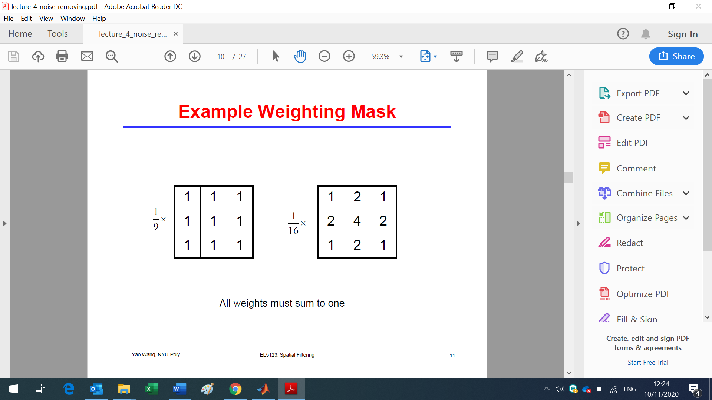

Take the image zebra.jpg. Show the results of filtering in a subplot in according to Figure 1.

Figure 1. Average Filtering

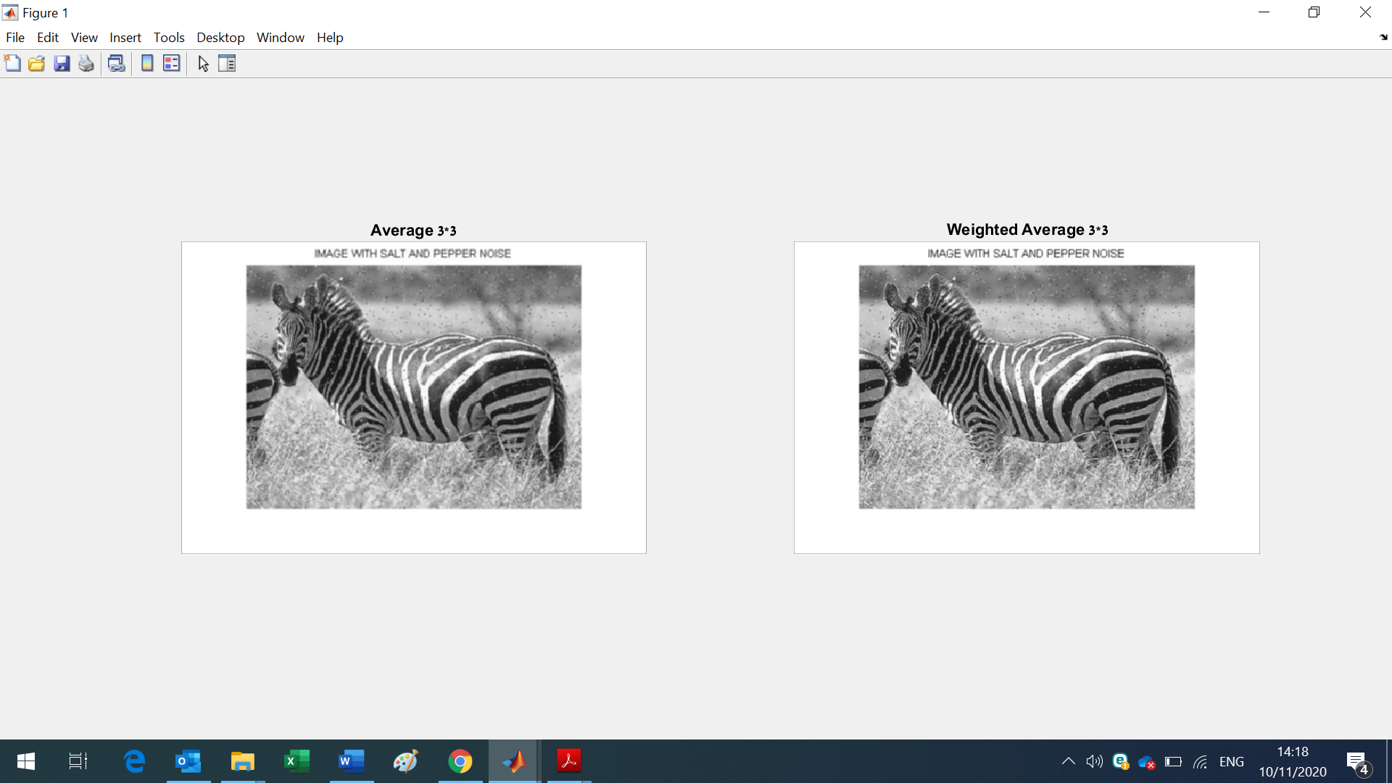

1. Write 2 functions for Median filtering with the methods:

- Median filtering 3*3,

- Median filtering 3*3 - Cross Window,

Take the image plane_noise2.png. Show the results of Median filtering 3*3, Double Median filtering 3*3, Median filtering 3*3 - Cross Window in according to Figure 2.

Figure 2. Median Filtering

