**Format of submission**

Submission contains MATLAB files with necessary code and .docx file with results and explanations which has to be archived in **ZIP FILE** with the following name:

lab<#>_<IDnumber1>_<IDnumber2>, where # is a lab number.

**Lab 7: Morphological Filters**

**Tasks to do:**

Read the file LecMotphology.

**Independent work:**

Write 4 functions for Morphological filters:

Dilation,

Erosion,

Closing and

Opening Filtering.

1. Take the image apple.jpg. R0=imread('Apple.jpg');

Convert the image to binary image R=im2bw(R0); or R=rgb2gray(R0);

R=double(R)./255;

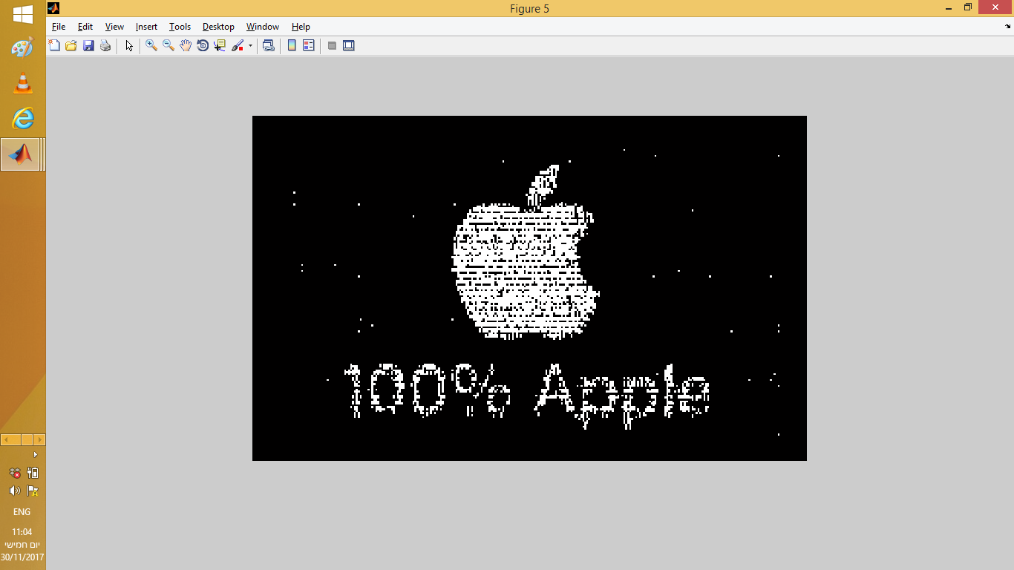

Show the results of each filtering in subplots in accordance with Example1 or Example2

1. Take the image text0.jpg. Convert the image to binary image Show the results of each filtering in subplots in accordance with Example3

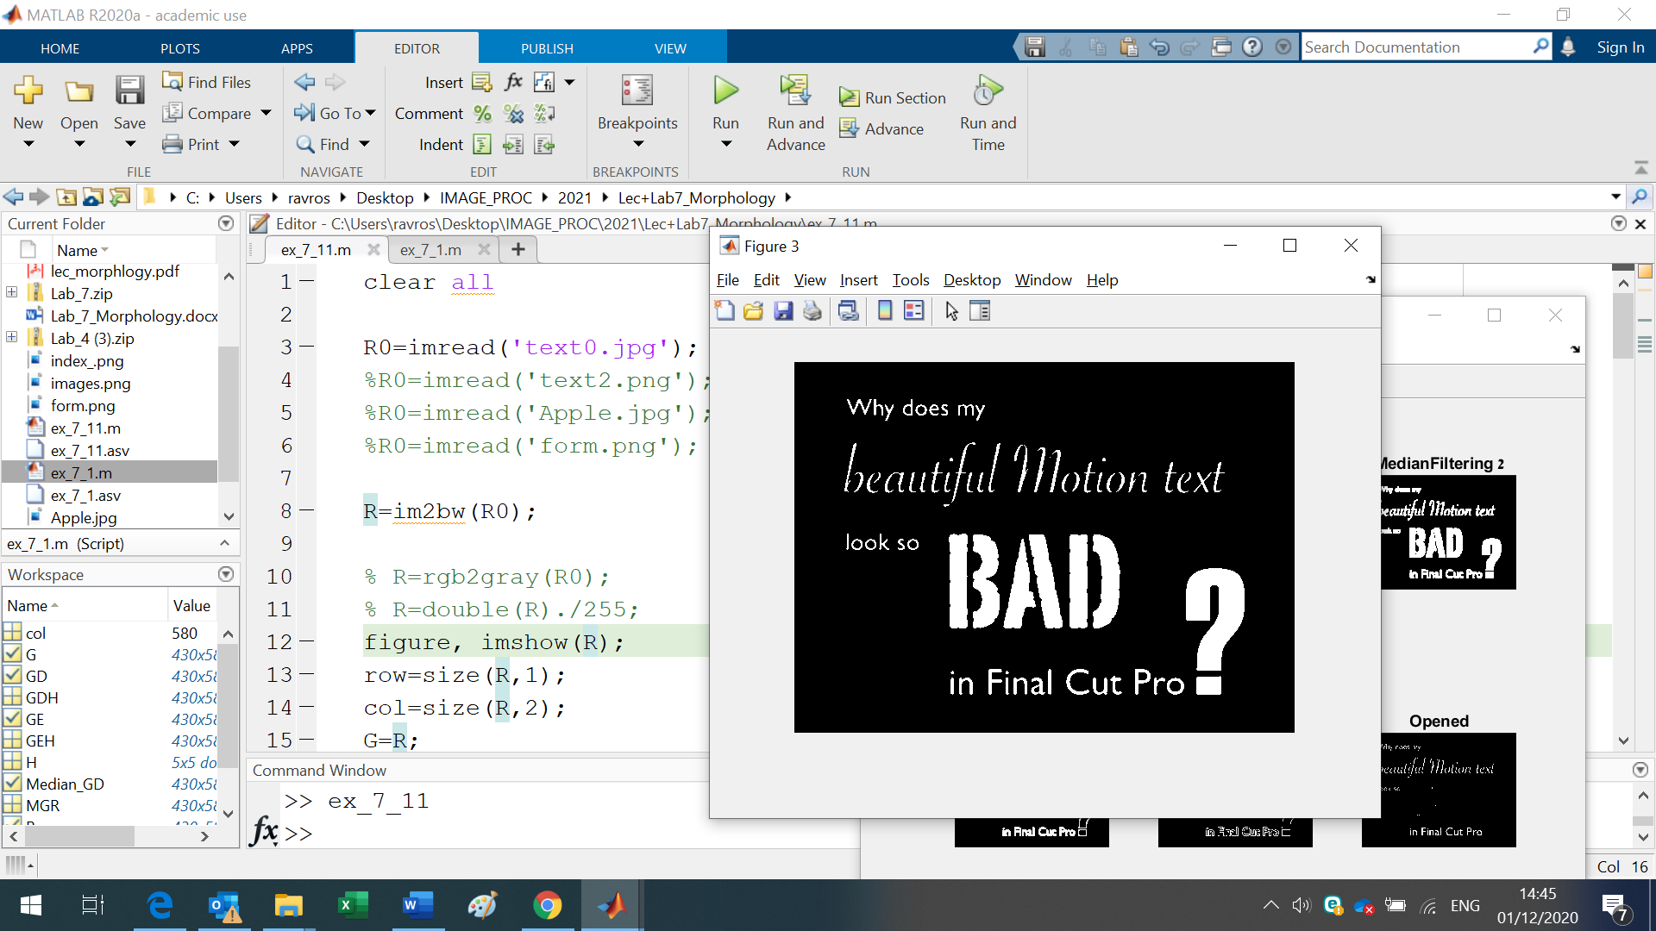

**Example 1**

H=ones(5);

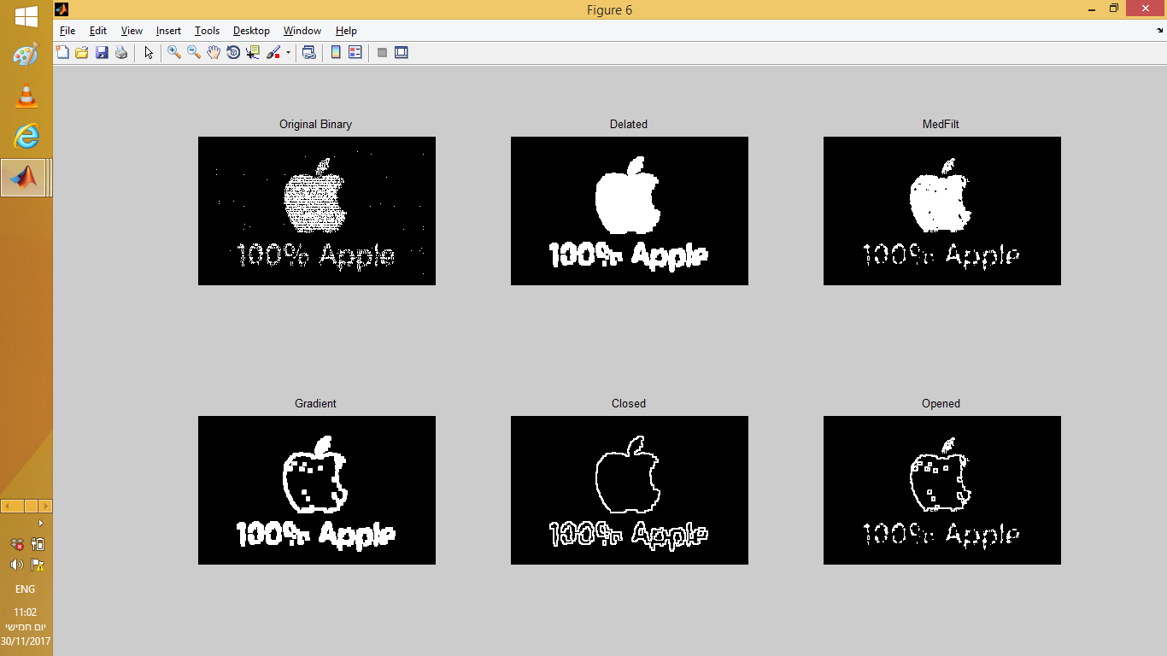

**Example 2**

H=[0 0 1 0 0;0 1 1 1 0; 1 1 1 1 1; 0 1 1 1 0; 0 0 1 0 0 ];

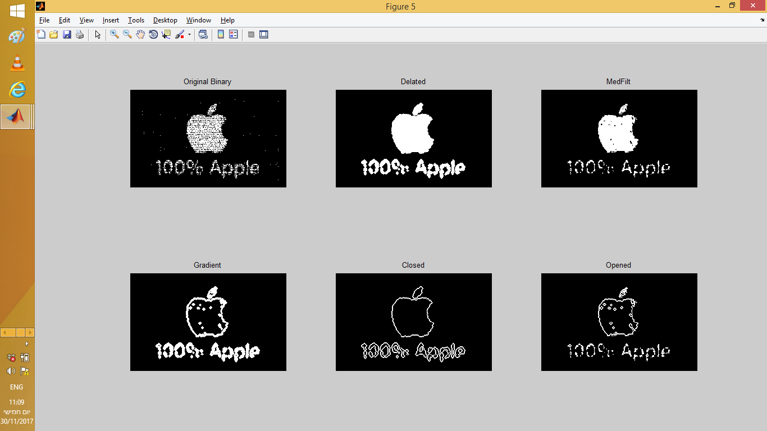

**Example 3**

H=ones(5);

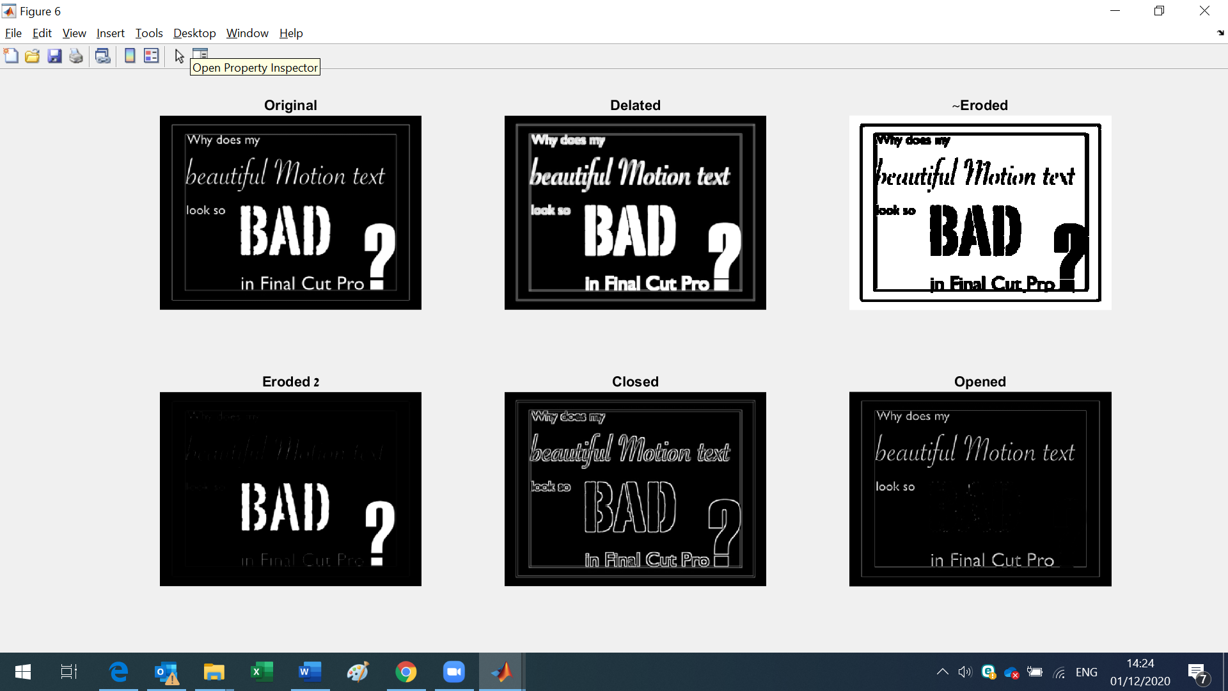

**Example 4**

H=ones(5);

