REPORT

a.

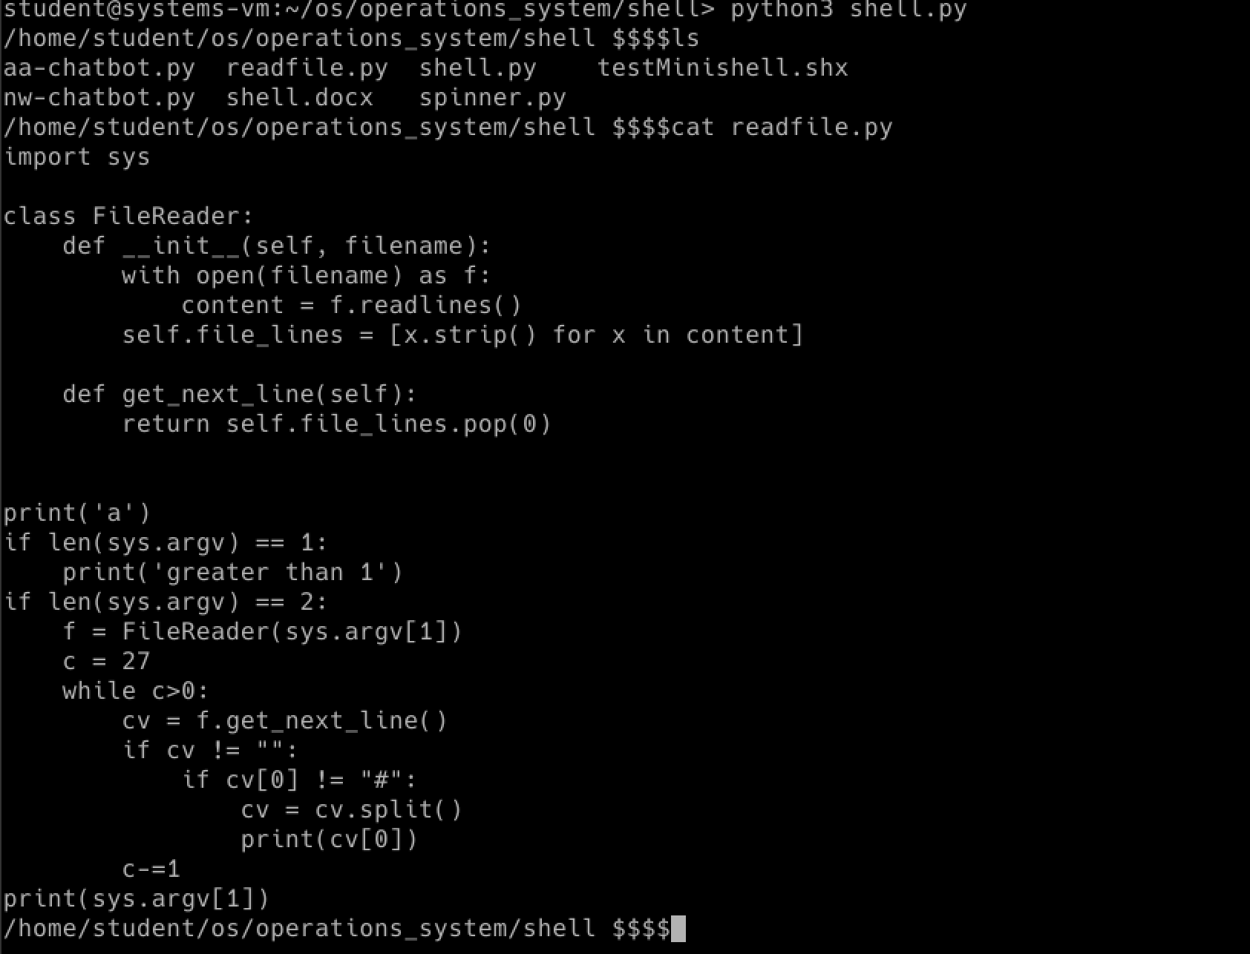

b.

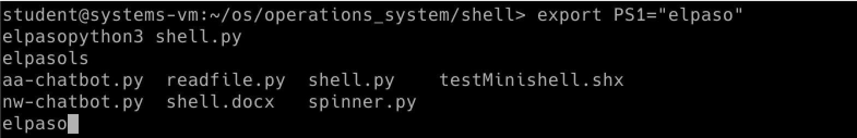c.

d.

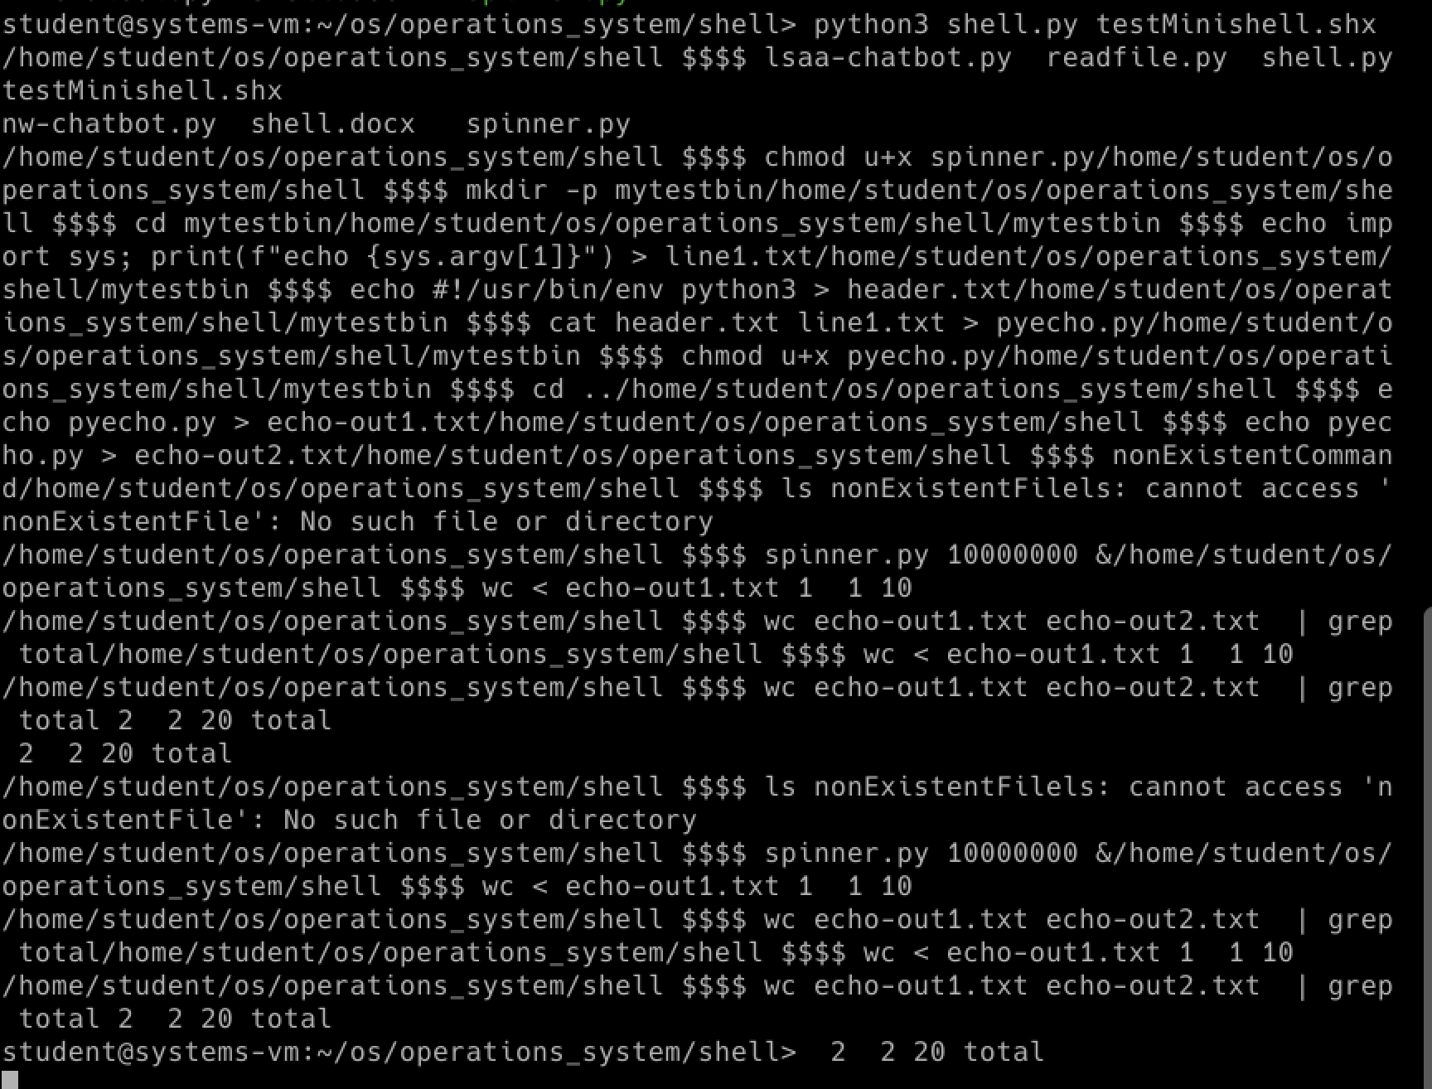

e.

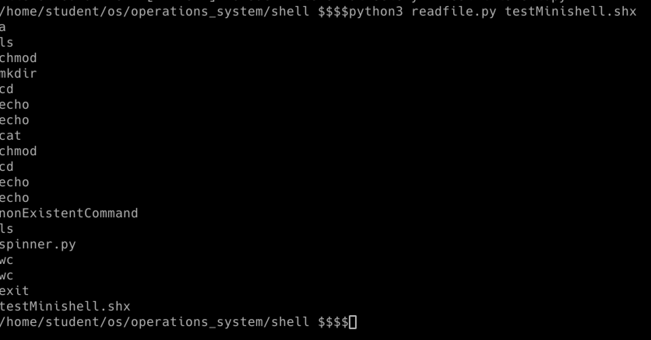f.

g.

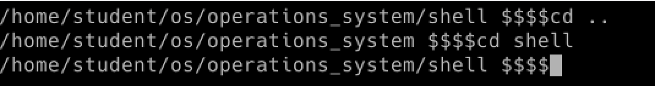i.

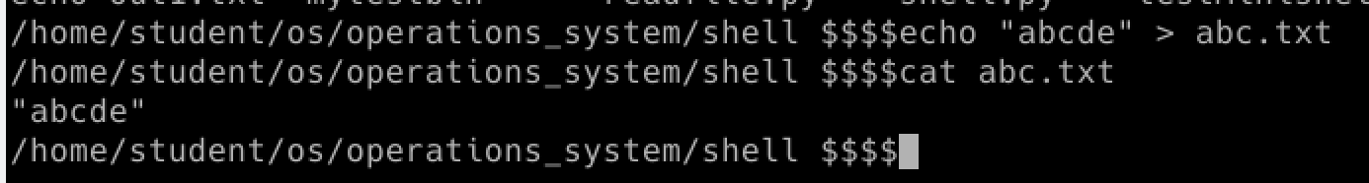j.

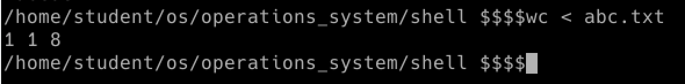

k.

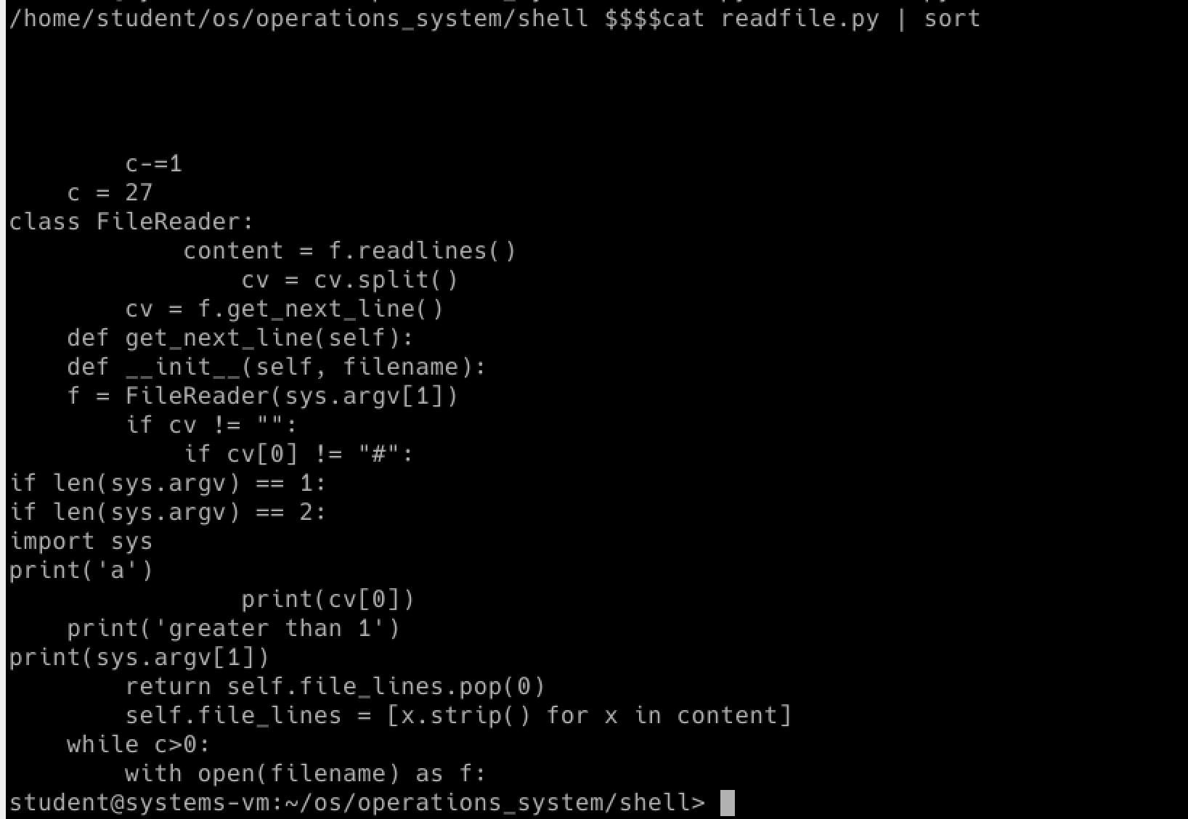l.

This assignment was good introduction to handle input, file descriptor, fork since all of those components are in this lab and give me the chance to learn. First of all, understanding what each command means were difficult such as pipe, redirections and background run(&). Numeorus source and many turorial video to learn from the internet helped me a lot to get in track to proceed to complete this lab. Secondary, it was difficult to do every command manually since it requires what kind of operation is done in ‘os’ such as closing os.close(1). It was required to know what file descriptor is being used or should be closed in order to run correctly and know the order of calls that is needed.