CS 4375

Professor Ward

**Shell Assignment**

Purposes: Gain experience weaving system calls into a functional program; learn to manipulate the properties of processes.

Goal: Build a user shell for a Unix operating system.

Functionality

1. Read a unix command from the user, execute it, and repeat. Handle at least the basic commands (**ls**, **cat**, **grep**, etc., typically found in **/usr/bin**), with all their normal parameters. [5 points]
2. Terminate if the input is **exit**. [1 point]
3. Before reading each line, print the prompt string specified by shell variable PS1, but if PS1 is not set, use the default prompt of **$$$$**. [1 pt]
4. Support background tasks, that is, tasks which run without requiring the user to wait before the next command, specified with **&**. [3 pts]
5. Accept commands from a file if one is specified; ignore lines starting with **#** [1 pt]
6. Also run commands that name a program anywhere in the path. [3 points]
7. If a command is not found, print an error message. [1 point]
8. If a command fails (with a non-zero exit value *n*), print "Program terminated: exit code *n*." [1 pt]
9. Change directories with the **cd** command. [1 pt]
10. Support redirection of output with **>** . [2 pts]
11. Support redirection of input with **<** . [1 pt]
12. Support simple pipes with **|** . [4 pts]

Grading: 30 points possible, including 6 points for general code quality and report quality.

Aim for 25 if you want an A, 20 for a B, and 15 for a C.

Hints

1. For the basic loop, you can borrow from someone’s chatbot code.
2. For each command, create a child process that uses **execve** to run it with its parameters.
3. You already know enough for a~c; the other topics will be covered soon.
4. Borrow code from Dr. Freudenthal’s demos in **https://github.com/robustUTEP/os-shell**
5. Read [**http://www.rozmichelle.com/pipes-forks-dups/**](http://www.rozmichelle.com/pipes-forks-dups/)

Constraints:

Use only the following python libraries:

* os
* sys
* re

From os, use only:

* pipe()
* fork()
* dup() or dup2()
* execve()
* wait()
* open() or create() and close()
* read() and write()
* chdir()

In particular, do not use system(), execvp(), or execvpe(). If you think you need to use another system call, consult with the instructor or TA.

Submit

1. a report including
   1. snapshots showing that your system works from the console: (function a ~ d)
   2. output showing that your system works in batch mode (function e)
   3. evidence that your system handles functions e ~ l. We will later provide test code to help you do this.
   4. a paragraph or two describing any interesting features of your system, and/or discussing where you had trouble and what you learned.
2. your code, as a py file that we can download and run

Due February 9

REPORT

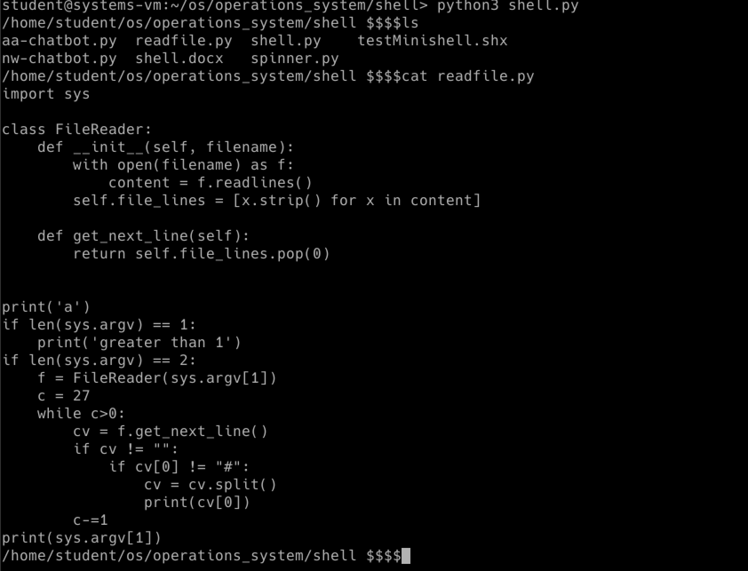a.

b.

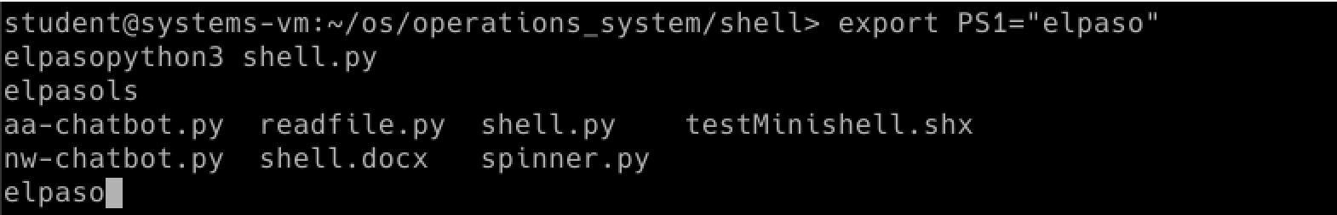c.

d.

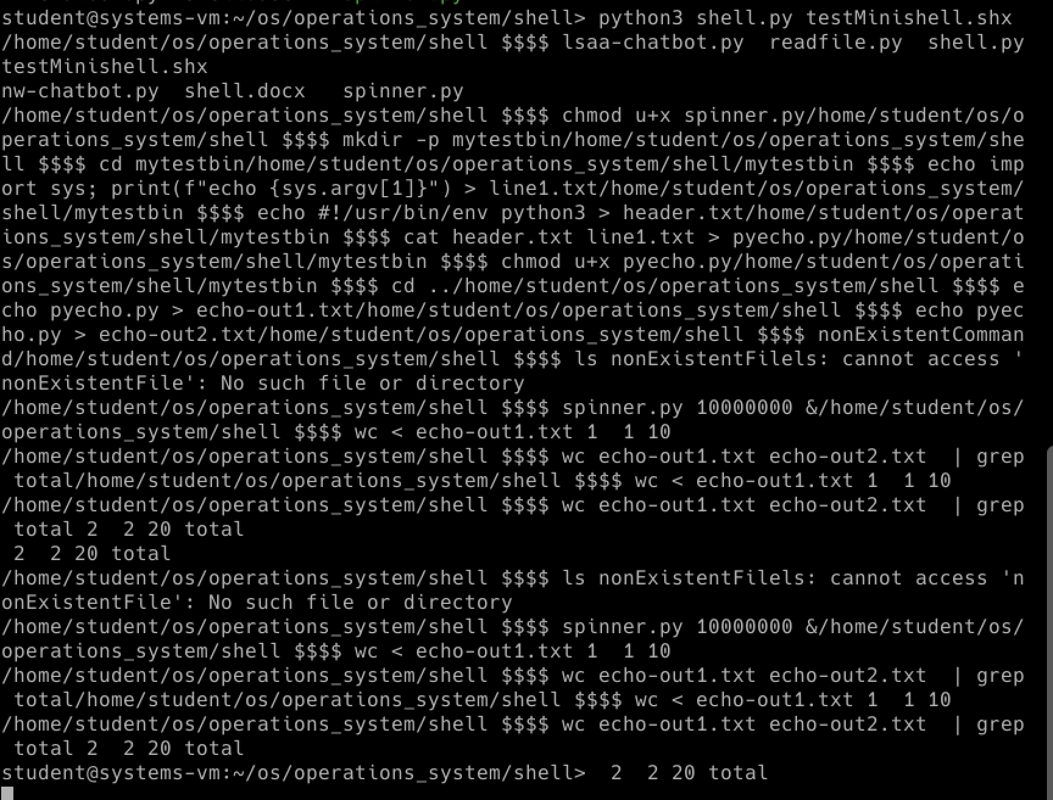

e.

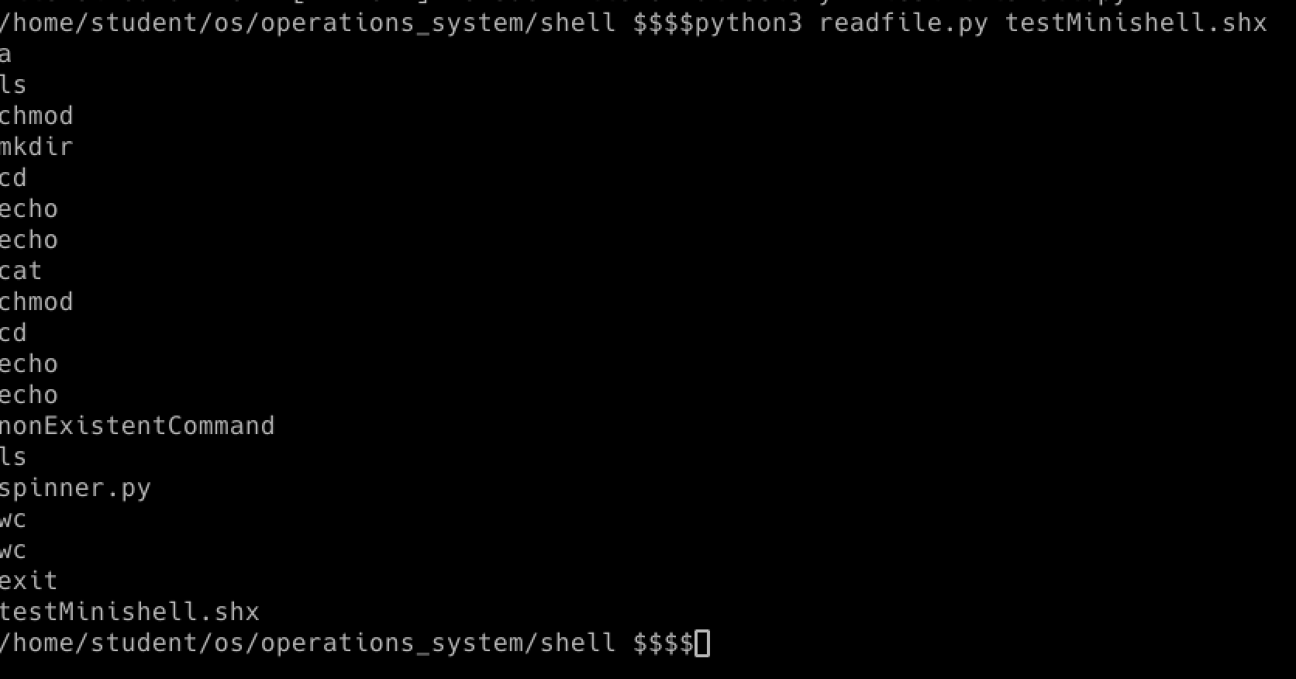f.

g.

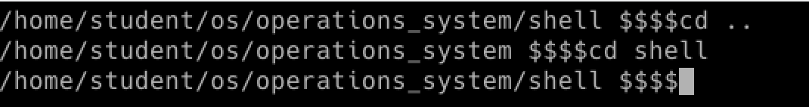i.

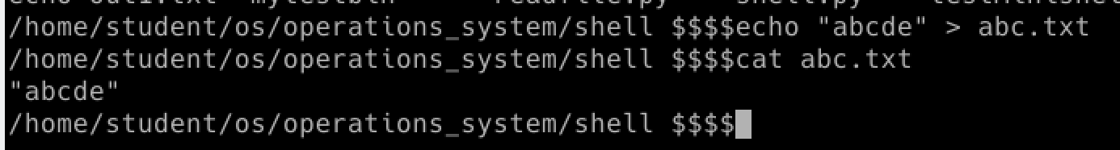j.

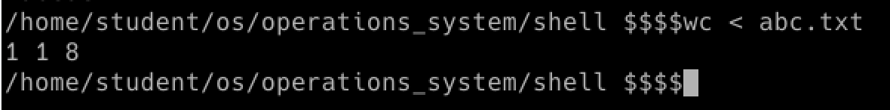

k.

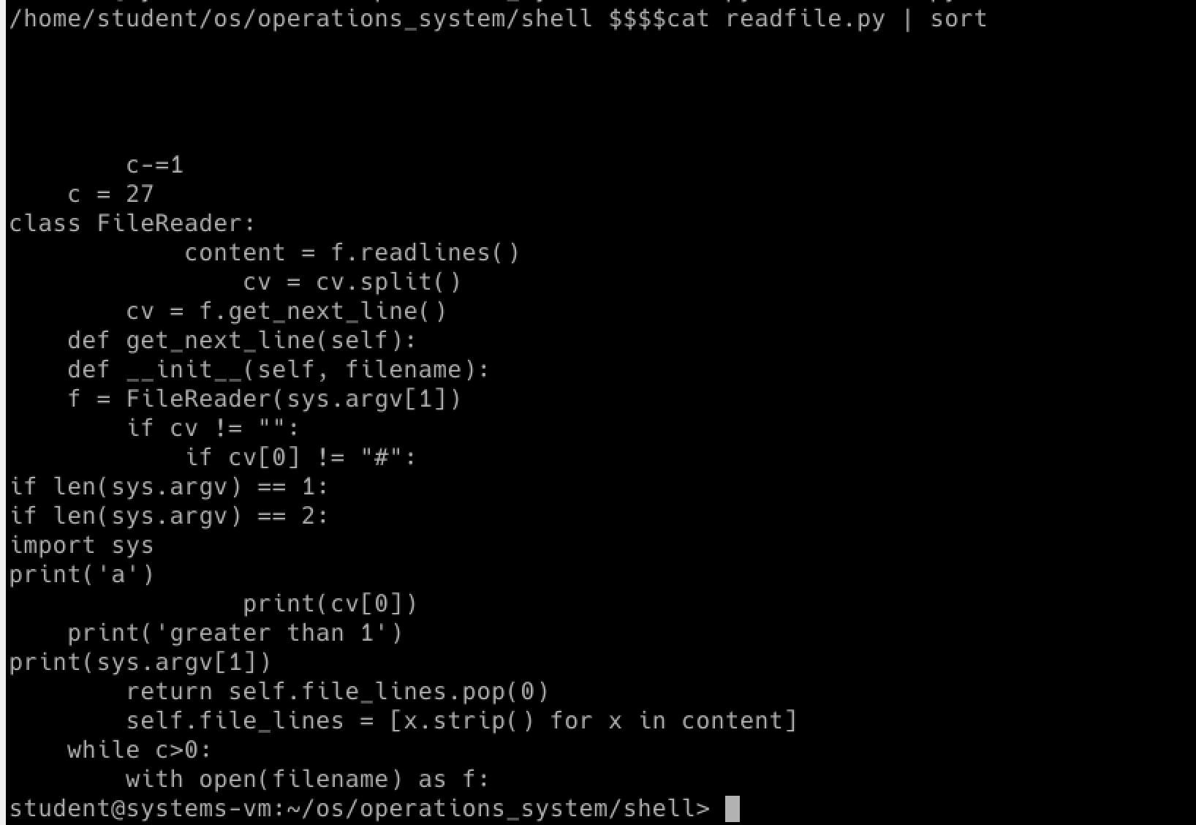l.

This assignment was good introduction to handle input, file descriptor, fork since all of those components are in this lab and give me the chance to learn. First of all, understanding what each command means were difficult such as pipe, redirections and background run(&). Numeorus source and many turorial video to learn from the internet helped me a lot to get in track to proceed to complete this lab. Secondary, it was difficult to do every command manually since it requires what kind of operation is done in ‘os’ such as closing os.close(1). It was required to know what file descriptor is being used or should be closed in order to run correctly and know the order of calls that is needed.