Text and Visual Annotation Tools for Scalable Design Feedback Generation

| 1st Author Name  Affiliation  City, Country  e-mail address | 2nd Author Name  Affiliation  City, Country  e-mail address | 3rd Author Name  Affiliation  City, Country  e-mail address |
| --- | --- | --- |

# ABSTRACT

Paste the appropriate copyright/license statement here. ACM now supports three different publication options:

* ACM copyright: ACM holds the copyright on the work. This is the historical approach.
* License: The author(s) retain copyright, but ACM receives an exclusive publication license.
* Open Access: The author(s) wish to pay for the work to be open access. The additional fee must be paid to ACM.

This text field is large enough to hold the appropriate release statement assuming it is single-spaced in Times New Roman 8-point font. Please do not change or modify the size of this text box.

Each submission will be assigned a DOI string to be included here.

Designers have access to a number of tools for soliciting feedback online. Yet there is little empirical evidence that could guide a designer’s decision for selecting one tool over another. We conducted an online study where 360 participants provided feedback using two classes of feedback interface, spatial and non-spatial. For each interface, we also manipulate access to history feedback. Our results show that presence of a history introduces a fixation effect where providers enter feedback that is more similar to history they reviewed. Providers in the non-spatial condition entered feedback that was 24% longer than the spatial condition. Spatial condition providers left more *investigation* feedback. There was no difference in specificity between conditions. Results suggest that the more important choice designers must make is not the class of tool they use but whether history feedback is included.

## Author Keywords

Crowdsourcing; design; feedback; creativity.

## ACM Classification Keywords

H.5.3 [Information Interface and Presentation]: Group and Organization Interfaces – Collaborative computing.

# INTRODUCTION

Collecting and addressing feedback are vital steps in the iterative design process. Generated insights help designers iterate towards solutions that better connect with the target audience [1]. Soliciting design feedback online offers several advantages over alternatives due to enhanced scalability, availability, and affordability [2, 3]. Designers must choose from many different tools to solicit feedback online. One way of organizing these tools into classes is by the type of interface they offer to the feedback provider.

A spatial interface is one where the feedback provider must first visually mark a location on the design before entering feedback. Examples of this class of tool are Adobe Acrobat and Redpen.io [4]. Asking a feedback provider to spatially mark the design requires them to visually search the design and focus their attention on specific details [3, 5]. But it is possible that spatially annotating the design might encourage a certain type of feedback over another.

Another class of these tools uses a text-centric open ended interface. These non-spatial interfaces feature a prominent text area in which the provider enters feedback. Reddit and Dribble are examples of this class of tool [6, 7]. These tools may elicit more high-level feedback because the provider leaves a comment referencing the design as a whole.

Our work will compare these two classes of feedback interface. This is an important comparison because prior work has found that even small differences in the interface can significantly alter the provider’s behavior. It has been shown that splitting design feedback task into multiple shorter tasks elicits more diverse feedback [8]. Researchers have employed techniques such as scaffolding resulting in enhanced quality of collected feedback [9, 10].

Another consideration is whether to use a tool that reveals history feedback. Displaying previous feedback to a provider may enhance creativity and encourage novel ideas [11-13]. But it may also reduce feedback diversity by introducing a fixation effect [14, 15]. However, fixation effects have only been studied in the context of design examples. Our work will study the possibility of this effect for writing design feedback.

There is little empirical evidence that could guide a designer’s decision in selecting a feedback tool. In this paper, we present four interfaces for soliciting design feedback. Interface conditions reflect two classes of popular real-world feedback collection tools. We also manipulate the presence of history for each of the two interfaces. We study characteristics of collected feedback in each condition.

We recruited participants (N=360) to provide feedback on three categories of designs across all conditions. Participants reviewed the goals and design image. They then left feedback in the assigned condition. If present, providers had the opportunity to review the history. After entering feedback, they completed a self-assessment survey.

For the feedback, we measured length, similarity to reviewed feedback, specificity, and analyzed the frequencies of specific categories of feedback. We also measured task completion time and analyzed effort and usefulness self-assessment scores.

Our main findings were that presence of history introduces a fixation effect. Feedback generated in the non-spatial interface was longer and had more stop words. There was no difference in feedback specificity between conditions. We also found that classes of interface produce different categories of feedback. For example, providers in the spatial interface left more *investigation* feedback. Our results show that the decision to use a spatial or non-spatial would be tied to whether the designer wants longer feedback or more *investigation* feedback. The more important decision is whether one would choose a tool which includes history in either of these interfaces as our results show it introduces a fixation effect. This fixation effect could lead to less diverse content, yet diversity of perspective is one of the reasons designers would choose to use an online feedback tool. We believe our results will contribute to helping designers know how choice of tool influences the received feedback.

# Related work

We build on two main areas of related work: feedback collection tools, and studies of crowd feedback systems.

## Feedback Collection Tools

There are at least four classes of online tools for collecting design feedback and conducting peer review. One class is spatial annotation tools. In these tools, a feedback provider must first select a region of the design to enter feedback. Adobe Acrobat and Redpen.io implement this class of tool [4, 16]. One advantage of these tools is that requiring feedback providers to visually search for and mark features can focus their attention on those details [17]. But it may also introduce a fixation effect, introducing an inability to see new ways of problem solving [14].

Another class is non-spatial. With the non-spatial tool, feedback providers can see an image of the design and can enter their feedback into a textbox. Reddit and Dribble implement this class of tool [6, 7]. These tools may encourage the feedback provider to generate longer feedback and more conceptual feedback because they don’t have to attach their comment to a specific element in the design. But this less actively engaging interface paradigm could reduce the diversity of generated feedback [8].

A third class of tool for the more general class of peer review is multi-modal. These tools track pen hovering movements in tandem with voice and digitizer writing. An implementation of this tool is RichReview++ [18]. Students preferred using a multi-modal interface to meeting in person. But the linear and irreversible nature of voice makes the commenting task more stressful since students had to think and speak at the same time.

A fourth class is visual. In a visual tool, providers use an image browser to compile their feedback. Moodsource is an example of a visual tool for collecting design feedback [19]. These tools are especially useful for communicating first impressions. But limiting providers to using images may make him unable to convey their ideas.

Our work targeted two classes that are widely utilized for giving design feedback in an online context, spatial and non-spatial. In addition, we also studied these two classes of tools with the presence of history. Redpen.io and Reddit are examples of tools that display history feedback to providers. Showing history feedback could increase provider creativity [11, 13]. But it could also introduce a fixation effect [14].

There has been little prior work on how different classes of feedback collection tool or how the presence of history influences generated feedback. Our work addresses this gap.

## Studies of Crowd Feedback Systems

A number of studies have been conducted studying the benefit of crowd feedback in the design process. The use of crowd feedback systems has been shown to lead to improvements in designs [2]. In Voyant, the authors explored a bi-directional interaction technique which linked overviews of feedback content and annotations on the design [3]. Designers could choose to receive up to five types of feedback. The system would then create sub-tasks to fulfill the request and submit them to an online labor market. Individual task outcomes were aggregated and presented to the user.

CrowdCrit explored showing the distribution of responses from the feedback providers in order to reveal the highest priority issues [9]. Scaffolding was employed to facilitate high-quality crowd critique. Crowd workers selected from a series of seventy pre-authored critique statements. Designers generally found the feedback helpful.

Critiki introduced a system that simplified the process of creating, distributing, and aggregating crowdsourced design critique for crowdfunding pages [10]. Scaffolding was used to guide crowd workers through the steps of an effective critique. The system also provided examples of high-quality critiquing points to assist them in composing useful critique.

Our work differs by comparing two classes of user interfaces for the feedback provider.

**METHODOLOGY**

Our study compared how two classes of Feedback Interface (spatial and non-spatial) and History (absent or present) influence generated feedback. We seek to answer the following questions concerning these aspects of the interface: whether they cause the provided feedback to be more specific or more general, if they influence the likelihood of generating a certain category of feedback, and if the presence of history introduces a fixation effect.

These questions are not exhaustive but are intended to give designers a better sense as to how their choice of feedback collection tool will influence feedback received online. The results may also create awareness among system developers as to how their implementation choices influence the feedback exchange.

## Experimental Design

To answer these questions, we conducted a full-factorial, between-subjects experiment. The factors were Interface (Non-spatial vs. spatial) x History (Absent vs. Present) x Design Category (Poster vs. Webpage vs. Web Interface), giving a 2x2x3 design.

## Participants

Feedback providers (N=360) were recruited from Mechanical Turk. To participate, providers were required to have successfully completed at least 50 tasks and to have a task approval rate greater than 95%. **Insert demographic** **data here**. Based upon a pilot study, they payment was set at $0.50 per task to reflect current US minimum wage.

## Designs

We chose three designs, selected to span a broad range of visual domains, to be familiar to a general audience, and to warrant design improvements. The selected designs included a poster advertising a university dance event, the home page of a community college (<http://parkland.edu>), and a web-based payment application (<https://venmo.com/>). Explicit permission from the creator of the first design was obtained and the two remaining designs were public domain.

## Feedback Interfaces

The feedback interface features a block of text introducing the task and includes a brief description of the design and its target audience. The design is then prominently displayed.

Figure 1 introduces the non-spatial Interface. In this interface, a text area prompting the provider for feedback was below the design image. A submit button was placed next to the text area to complete the task. In the presence of the history, past feedback was displayed underneath this form. Rather than pre-generating history, we mimicked real world systems by allowing the history to grow organically from feedback submitted by previous providers.

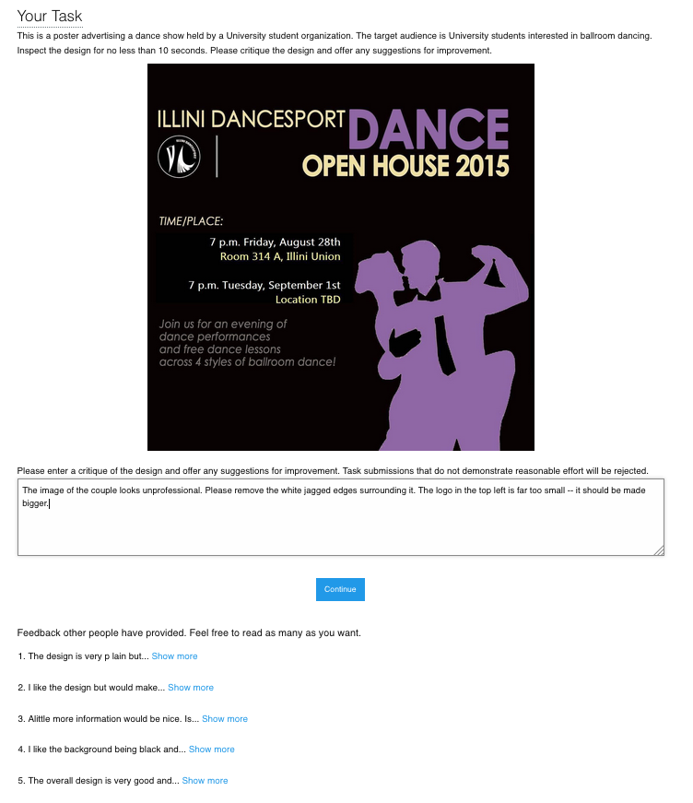

**Figure 1. The interface for leaving feedback in the non-spatial condition. A feedback provider enters their feedback in a text area. In the history condition, feedbacks left by previous providers were visible. The participant may choose to view the full feedback by selecting ‘Show more.’**



**Figure 2. The interface for leaving feedback in the spatial condition. A Provider can leave a comment by selecting a region on the design and entering text in a window. They could leave as many comments desired and were allowed to look at the history by hovering existing markers.**

The presentation of the history was based on how online platforms such as Reddit or Dribble function, where the provider has access to an evolving history [6, 7]. We adapted this format however to include a “Show more” interaction which allowed us to log which pieces of feedback were viewed.

Figure 2 introduces the spatial Interface. Here, the feedback provider first selects a location on the design and is then prompted to enter feedback in the window that appears. The feedback is committed by pressing elsewhere on the image. A visual marker representing the feedback is then overlaid on the design to represent the feedback left at the location. The provider could leave as many pieces of feedback as desired, inspect the feedback they had left by hovering over the associated visual marker, and could always edit their own feedback by clicking a marker. In the presence of the History, the pieces of feedback left by previous providers were shown. The participant was allowed to hover over any visual markers to reveal the annotated feedback. Otherwise, the interface operated the same as the History absent condition. The spatial condition was designed and implemented to reflect popular annotation feedback tools such as Adobe Acrobat and Red Pen [4, 16]. Once satisfied with the feedback, the provider submitted their work.

## Procedure

Upon accepting the task, the feedback provider was presented with a consent form. If accepted, they were randomly assigned to one of 12 experimental conditions. The experimental conditions were implemented in JavaScript and the feedback provider did not have to leave the Mechanical Turk platform. In each condition, they read the task instructions, viewed the design, and entered feedback based on the interface condition assigned. After entering feedback in the interface provided, they submitted their work and completed a brief survey.

## Measures

The study consisted of three sets of measures: content analysis, behavioral measures, and self-assessment.

*Content analysis*

For content analysis, we calculated specificity, categorized the feedback content, and measured general metrics such as its length.

A measure of specificity was calculated for each feedback response. Specificity was measured using the NLTK toolkit. The toolkit calculated specificity by determining how deep each word appears in the Wordnet structure. Words closer to the root are more general (e.g. “dog”) while deeper words are more specific (e.g. “Labrador”). In calculating sentence specificity, stop words and punctuation were ignored. The specificity metric was normalized to range from 0.0 to 1.0. In the past, other researchers have used this technique [20].

To categorize the feedback content, each feedback response was partitioned into individual idea units. An idea unit represents a coherent unit of thought. The idea units were then coded based upon a taxonomy of critique discourse [21]. For example, the taxonomy included categories for judgement (*“I like that sketch but not that design. I don’t like this up here because it looks paperish—you know, not ceramic.”*) and interpretation (*“There’s a whole mysterious quality. There’s a shadow and a mystery, and you wonder, what’s going on in there?”*).

Two coders with experience in HCI categorized each idea unit according to the taxonomy. In total, 1206 idea units were categorized. Cohen’s Kappa, a measure of reliability between multiple raters, was 0.81 on 80 training samples (5% of the dataset). Coders were paid $25 for their effort.

Additionally, we measured feedback text length by cumulative character length of all feedback from a single provider.

*Behavioral measures*

For behavioral measures, we calculated the similarity between generated feedback and history feedback and computed general behavioral metrics. A provider’s interactions with prior feedback were logged. For the spatial condition, we logged each time the provider revealed a previous feedback by hovering over a visual marker. Likewise, in the non-spatial condition, we logged each time the provider selected a ‘Show more’ link.

Next, for each provider, we aggregated the set of prior feedback that they viewed. For each comment that a provider left, we aggregated the set of feedback they had viewed up to that point. We computed the distances between the recent comment and history feedback using the cosine similarity similarity metric as implemented in the Python pattern.en toolkit.

|  |  |  |  |  |  |  |  |  |  |  |  |  |  |  |  |  |  |  |  |  |  |  |  |  |  |  |  |  |  |  |  |  |  |  |  |  |  |  |  |  |  |  |  |  |  |  |  |  |  |  |  |  |  |  |  |  |  |  |  |  |  |  |  |  |  |  |  |  |  |  |  |  |  |  |  |  |  |  |
| --- | --- | --- | --- | --- | --- | --- | --- | --- | --- | --- | --- | --- | --- | --- | --- | --- | --- | --- | --- | --- | --- | --- | --- | --- | --- | --- | --- | --- | --- | --- | --- | --- | --- | --- | --- | --- | --- | --- | --- | --- | --- | --- | --- | --- | --- | --- | --- | --- | --- | --- | --- | --- | --- | --- | --- | --- | --- | --- | --- | --- | --- | --- | --- | --- | --- | --- | --- | --- | --- | --- | --- | --- | --- | --- | --- | --- | --- | --- |
| |  |  |  |  |  |  | | --- | --- | --- | --- | --- | --- | |  | **Condition** | | | |  | |  | **Non-spatial** | | **Spatial** | |  | | **Category** | **No History** | **History** | **No-History** | **History** | **Total** | | Judgement | 47.2% (151) | 53.8% (164) | 44.9% (151) | 44.1% (154) | 620 | | Recommendation | 39.4% (126) | 32.1% (98) | 29.5% (99) | 36.1% (126) | 449 | | Investigation | 1.2% (4) | 1.0% (3) | 4.5% (15) | 3.2 % (11) | 33 | | Interpretation | 2.8% (9) | 0.7% (2) | 2.1% (7) | 1.7% (6) | 24 | | Brainstorming | 4.7% (15) | 6.9% (21) | 10.4% (35) | 5.2% (18) | 89 | | Process | 0.3% (1) | 0.0% (0) | 0.0% (0) | 0.0% (0) | 1 | | Comparison | 0.9% (3) | 1.0% (3) | 1.5% (4) | 2.0% (7) | 17 | | Identity Invoking | 0.0% (0) | 0.0% (0) | 0.0% (0) | 0.0% (0) | 0 | | Association | 1.9% (6) | 1.6% (5) | 0.0% (0) | 1.4% (5) | 16 | | **Total Idea Units** | **315** | **296** | **311** | **327** | **1249** |   **Table 1. Frequencies of the categories of idea units by Interface and History** |

We also measured behavioral metrics such as task completion time, number of prior feedback responses revealed, and number of feedbacks provided. These measures help us understand how different interface conditions affected the behavior of feedback providers.

*Self-assessment*

Following the feedback task, the provider completed a self-assessment survey. Providers rated their design expertise, perceived effort, and perceived usefulness of the feedback given on a five point Likert-scale, with a score of 5 as the most favorable. The survey also included two questions for demographics (age and gender).

# Results

In total, 30 responses were collected per experimental condition for a total of 360 responses. We reviewed all the submissions and excluded any that were irrelevant or incomprehensible. 3 submissions were excluded, leaving us with 357 feedback responses of reasonable quality.

**Content Analysis**

*Non-spatial condition produced longer feedback*

An ANOVA revealed that Interface had a main effect on feedback length (F(3,357)=7.86; *p*=0.0053). Character count per condition can be seen in Figure 2. Pairwise comparison using Tukey’s HSD showed that the length of the feedback in the non-spatial condition (*μ*=269.7 characters) was longer than the feedback from the spatial condition (*μ*=217.4; *p*=0.0051). No other effects were discovered.

The non-spatial condition may have led to longer feedback due to the need for use of deixis, i.e. words or phrases such as “here” or “there” that require further contextual information to be understood but eliminate the need for explicit description of the visual elements referenced by feedback.

*Conditions produce different categories of feedback*

After categorizing the idea units from generated feedback, we performed z-tests for population proportions to look for patterns of interest.

Table 1 shows the breakdown of idea unit categories per condition. We found that the spatial Interface generated more *investigations* (4.1%) than the non-spatial Interface (1.1%; *z*=3.23; *p*=0.001). An *investigation* is when a feedback provider asked questions about a specific piece of the design. Requiring the feedback provider to select a location on the design before entering feedback may cause them to visually scan the elements in the design before performing feedback entry.

No other significant results were discovered.

*Non-spatial feedback had more stop words*

An ANOVA did not detect a main effect of Interface or History on feedback specificity. In the spatial condition, mean specificity was 0.34 (*σ* = 0.17), while the non-spatial condition had a mean specificity of 0.37 (*σ* = 0.14).

An ANOVA uncovered a main effect of Interface on stop word count (F(3,357)=6.93; *p*=0.0089). Figure 1 summarizes stop word count. Tukey’s HSD showed that stop word count in the non-spatial condition (*μ*=27.31) was greater than the spatial condition (*μ*=21.98; *p*=0.0084).

One explanation for this is that the context provided by the spatial condition reduced the need for language necessary to convey the same information in the non-spatial condition. In the non-spatial condition, stop words were used to reference specific elements of the design: *“The logo must come at top before title and it must be large. The sentence written at the bottom should be brightened… There should be a name and contact details of a person to contact.”* Providers neglected these words in the spatial condition: *“Unappealing shade of purple. Perhaps more distinctness between the two silhouettes – looks kind of blobby right now. Maybe use bullet points.”*

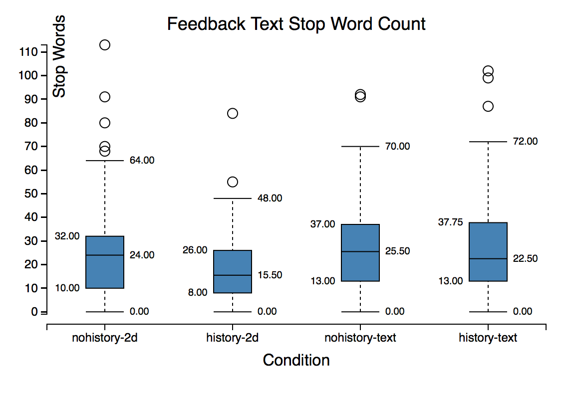

**Figure 1. This chart shows how the experimental condition affected stop word count of the feedback content. Analysis show providers included more stop words in their feedback in the non-spatial condition.**

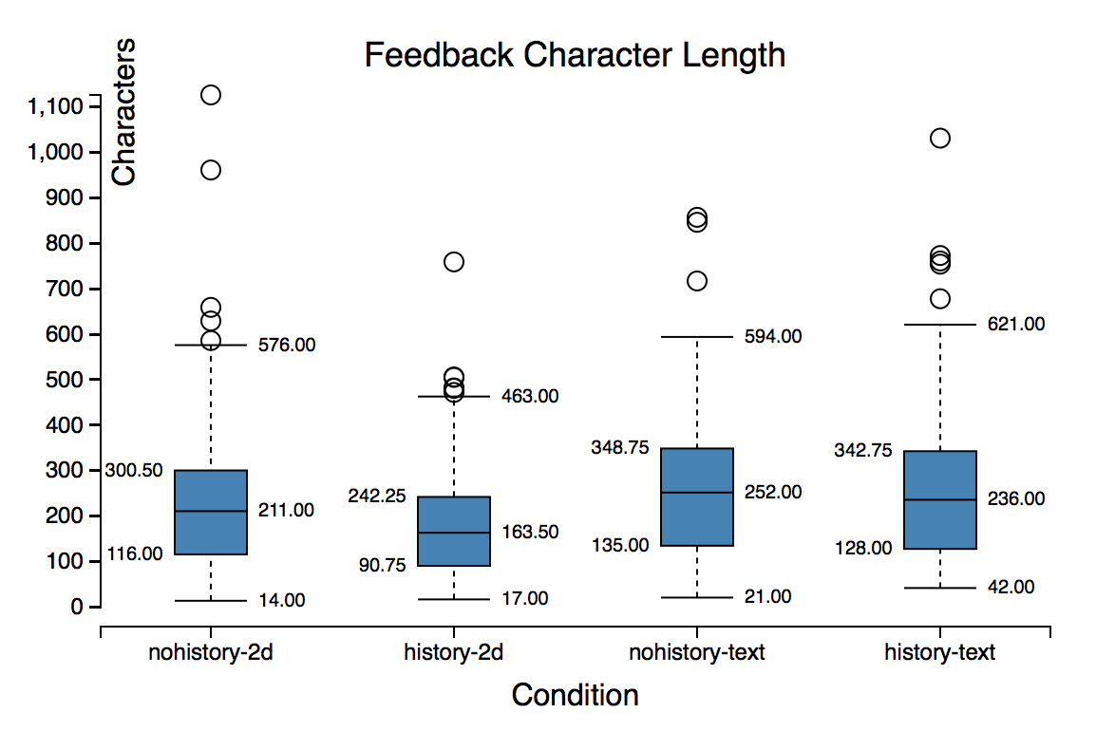

**Figure 2. The effect of experimental condition on length of feedback content is shown in this chart. Analysis shows providers left longer feedback in the non-spatial condition. No other effects were found.**

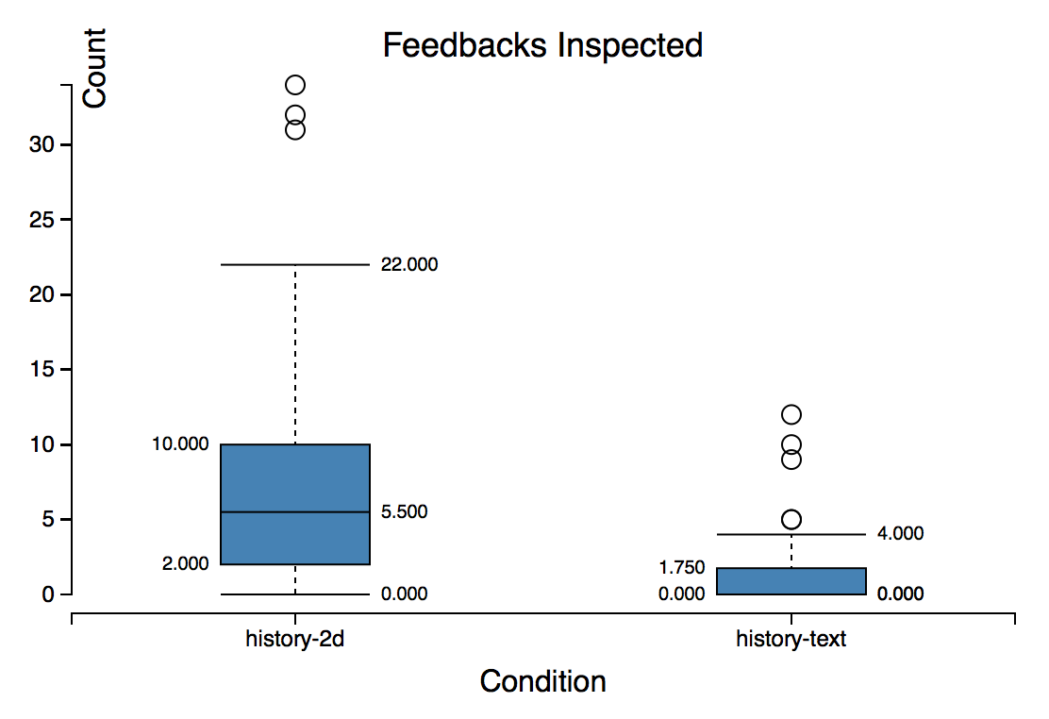

**Figure 3. This chart shows the count of instances of History condition feedbacks inspected by Interface. Analysis shows providers inspected more feedback instances under the visual condition.**

**Behavioral Measures**

*Providers inspect more feedback in spatial Interface*

When History was presented in the spatial Interface, we found 55% of providers (99 providers) inspected history feedback. When History was presented in the non-spatial Interface, we found 19% of providers (33 providers) inspected history feedback. The number of instances of feedback inspected by providers is visualized in Figure 3. An ANOVA revealed a main effect of Interface on instances of feedback inspected (F(3, 180)=60.57; *p*=0.0001). Tukey’s HSD showed that spatial Interface providers inspected more feedback instances (*μ*=7.29) than the non-spatial condition (*μ*=1.14, *p*=0.0001).

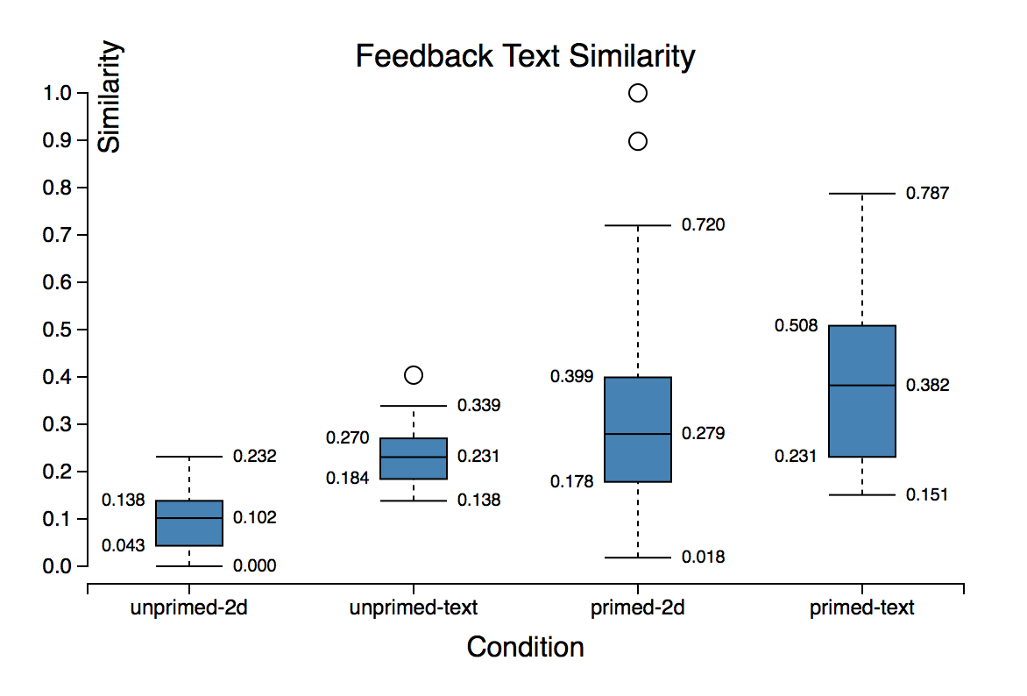

**Figure 4. Similarity scores of generated feedbacks compared to viewed and unviewed history by condition. Generated feedback was more similar to viewed history.**

One explanation for this effect is the cost of access of history feedback in the non-spatial Interface relative to the spatial condition. Providers in the spatial Interface didn’t have to scroll and didn’t have to click a ‘Show more’ link to unveil history feedback.

*Generated feedback was more similar to viewed history*

We only considered instances of generated feedback where the provider had examined the history. This left us with 200 instances of feedback in the spatial condition and 42 instances of feedback in the non-spatial condition. Figure 4 displays feedback similarity scores.

An ANOVA showed that when a provider generated feedback, the feedback was more similar to the history that the provider looked at (*μ*=0.11) than it was to the history that the provider did not look at (*μ*=0.044; F(3,232)=26.59; *p*=0.0001). Tukey’s HSD deemed this difference significant (*p*=0.0001).

This suggests that presence of a History introduces a fixation effect for the feedback providers. This effect is analogous to how pictorial representations of examples introduce a fixation effect when solving design problems [14].

*Non-spatial feedback was more similar to viewed history*

An additional main effect revealed by ANOVA was the influence of Interface on similarity to viewed history (F(3,230)=12.88; *p*=0.0004). Tukey’s HSD showed that similarity to viewed feedbacks in the non-spatial condition (*μ*=0.11) was higher than that of the spatial Interface (μ=0.069; p=0.0039). This effect is visible in Figure 3.

This effect may have been due to the non-permanence of the feedback window in the spatial Interface. This interface required the feedback provider to hover over a marker to reveal the content. This was in contrast to the non-spatial Interface where an inspected feedback remained visible until the provider explicitly chose to hide it.

Analysis of data did not show effects of conditions on task completion time. Providers completed the task in 221.3 seconds on average (*σ*=178.27 seconds).

|  |  |  |
| --- | --- | --- |
| **Effort Self-assessment** | | |
|  | Non-spatial | **Spatial** |
| History Absent | *μ*=3.3; *σ*=1.1 | *μ*=3.1; *σ*=1.2 |
| History Present | *μ*=3.3; *σ*=1.2 | *μ*=3.1; *σ*=1.0 |

**Table 2. Provider perceived effort self-assessment by condition. Conditions had no significant effect of perceived effort.**

**Self-Assessment**

*Design influenced perceived usefulness of the feedback*

Table 2 shows the breakdown of effort ratings across conditions. ANOVA did not detect differences between these conditions.

ANOVA detected a main effect of Design on self-assessed feedback usefulness rating (F(3,357)=5.0; *p*=0.046). Perceived usefulness of the feedback generated in Design B (*μ*=4.1; *σ*=0.86) and Design C (*μ*=4.0; *σ*=0.89) was higher on average than that of Design A (*μ*=3.8; *σ*=0.93).

An explanation for this effect is the fact that Design A had more opportunity for improvement since it was designed by a novice, whereas Designs B and C were professional web pages.

## DISCUSSION AND FUTURE WORK

The goal of our work was to study the influence of Interface and History on generated feedback. We found that the presence of a History introduces a fixation effect. This effect causes feedback providers to generate feedback that is more similar to the history feedback they reviewed. This means that a designers using a history enabled tool to generate feedback will end up with more convergent responses. While this effect was more prominent in the non-spatial interface, people reviewed more feedback in the spatial interface. Our results did not detect differences in task completion time between conditions.

We found that providers using the non-spatial interface produced feedback that was 24% longer and had more stop words. We also found that conditions produce different categories of feedback. The spatial Interface generated more *investigation* feedback. This category of feedback may be particularly useful at the early stages of design. Our results did not detect differences in the frequency of other categories of feedback. The conditions had no impact of the specificity of generated feedback.

While Interface and History did not influence self-assessed perceived feedback usefulness, providers critiquing the novice design tended to perceive their feedback as less useful. Results found no interaction between conditions and self-assessed provider effort.

We found only two factors that would affect one’s decision to use one interface class over another: feedback length and category. Our conclusion is that the only attributes that matter for choice of feedback interface whether one seeks more *investigation* feedback and if they want longer feedback.

Our results showed that the presence of history feedback introduces a fixation effect. Maybe the more important choice designers must make is not the class of tool, but whether the history is included. The reason this result is interesting is designers can have more confidence that their choice of interface for providers will have little consequence for the feedback they collect.

Designers seek different kinds of feedback at different stages in the design process. For example, low-fidelity paper prototypes encourage early exploration of more design alternatives [12, 22]. Our study did not consider different stages of design and how they would interact with the choice of design tool. Due to the number of factors we included, it was not feasible to include an additional factor of design stage in this study.

The conditions in our study represented two classes of feedback interface with features that were exclusive of each other. However, there are feedback interfaces that do not fit neatly into either of these conditions. For example, in the Voyant and CrowdCrit systems, in addition to offering a free-form response and a text box, the provider could also annotate a region of the design to associate with that comment [3, 9]. Future work is necessary to understand how these hybrid interfaces compare to the two conditions that we studied.

We also did not consider different levels of expertise of the feedback provider. For instance, an expert may find it less necessary to access the history of feedback when generating their own insights whereas novices may value access to history feedback for inspiration [9, 20]. Experts tend to both generate more ideas and to fixate more often [14]. Future work is needed to explore how expertise interacts with the choice of feedback collection interface.

**Limitations**

Our study compared different features of the feedback generated for two classes of interfaces. However, our study did not measure the objective quality of the feedback itself. Future work could address this limitation by recruiting independent experts to evaluate the quality of the feedback.

A second limitation is that we recruited feedback providers from the Mechanical Turk platform. The primary incentive for the participant in the study would be financial gain. Future work could test the generalizability of these findings by using crowds driven by different incentives, such as classroom peers, people recruited from social networks, or in the context of online communities such as Reddit.

**CONCLUSION**

Designers are increasingly turning to the use of online tools to collect feedback on in-progress work. They have many tools to choose from. The main contribution of this work is reporting how interface and history influence the generated feedback. First, we showed that access to history feedback across both classes of interfaces studied introduced a fixation effect. Fixation can therefore lead to more convergent feedback or feedback that has less diversity. Diversity is one of the reasons people want to use online tools in the first place. Second, we found that providers in the non-spatial interface led to 24% longer feedback. But while generated feedback in this condition is longer, it is not necessarily more useful. Third, we discover that spatial interfaces generate more *investigation* feedback. While significant, there was no effect of conditions on the frequency of the other nine categories of feedback. We hope this work contributes to building more extensive interfaces for feedback exchange, can help feedback providers better communicate the evaluation of their design, and help designers improve their work through higher quality feedback.

1. Elkins, J., *Art Critiques: A Guide.* New Academia Publishing, 2012.

2. Xu, A., et al., *A Classroom Study of Using Crowd Feedback in the Iterative Design Process*, in *Proceedings of the 18th ACM Conference on Computer Supported Cooperative Work &#38; Social Computing*. 2015, ACM: Vancouver, BC, Canada. p. 1637-1648.

3. Xu, A., S.-W. Huang, and B. Bailey, *Voyant: generating structured feedback on visual designs using a crowd of non-experts*, in *Proceedings of the 17th ACM conference on Computer supported cooperative work &#38; social computing*. 2014, ACM: Baltimore, Maryland, USA. p. 1433-1444.

4. *Red Pen.*

5. Willett, W., J. Heer, and M. Agrawala, *Strategies for crowdsourcing social data analysis*, in *Proceedings of the SIGCHI Conference on Human Factors in Computing Systems*. 2012, ACM: Austin, Texas, USA. p. 227-236.

6. *Reddit*. Available from: <https://www.reddit.com/r/design_critiques>.

7. *Dribble.*

8. Hicks, C.M., et al., *Framing Feedback: Choosing Review Environment Features that Support High Quality Peer Assessment*, in *Proceedings of the 2016 CHI Conference on Human Factors in Computing Systems*. 2016, ACM: Santa Clara, California, USA. p. 458-469.

9. Luther, K., et al., *Structuring, Aggregating, and Evaluating Crowdsourced Design Critique*, in *Proceedings of the 18th ACM Conference on Computer Supported Cooperative Work &#38; Social Computing*. 2015, ACM: Vancouver, BC, Canada. p. 473-485.

10. Greenberg, M.D., M.W. Easterday, and E.M. Gerber, *Critiki: A Scaffolded Approach to Gathering Design Feedback from Paid Crowdworkers*, in *Proceedings of the 2015 ACM SIGCHI Conference on Creativity and Cognition*. 2015, ACM: Glasgow, United Kingdom. p. 235-244.

11. Yu, L. and J.V. Nickerson, *Cooks or cobblers?: crowd creativity through combination*, in *Proceedings of the SIGCHI Conference on Human Factors in Computing Systems*. 2011, ACM: Vancouver, BC, Canada. p. 1393-1402.

12. Tohidi, M., et al., *Getting the right design and the design right*, in *Proceedings of the SIGCHI Conference on Human Factors in Computing Systems*. 2006, ACM: Montr&#233;al, Qu&#233;bec, Canada. p. 1243-1252.

13. Siangliulue, P., et al., *Providing Timely Examples Improves the Quantity and Quality of Generated Ideas*, in *Proceedings of the 2015 ACM SIGCHI Conference on Creativity and Cognition*. 2015, ACM: Glasgow, United Kingdom. p. 83-92.

14. Gero, J.S., *Fixation and Commitment While Designing and its Measurement.* The Journal of Creative Behavior, 2011. **45**(2): p. 108-115.

15. Viswanathan, V.L., Julie, *UNDERSTANDING FIXATION: A STUDY ON THE ROLE OF EXPERTISE.* Proceedings of the 18th International Conference on Engineering Design (ICED 11), 2011. **7**: p. 309-319.

16. *Adobe Acrobat.*

17. Hill, W.C. and J.D. Hollan, *Deixis and the future of visualization excellence*, in *Proceedings of the 2nd conference on Visualization '91*. 1991, IEEE Computer Society Press: San Diego, California. p. 314-320.

18. Yoon, D., et al., *RichReview++: Deployment of a Collaborative Multi-modal Annotation System for Instructor Feedback and Peer Discussion*, in *Proceedings of the 19th ACM Conference on Computer-Supported Cooperative Work & Social Computing*. 2016, ACM: San Francisco, California, USA. p. 195-205.

19. Robb, D.A., et al., *Moodsource: Enabling Perceptual and Emotional Feedback from Crowds*, in *Proceedings of the 18th ACM Conference Companion on Computer Supported Cooperative Work &#38; Social Computing*. 2015, ACM: Vancouver, BC, Canada. p. 21-24.

20. Yuan, A., et al., *Almost an Expert: The Effects of Rubrics and Expertise on Perceived Value of Crowdsourced Design Critiques*, in *Proceedings of the 19th ACM Conference on Computer-Supported Cooperative Work & Social Computing*. 2016, ACM: San Francisco, California, USA. p. 1005-1017.

21. Dannels, D.P., and Martin, K. N., *Critiquing critiques a genre analysis of feedback across novice to expert design studios.* Jo. Bus. & Tech. Comm. , 2008. **22**(2).

22. Rettig, M., *Prototyping for tiny fingers.* Commun. ACM, 1994. **37**(4): p. 21-27.