CENSUS INCOME AND
DEMOGRAPHIC ANALYSIS
Final Project Documentation
Python / Google Colab • Exploratory Data Analysis • Power BI
Dataset: UCI Adult Dataset (adult.data)
Final cleaned data: 32,537 records × 15 columns
PROJECT OVERVIEW
Objective: Analyze demographic and employment factors associated with income <=50K and >50K.
Workflow: Python / Google Colab → Data Cleaning → EDA → Power BI Dashboard
Dashboard: 3 pages covering Income Overview, Demographic Analysis and Detailed Analysis.
Key Result: 32,537 cleaned records | 24.09% high-income (>50K) | Average working hours: 40.44
Project Focus
Education • Age • Occupation • Gender • Race • Workclass • Working Hours • Native Country

1. Project Overview
Project Title: Census Income and Demographic Analysis
Dataset: UCI Adult Dataset / Census Income Dataset
Tools Used: Python, Google Colab, Pandas, Matplotlib/Seaborn, Power BI
Dashboard Structure: 3 interactive Power BI pages
Primary Analytical Theme: Understanding income distribution and the demographic/employment factors associated with income above and below $50K.

2. Executive Summary
This project follows an end-to-end analytics workflow: data preparation in Python/Google Colab, exploratory data analysis (EDA), and an interactive three-page Power BI dashboard.
The working adult.data file contains 32,561 records × 15 columns. After handling missing categorical values and removing 24 duplicates, the final dataset contains 32,537 records × 15 columns.
The analysis focuses on <=50K and >50K income groups across age, education, occupation, gender, race, workclass, working hours and native country.

3. Dataset Background
The UCI Adult (Census Income) dataset is used to study whether annual income exceeds $50K using census-related attributes. It contains categorical/integer features and missing values.
For this project, the adult.data working file is used: 32,561 records × 15 columns before cleaning.
Dataset Source: UCI Machine Learning Repository – Adult Dataset

4. Dataset Column Details
Column | Data Type | Meaning
age | Integer | Age of the individual
workclass | Categorical | Type/category of employment
fnlwgt | Integer | Final sampling weight
education | Categorical | Highest education level
education-num | Integer | Numeric representation of education
marital-status | Categorical | Marital status
occupation | Categorical | Occupation category
relationship | Categorical | Relationship status within household
race | Categorical | Race category
sex | Binary/Categorical | Male / Female
capital-gain | Integer | Capital gain
capital-loss | Integer | Capital loss
hours-per-week | Integer | Hours worked per week
native-country | Categorical | Country of origin
income | Target | <=50K / >50K

5. Business Problem and Objectives
Business Problem: Understand how demographic and employment characteristics are associated with whether an individual falls into the <=50K or >50K annual income category.

Objectives
- Prepare and clean the Adult dataset for analysis.
- Identify and remove duplicate records and handle missing categorical values.
- Create useful analytical features such as Age Group and Work Hours Category.
- Perform exploratory analysis of income across demographic and employment dimensions.
- Build an interactive three-page Power BI dashboard.
- Summarize actionable patterns for workforce segmentation, education/upskilling and workforce planning.

6. End-to-End Project Workflow
- Load the adult.data dataset in Google Colab.
- Inspect columns, data types, missing values and duplicate records.
- Clean missing categorical values and remove duplicate records.
- Validate the cleaned data and create derived analytical features.
- Perform EDA with charts and statistical summaries.
- Import the cleaned dataset into Power BI.
- Create measures/visuals and organize them into three dashboard pages.
- Interpret dashboard findings and document business implications.

7. Python / Google Colab Work
Google Colab was used as the main Python analysis environment. The notebook covers data preparation and exploratory data analysis before the Power BI dashboard stage.

7.1 Data Cleaning and Transformation
- Handled missing categorical values.
- Removed 24 duplicate records.
- Validated data types and categorical consistency.
- Created Age Group categories: 18–25, 26–35, 36–45, 46–55, 56–65 and 66+.
- Created Work Hours Category for working-hour based comparisons.
- Prepared the final cleaned dataset for visualization and Power BI.
Key Python code used
# Load, clean and prepare the Adult dataset
import pandas as pd
df = pd.read_csv("adult.data", header=None)
df = df.replace(" ?", pd.NA)
df = df.drop_duplicates()
df["age_group"] = pd.cut(
df[0], bins=[17,25,35,45,55,65,100],
labels=["18-25","26-35","36-45","46-55","56-65","66+"]
)

7.2 Exploratory Data Analysis
The project documentation records 19 EDA visualizations covering income, age, education, occupation, gender, race, workclass, working hours and native country.

Representative EDA interpretations
- Education-level analysis shows that higher educational attainment generally has a stronger representation in the >50K income group.
- Age-group analysis shows that the share of high-income individuals changes substantially across age groups.
- Working-hours analysis shows different income distributions across full-time, part-time, very-high-hours and overtime categories.
- Correlation analysis was used to inspect relationships among numerical variables such as age, fnlwgt, education-num, capital-gain, capital-loss and hours-per-week.
- The age-versus-working-hours concentration plot helps show where the dataset has the greatest concentration of observations.

7.3 Important EDA Finding
The overall analysis indicates that income is not associated with a single variable. Instead, income patterns vary across multiple demographic and employment dimensions. Therefore, the Power BI dashboard combines several dimensions so that users can compare income patterns interactively.

8. Power BI Dashboard
The final dashboard contains three pages. The same dashboard should be used during the project presentation because it summarizes the Python analysis in an interactive business-facing format.

8.1 Page 1 – Income Overview
Purpose: Provide a high-level view of the dataset and compare income distribution across age, education and occupation.
- Original Dataset: 32,561 records × 15 columns. Final Cleaned Dataset: 32,537 records × 15 columns (24 duplicates removed).
- High-Income Percentage: 24.09%.
- Average Working Hours: 40.44 hours per week.
- Income Distribution Across Age Groups.
- Income Distribution Across Education Levels.
- Income Distribution Across Occupation Categories.
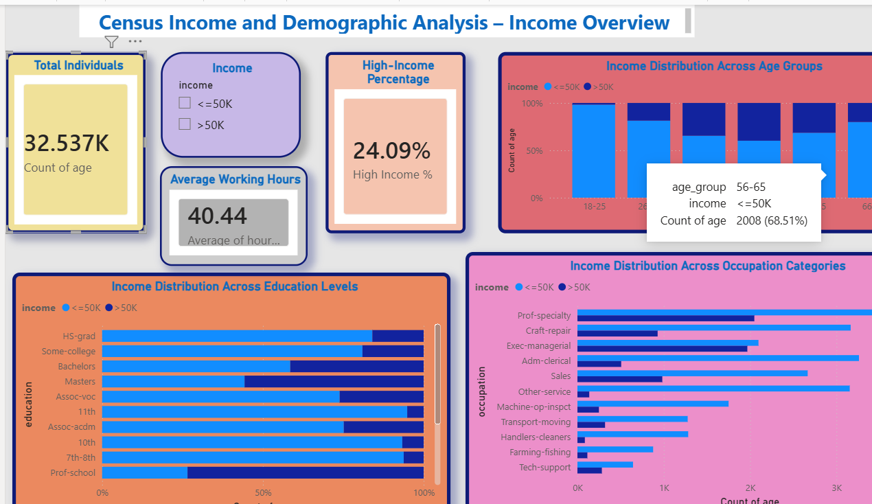
Figure 1. Power BI Page 1 – Income Overview

How to explain Page 1
“This page gives the overall income picture. I have used KPI cards for total individuals, high-income percentage and average working hours. The charts then compare income distribution by age group, education level and occupation.”

8.2 Page 2 – Demographic Analysis
Purpose: Compare income patterns across demographic and employment characteristics.
- Income Distribution by Gender.
- Overall Income Distribution.
- Income Distribution by Working Hours.
- Income Distribution by Race.
- Income Distribution by Workclass.
- Average Working Hours by Age Group and Income.
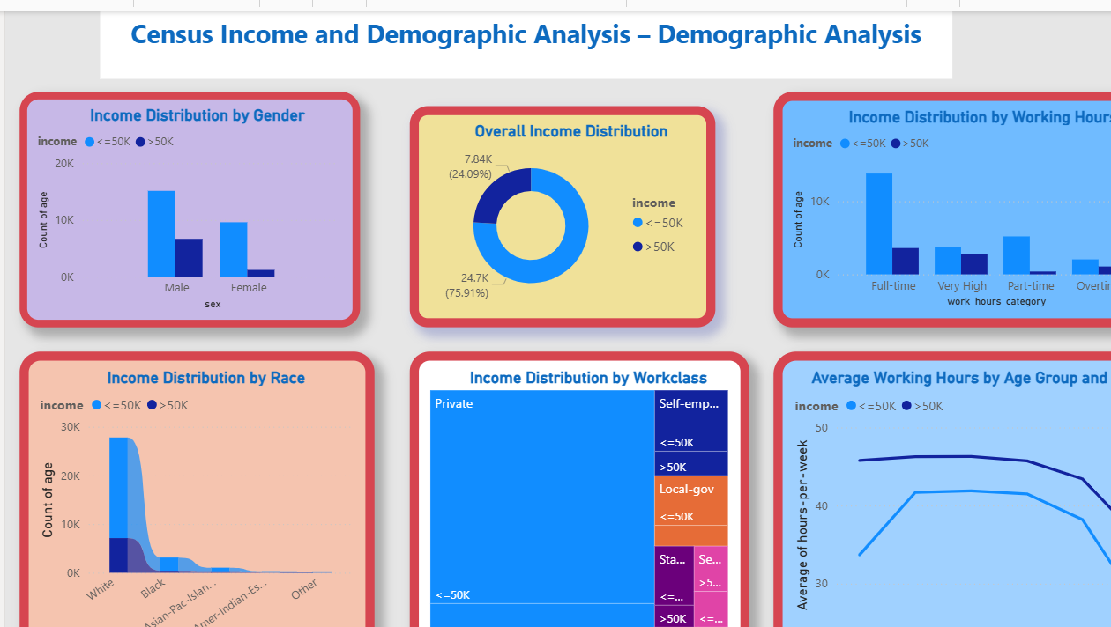
Figure 2. Power BI Page 2 – Demographic Analysis

How to explain Page 2
“This page focuses on demographic and work-related factors. I compare income across gender, race, workclass and working-hour categories, and I also compare average working hours across age groups for the two income categories.”

8.3 Page 3 – Detailed Analysis
Purpose: Provide deeper analysis using high-income percentage, education summary, native-country distribution and Power BI Key Influencers.
- Gender Distribution.
- High-Income Individuals (%): 24.09%.
- High-Income Percentage by Age Group.
- Income Distribution by Native Country.
- Income Summary by Education.
- Key Factors Influencing Income.
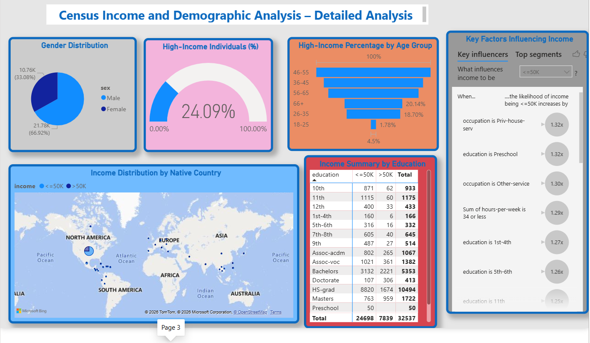
Figure 3. Power BI Page 3 – Detailed Analysis

How to explain Page 3
“This is the detailed analysis page. It shows the overall high-income percentage, how high-income representation changes by age group, the country-wise distribution, an education-level income summary and the Key Influencers visual to explore factors associated with the selected income category.”

9. Key Findings
Area | Finding
Final dataset size | 32,537 individuals after cleaning.
High-income share | 24.09% of the cleaned dataset is in the >50K income category.
Education | Higher education generally shows stronger high-income representation.
Occupation | Professional and managerial occupations show substantial higher-income representation.
Age | High-income representation varies strongly across age groups, with the 46–55 group highest among the displayed age groups in Page 3.
Gender | The dashboard shows a larger number of male records than female records in the cleaned dataset.
Working hours | Income distribution changes across working-hour categories, and average hours differ between income groups.
Other dimensions | Income patterns also vary across race, workclass and native country.

10. Detailed Dashboard Metrics
Metric | Value | Dashboard Location
Total Individuals | 32,537 | Page 1 KPI
High-Income Percentage | 24.09% | Pages 1 and 3
Average Working Hours | 40.44 | Page 1 KPI
Male share | 66.92% | Page 3 Gender Distribution
Female share | 33.08% | Page 3 Gender Distribution
46–55 high-income percentage | 39.36% | Page 3 Age Group visual
36–45 high-income percentage | 34.61% | Page 3 Age Group visual
56–65 high-income percentage | 31.49% | Page 3 Age Group visual
66+ high-income percentage | 20.14% | Page 3 Age Group visual
26–35 high-income percentage | 18.70% | Page 3 Age Group visual
18–25 high-income percentage | 1.78% | Page 3 Age Group visual

11. Business Interpretation
The dashboard can be used as a workforce and income-pattern exploration tool. It helps users compare demographic and employment segments rather than relying only on the overall income percentage.
- Workforce segmentation: compare income patterns across occupation, workclass, age and gender groups.
- Education and upskilling: identify education levels where higher-income representation is stronger and use the insight for training discussions.
- Workforce planning: compare working-hour patterns and occupation groups to understand how work characteristics differ across income categories.
- Interactive comparison: use the dashboard filters and visuals to investigate a specific demographic or employment segment.

12. How the Dashboard Should Be Used
- Start with Page 1 to understand the overall dataset and income picture.
- Use the income filter to compare <=50K and >50K groups.
- Move to Page 2 to investigate demographic and working-hour differences.
- Use Page 3 for deeper age, education and native-country analysis.
- Use Key Influencers to explore factors associated with the selected income category.
- Use the findings section of this document as the explanation for the presentation.

13. Project Presentation Script – Short Version
“My project is Census Income and Demographic Analysis using the UCI Adult dataset. I started with 32,561 records and 15 columns. In Python and Google Colab, I handled missing categorical values, removed 24 duplicate records and created Age Group and Work Hours Category features. The final cleaned dataset contains 32,537 records.”
“I performed EDA across income, age, education, occupation, gender, race, workclass, working hours and native country. Then I built a three-page Power BI dashboard.”
“Page 1 is Income Overview, Page 2 is Demographic Analysis and Page 3 is Detailed Analysis. The high-income share is 24.09%. The analysis also shows stronger high-income representation at higher education levels and substantial representation in professional and managerial occupations.”
“Overall, this project demonstrates an end-to-end analytics workflow from data preparation and EDA in Python to interactive business reporting in Power BI.”

14. Limitations and Interpretation Note
The dashboard is primarily descriptive and exploratory. The observed relationships should be interpreted as patterns or associations in the dataset, not as proof that one variable directly causes a change in income.
The dataset represents census-derived historical information. Therefore, dashboard findings should be used for analysis and learning rather than as a direct statement about current salaries or present-day labor-market conditions.

15. Future Enhancements
- Predictive income modeling.
- Advanced statistical analysis.
- Drill-through pages for deeper segment analysis.
- Dynamic tooltips for additional context.
- Automated data refresh.
- Model evaluation using classification metrics if a predictive model is added.

16. Conclusion
This project demonstrates a complete analytics workflow: data preparation and cleaning in Python/Google Colab, exploratory data analysis, transformation of analytical features, and interactive reporting in Power BI.
The final three-page dashboard converts the cleaned dataset into an easy-to-explore analytical report. The main conclusion is that income patterns vary across multiple demographic and employment dimensions, with education, occupation, age and working-hour characteristics providing useful perspectives for understanding the <=50K and >50K income groups.

17. References
UCI Machine Learning Repository – Adult Dataset: Official Dataset Source
Project Google Colab Notebook: Open Project Notebook
Note: The Google Colab link is included as the project notebook reference. The notebook itself may require the owner's sharing permission to open.
Objective | Analyze demographic and employment factors associated with income <=50K and >50K.
Workflow | Python / Google Colab → Data Cleaning → EDA → Power BI Dashboard
Dashboard | 3 interactive pages covering income, demographics and detailed analysis.
Key Result | 32,537 cleaned records; 24.09% are in the >50K income group.

