Customer Segmentation and Product

Recommendation System
Project Documentation Report

1. Introduction
In today's competitive retail and e-commerce landscape, understanding customer behaviour and offering personalized experiences are key drivers of business growth. This project presents an interactive application that combines customer segmentation with a product recommendation engine, built on top of a real-world online retail transaction dataset.
The application allows business users to explore key sales metrics, predict the behavioural segment of a customer based on their purchase patterns, and discover products that are similar to a chosen item. By integrating machine learning models with an easy-to-use dashboard interface, the system bridges the gap between raw transactional data and actionable business insight.

2. Project Summary
The system is built around three core modules accessible from a sidebar navigation menu: Dashboard, Customer Segmentation, and Recommendation. The underlying dataset contains invoice-level transaction records, including invoice number, stock code, product description, quantity, invoice date, unit price, customer ID, and country.
The Dashboard module provides a high-level overview of the business, displaying total customers, total products, total revenue, a preview of the raw dataset, and a chart of the top-selling products by quantity sold.
The Customer Segmentation module applies an RFM (Recency, Frequency, Monetary) based clustering model. Users can input a customer's recency, frequency, and monetary values, and the system predicts which behavioural segment the customer belongs to, along with a visualization of the overall cluster distribution across the customer base.
The Recommendation module uses a product similarity model. Users select a product from a dropdown list, and the system returns the top five most similar products, along with a bar chart showing the recommendation similarity scores for each suggested item.

3. Objectives
- To analyze and summarize key business metrics such as total customers, total products, and total revenue from transactional sales data.
- To visualize top-selling products and identify which items contribute most to overall sales volume.
- To segment customers into meaningful behavioural groups using RFM (Recency, Frequency, Monetary) analysis and clustering techniques.
- To enable prediction of a customer's segment (e.g., At Risk Customer) based on their individual RFM values.
- To build a product recommendation engine that suggests similar products based on a selected item.
- To present all insights through an interactive, easy-to-navigate dashboard interface for non-technical business users.

4. Dashboard Module
The Dashboard is the landing page of the application. It presents a summary of the dataset, including the total number of unique customers, total number of unique products, and total revenue generated. Below the summary metrics, a preview of the raw transaction dataset is displayed, showing fields such as Invoice No, Stock Code, Description, Quantity, Invoice Date, Unit Price, Customer ID, and Country.
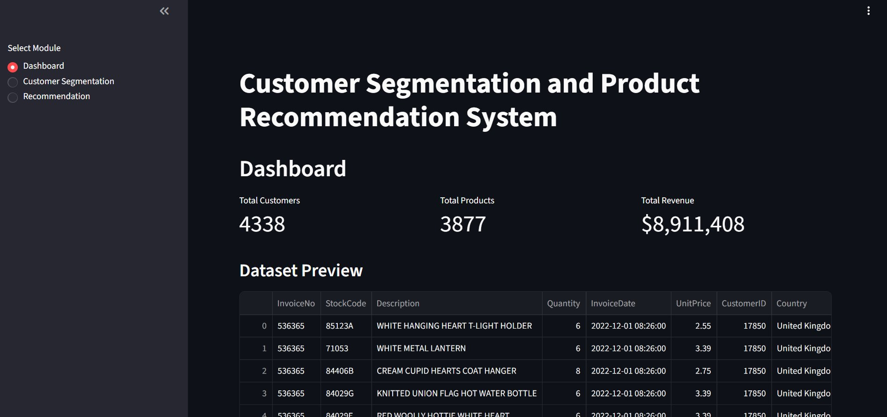

4.1 Top Selling Products
The dashboard also includes a horizontal bar chart ranking the top 10 products by quantity sold. The chart highlights best-performing items such as the White Hanging Heart T-Light Holder, Regency Cakestand 3 Tier, and Jumbo Bag Red Retrospot, helping stakeholders quickly identify the most popular products.
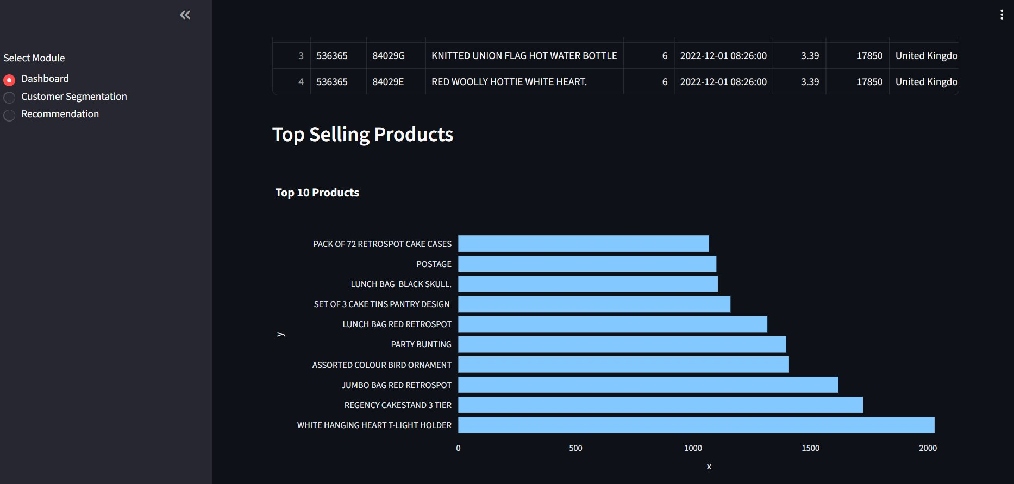

5. Customer Segmentation Module
The Customer Segmentation module allows users to enter a customer's RFM values manually: Recency (days since last purchase), Frequency (number of purchases), and Monetary Value (total amount spent). Clicking the 'Predict Segment' button passes these values to a trained clustering model.
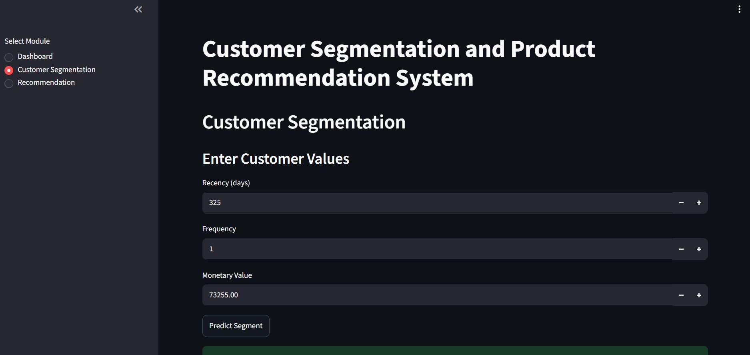

5.1 Prediction Result and Cluster Distribution
Based on the entered values (e.g., Recency = 325 days, Frequency = 1, Monetary Value = 73255.00), the model predicts the customer's segment — in this example, the customer is classified as an 'At Risk Customer'. A pie chart further visualizes the distribution of all customers across the identified clusters, showing that the majority of customers (93.7%) fall into one dominant cluster (Cluster 0), while smaller clusters (3, 1, and 2) represent niche customer groups such as at-risk or high-value customers.
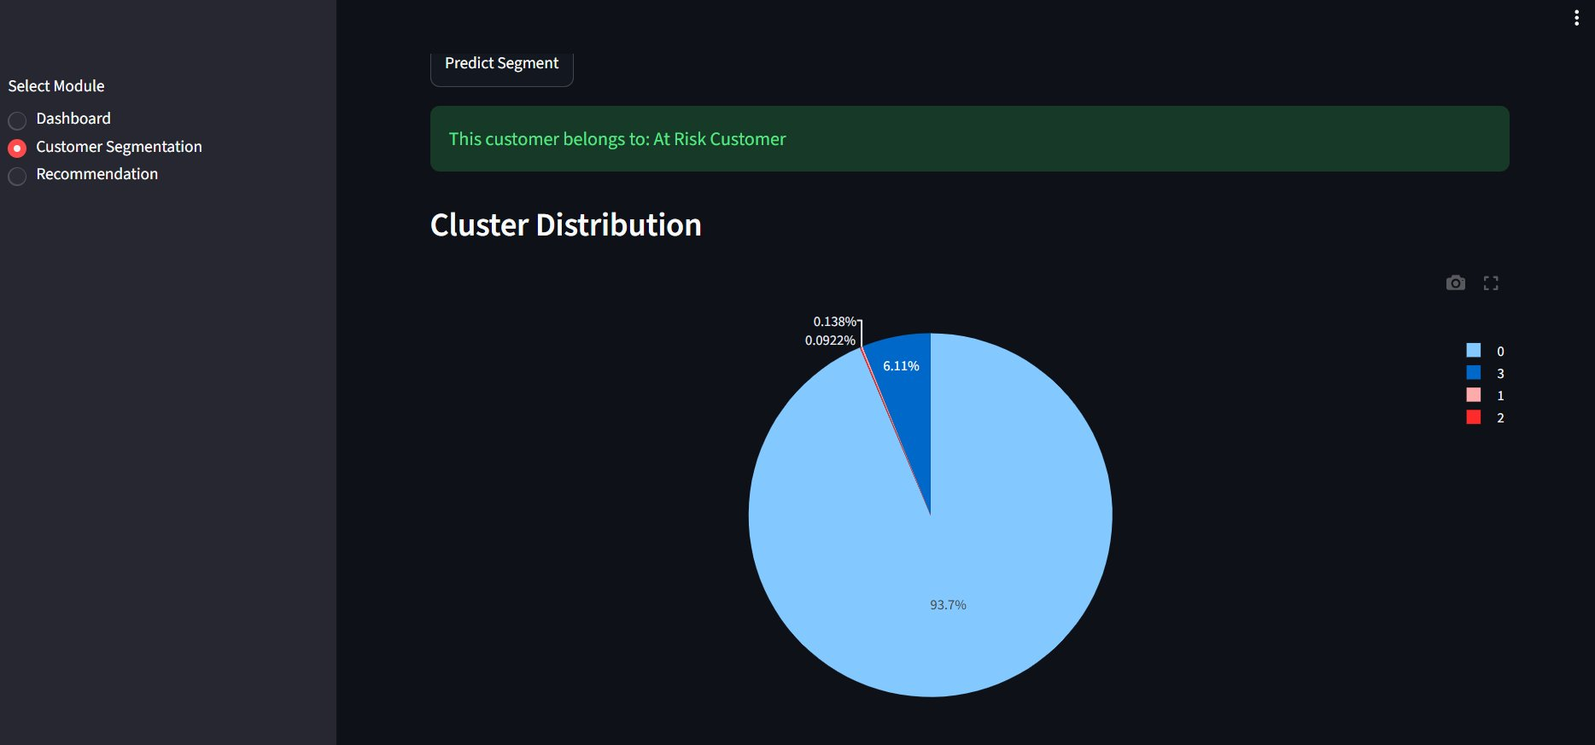

6. Recommendation Module
The Recommendation module enables users to select a product from a dropdown menu (e.g., 'Green Vintage Spot Beaker') and click 'Get Recommendations' to retrieve a list of the top 5 most similar products. In this example, the system returns Pink Vintage Spot Beaker, Red Vintage Spot Beaker, Blue Vintage Spot Beaker, Set of 60 Pantry Design Cake Cases, and Set of 4 Knick Knack Tins Doiley as the most similar items.
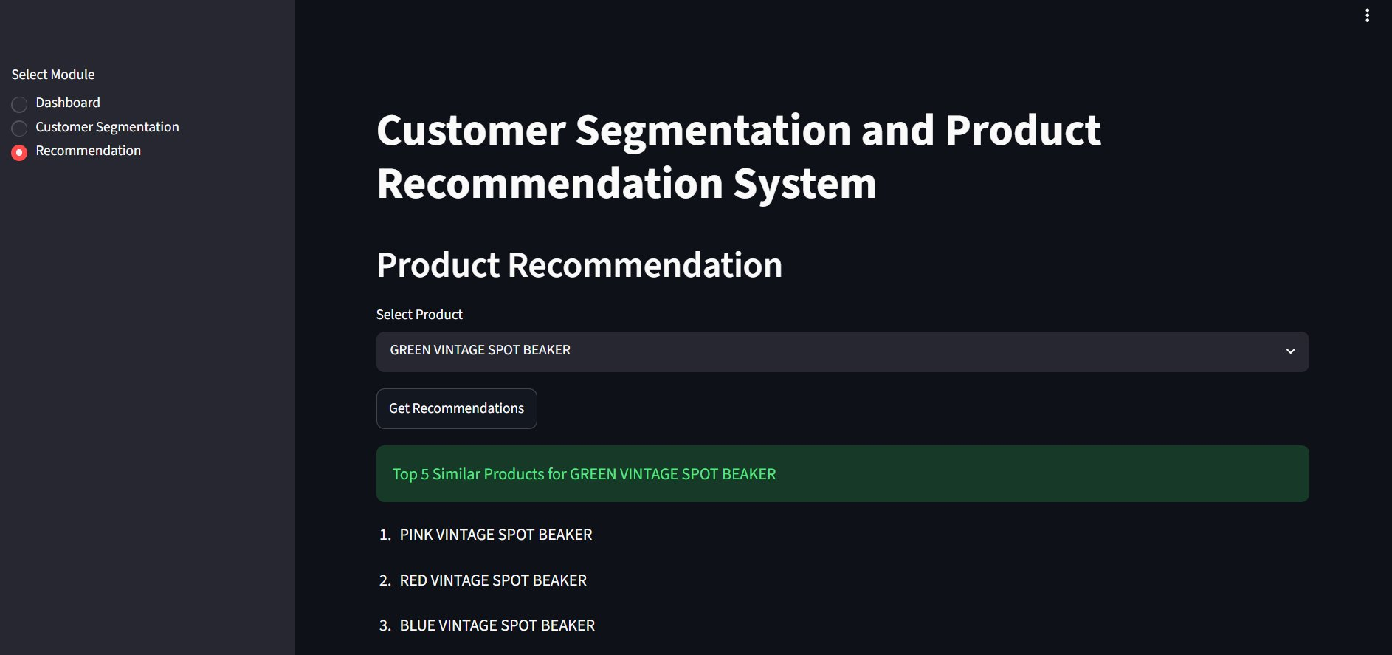

6.1 Recommendation Scores
A bar chart displays the similarity score of each recommended product relative to the selected item. Higher bars indicate a stronger similarity. In this example, the Pink, Blue, and Red Vintage Spot Beakers show the highest similarity scores (above 0.7), while the Set of 4 Knick Knack Tins Doiley and Set of 60 Pantry Design Cake Cases show comparatively lower similarity scores (around 0.3).
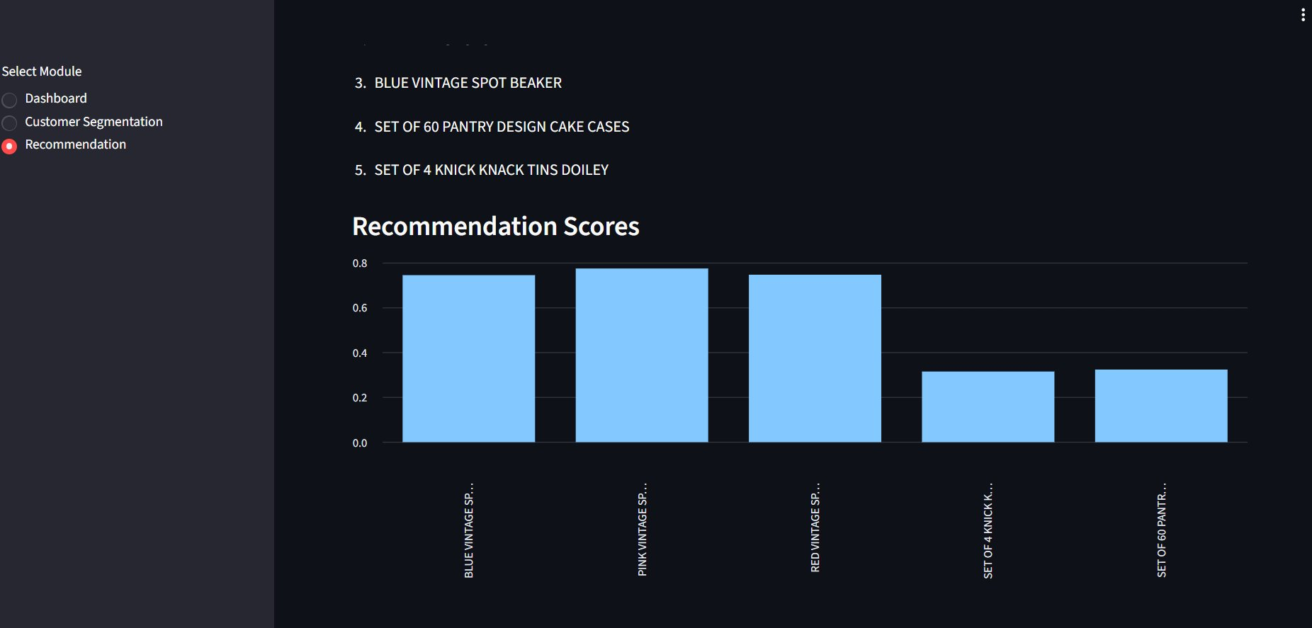

7. Conclusion
The Customer Segmentation and Product Recommendation System successfully demonstrates how transactional retail data can be transformed into actionable business intelligence. By combining descriptive analytics (the Dashboard), predictive customer segmentation (RFM-based clustering), and a product recommendation engine, the application provides a comprehensive toolkit for understanding customer behaviour and improving product targeting strategies. This system can be extended further with additional features such as automated marketing recommendations, real-time data updates, and deeper integration with customer relationship management (CRM) systems.

