[TITLE]

Introduction
Brief overview of the control volume, hypothesized water balance, motivation for the analysis, and objectives. [250 words)

Previous Work
Lit. review goes here. If your lit. review was multiple pages, you will want to condense it down to a couple paragraphs! [500 words]

Methods
How did you go about quantifying the water balance [750 words]

Data Sources
What data is available, what is the spatial coverage (and resolution if using gridded), how was it accessed, what is the period of record

Data Analysis
Did you use any methods to estimate or verify water balance components.

Results
What is the water balance. What are the major sources of uncertainty. [750 words]

Conclusions & Next Steps
Did the data confirm or reject your hypothesized water balance (i.e., is the system not steady-state, is exporting/importing groundwater flows, etc.) How would you improve your analysis given more time (and more money, if you were a consultant) [350 words]

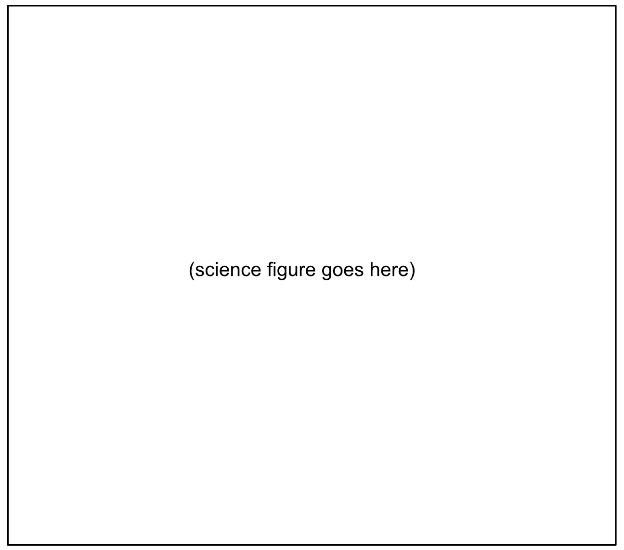
Figure 1. Figure caption.
Figure 1 – Well ASR-4 Fe versus Field H2S

Table 1. Table caption.
Table Header 1 | Table Header 1 | Table Header 1 |  | Table Header 1
 |  | Table Header 1 |  | Table Header 1
 |  | Table Header 2 | Table Header 2 | Table Header 2
Table Text | Table Text | Table Text | Table Text | Table Text
Table Text | Table Text | Table Text | Table Text | Table Text
Table Text | Table Text | Table Text | Table Text | Table Text
Table Text | Table Text | Table Text | Table Text | Table Text

References
Condon, L. E., Markovich, K. H., Kelleher, C. A., McDonnell, J. J., Ferguson, G., & McIntosh, J. C. (2020). Where is the bottom of a watershed? Water Resources Research, 56, e2019WR026010. https://doi.org/10.1029/2019WR026010

