Assignment 5 implementation

Kobie Marsh

Professor Grinberg

# UML Diagram

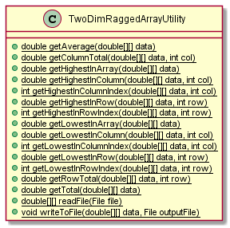

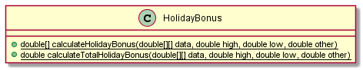

# Test Pictures

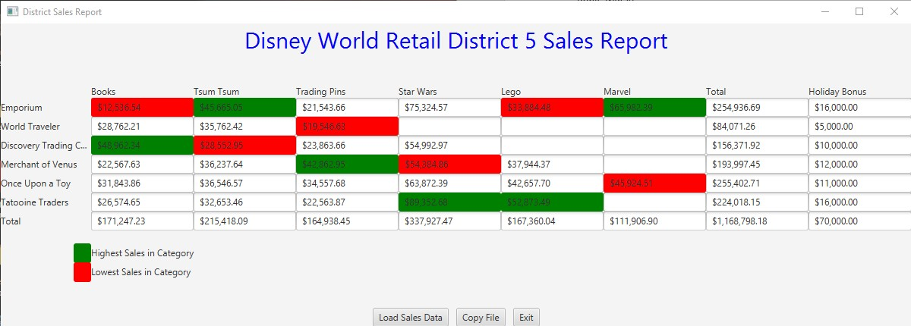

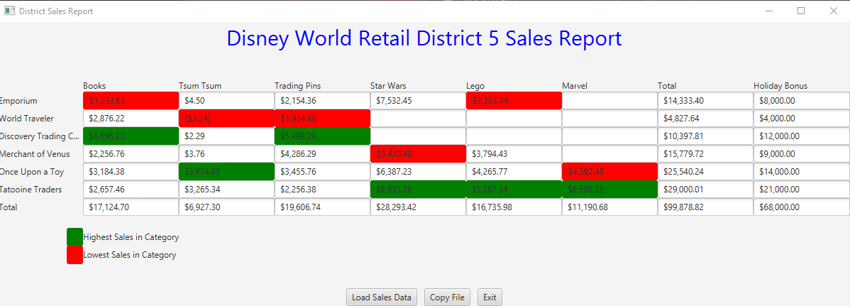

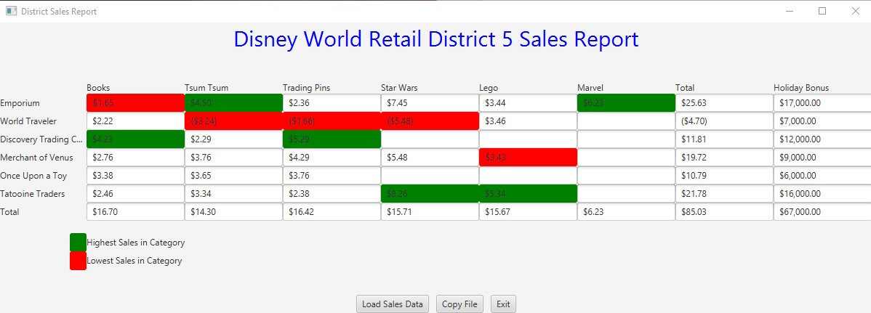

# Learning Experience

This project was the first time that I dealt with both ragged arrays and files in any capacity, which both provided me with difficulties. At first, I had problems with null pointer exceptions when dealing with ragged arrays. I guessed it was because I didn’t somehow consider what to do with unused elements. So, I decided to just fill all the unused information with 0’s, which obviously wasn’t a ragged array. Needless to say that was a short-lived endeavor, since it was against the basic premise of the project.

Eventually I decided to implement two for loops even when a row or column was given, previously I thought it didn’t need to go through both dimensions if one of them was passed into the method. However, when I wrote the second for loop and only used it when the iteration equaled the given column/row.

My other problem was when I had to read and write into a file. The way in Java is extremely different from the way in C++, at least from what I remembered. For the longest time I couldn’t figure out how to read it into the data 2D array, even when I thought my logic was sound. I ended up rewriting the method multiple times, even trying to use an ArrayList. In the end however, the problem was that k needed to be reset to 0 after each row. It was a simple mistake in a line that derailed my entire method and gave me hours of grief.