Quiz 2

Student name:

1(20): what is the firewall, what are the types of the firewall according to filtering directions.

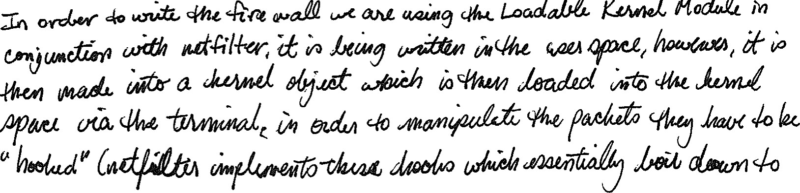What type is the default ufw according to it's filtering direction(without setting up anything)? Can ufw be both direction? How? if you'd like to use ufw to block traffic, what is the first thing to do in VM(assume it is already enabled)? What is the reason?

2(20): How many types of firewall do we have according to it functions?

3(20): Where does firewall run: Kernel or user space?

4(40): What is the module are you using to write firewall in this lab, is it in the user space or kernel space? how does it work? (not in code detail, in names detail, such as what do you call those connections function? where does this module run and how does it achieve it's purpose etc)