CPS 500 – Homework 1
Kevin Martin
10/30/2019

Q1

MIPS:
sll $t0, $s0, 2 # $t0 = f *4 (or +1 in C)
add $t0, $s6, $t0 # $t0 = A[f] ($t0 already holds f)
sll $t1, $s1, 2 # $t1 = g * 4 (or +1 in C)
add $t1, $s7, $t1 # $t1 = B[g] ($t1 already holds g)
lw $s0, 0($t0) # $f = A[0] (which is A[f])
addi $t2, $t0, 4 # $t2 = A[f + 1] (add 1 to $t0, already in A)
lw $t0, 0($t2) # $t0 = A[f + 1]
add $t0, $t0, $s0 # $t0 = A[f + 1] + A[f]
sw $t0, 0($t1) # $t1 = A[f + 1] + A[f] ($t1 = B[g])

C code:
B[g] = A[f + 1] + A[f];

Q2

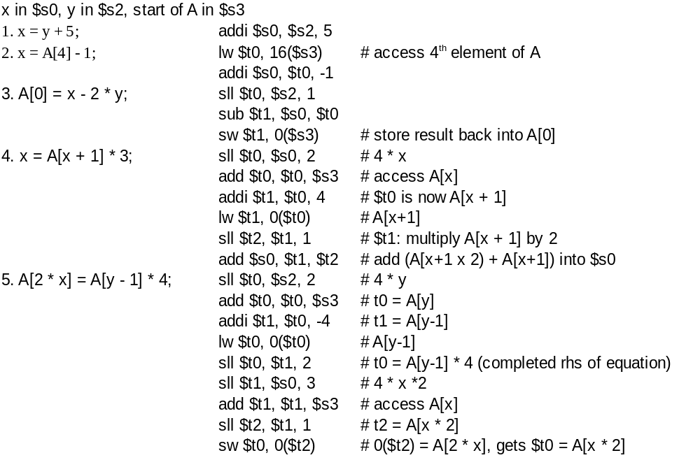

Q3

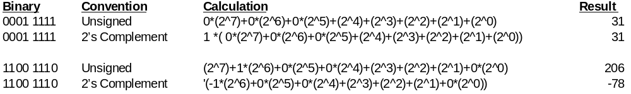

Q4

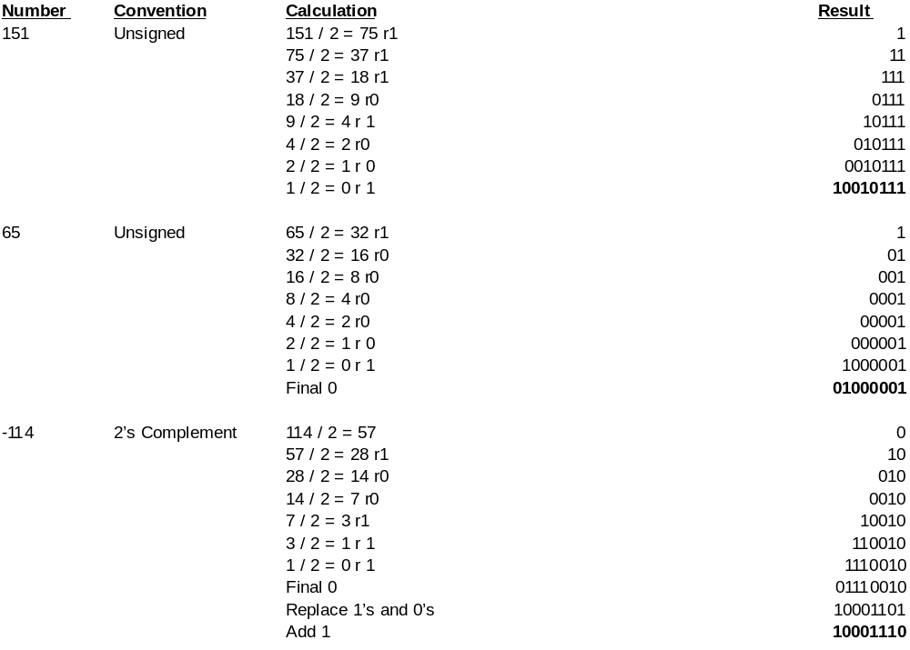
Q5

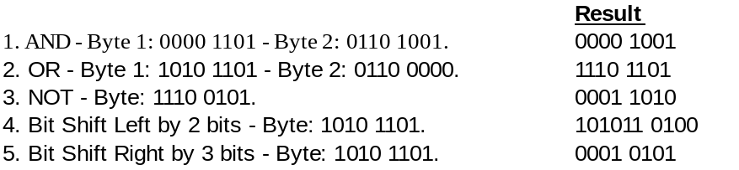

Q6 (Extra Credit)

