Processing dome image sets with relightab Aug 2025
by Kirk Martinez -
With thanks to Federico Ponchio (CNR IT)

Calibrating the light positions of a dome is covered elsewhere

Processing a set of images (Windows)
- Move the images from the camera card to a folder on your PC (with an ID name)
The card appears as a drive – (safer to make it show filename list not icons of any sort) the quick way for one capture is control A, control X. click into destination and control V.
- In relightlab start a new project
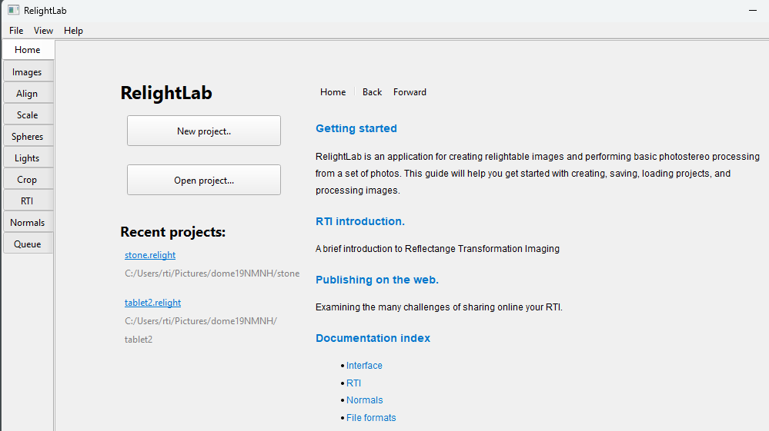
Select the folder you placed your images in
It will open the Images view:
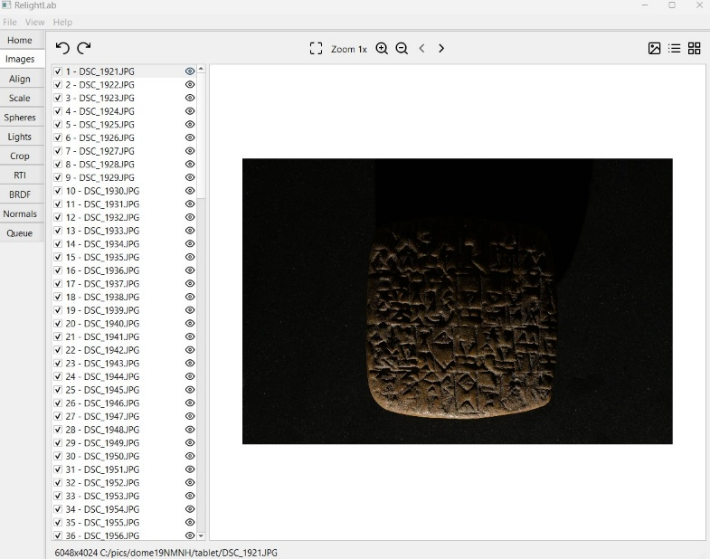
- Click on the Lights task on the left:

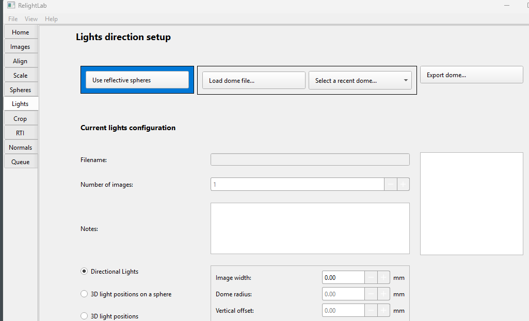

- If this is your first use of relightlab click on “Load dome file” and select your dome’s .dome file. It will remember it and in future you only have to use “Select a recent dome”
It will then show the dome calibration information:
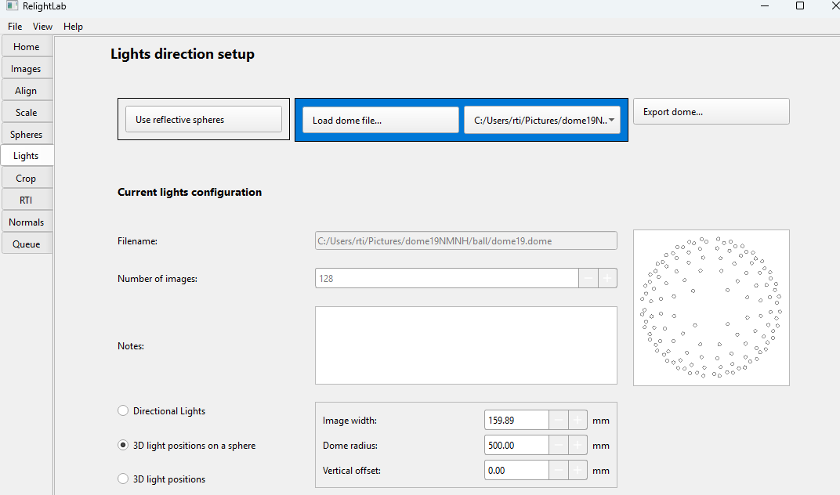

- Now Click on the Crop task and move the crop box using the corner squares (not too tight) – ignore the “Crop images” button (it is an advanced way to save disk space by cropping the originals)
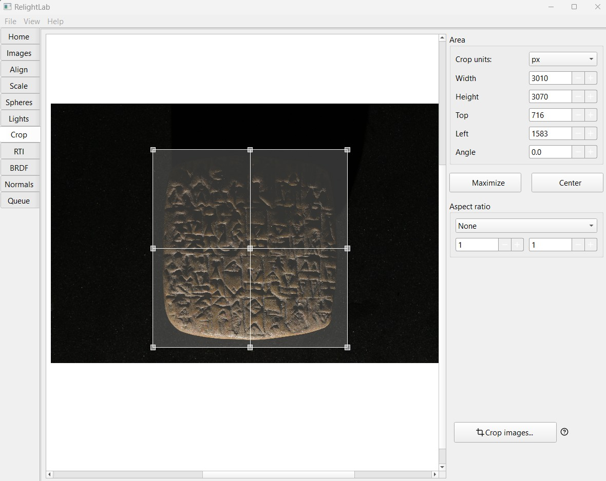

- Now click on the RTI task and you will see your output choices:
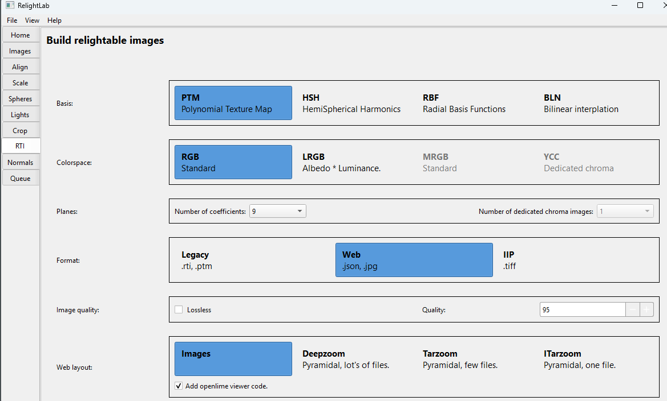

- A good choice for most objects is HSH, RGB, Web, Images as shown here:
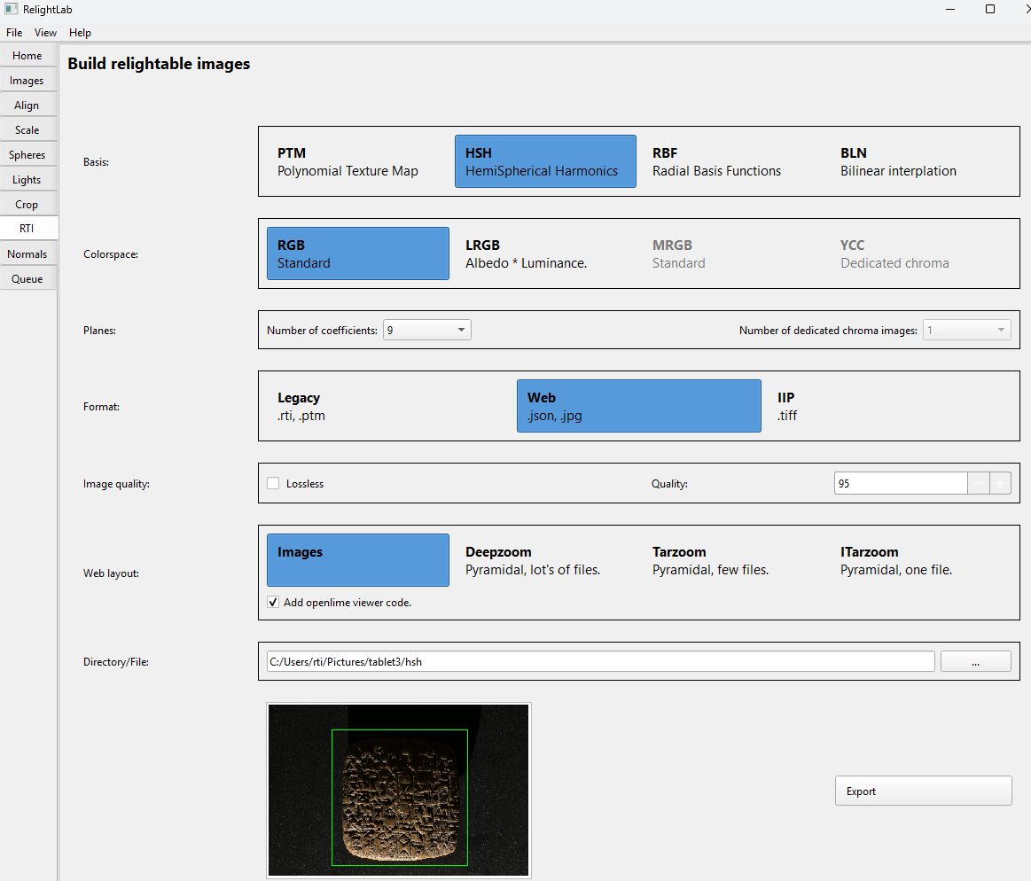

You can build RBF versions and compare them side-by side to determine which format you want to use by normally.

- Edit the destination using the Directory/File … button to point to a folder in your images folder. Here we have called it hsh.

- Save your workspace/project now with File->Save Project and put the .relight file into the same folder. This will let you easily load it of you need to make other outputs afterwards.

- Click on the Export button at the bottom to build your output. You will see the Queue task pane with a progress bar (this takes a couple of minutes, an rbf takes 1min on my desktop):

- Once it has completed you can view your output by clicking on this button on the right side of the task:
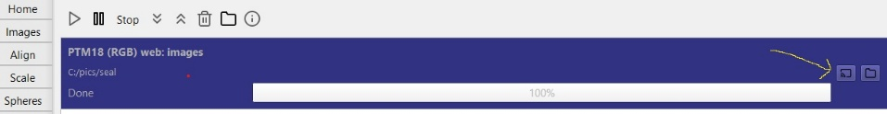
- This will view your result in your web browser:

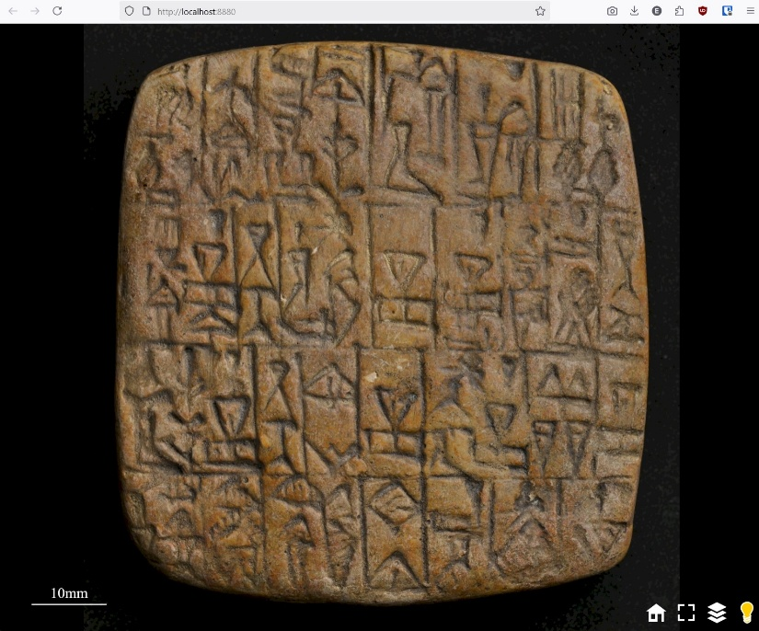

You can Zoom in/out using the +- keys on your keyboard and try the different visualisations by clicking on the three-layer icon.
To open the html file afterwards the easiest way is to run relightlab and select the top View->View RTI in Browser option. Select the folder containing it (in this case the hsh folder).

15 Output other types of data if needed. You can go back to the RTI task and select other outputs. For example HSH or PTM “legacy” format as a .rti file which can be loaded into RTIViewer. RBF can show more details for some objects (e.g. shiny). Different web outputs can be made if your image is very high resolution (Deepzoom and Tarzoom).
If you need normals or 3D meshes click on the Normals task which can produce a jpg normals image or a ply polygon mesh (see documentation for details).
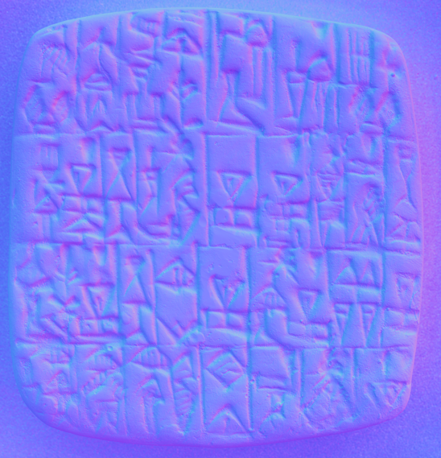
Normals jpg produced for this tablet
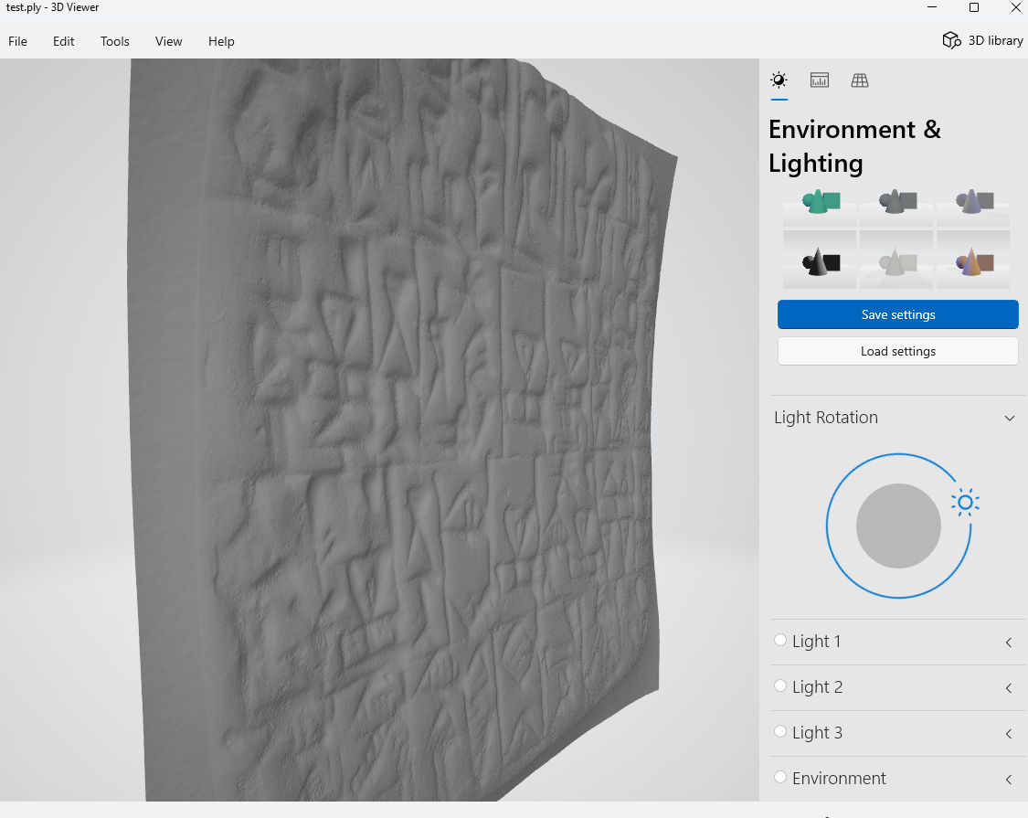
This is a mesh viewed in microsoft’s free 3D Viewer.

