Your Information:

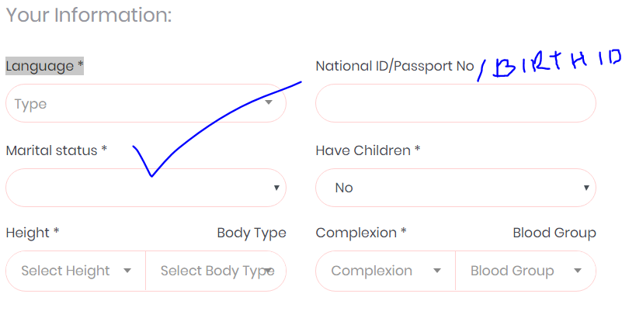

Done

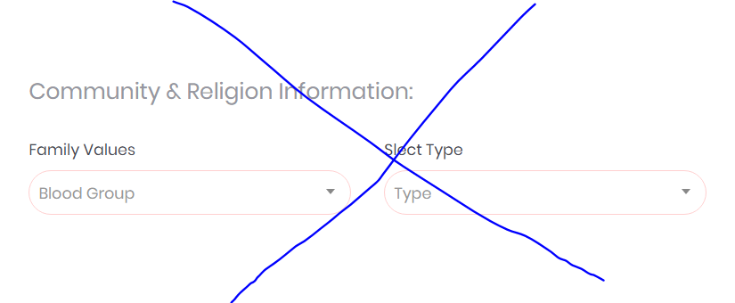

Family information:

1. Father's Status 02. Mother's Status

03. Number Of Brother's 04. Number Of Sister's 05. I'M The Number Of My Parents

06. Family Values 07. Family Status

08. Guardian Contact No (Admin Use Only) 09. Relationship with Guardian

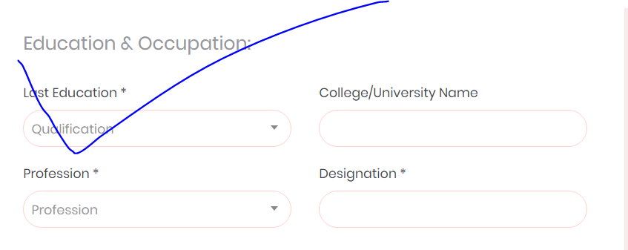

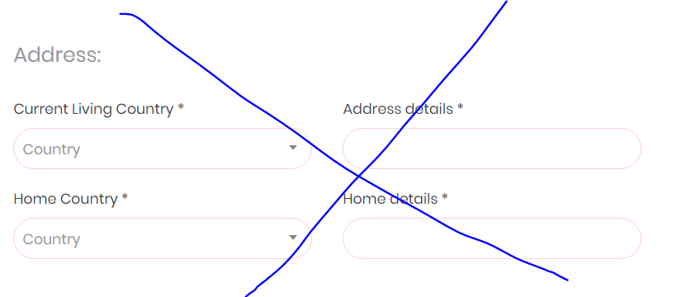

My Location :

1. My Home Country ( Permanent ) 02. District
2. Current Living Country 03. District/ State

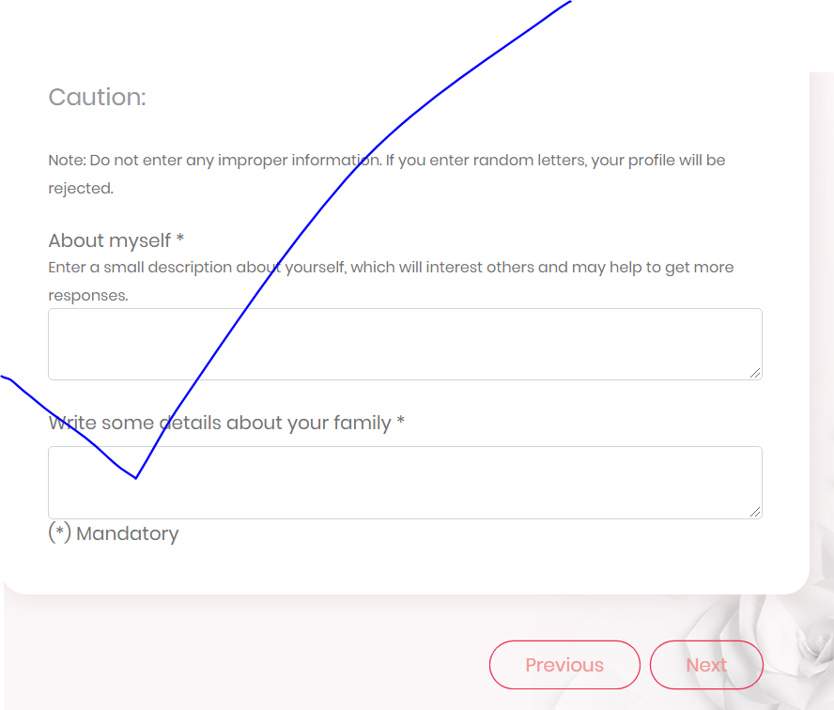

Done