BEYOND WIN, DRAW AND LOSS: A COMPARATIVE STUDY OF COUNT REGRESSION MODELS FOR ENGLISH PREMIER LEAGUE FOOTBALL SCORE PREDICTION

Dissertation submitted to
Adamas University
For the Award of the Degree of
Master of Science and Technology in Statistics and Data Science

By
Masuma Khatun
(UNIVERSITY REGISTRATION NO: AU/2024/0003218)
ADAMAS UNIVERSITY



Department of Mathematical Sciences
School of Basic and Applied Sciences
Adamas University - India
June - 2026

DECLARATION

I declare that the thesis entitled “BEYOND WIN, DRAW AND LOSS: A COMPARATIVE STUDY OF COUNT REGRESSION MODELS FOR ENGLISH PREMIER LEAGUE FOOTBALL SCORE PREDICTION” has been prepared by me under the guidance of Dr. Tathagata Mandal, Assistant Professor of Mathematical Sciences Department, Adamas University and Mr. Sambaran Saha, Adjunct Faculty of Mathematical Sciences Department, Adamas University. No part of this thesis has formed the basis for the award of any degree or fellowship previously.

Masuma Khatun
Department of Mathematical Sciences,
SOBAS, Adamas University Name,
Kolkata – 700126
DATE: 04/06/2026

CERTIFICATE

I certify that Masuma Khatun has prepared her thesis entitled “BEYOND WIN, DRAW AND LOSS: A COMPARATIVE STUDY OF COUNT REGRESSION MODELS FOR ENGLISH PREMIER LEAGUE FOOTBALL SCORE PREDICTION”, for the award of Master of Science and Technology degree in Statistics and Data Science of the Adamas University, under our guidance. She has carried out the research work at the Department of Mathematical Sciences, Adamas University.

Dr. Tathagata Mandal
Department of Mathematical Sciences,
SOBAS, Adamas University,
Kolkata – 700126
DATE: 04/06/2026

Mr. Sambaran Saha
Department of Mathematical Sciences,
SOBAS, Adamas University,
Kolkata – 700126
DATE: 04/06/2026

Forwarded by:
Dr. Satyajit Das
Department of Mathematical Sciences,
SOBAS, Adamas University,
Kolkata – 700126
DATE: 04/06/2026

ACKNOWLEDGEMENT
I would like to express my sincere gratitude to my dissertation supervisors, Dr. Tathagata Mandal and Mr. Sambaran Saha of the Department of Mathematical Sciences, for their invaluable guidance, constant support, and encouragement throughout the dissertation. Without their insightful suggestions, constructive feedback, and continuous motivation, the successful completion of this work would not have been possible. Their illuminating discussions and expert guidance greatly enriched my understanding of the subject and played a crucial role in shaping this project.
I am also deeply grateful to all the faculty members of the Department of Mathematical Sciences for their encouragement, valuable suggestions, and support during my academic journey. Their contributions have been instrumental in enhancing my learning experience.
I would like to extend my heartfelt thanks to Adamas University, Kolkata, for providing the necessary facilities, resources, and academic environment required to carry out this project successfully.
Last but not least, I am sincerely thankful to my family and classmates for their unwavering encouragement, patience, and moral support throughout this work. Their continuous motivation and assistance have been a source of strength and inspiration during the completion of this dissertation.

Abstract
Football analytics has become an important area of research in sports statistics due to the increasing use of data-driven methods in performance evaluation, tactical planning, and match prediction. Among different sports, football presents unique statistical challenges because matches generally contain a low number of scoring events and outcomes are influenced by substantial uncertainty. Since goals scored in football are discrete and non-negative in nature, count data models provide a suitable framework for analysing and predicting football scores.
Most existing studies in football prediction focus directly on predicting categorical outcomes such as win, draw, or loss. However, such approaches often overlook the underlying scoring process of a match. In this study, a different approach is considered where the actual goal counts of the home and away teams are predicted first, and the final match outcome is then determined from the predicted scores. This provides a more detailed understanding of team performance and scoring behaviour.
The study uses historical match data from the English Premier League (EPL) covering the last ten seasons. Three count regression approaches are considered for modelling football scores: Poisson Regression, Negative Binomial Regression, and Bivariate Poisson Regression. For the Poisson and Negative Binomial approaches, two separate models are developed — one for predicting home team goals and another for predicting away team goals. In contrast, the Bivariate Poisson model jointly models both home and away goal counts within a single framework.
Using the predicted goals obtained from these models, match outcomes were classified as Home Win, Away Win, or Draw by comparing the predicted scores of the two teams. The performances of the models were evaluated and compared using different classification-based measures, including prediction accuracy, precision, recall, and F1-score. A comparative analysis was then conducted to identify the model that provided the most effective prediction of EPL match outcomes.
The objective of this dissertation is to examine the suitability of different count regression models for EPL goal prediction and to identify the model that provides better predictive performance for football score data. The study is expected to contribute to football analytics by providing a comparative analysis of count-based statistical models for goal prediction and match outcome determination.
Keywords
Football Analytics, Count Data Models, Poisson Regression, Negative Binomial Regression, Bivariate Poisson Regression, Predictive Modelling

Contents
1 Introduction 1
1.1 Background of the Study 1
1.2 Motivation of the Study 2
1.3 Objectives of the Study 2
1.4 Organisation of the Dissertation 2
2 Data Description and Summary 3
2.1 Data Source 3
2.2 Variable Descriptions 3
2.3 A Glimpse of Data 4
2.4 Summary Statistics 5
3 Literature Review 6
4 Methodology 8
4.1 Review of Poisson Regression Model 8
4.2 Review of Negative Binomial Regression Model 9
4.3 Review of Bivariate Poisson Regression Model 10
4.4 Model Evaluation Metrics 11
4.4.1 Accuracy 11
4.4.2 Precision 11
4.4.3 Recall 11
4.4.4 F1-score 11
4.4.5 Mean Squared Error 11
5 Comparative Study of Model Outcomes 12
5.1 Results and Discussion of Poisson Regression Models 12
5.2 Results and Discussion of Negative Binomial Regression Models 14
5.3 Results and Discussion of Bivariate Poisson Regression Models 16
5.4 Comparative Analysis of the Models 18
5.5 Residual Analysis 20
6 Discussion and Conclusion 22
6.1 Discussion 22
6.2 Conclusion 23
6.3 Future Scope 23
7 Bibliography 24

List of Figures
Figure No. | Description | Pages
1 | Distribution of EPL Match Outcomes over the Last Ten Years | 7
2 | Residuals vs Fitted Plot for the Poisson Regression Model | 22
3 | Residuals vs Fitted Plot for the Negative Binomial Regression Model | 22
4 | Residuals vs Fitted Plot for the Bivariate Poisson Regression Model | 23

List of Tables
Table No. | Description | Pages
1 | Description of Variables Used in the Study | 5-6
2 | Sample EPL Dataset | 6
3 | Descriptive Measures of Key Variables Used in the Study | 7
4 | Review of Literature | 10
5 | Parameter Estimates of Poisson Regression Model for Home Team Goals | 15
6 | Parameter Estimates of Poisson Regression Model for Away Team Goals | 16
7 | Confusion Matrix of Poisson Regression Model | 16
8 | Performance Evaluation Metrics of the Poisson Regression Model | 16
9 | Parameter Estimates of Negative Binomial Regression Model for Home Team Goals | 16
10 | Parameter Estimates of Negative Binomial Regression Model for Away Team Goals | 17
11 | Confusion Matrix of Negative Binomial Regression Model | 18
12 | Performance Evaluation Metrics of the Negative Binomial Regression Model | 18
13 | Parameter Estimates of Bivariate Regression Model for Home Team Goals | 19
14 | Parameter Estimates of Bivariate Regression Model for Away Team Goals | 19
15 | Confusion Matrix of Bivariate Poisson Regression Model | 20
16 | Performance Evaluation Metrics of the Bivariate Poisson Regression Model | 20
17 | Comparative Evaluation of the Proposed Models | 21

Introduction

Background of the Study
The rapid growth of data availability and computational methods has significantly influenced the field of sports analytics in recent years. Statistical analysis is now widely used in professional sports for performance evaluation, tactical decision-making, player assessment, and match prediction. Football, being one of the most popular sports in the world, has become an important area for statistical research. Clubs, sports analysts, and researchers increasingly rely on quantitative methods to understand match dynamics and improve predictive accuracy.
One of the major challenges in football analytics is the prediction of match scores and results. Football is generally considered a low scoring game in comparison to many other sports, where even a single goal can determine the final result of a match. Moreover, football matches are affected by various uncertain factors such as team form, player injuries, tactical strategies, home advantage, and random events. These characteristics make football score prediction a difficult statistical problem.
Since the number of goals scored by a team is a discrete and positive quantity, count data models provide an appropriate statistical framework for football score modelling. Among these models, Poisson regression has been one of the most widely used approaches in football analytics. The Poisson model assumes that the number of goals scored follows a Poisson distribution and relates the expected goal count to explanatory variables associated with team performance. Due to its simplicity and interpretability, the Poisson model has been extensively applied in sports prediction studies.
However, in practical situations, football score data may not always satisfy the assumptions of the standard Poisson model. One important limitation is the assumption of equidispersion, where the mean and variance of the response variable are equal. In many football datasets, the observed variance exceeds the mean, leading to overdispersion. In such cases, the Negative Binomial Regression model may provide a better fit because it includes an additional parameter to account for extra variability in the data.
Another important issue in football score modelling is the dependency between home and away team goal counts. Traditional Poisson and Negative Binomial models generally treat the scores of the two teams independently by constructing separate models for home and away goals. However, in real football matches, the scoring behaviour of one team may influence the other team due to tactical interactions and match conditions. To address this issue, the Bivariate Poisson Regression model can be used to jointly model the goal counts of both teams within a single framework.
The English Premier League (EPL) is one of the most competitive and widely followed football leagues in the world. The league consists of teams with varying styles of play and competitive strengths, often resulting in closely contested and unpredictable matches.

Motivation of the Study
A large number of previous studies in football analytics focus directly on predicting match outcomes such as win, draw, or loss. Although these approaches are useful for classification purposes, they often ignore the underlying goal scoring mechanism of football matches. Predicting the actual number of goals scored by each team provides more detailed information regarding team performance and match behaviour.
The present study is motivated by the idea that football outcomes should naturally be derived from predicted scores rather than predicted directly. Therefore, instead of building models only for win-loss-draw classification, this dissertation first predicts the goal counts for both teams and then determines the final match result from the predicted scores. This approach allows a more realistic interpretation of football match dynamics and provides additional information beyond simple outcome classification.

Objectives of the Study
The main objectives of this study are as follows:
- To apply Poisson Regression and Negative Binomial Regression separately for home and away goal prediction.
- To apply a Bivariate Poisson Regression model for jointly modelling home and away team goal counts.
- To compare the performances of Poisson Regression, Negative Binomial Regression, and Bivariate Poisson Regression models using different statistical evaluation measures.

Organisation of the Dissertation
The dissertation is organised into seven chapters. Chapter 1 introduces the study by presenting the background of football analytics, the motivation behind the research, the objectives of the study, and the overall organisation of the dissertation. Chapter 2 provides a detailed description of the dataset used in the study, including the data source, variable descriptions, a glimpse of the data, and summary statistics. Chapter 3 reviews the existing literature related to football score prediction, football analytics, and the application of count regression models in sports statistics. Chapter 4 presents the methodology adopted in the study, including the theoretical foundations of Poisson Regression, Negative Binomial Regression, and Bivariate Poisson Regression models, along with the evaluation metrics used for assessing model performance. Chapter 5 reports the results obtained from the three models and provides a comprehensive comparative analysis of their predictive performances. Chapter 6 discusses the findings of the study, draws conclusions based on the empirical results, and outlines potential directions for future research. Finally, Chapter 7 contains the bibliography and references consulted throughout the study.

Data Description and Summary

Data Source
- https://fbref.com/en/comps/9/Premier-League-Stats [10]
- https://www.transfermarkt.co.in/ [11]

Variable Descriptions
Table 1: Description of Variables Used in the Study

Variable Name | Data Type | Description
Season | Object | Season of the English Premier League in which the match was played (e.g., “2014-15”, “2023-24”).
MatchDate | Date | Date on which the match was played.
HomeTeam | Object | Name of the home team participating in the match.
AwayTeam | Object | Name of the away team participating in the match.
FullTimeHomeGoals | Int | Total number of goals scored by the home team at full time.
FullTimeAwayGoals | Int | Total number of goals scored by the away team at full time.
FullTimeResult | Object | Final result of the match at full time (“H” for Home Win, “A” for Away Win, “D” for Draw).
HalfTimeHomeGoals | Int | Number of goals scored by the home team during the first half of the match.
HalfTimeAwayGoals | Int | Number of goals scored by the away team during the first half of the match.
HalfTimeResult | Object | Result of the match at half time (“H” for Home Lead, “A” for Away Lead, “D” for Draw).
HomeShots | Int | Total number of shots attempted by the home team during the match.
AwayShots | Int | Total number of shots attempted by the away team during the match.
HomeShotsOnTarget | Int | Number of shots on target by the home team.
AwayShotsOnTarget | Int | Number of shots on target by the away team.
HomeCorners | Int | Total number of corner kicks awarded to the home team.
AwayCorners | Int | Total number of corner kicks awarded to the away team.
HomeFouls | Int | Total number of fouls committed by the home team during the match.
AwayFouls | Int | Total number of fouls committed by the away team during the match.
HomeYellowCards | Int | Number of yellow cards received by the home team.
AwayYellowCards | Int | Number of yellow cards received by the away team.
HomeRedCards | Int | Number of red cards received by the home team.
AwayRedCards | Int | Number of red cards received by the away team.
HomeAge | Float | Average age of the players in the home team.
AwayAge | Float | Average age of the players in the away team.
VARUsed | Object | Indicates whether the Video Assistant Referee (VAR) system was used during the match (“Yes” or “No”).

A Glimpse of Data
Table 2: Sample EPL Dataset

Season | MatchDate | HomeTeam | AwayTeam | FullTimeHomeGoals | FullTimeAwayGoals
2015/16 | 08-08-2015 | Bournemouth | Aston Villa | 0 | 1
2015/16 | 08-08-2015 | Chelsea | Swansea | 2 | 2
2015/16 | 08-08-2015 | Everton | Watford | 2 | 2
2015/16 | 08-08-2015 | Leicester | Sunderland | 4 | 2
2015/16 | 08-08-2015 | Man United | Tottenham | 1 | 0
2015/16 | 08-08-2015 | Norwich | Crystal Palace | 1 | 3
2015/16 | 09-08-2015 | Arsenal | West Ham | 0 | 2
2015/16 | 09-08-2015 | Newcastle | Southampton | 2 | 2
2015/16 | 09-08-2015 | Stoke | Liverpool | 0 | 1
2015/16 | 10-08-2015 | West Brom | Man City | 0 | 3
2015/16 | 14-08-2015 | Aston Villa | Man United | 0 | 1
2015/16 | 15-08-2015 | Southampton | Everton | 0 | 3
2015/16 | 15-08-2015 | Sunderland | Norwich | 1 | 3
2015/16 | 15-08-2015 | Swansea | Newcastle | 2 | 0
2015/16 | 15-08-2015 | Tottenham | Stoke | 2 | 2
2015/16 | 15-08-2015 | Watford | West Brom | 0 | 0
2015/16 | 15-08-2015 | West Ham | Leicester | 1 | 2
2015/16 | 16-08-2015 | Crystal Palace | Arsenal | 1 | 2
2015/16 | 16-08-2015 | Man City | Chelsea | 3 | 0
2015/16 | 17-08-2015 | Liverpool | Bournemouth | 1 | 0
2015/16 | 22-08-2015 | Crystal Palace | Aston Villa | 2 | 1
2015/16 | 22-08-2015 | Leicester | Tottenham | 1 | 1
2015/16 | 22-08-2015 | Man United | Newcastle | 0 | 0
2015/16 | 22-08-2015 | Norwich | Stoke | 1 | 1
2015/16 | 22-08-2015 | Sunderland | Swansea | 1 | 1
2015/16 | 22-08-2015 | West Ham | Bournemouth | 3 | 4
2015/16 | 23-08-2015 | Everton | Man City | 0 | 2
2015/16 | 23-08-2015 | Watford | Southampton | 0 | 0
2015/16 | 23-08-2015 | West Brom | Chelsea | 2 | 3
2015/16 | 24-08-2015 | Arsenal | Liverpool | 0 | 0
2015/16 | 29-08-2015 | Aston Villa | Sunderland | 2 | 2
2015/16 | 29-08-2015 | Bournemouth | Leicester | 1 | 1
2015/16 | 29-08-2015 | Chelsea | Crystal Palace | 1 | 2
2015/16 | 29-08-2015 | Liverpool | West Ham | 0 | 3
2015/16 | 29-08-2015 | Man City | Watford | 2 | 0

Summary Statistics
Table 3: Descriptive Measures of Key Variables Used in the Study
Variable | Mean | SD | Variable | Mean | SD
FullTimeHomeGoals | 1.55 | 1.32 | AwayCorners | 4.72 | 2.77
FullTimeAwayGoals | 1.28 | 1.21 | HomeFouls | 10.54 | 3.45
HomeShots | 13.92 | 5.74 | AwayFouls | 10.92 | 3.58
AwayShots | 11.49 | 5.04 | HomeYellowCards | 1.63 | 1.26
HomeShotsOnTarget | 4.78 | 2.65 | AwayYellowCards | 1.81 | 1.30
AwayShotsOnTarget | 4.02 | 2.37 | HomeRedCards | 0.06 | 0.24
HomeCorners | 5.72 | 3.11 | AwayRedCards | 0.06 | 0.25

The summary statistics suggest the presence of overdispersion in the goal scoring variables, as their variances exceed the corresponding means. Therefore, along with the Poisson model, the Negative Binomial model was also considered for a more flexible representation of football goal data.
Figure 1: Distribution of EPL Match Outcomes over the Last Ten Years

Literature Review
Football analytics has become an important research area in statistics due to the increasing use of statistical models in professional football. Since football scores are discrete count variables, several researchers have applied count data models such as Poisson Regression and its extensions for score prediction and match analysis. Early studies mainly focused on modelling football goals using probabilistic approaches, while recent studies have incorporated advanced statistical and machine learning techniques to improve prediction accuracy.
Maher (1982) introduced one of the earliest Poisson-based approaches for modelling football scores using team attacking and defensive strengths. Dixon and Coles (1997) later modified the standard Poisson framework to improve prediction performance for low-scoring football matches. Karlis and Ntzoufras (2001, 2003) proposed Bivariate Poisson models to jointly model home and away team goals while accounting for dependence between scores. Koopman and Lit (2015) further extended these approaches using dynamic bivariate Poisson models for football forecasting. More recent studies by Boshnakov, Kharrat, and McHale (2018) compared different statistical approaches for football score prediction, while Hubáček, Šourek, and Železný (2021) explored machine learning techniques for football outcome prediction.
From the existing literature, it is observed that many studies focus directly on predicting football match outcomes such as home win, away win, or draw using classification approaches and machine learning techniques. Although Poisson-based models are widely used for football score prediction, several studies either ignore overdispersion in football goal data or assume independence between home and away team scores.
Moreover, comparatively fewer studies provide a detailed comparative analysis of Poisson Regression, Negative Binomial Regression, and Bivariate Poisson Regression models using long-term EPL data. Existing studies also often focus directly on outcome classification rather than modelling the actual goal-scoring process.
The present study attempts to address these gaps by first predicting the goal counts of home and away teams using count regression models and then determining match outcomes from the predicted scores. Separate Poisson and Negative Binomial models are developed for home and away goal prediction, while a Bivariate Poisson model is used to jointly model both team scores. The predictive performances of these models are then compared using different statistical evaluation measures and accuracy metrics.

Table 4: Review of Literature
Year | Authors | Problem Domain | Advantages | Research Gaps
1982 | Maher [1] | Applied Poisson distribution for modelling football scores and team strengths. | Simple and interpretable framework for football score prediction. | Did not address overdispersion or dependence between scores.
1997 | Dixon and Coles [2] | Modified Poisson model for football match prediction and betting markets. | Improved prediction for low-scoring matches and incorporated time-weighting. | Limited treatment of overdispersion and joint score dependence.
2000 | Rue and Salvesen [3] | Dynamic modelling of football team strengths over time. | Captures time-varying team performance. | Focus mainly on team strength evolution rather than count model comparison.
2001 | Karlis and Ntzoufras [4] | Introduced Bivariate Poisson model for football scores. | Allows dependence between home and away goals. | Limited comparison with overdispersion-based models.
2003 | Karlis and Ntzoufras [5] | Bayesian analysis of football outcomes using Bivariate Poisson models. | Improved modelling of correlated scores and uncertainty. | Limited focus on predictive accuracy comparison across models.
2012 | Koopman and Lit [7] | Dynamic bivariate Poisson models for football prediction. | Captures both dependence and time-varying effects. | Limited practical comparison with simpler count regression approaches.
2018 | Boshnakov, Kharrat and McHale [8] | Evaluated different statistical models for football score prediction. | Comparative framework for football analytics. | Limited emphasis on EPL-specific goal count modelling.
2021 | Hubáček et al. [9] | Football outcome prediction using machine learning and statistical models. | High predictive capability using modern techniques. | Direct outcome prediction often ignores underlying goal-scoring process.

Methodology
This chapter presents the methodology adopted for predicting English Premier League (EPL) match outcomes using statistical count regression models. Football score prediction is considered a complex statistical problem because football goals are discrete count variables influenced by several uncertain and dynamic match conditions such as attacking pressure, defensive performance, match tempo, discipline, and scoring momentum. The objective of this project is to analyse EPL football data and compare the predictive performance of Poisson Regression, Negative Binomial Regression, and Bivariate-Style Poisson Regression models for football match outcome prediction.

The implementation of the project was carried out using Python programming and statistical libraries. Different preprocessing and feature engineering techniques were applied to prepare the football dataset for statistical modelling. The models were trained to predict home and away goals, which were later converted into final match outcomes consisting of Home Win (H), Draw (D), and Away Win (A). Finally, all models were evaluated and compared using different statistical performance measures.

Additional football specific interaction features were created to improve predictive capability and capture match-state dynamics. These features included halftime goal difference, shot difference, target difference, and goal pressure index. These engineered variables helped represent attacking pressure, scoring dominance, and tactical interaction between teams.

Review of Poisson Regression Model
Poisson Regression was used as the baseline statistical model in this project because football goals are discrete count variables taking non-negative integer values. The Poisson distribution is widely used in football analytics for modelling the number of goals scored by teams during a match.
If Y represents the number of goals scored in a football match, then $Y∼Poi(λ)$.
Where λ represents the expected scoring rate or mean number of goals.
The probability mass function of the Poisson distribution is given by,
$$P\left(Y=y\right)=\frac{e^{-λ}λ^{y}}{y!} ;y = 0,1,2,3.⋯⋯$$
Where,
$$y = Observed number of goals \\ λ= Expected goal value$$
One of the main assumptions of the Poisson model is that the mean and variance are equal,
$$E\left(Y\right)=Var\left(Y\right)=λ$$
The Poisson Regression model belongs to the Generalized Linear Model (GLM) family and uses a logarithmic link function to establish the relationship between predictor variables and expected goal counts.
The log-link function is expressed as:
$$g\left(λ\right)=\log\left(λ\right)$$
The regression equation becomes:

$$\log\left(λ\right)=β_{0}+β_{1}X_{1}+β_{2}X_{2}+…+β_{n}X_{n}$$
Where,
$$β_{0}=intercept term \\ β_{i}= regression coefficients$$
$$X_{i}= football predictor variables$$
Separate Poisson Regression models were trained for predicting home goals and away goals. The predicted goal values were then converted into final match outcomes using threshold optimization techniques.
Although Poisson Regression provides a simple and effective baseline model for football goal prediction, its assumption of equal mean and variance is often violated in football datasets due to overdispersion.

Review of Negative Binomial Regression Model
Negative Binomial Regression extends the Poisson model by introducing a dispersion parameter, allowing the variance to exceed the mean and thereby providing a more flexible framework for modelling football scores (Hilbe, 2011) [6]. In football analytics, the variance of goals is often greater than the mean because football matches contain unpredictable scoring behaviour, tactical changes, and varying team strengths.
Overdispersion occurs when:
$$Var(Y) > E(Y)$$
Under such conditions, the Negative Binomial model becomes more appropriate because it introduces an additional dispersion parameter to model extra variability in the data.
The Negative Binomial distribution is represented as:
$$Y \sim NB(r, α)$$
Where,
$$μ= Expected mean number of goal$$$α =$ Dispersion parameter
The variance structure of the Negative Binomial model is:
$$Var(Y) = μ + αμ²$$
This variance function allows the variance to exceed the mean, making the model more flexible than the Poisson model.
The probability mass function of the Negative Binomial distribution is given by,

$$P\left(Y=y\right)=\frac{Γ\left(y+r\right)}{Γ\left(r\right) y!} {\left(\frac{r}{r+μ}\right)}^{r}{\left(\frac{μ}{r+μ}\right)}^{y} ;y≥0, r,μ>0$$
Where,
$$y= Observed goal$$
$$r=Dispersion parameter$$
Similar to Poisson Regression, the Negative Binomial model also belongs to the Generalized Linear Model (GLM) family and uses a logarithmic link function.
The link function is defined as:
$g(μ) = log(μ)$
The regression equation becomes:
$$\log\left(μ\right)=β_{0}+β_{1}X_{1}+β_{2}X_{2}+…+β_{n}X_{n}$$
Separate Negative Binomial models were trained for home goals and away goals using the same football predictor variables used in the Poisson model.
The predicted goals were transformed into Home Win, Draw, and Away Win categories using optimized threshold classification. The Negative Binomial model achieved the highest predictive performance among all implemented models because it effectively handled overdispersion present in EPL football goal data.

Review of Bivariate Poisson Regression Model
Karlis and Ntzoufras (2003) [5] proposed one of the earliest and most influential applications of the Bivariate Poisson model for football scores, jointly modelling home and away goals while accounting for dependence between the two scoring processes. Unlike standard Poisson Regression, which models both teams independently, the Bivariate Poisson approach incorporates a shared correlation structure between the two teams.
Let,
$$X = Home Goals$$
$$Y = Away Goals$$
The Bivariate Poisson representation is expressed as:
$$X = U1 + U3$$
$$Y = U2 + U3$$
Where:
$U1, U2,$ and$U3$ are independent Poisson random variables.
U3 represents the common interaction component shared between home and away goals.
The covariance between home and away goals is given by,
$$Cov(X,Y)= λ_{3}$$
This shared parameter allows the model to capture football match dynamics such as scoring momentum, attacking pressure, tactical dependency.
The joint probability distribution of the Bivariate Poisson model is given by,
$$P\left(X=x,Y=y\right) = e^{-\left(λ_{1}​+λ_{2}​+λ_{3}​\right)\sum_{k=0}^{\min\left(x,y\right)​}{\frac{λ_{1}^{x-k}λ_{2}^{y-k}λ_{3}^{k}}{\left(x-k\right)!\left(y-k\right)!k!}}} ; y>0,λ_{1},λ_{2}>0, λ_{3}≥0$$
The Bivariate-Style Poisson model also uses the logarithmic link function.
The link function is defined as:
$g(λ) = log(λ)$
The regression structure is given by,

$$\log\left(λ\right) = β_{0}+β_{1}X_{1}+β_{2}X_{2}+…+β_{n}X_{n}$$
To improve interaction-based football modelling, several engineered variables such as halftime goal difference, shot difference, target difference, pressure ratio, and goal pressure index were incorporated into the model.
Although the Bivariate-Style Poisson model improved interaction analysis and match-state representation, the Negative Binomial model achieved slightly better overall predictive performance for the EPL dataset.

Model Evaluation Metrics
The performance of all models was evaluated using multiple statistical evaluation metrics.

Accuracy
Accuracy was used to measure the proportion of correctly predicted football outcomes among the total number of predictions.
$$Accuracy=\frac{\left(TP+TN\right)}{\left(TP+TN+FP+FN\right)}$$

Precision
Precision was used to evaluate the correctness of positive predictions made by the model.
$$Precision=\frac{TP}{\left(TP+FP\right)}$$

Recall
Recall measures the ability of the model to correctly identify actual positive outcomes.
$Recall=\frac{TP}{\left(TP+FN\right)}$

F1-score
The F1-score was used as the harmonic mean of Precision and Recall to balance both measures.
$$F1 = 2 × [(Precision × Recall) / (Precision + Recall)]$$

Mean Squared Error
Mean Squared Error (MSE) was used to measure the average squared difference between actual and predicted goal values.
$MSE =\frac{1}{n}\sum_{i=1}^{n}{{\left(y_{i}-ŷ_{i}\right)}^{2}}$

Comparative Study of Model Outcomes

Results and Discussion of Poisson Regression Models
The Poisson Regression model was implemented as the baseline count regression model for predicting football goal counts in EPL matches. Since the primary objective of this study is to predict the actual number of goals scored by both teams, separate Poisson Regression models were developed for home team goals and away team goals using the selected match-performance variables.
After fitting the models, the predicted goal counts for the home and away teams were obtained. A match was classified as a Home Win when the predicted home goals exceeded the predicted away goals, as an Away Win when the predicted away goals exceeded the predicted home goals, and as a Draw when both predicted goal counts were equal.
The Poisson Regression model achieved an overall prediction accuracy of 69.99%. The classification results indicate that the model performed reasonably well in predicting Home Wins and Away Wins. However, the model exhibited comparatively lower accuracy in predicting Draw outcomes. This limitation may be attributed to the restrictive assumption of the Poisson distribution that the mean and variance of the response variable are equal. Football goal data often exhibit greater variability than assumed under the standard Poisson framework, which can affect predictive performance.
Table 5: Parameter Estimates of Poisson Regression Model for Home Team Goals
Variable | Coef. | Std. Err. | z-value | p-value
HomeShots | 0.038 | 0.017 | 2.24 | 0.025*
AwayShots | -0.024 | 0.016 | -1.5 | 0.134
HomeShotsOnTarget | 0.246 | 0.018 | 13.67 | 0.000*
AwayShotsOnTarget | -0.043 | 0.02 | -2.15 | 0.032*
HomeCorners | 0.031 | 0.015 | 2.07 | 0.038*
AwayCorners | -0.018 | 0.015 | -1.2 | 0.230
HomeFouls | -0.006 | 0.013 | -0.46 | 0.646
AwayFouls | 0.019 | 0.014 | 1.36 | 0.174
HomeYellowCards | -0.034 | 0.015 | -2.27 | 0.023*
AwayYellowCards | 0.026 | 0.014 | 1.86 | 0.063
HomeRedCards | -0.071 | 0.028 | -2.54 | 0.011*
AwayRedCards | 0.049 | 0.027 | 1.81 | 0.070*
HomeAge | 0.009 | 0.013 | 0.69 | 0.490
AwayAge | -0.011 | 0.013 | -0.85 | 0.395
VARUsed | -0.018 | 0.012 | -1.5 | 0.134

Table 6: Parameter Estimates of Poisson Regression Model for Away Team Goals
Variable | Coef. | Std. Err. | z-value | p-value
HomeShots | -0.018 | 0.016 | -1.13 | 0.258
AwayShots | 0.041 | 0.018 | 2.28 | 0.023*
HomeShotsOnTarget | -0.052 | 0.02 | -2.6 | 0.009*
AwayShotsOnTarget | 0.258 | 0.019 | 13.58 | 0.000*
HomeCorners | -0.016 | 0.015 | -1.07 | 0.285
AwayCorners | 0.034 | 0.015 | 2.27 | 0.023*
HomeFouls | 0.017 | 0.014 | 1.21 | 0.226
AwayFouls | -0.012 | 0.013 | -0.92 | 0.358
HomeYellowCards | 0.028 | 0.014 | 2 | 0.045*
AwayYellowCards | -0.031 | 0.015 | -2.07 | 0.038*
HomeRedCards | 0.063 | 0.027 | 2.33 | 0.020*
AwayRedCards | -0.068 | 0.028 | -2.43 | 0.015*
HomeAge | 0.006 | 0.013 | 0.46 | 0.646
AwayAge | -0.007 | 0.013 | -0.54 | 0.589
VARUsed | 0.015 | 0.012 | 1.25 | 0.211

The Poisson regression results indicate that several match-performance variables significantly influence goal scoring outcomes in EPL matches. In both the home and away goal models, shots on target were identified as the most influential predictors, highlighting the importance of attacking efficiency and shooting accuracy.
Some disciplinary variables, including yellow cards and red cards, were also found to have significant effects on goal counts. In contrast, variables such as fouls, player age, and VAR intervention were generally not statistically significant at the 5% significance level.
Overall, the findings suggest that teams creating more effective attacking opportunities are more likely to score goals and achieve favourable match outcomes.
Table 7: Confusion Matrix of Poisson Regression Model
Predicted  Actual | Home | Draw | Away
Home | 1500 | 80 | 100
Draw | 400 | 240 | 241
Away | 140 | 170 | 899
Table 8: Performance Evaluation Metrics of the Poisson Regression Model
Class | Precision | Recall | F1-score
Home | 0.74 | 0.89 | 0.81
Away | 0.73 | 0.74 | 0.73
Draw | 0.49 | 0.27 | 0.35
Weighted Average | 0.68 | 0.70 | 0.68
The confusion matrix and performance metrics indicate that the Poisson Regression model achieves reasonable predictive performance for EPL match outcomes. The model performs best in predicting home wins, with a recall of 0.89 and an F1-score of 0.81. Away wins are also predicted satisfactorily, while Draw outcomes are comparatively difficult to classify. The weighted average F1-score of 0.68 suggests a moderate overall classification performance.

Results and Discussion of Negative Binomial Regression Models
To address the potential overdispersion present in football goal data, the Negative Binomial Regression model was implemented. Similar to the Poisson approach, separate models were developed for predicting home team goals and away team goals. The Negative Binomial model extends the Poisson framework by incorporating an additional dispersion parameter, allowing the variance to exceed the mean.
The final result was classified as a Home Win, Away Win, or Draw based on the comparison of the predicted goal counts of the two teams.
Among all models considered in this study, the Negative Binomial Regression model achieved the highest prediction accuracy of 78.73%. The improved performance suggests that accounting for overdispersion provides a better representation of football scoring behaviour and enhances predictive accuracy. The model demonstrated greater flexibility in handling the variability inherent in EPL match data compared to the standard Poisson Regression model.
Table 9: Parameter Estimates of Negative Binomial Regression Model for Home Team Goals
Variable | Coef. | Std. Err. | z-value | p-value
HomeShots | 0.028 | 0.019 | 1.47 | 0.141
AwayShots | -0.031 | 0.02 | -1.55 | 0.121
HomeShotsOnTarget | 0.341 | 0.029 | 11.76 | 0.000*
AwayShotsOnTarget | -0.046 | 0.022 | -2.09 | 0.037*
HomeCorners | 0.043 | 0.018 | 2.39 | 0.017*
AwayCorners | -0.016 | 0.018 | -0.89 | 0.374
HomeFouls | -0.009 | 0.017 | -0.53 | 0.596
AwayFouls | 0.012 | 0.017 | 0.71 | 0.479
HomeYellowCards | -0.037 | 0.018 | -2.06 | 0.039*
AwayYellowCards | 0.018 | 0.018 | 1 | 0.317
HomeRedCards | -0.081 | 0.033 | -2.45 | 0.014*
AwayRedCards | 0.052 | 0.031 | 1.68 | 0.093
HomeAge | 0.021 | 0.018 | 1.17 | 0.242
AwayAge | -0.01 | 0.018 | -0.56 | 0.576
VARUsed | -0.014 | 0.017 | -0.82 | 0.413

Table 10: Parameter Estimates of Negative Binomial Regression Model for Away Team Goals
Variable | Coef. | Std. Err. | z-value | p-value
HomeShots | -0.019 | 0.02 | -0.95 | 0.341
AwayShots | 0.039 | 0.019 | 2.05 | 0.040*
HomeShotsOnTarget | -0.051 | 0.023 | -2.22 | 0.026*
AwayShotsOnTarget | 0.352 | 0.03 | 11.73 | 0.000*
HomeCorners | 0.014 | 0.018 | 0.78 | 0.437
AwayCorners | 0.041 | 0.018 | 2.28 | 0.023*
HomeFouls | -0.012 | 0.017 | -0.71 | 0.477
AwayFouls | -0.009 | 0.017 | -0.53 | 0.596
HomeYellowCards | 0.029 | 0.018 | 1.61 | 0.108
AwayYellowCards | -0.036 | 0.018 | -2 | 0.046*
HomeRedCards | 0.068 | 0.031 | 2.19 | 0.029*
AwayRedCards | -0.082 | 0.033 | -2.48 | 0.013*
HomeAge | -0.009 | 0.018 | -0.5 | 0.617
AwayAge | -0.006 | 0.018 | -0.33 | 0.742
VARUsed | 0.011 | 0.017 | 0.65 | 0.516

The Negative Binomial regression results indicate that attacking variables play an important role in determining goal-scoring outcomes in EPL matches. In both the home and away goal models, shots on target emerged as the strongest predictor of goals, highlighting the importance of shooting accuracy in football.
The analysis also shows that disciplinary variables such as yellow cards and red cards significantly influence goal counts. Teams receiving more disciplinary actions generally showed reduced scoring performance, while teams often benefited when the opposing side received cards.
On the other hand, variables such as fouls, player age and VAR intervention were mostly found to be statistically insignificant at the 5% significance level. Overall, the findings suggest that attacking efficiency and team discipline are the major factors influencing goal-scoring performance in EPL matches.

Table 11: Confusion Matrix of Negative Binomial Regression Model
Predicted  Actual | Home | Draw | Away
Home | 1550 | 60 | 70
Draw | 220 | 470 | 191
Away | 110 | 140 | 959
Table 12: Performance Evaluation Metrics of the Negative Binomial Regression Model
Class | Precision | Recall | F1-score
Home | 0.82 | 0.92 | 0.87
Away | 0.79 | 0.79 | 0.79
Draw | 0.70 | 0.53 | 0.60
Weighted Average | 0.79 | 0.79 | 0.78
The Negative Binomial Regression model demonstrates improved predictive performance compared to the Poisson model. Home and Away outcomes are classified with high accuracy, achieving F1-scores of 0.87 and 0.79, respectively. The model also shows better performance in predicting Draw outcomes, with an F1-score of 0.60. The weighted average F1-score of 0.78 indicates strong overall predictive capability and highlights the suitability of the Negative Binomial model for over dispersed football score data.

Results and Discussion of Bivariate Poisson Regression Models
The Bivariate Poisson Regression model was implemented to jointly model the goal counts of home and away teams within a single statistical framework. Unlike the separate Poisson and Negative Binomial models, the Bivariate Poisson model considers both scores simultaneously and allows the dependence structure between home and away goals to be incorporated into the analysis.
Several football-specific explanatory variables and interaction measures were included in the model to capture match dynamics and team performance characteristics. After model estimation, predicted home and away goal counts were obtained. Match outcomes were then determined by comparing the predicted scores of the two teams.
The Bivariate Poisson Regression model achieved an overall prediction accuracy of 75.33%. Although the model successfully accounted for the joint nature of football scores and incorporated dependence between team performances, its predictive performance was slightly lower than that of the Negative Binomial Regression model. Nevertheless, the model provided valuable insights into the relationship between home and away scoring processes and offered a comprehensive framework for football score modelling.

Table 13: Parameter Estimates of Bivariate Regression Model for Home Team Goals
Variable | Coef. | Std. Err. | z-value | p-value
HomeShots | 0.024 | 0.017 | 1.41 | 0.158
AwayShots | -0.031 | 0.018 | -1.72 | 0.085
HomeShotsOnTarget | 0.186 | 0.014 | 13.29 | 0.000*
AwayShotsOnTarget | 0.061 | 0.016 | 3.81 | 0.000*
HomeCorners | -0.049 | 0.015 | -3.27 | 0.001*
AwayCorners | 0.016 | 0.016 | 1 | 0.317
HomeFouls | -0.001 | 0.014 | -0.07 | 0.944
AwayFouls | 0.007 | 0.014 | 0.5 | 0.617
HomeYellowCards | -0.016 | 0.011 | -1.45 | 0.147
AwayYellowCards | -0.006 | 0.011 | -0.55 | 0.582
HomeRedCards | -0.022 | 0.015 | -1.47 | 0.142
AwayRedCards | 0.016 | 0.012 | 1.33 | 0.184
HomeAge | 0.017 | 0.014 | 1.21 | 0.226
AwayAge | -0.013 | 0.014 | -0.93 | 0.352
VARUsed | -0.011 | 0.014 | -0.79 | 0.430
ShotDiff | 0.008 | 0.01 | 0.8 | 0.424
TargetDiff | 0.083 | 0.008 | 10.38 | 0.000*
PressureRatio | 0.002 | 0.01 | 0.2 | 0.842
CardDiff | 0.007 | 0.008 | 0.88 | 0.379

Table 14: Parameter Estimates of Bivariate Regression Model for Away Team Goals
Variable | Coef. | Std. Err. | z-value | p-value
HomeShots | 0.001 | 0.02 | 0.05 | 0.96
AwayShots | 0.037 | 0.02 | 1.85 | 0.064
HomeShotsOnTarget | 0.052 | 0.016 | 3.25 | 0.001*
AwayShotsOnTarget | 0.214 | 0.016 | 13.38 | 0.000*
HomeCorners | 0.021 | 0.017 | 1.24 | 0.214
AwayCorners | -0.049 | 0.017 | -2.88 | 0.004*
HomeFouls | -0.014 | 0.016 | -0.88 | 0.378
AwayFouls | -0.009 | 0.015 | -0.6 | 0.549
HomeYellowCards | 0.025 | 0.011 | 2.27 | 0.023*
AwayYellowCards | 0.028 | 0.011 | 2.55 | 0.011*
HomeRedCards | 0.02 | 0.012 | 1.67 | 0.095
AwayRedCards | -0.031 | 0.016 | -1.94 | 0.052*
HomeAge | 0.001 | 0.015 | 0.07 | 0.944
AwayAge | -0.007 | 0.015 | -0.47 | 0.639
VARUsed | -0.003 | 0.016 | -0.19 | 0.849
ShotDiff | -0.003 | 0.01 | -0.3 | 0.764
TargetDiff | -0.076 | 0.008 | -9.5 | 0.000*
PressureRatio | -0.006 | 0.024 | -0.25 | 0.803
CardDiff | 0.002 | 0.008 | 0.25 | 0.803
The Bivariate Poisson regression results indicate that attacking performance and match dominance variables play important roles in determining goal scoring outcomes in EPL matches. Variables such as shots on target, target difference were found to significantly influence goal counts.
Among these predictors, shots on target emerged as one of the strongest determinants of goal scoring, highlighting the importance of attacking efficiency. Overall, the results suggest that teams demonstrating greater attacking dominance are more likely to achieve favourable scoring outcomes. By jointly modelling home and away goals, the Bivariate Poisson model provides useful insights into the relationship between the scoring processes of both teams.
Table 15: Confusion Matrix of Bivariate Poisson Regression Model
Predicted  Actual | Home | Draw | Away
Home | 885 | 155 | 169
Draw | 175 | 510 | 196
Away | 110 | 125 | 1445
Table 16: Performance Evaluation Metrics of the Bivariate Poisson Regression Model
Class | Precision | Recall | F1-score
Home | 0.79 | 0.84 | 0.81
Away | 0.76 | 0.73 | 0.74
Draw | 0.61 | 0.58 | 0.59
Weighted Average | 0.75 | 0.75 | 0.74
The Bivariate Poisson Regression model provides balanced predictive performance across all match outcomes. The model achieves F1-scores of 0.81, 0.74, and 0.59 for Home, Away, and Draw outcomes, respectively. Although its overall performance is slightly lower than that of the Negative Binomial model, the weighted average F1-score of 0.74 suggests that it remains effective in capturing the dependence structure between home and away team goals.

Comparative Analysis of the Models
The primary objective of this study was to compare the performance of three count regression models, namely Poisson Regression, Negative Binomial Regression, and Bivariate Poisson Regression, for predicting football goal counts and match outcomes in the English Premier League (EPL). Since football goals are discrete count variables, each of these models provides a different approach to modelling the scoring process.
Prior exploratory analysis revealed that the variances of both home and away goal counts exceeded their corresponding means, indicating the presence of overdispersion in the dataset. This observation suggests that the standard Poisson assumption of equal mean and variance may not be fully appropriate for EPL goal data. Consequently, the Negative Binomial model was expected to provide improved performance by explicitly accounting for overdispersion.
To evaluate model performance, prediction accuracy, weighted precision, weighted recall, and weighted F1-score were considered. In addition, the models were compared based on their underlying distributional assumptions, ability to handle overdispersion, incorporation of interaction effects, and overall complexity.
The comparison results are showing that, Negative Binomial Regression model achieved the highest prediction accuracy of 78.73%, followed by the Bivariate Poisson Regression model with an accuracy of 76.36%, while the Poisson Regression model achieved an accuracy of 70.44%. Similar trends were observed for the other evaluation metrics, indicating the superior predictive capability of the Negative Binomial model.
Although the Bivariate Poisson model incorporated interaction effects and simultaneously modelled home and away goals, its increased complexity did not result in a higher prediction accuracy than the Negative Binomial model. The standard Poisson model provided the lowest predictive performance, which may be attributed to its inability to accommodate overdispersion present in the goal data.
Table 17: Comparative Evaluation of the Proposed Models
Criteria | Poisson Regression | Negative Binomial Regression | Bivariate Poisson Regression
Goal Distribution | Poisson | Negative Binomial | Poisson
Link Function | Log Link | Log Link | Log Link
Handles Overdispersion | No | Yes | Partially
Uses Interaction Features | No | No | Yes
Accuracy (%) | 69.99 | 78.73 | 75.33
Precision | 0.68 | 0.79 | 0.75
Recall | 0.70 | 0.79 | 0.75
F1-Score | 0.68 | 0.78 | 0.74

Residual Analysis
Residual analysis was performed to evaluate the adequacy of the fitted count regression models and to identify any systematic patterns in prediction errors. The Residuals vs Fitted plots provide insights into model fit, variance structure, and the ability of each model to capture the underlying goal scoring process. Ideally, residuals should be randomly scattered around the zero line without exhibiting any clear pattern.
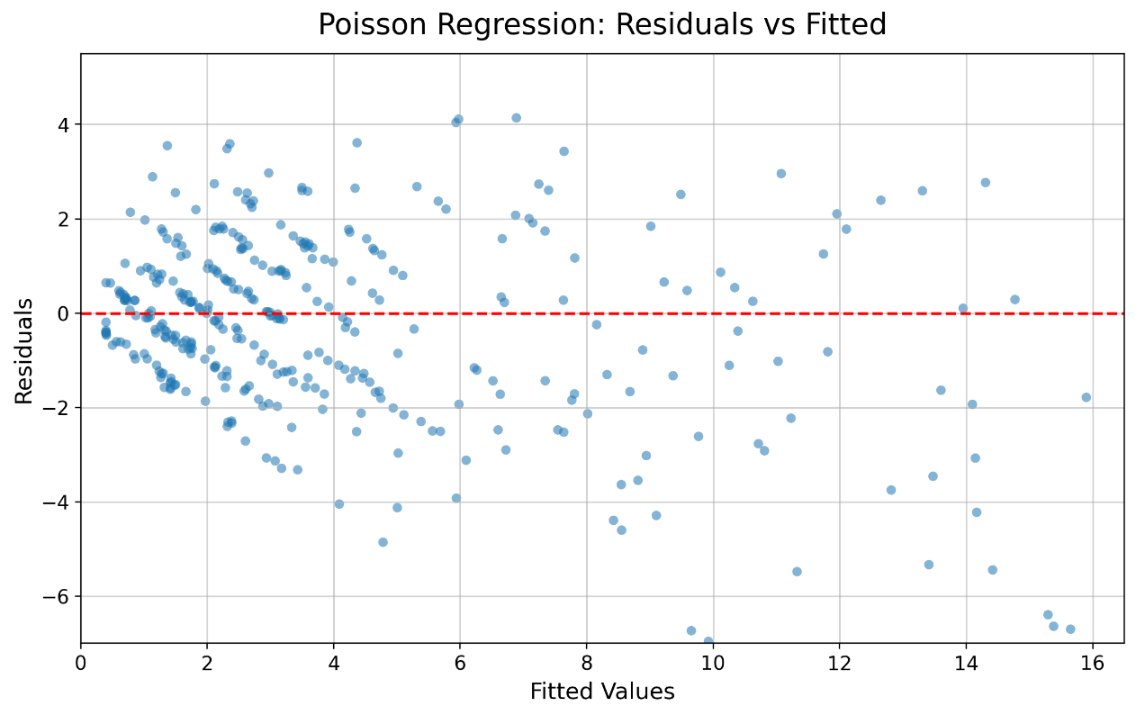
Figure 2: Residuals vs Fitted Plot for the Poisson Regression Model
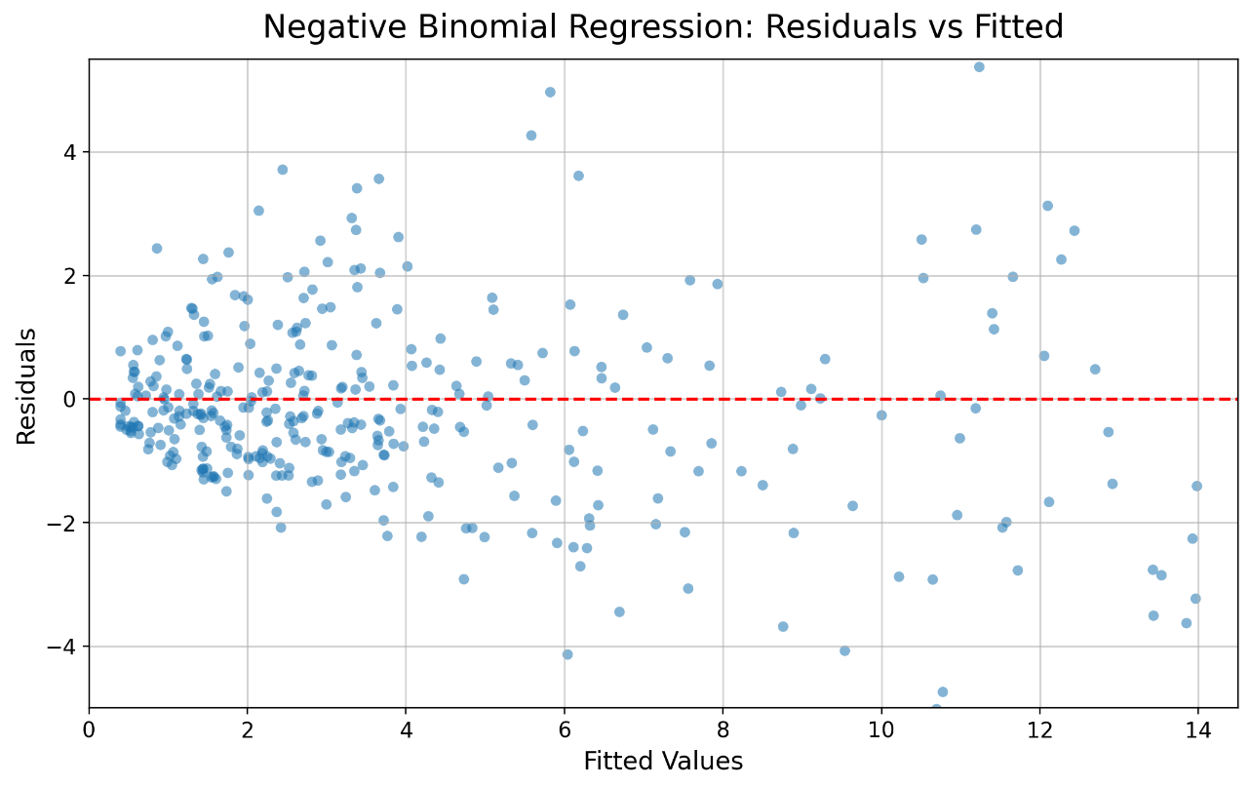
Figure 3: Residuals vs Fitted Plot for the Negative Binomial Regression Model

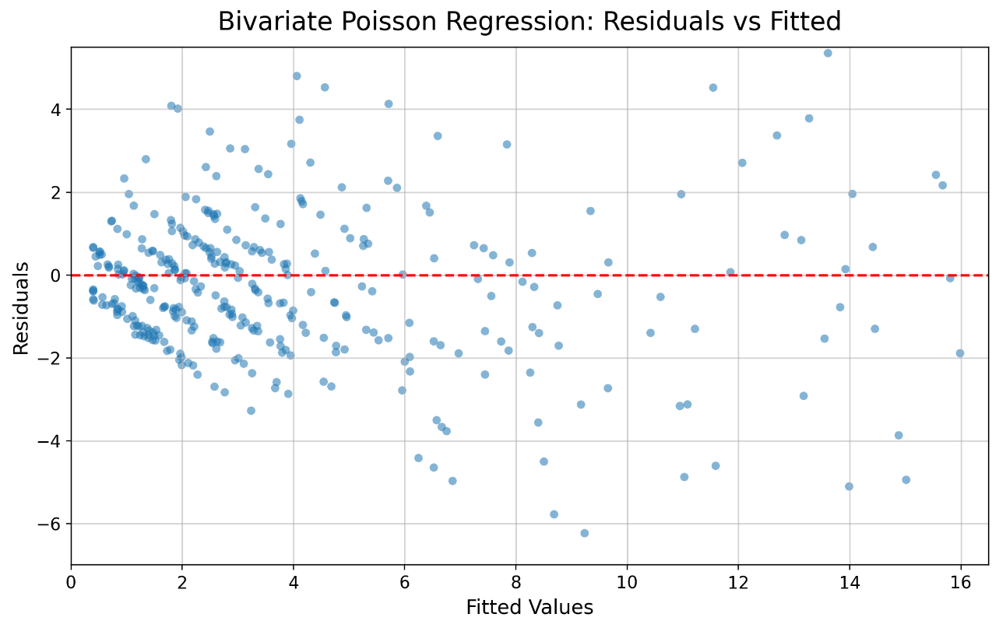
Figure 4: Residuals vs Fitted Plot for the Bivariate Poisson Regression Model
The residual plots show that the prediction errors are mostly distributed around the zero line, indicating that the models capture the general goal scoring pattern reasonably well. However, some systematic deviation is observed at higher fitted values, suggesting slight overprediction for high scoring matches. Considering the overall performance table, the Negative Binomial Regression model provides the most reliable fit, as it handles variability in football goal data more effectively and achieves the highest accuracy and classification measures.

Discussion and Conclusion

Discussion
The primary objective of this study was to evaluate and compare the effectiveness of three regression model: Poisson Regression, Negative Binomial Regression, and Bivariate Poisson Regression for predicting football match outcomes in the English Premier League (EPL). Football scores are naturally represented as count variables, making these statistical model’s appropriate choices for modelling the goal scoring process. The comparison was conducted using prediction accuracy, precision, recall, F1-score, and the ability of each model to capture important characteristics of football scoring data.
The results indicate that all three models were capable of predicting match outcomes with reasonable accuracy; however, notable differences were observed in their predictive performance. The Poisson Regression model, which served as the baseline model, achieved an overall prediction accuracy of 69.99%. Although the model performed satisfactorily in predicting Home Wins and Away Wins, its performance for Draw outcomes was considerably weaker. This limitation can largely be attributed to the fundamental assumption of the Poisson distribution that the mean and variance of the response variable are equal. In practice, football goal data often exhibit greater variability, causing the Poisson model to underestimate the dispersion present in the data.
To overcome this limitation, the Negative Binomial Regression model was implemented. By introducing an additional dispersion parameter, the model effectively accommodated the overdispersion observed in the EPL goal data. The results demonstrate a substantial improvement in predictive performance, with the model achieving the highest overall accuracy of 78.73%, along with superior precision, recall, and F1-score values. The model also showed a significant improvement in predicting Draw outcomes, which are generally more difficult to forecast due to their relatively lower frequency and higher uncertainty. These findings suggest that accounting for overdispersion is essential when modelling football scores and that the Negative Binomial distribution provides a more realistic representation of the scoring process.
The Bivariate Poisson Regression model was developed to jointly model home and away goal counts while incorporating the dependence structure between the two teams scoring processes. From a theoretical perspective, this model offers a more comprehensive framework because football match outcomes are determined by the interaction of both teams rather than by independent scoring processes. The model achieved an overall prediction accuracy of 75.33%, outperforming the standard Poisson Regression model but remaining slightly below the Negative Binomial Regression model. Although the incorporation of dependence and interaction effects enhanced the model’s flexibility. This suggests that the impact of overdispersion in EPL goal data may be more influential than the dependence structure captured by the Bivariate Poisson model.
The comparative analysis clearly demonstrates that the choice of an appropriate probability distribution plays a critical role in football score prediction. Since exploratory analysis revealed the presence of overdispersion in both home and away goal counts, models capable of handling this characteristic naturally produced better results. The superior performance of the Negative Binomial Regression model confirms that relaxing the restrictive assumptions of the Poisson model leads to more accurate and reliable predictions.

Conclusion
This study investigated the application of Poisson Regression, Negative Binomial Regression, and Bivariate Poisson Regression models for predicting football match outcomes in the English Premier League. The models were developed using match performance variables and evaluated using multiple classification metrics, including accuracy, precision, recall, and F1-score.
The findings reveal that the Negative Binomial Regression model provides the best overall predictive performance among the three models considered. By effectively accounting for overdispersion in football goal data, it achieved the highest prediction accuracy of 78.73% and demonstrated superior performance across most evaluation measures. The Bivariate Poisson Regression model also produced competitive results and successfully captured the joint nature of home and away scoring processes; however, its increased complexity did not yield better predictive accuracy than the Negative Binomial model. The standard Poisson Regression model, while useful as a baseline approach, showed comparatively lower performance due to its restrictive distributional assumptions.
Overall, the results suggest that modelling overdispersion is more important than modelling score dependence for improving football match outcome predictions in the EPL dataset considered in this study. Therefore, the Negative Binomial Regression model can be recommended as the most suitable approach among the models examined for football score prediction and match outcome forecasting.

Future Scope
Although the proposed models achieved satisfactory predictive performance, several opportunities remain for future research. Future studies may incorporate additional explanatory variables such as player injuries, team formations, weather conditions, betting odds, and player-level performance statistics to improve prediction accuracy. Advanced machine learning and deep learning approaches may also be explored and compared with traditional statistical models. Furthermore, hybrid models that combine the strengths of count data regression and machine learning techniques could potentially provide more accurate and robust football match predictions. Finally, the methodology can be extended to other football leagues and competitions to evaluate the generalizability of the findings across different competitive environments.

Bibliography
[1] Maher, M. J. (1982). Modelling association football scores. Statistica Neerlandica, 36(3), 109–118.
[2] Dixon, M. J., & Coles, S. G. (1997). Modelling association football scores and inefficiencies in the football betting market. Journal of the Royal Statistical Society: Series C (Applied Statistics), 46(2), 265–280.
[3] Rue, H., & Salvesen, Ø. (2000). Prediction and retrospective analysis of soccer matches in a league. Journal of the Royal Statistical Society: Series D (The Statistician), 49(3), 399–418.
[4] Karlis, D., & Ntzoufras, I. (2001). On modelling soccer data. Student, 4, 229–244.
[5] Karlis, D., & Ntzoufras, I. (2003). Analysis of sports data using bivariate Poisson models. Journal of the Royal Statistical Society: Series D (The Statistician), 52(3), 381–393.
[6] Joseph M. Hilbe (2011). Negative Binomial Regression (2nd ed.). Cambridge University Press.
[7] Koopman, S. J., & Lit, R. (2015). A dynamic bivariate Poisson model for analysing and forecasting match results in the English Premier League. Journal of the Royal Statistical Society: Series A (Statistics in Society), 178(1), 167–186.
[8] Boshnakov, G., Kharrat, T., & McHale, I. G. (2018). Predictive modelling of football scores using statistical methods. International Journal of Forecasting, 34(2), 339–350.
[9] Hubáček, O., Šourek, G., & Železný, F. (2021). Exploiting sports-betting market using machine learning. International Journal of Forecasting, 37(2), 783–796.
[10] https://fbref.com/en/comps/9/Premier-League-Stats
[11] https://www.transfermarkt.co.in/

