Skip to content

  
</>

* [Home](/)
* [Join](/membership/)
* [RLCT](/rlct/)
* [Shop](/boutique/)
* Members
  + [Members Area](/members-area/)
  + [Calendar](/club-calendar/)
  + [Discounts](/discounts/)
  + [Newsletter](/newsletter/)
  + [Photos](/photos/)
  + [By-Laws and Policies](/by-laws-and-policies/)
  + [Socials](/socials/)
* Ride
  + [Ride With Us](/ride-with-us/)
  + [Road Rides](/road-rides/)
  + [Gravel Rides](/gravel-rides/)
  + [Women’s Rides](/womens-rides/)
  + [Zwift Rides](/zwift-rides/)
* Race
  + [TT Results](https://www.ottawabicycleclub.ca/tt)
  + [Open Time Trials](/opentt/)
  + [Women’s Time Trials](/wtt/)
  + [Almonte Area Time Trials](/aatt/)
  + [Almonte Paris Roubaix](/almonte-paris-roubaix/)
* Education
  + [Education Overview](/education/)
  + [Riding Skills Clinics](/riding-skills-clinics/)
  + [Group Riding Clinics](/group-riding-clinics/)
  + [Cycling Safety Presentation](/cycling-safety-presentation/)
  + [Ride Leaders Training](/ride-leaders-training/)
  + [Group Riding](/group-riding/)
  + [Safety Basics](/safety-basics/)
  + [Group Riding Manoeuvres](/auto-draft/)
  + [Group Riding Terminology](/group-riding-terminology/)
  + [Bicycles and Equipment](/bicycles-and-equipment/)
  + [Cycling and the Law](/cycling-and-the-law/)
  + [Railway Crossing Guidelines](/railway-crossing-guidelines/)
  + [Decision Matrix](/decision-matrix/)
  + [Road Safety](/road-safety/)
* Youth
  + [Development Program](/youth-development-program/)
  + [Racing Program](/youth-racing-program/)
* About
  + [About Us](/about/)
  + [Advocacy](/advocacy/)
  + [Awards](/awards/)
  + [Board](/board/)
  + [Contact](/contact/)
  + [Club Office](/office/)
  + [Legal](/legal/)
  + [Social Media](/social-media/)

Menu

* [Home](/)
* [Join](/membership/)
* [RLCT](/rlct/)
* [Shop](/boutique/)
* Members
  + [Members Area](/members-area/)
  + [Calendar](/club-calendar/)
  + [Discounts](/discounts/)
  + [Newsletter](/newsletter/)
  + [Photos](/photos/)
  + [By-Laws and Policies](/by-laws-and-policies/)
  + [Socials](/socials/)
* Ride
  + [Ride With Us](/ride-with-us/)
  + [Road Rides](/road-rides/)
  + [Gravel Rides](/gravel-rides/)
  + [Women’s Rides](/womens-rides/)
  + [Zwift Rides](/zwift-rides/)
* Race
  + [TT Results](https://www.ottawabicycleclub.ca/tt)
  + [Open Time Trials](/opentt/)
  + [Women’s Time Trials](/wtt/)
  + [Almonte Area Time Trials](/aatt/)
  + [Almonte Paris Roubaix](/almonte-paris-roubaix/)
* Education
  + [Education Overview](/education/)
  + [Riding Skills Clinics](/riding-skills-clinics/)
  + [Group Riding Clinics](/group-riding-clinics/)
  + [Cycling Safety Presentation](/cycling-safety-presentation/)
  + [Ride Leaders Training](/ride-leaders-training/)
  + [Group Riding](/group-riding/)
  + [Safety Basics](/safety-basics/)
  + [Group Riding Manoeuvres](/auto-draft/)
  + [Group Riding Terminology](/group-riding-terminology/)
  + [Bicycles and Equipment](/bicycles-and-equipment/)
  + [Cycling and the Law](/cycling-and-the-law/)
  + [Railway Crossing Guidelines](/railway-crossing-guidelines/)
  + [Decision Matrix](/decision-matrix/)
  + [Road Safety](/road-safety/)
* Youth
  + [Development Program](/youth-development-program/)
  + [Racing Program](/youth-racing-program/)
* About
  + [About Us](/about/)
  + [Advocacy](/advocacy/)
  + [Awards](/awards/)
  + [Board](/board/)
  + [Contact](/contact/)
  + [Club Office](/office/)
  + [Legal](/legal/)
  + [Social Media](/social-media/)

Search OBC Website...

# Come Ride With Us!

[Join OBC](/membership)

Upcoming Events

### View Upcoming Events

Close

Whether you just bought your first bike, have been biking on your own for a few months or are an experienced cyclist, the Ottawa Bicycle Club has something for you. The OBC is dedicated to providing high quality recreational and competitive cycling opportunities for cyclists of all ages.

[View all News](/category/obc)

[Subscribe](/subscribe)

### [Profile: Our new Youth Development Mountain Bike Program Coordinator/Coach](/2023/02/24/profile-our-new-youth-development-mountain-bike-program-coordinator-coach/)

We are pleased to announce that Flanderson Prates is joining

[Read More »](/2023/02/24/profile-our-new-youth-development-mountain-bike-program-coordinator-coach/)

February 24, 2023

### [RLCT Registration Open](/2023/01/16/rlct-registration-open/)

Registration open for the 50th edition of the Rideau Lakes Cycle Tour

[Read More »](/2023/01/16/rlct-registration-open/)

January 16, 2023

## Group Rides

The OBC offers a full calendar of weekly group rides and weekend-getaway cycling tours, including road, gravel and women’s-only rides during the cycling season and [Zwift](/zwift-rides) virtual rides over the winter months.

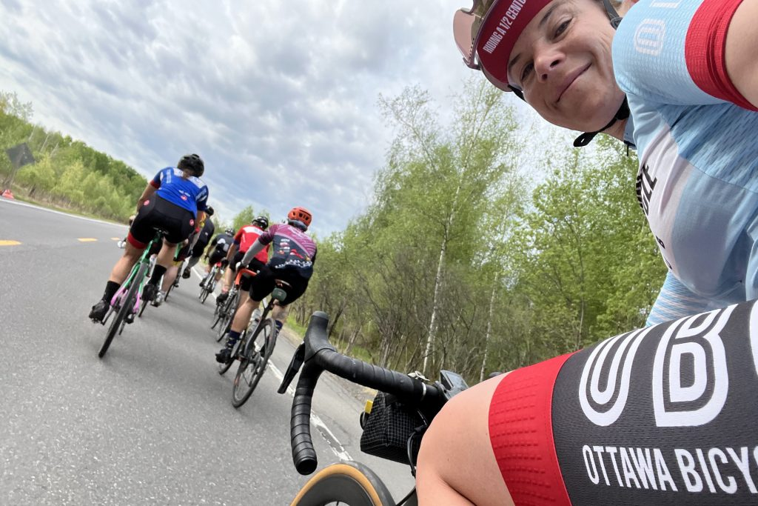

[Road](/road-rides)

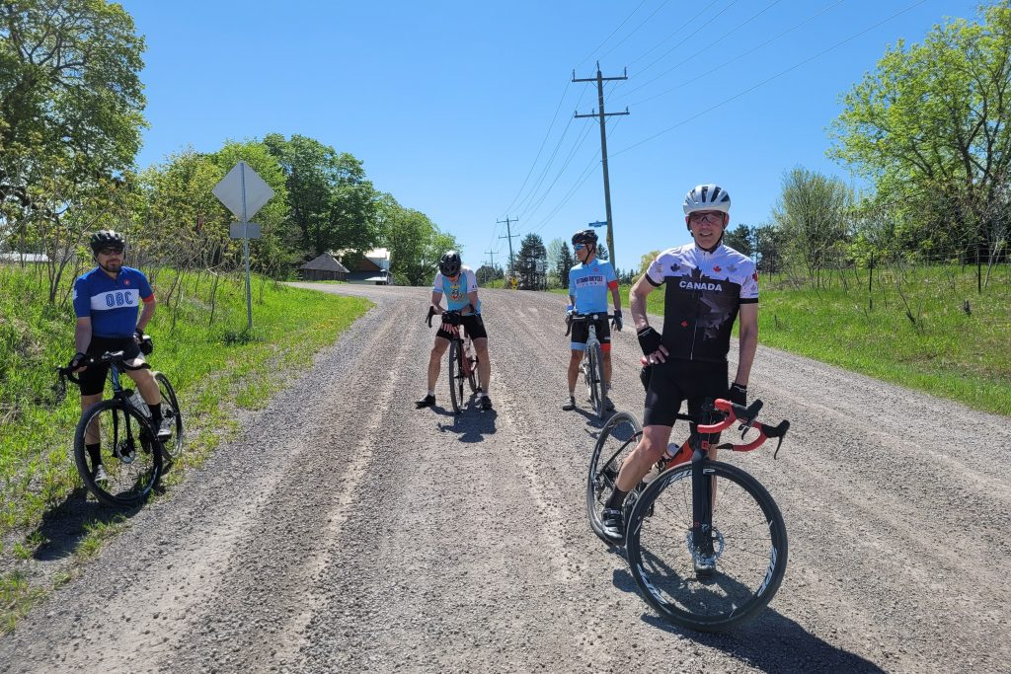

[Gravel](/gravel-rides)

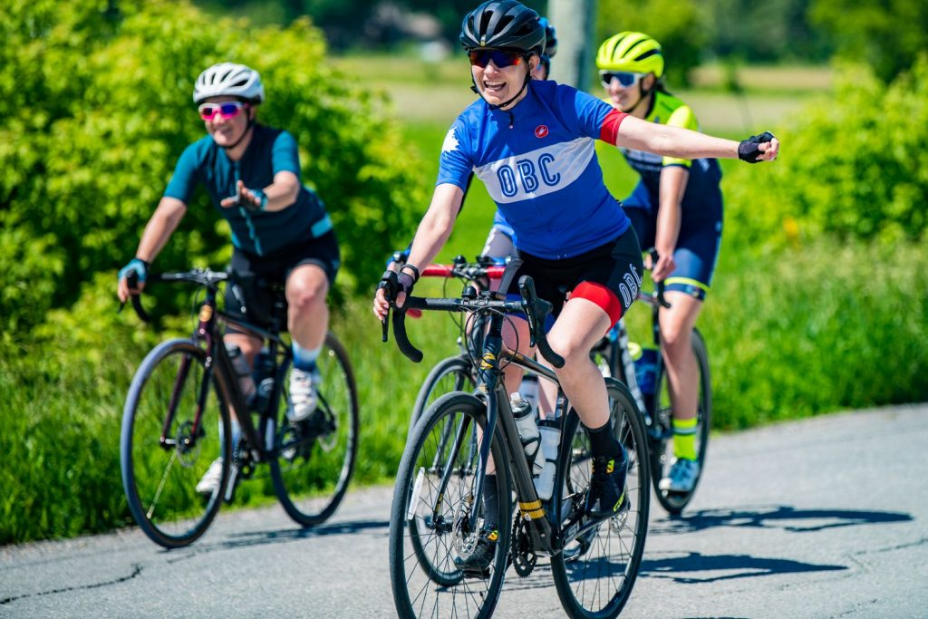

[Women's](/womens-rides)

## Rideau Lakes Cycle Tour

The OBC’s largest and best-known event is the [Rideau Lakes Cycle Tour](/rlct) (RLCT), normally held the second weekend in June, where cyclists of all levels ride through picturesque countryside between Ottawa and Kingston.

The RLCT has attracted up to 2000 cyclists from all over North America for an unforgettable cycling experience.

[Learn More](/rlct)

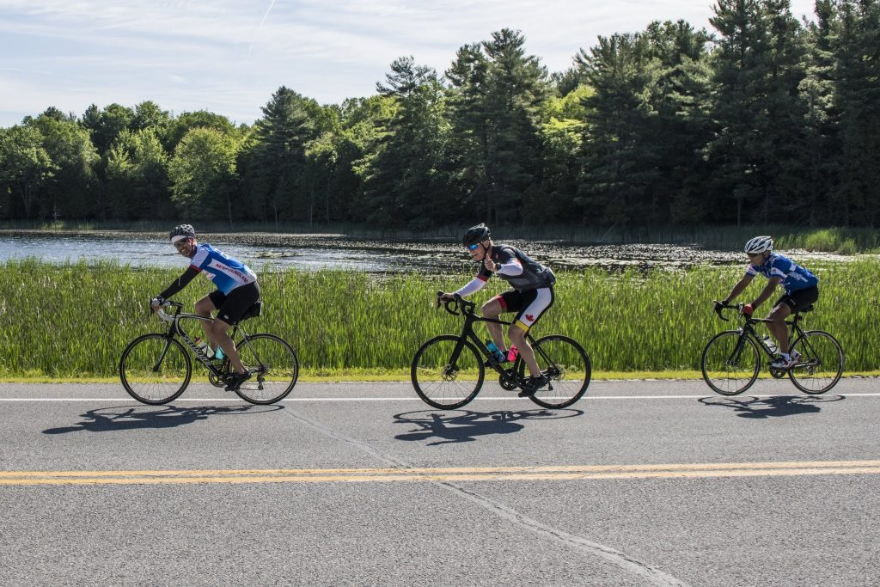

## Youth

The OBC runs a youth development and racing program that has produced nationally-ranked competitors. The OBC Youth Program is structured to meet the needs of athletes and families, while providing quality coaching.

[Learn More](/youth)

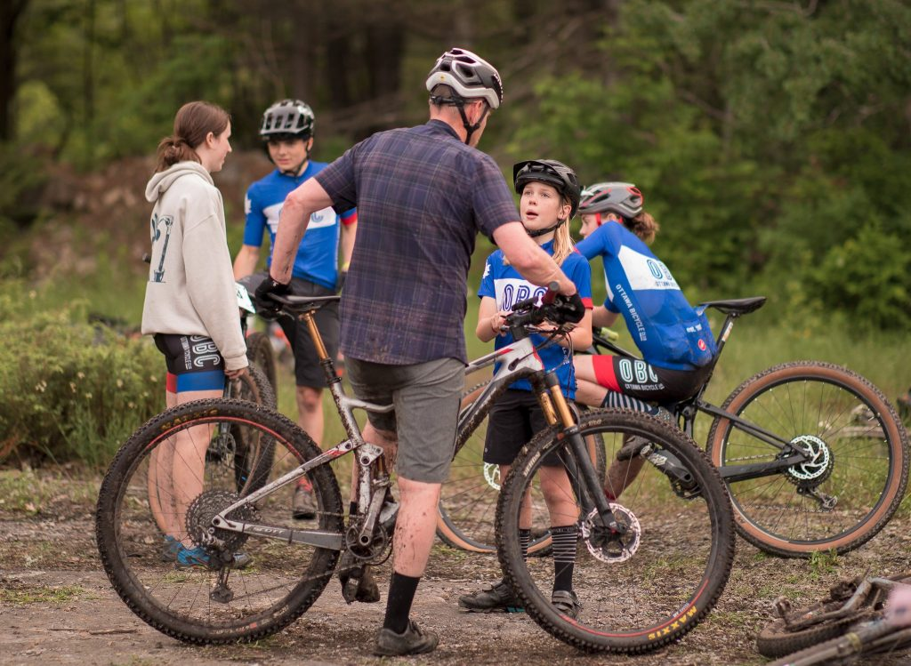

## Racing

For gravel lovers, the OBC hosts the Almonte Paris-Roubaix Cyclosportif in spring and offers weekly time trials, held on Tuesday (women’s-only) and Thursday (open) evenings, for those who prefer smoother roads.

[Learn More](/racing)

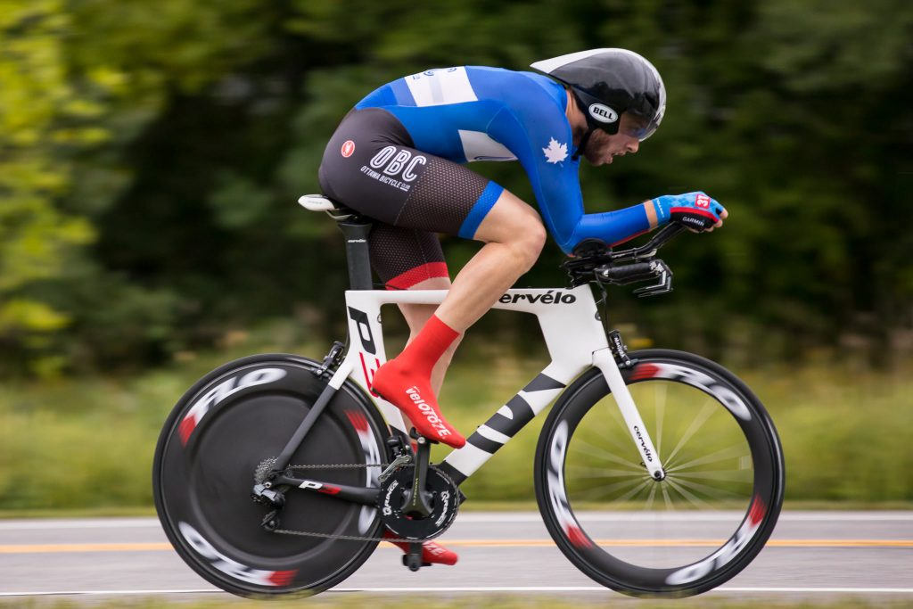

## Education

The OBC offers a number of clinics designed to help members ride safely in a group with a high level of skill, comfort, and fun. For safety reasons, new members are encouraged to complete a [free half-day clinic](/clinics) prior to their first OBC group ride to learn group riding techniques.

[Learn More](/education)

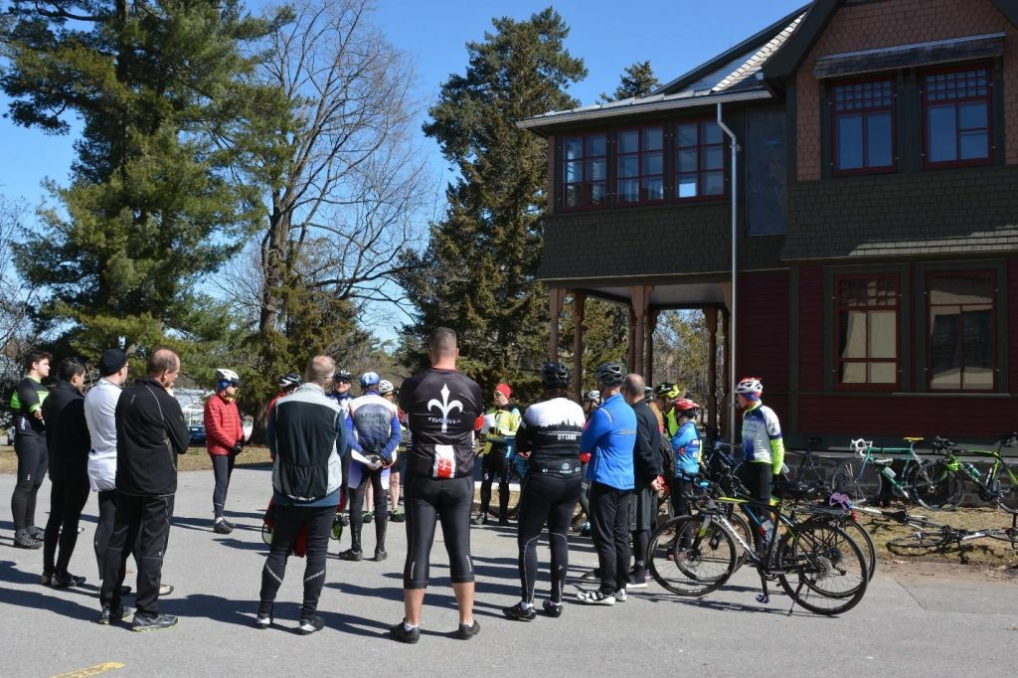

## Social Events

From casual discussions to sharing experiences and learning helpful tips and tricks from other members, club socials are simply meant to be a way for us to get to know each other… OFF the bike!

[Learn More](/socials)

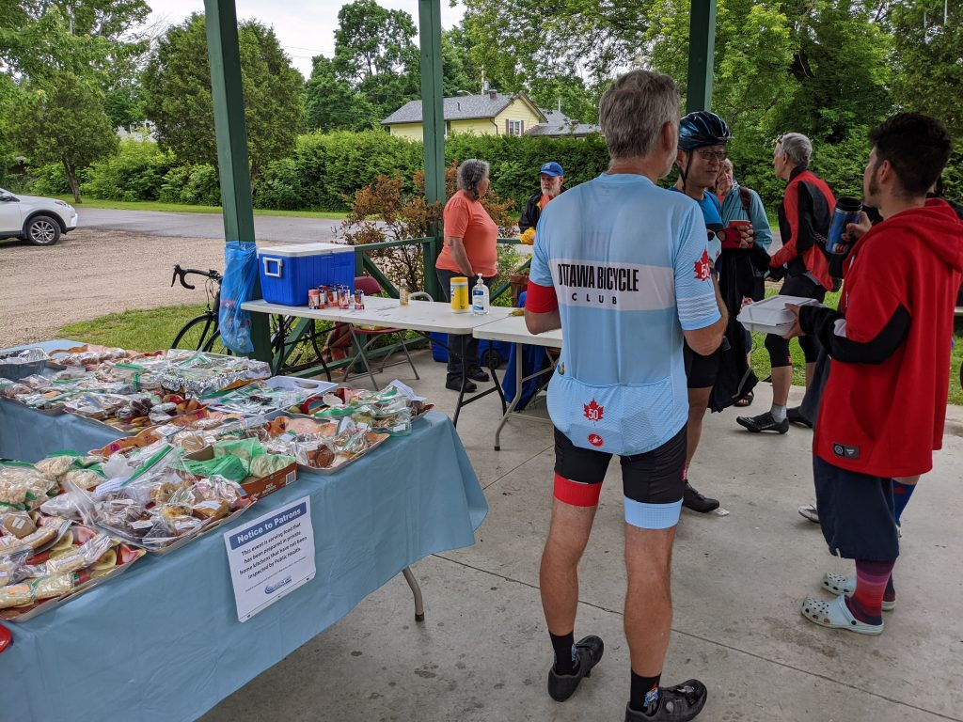

[Ottawa Bicycle Club - Come Ride With Us!](https://www.youtube.com/embed/ET_mERazXNM?controls=1&rel=0&playsinline=0&modestbranding=0&autoplay=0&widget_referrer=http%3A%2F%2Flocalhost%3A3001%2Ftools%2Fimporter%2Fhelix-importer-ui%2Fimport.html&enablejsapi=1&origin=http%3A%2F%2Flocalhost%3A3001&widgetid=1)

### [ottawabicycleclub](https://www.instagram.com/ottawabicycleclub/)

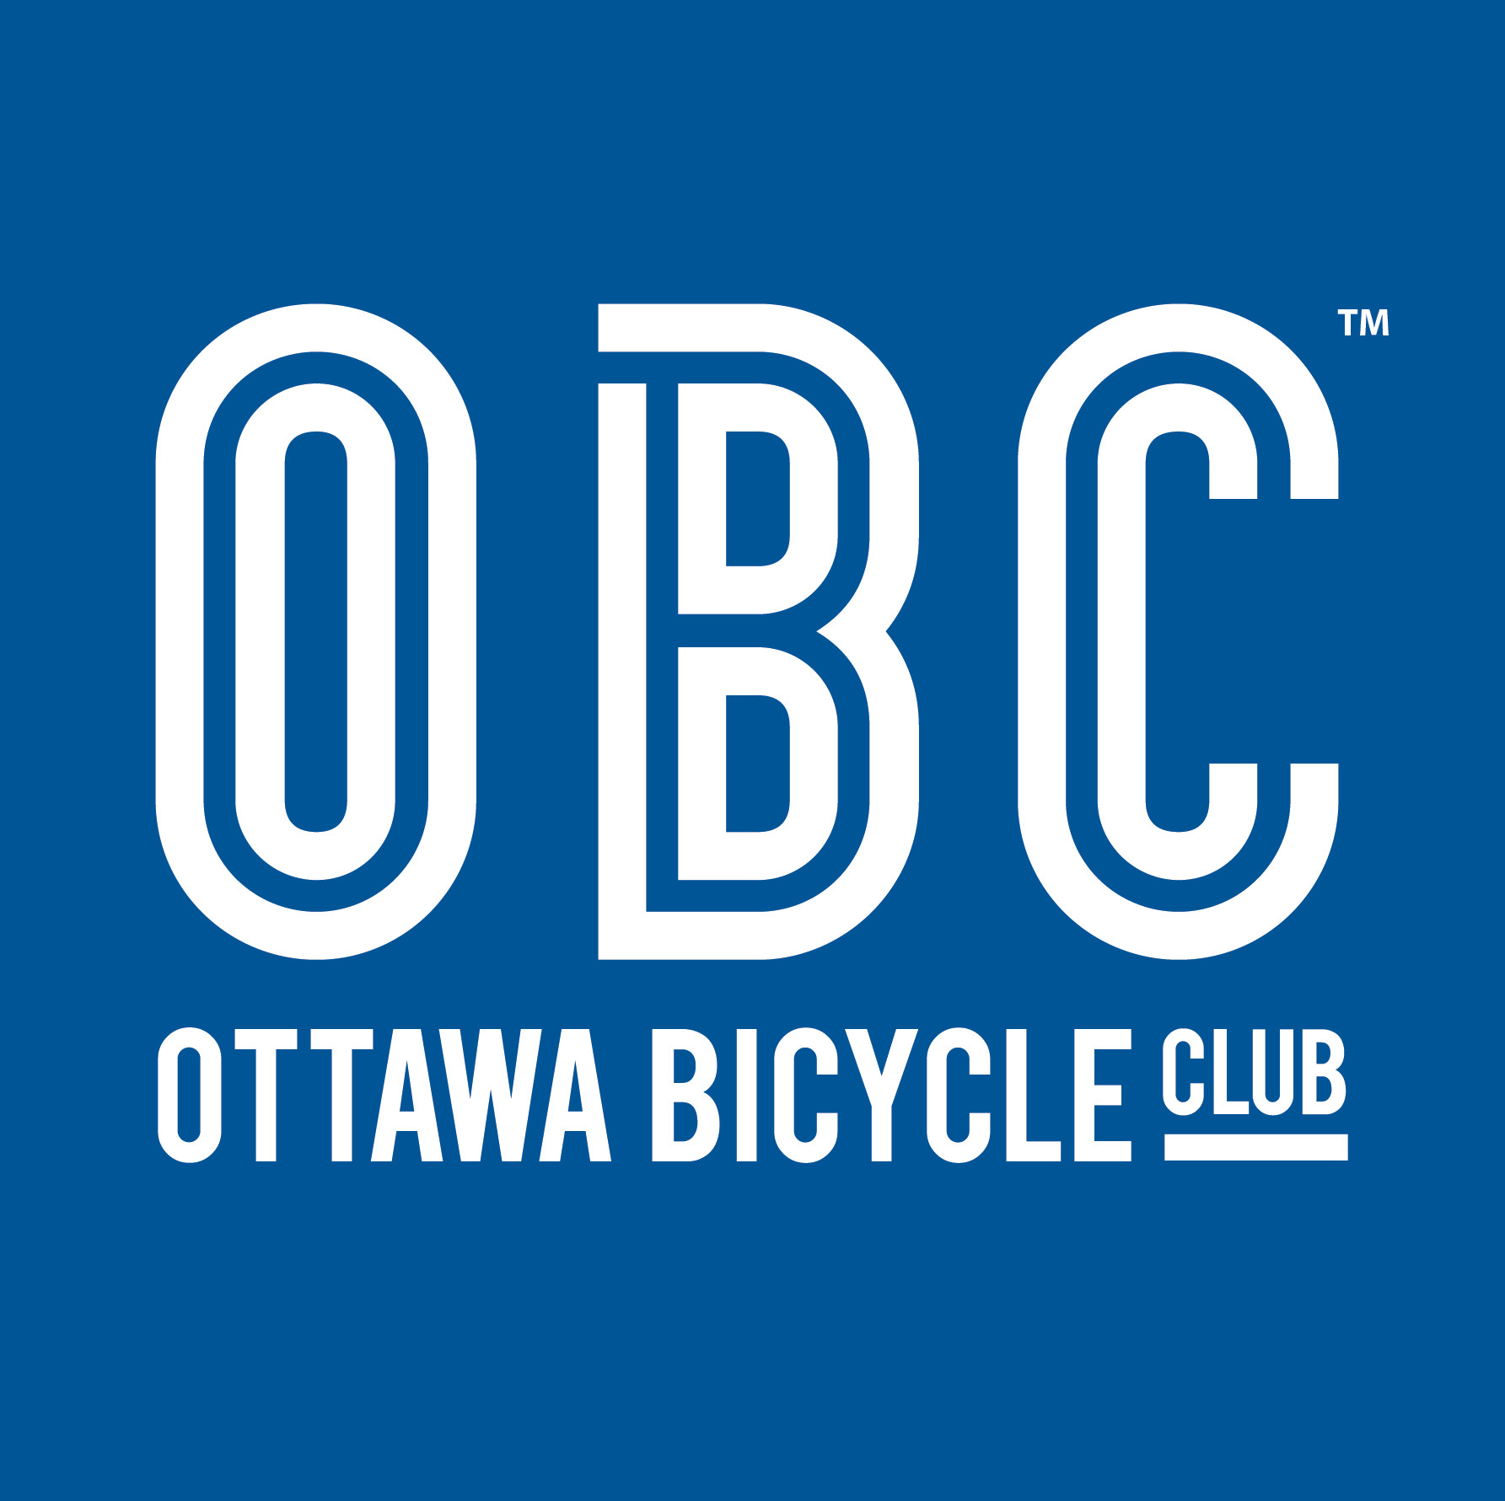  
<https://www.instagram.com/ottawabicycleclub/>

[We are pleased to announce that Flanderson Prates](https://www.instagram.com/p/CpD4N7otjX8/)

[#Repost @rideaulakescycletour ・・・ 400 r](https://www.instagram.com/p/CoQrnQVLoET/)

[Get Your OBC Kit Today! It is a new year and now i](https://www.instagram.com/p/Cn0hKeyom1E/)

[#Repost @rideaulakescycletour ・・・ Spread th](https://www.instagram.com/p/Cnk4AIaLuSO/)

[Load More](javascript:void(0);)  [Follow on Instagram](https://www.instagram.com/ottawabicycleclub/)

  
</>

* [Legal](/legal)
* [News](/category/obc)
* [Credits](/credits)
* [Office](/office)
* [Contact](/contact)

©2023 · Ottawa Bicycle Club · All Rights Reserved