Step 1

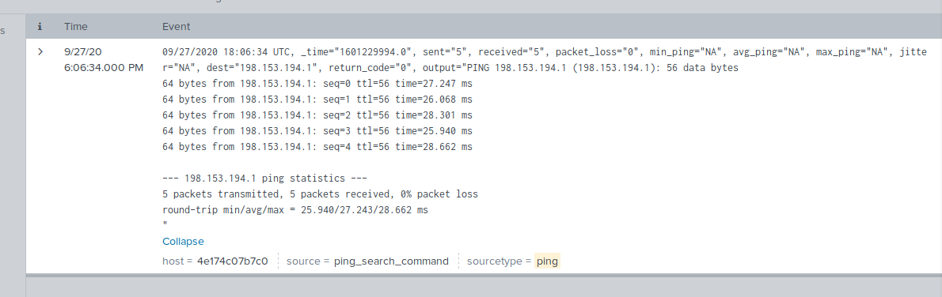

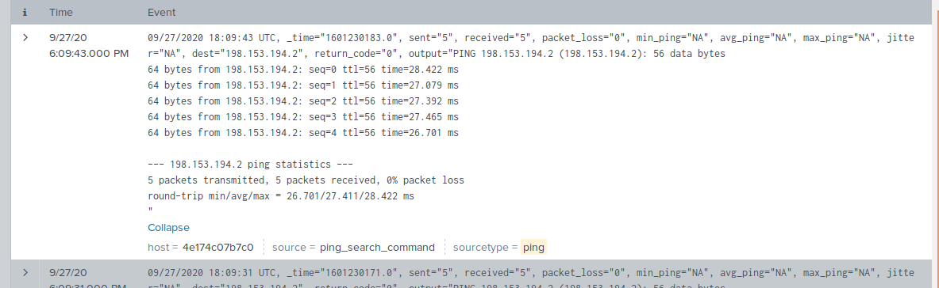

Step 2

2. 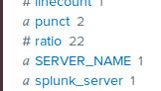

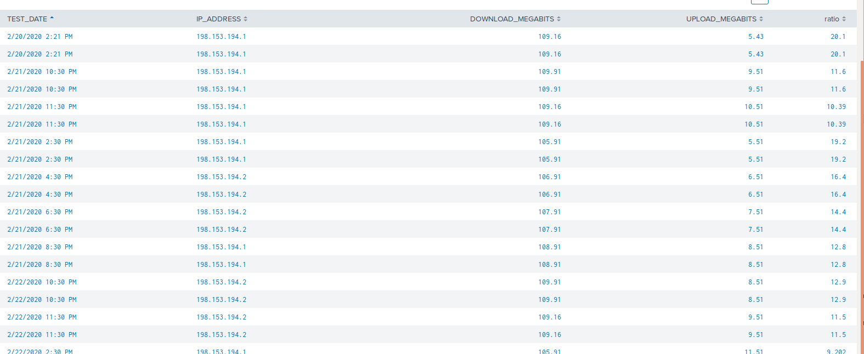

The attack was on the 21st and 22nd, mostly in the evening.

On the 23rd in the afternoon.

Step 3

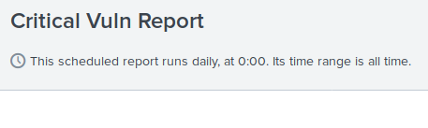

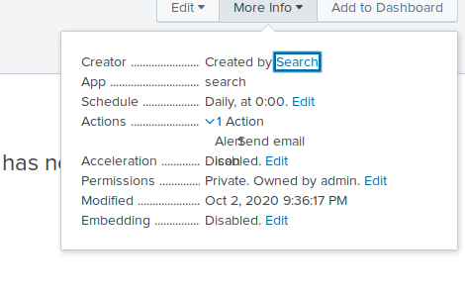

Step 4

2. 0900-1359

Baseline is between 1-39 events. Threshold is >40 events

