HW4

Reading: Chapter 9

The goal of this assignment is to use tkinter to produce a WordGame game. There will be two parts, 1) a class WordGame that implements a text based game and 2) a class WordGameGUI that provides an interface to play the game. Assume that all letters are uppercase. There are two parts:
- WordGame – This class implements a text based WordGame game. Here are the methods you should implement:
- __init__/constructor – accepts one str argument, the secret word. This method should create and initialize 3 attributes (ie., something like self.????? ):
  - string attribute to keep track of the secret word, initialized to the given secret word.
  - string attribute to keep track of correct/right guesses, initialized to an empty str.
  - string attribute to keep track of incorrect/wrong guesses, initialized to an empty str.
- getSecret, getRight, getWrong –methods that return the strings above.
- getHint – returns masked version of the secret word. Only the letters that have been guessed correctly are revealed, all others display as ‘?’.
- getState – returns one of three str values:
  - ‘won’ – if all letters have been guessed correctly (how do you know in terms of the three attributes)
  - ‘lost’ – if there have been 6 (or more) incorrect guesses,
  - ‘playing’ – otherwise
- guess – accepts one argument, an uppercase letter. Does the following:
  - if the game is already won or lost (can call getState to find out), do nothing (quit)
  - if the letter has already been guessed (right or wrong), do nothing (quit)
  - if the letter is in the secret word, add the letter to the correct/right guess attribute,
  - Otherwise (the letter is incorrect) so add it to the wrong/incorrect guess attribute.
- Remark: if you have written the class correctly you should be able to play a text version of the game by running the playWordGame function included at the bottom of this assignment.

]
>>> wg = WordGame('APPLE')
>>> wg.getState(), wg.getHint(), wg.getRight(), wg.getWrong()
('playing', '?????', '', '')
>>> wg.guess('P')
>>> wg.getState(), wg.getHint(), wg.getRight(), wg.getWrong()
('playing', '?PP??', 'P', '')
>>> wg.guess('Q')
>>> wg.getState(), wg.getHint(), wg.getRight(), wg.getWrong()
('playing', '?PP??', 'P', 'Q')
>>> wg.guess('R')
>>> wg.getState(), wg.getHint(), wg.getRight(), wg.getWrong()
('playing', '?PP??', 'P', 'QR')
>>> wg.guess('L')
>>> wg.getState(), wg.getHint(), wg.getRight(), wg.getWrong()
('playing', '?PPL?', 'PL', 'QR')
>>> wg.guess('L')
>>> wg.getState(), wg.getHint(), wg.getRight(), wg.getWrong()
('playing', '?PPL?', 'PL', 'QR')
>>> wg.guess('A')
>>> wg.getState(), wg.getHint(), wg.getRight(), wg.getWrong()
('playing', 'APPL?', 'PLA', 'QR')
>>> wg.guess('E')
>>> wg.getState(), wg.getHint(), wg.getRight(), wg.getWrong()
('won', 'APPLE', 'PLAE', 'QR')
>>> wg.guess('X')
>>> wg.getState(), wg.getHint(), wg.getRight(), wg.getWrong()
('won', 'APPLE', 'PLAE', 'QR')
>>> wg = WordGame('RAILROAD')
- WordGameGUI – this class provides a GUI that allows the user to play WordGame. You can use the Calculator from class as a model for the interface (see images below). Note that this will be evaluated by hand (hard to write a doctest for a GUI). Guidelines (see images below for layout and gameplay):
- WordGameGUI should inherit from Frame.
- __init__/constructor
  - Accepts two arguments, the secret word and a parent (defaults to None).
  - Creates an attribute self.wordgame and initializes it to a new WordGame object that is initialized with the secret word.
  - Creates the following subwidgets (the Entry’s should be stored for later reference). The widgets will be laid out across 6 columns.
    - Word - Label (columnspan 2) & Entry (columnspan 4) displays the current state of the guessed work. This should be initialized by calling self.wordgame.getHint() and filling it into the Entry.
    - Right - Label & Entry – letters guessed correctly so far (starts empty)
    - Wrong - Label & Entry – letters guessed incorrectly so far (starts empty).
    - 26 buttons, one for each letter of the alphabet. Each button should set command=cmd, where cmd is a local function accepting one argument that defaults to the same letter on the button label (same thing we did with the calculator). cmd calls another method click to implement the gameplay above.

- click – will handle the gameplay. It will accept one argument, the letter presses. It accepts one argument, the letter pressed. (Important: when implementing click you should refer to the WordGame (game) object you have stored in the attribute self.wordgame). This method should:
  - Call the guess method for the WordGame game using the letter as an argument
  - Call the getHint method and write the result in the first (Word) Entry.
  - Call getRight method and write the result in the second (Right) Entry.
  - Call getWrong method and write the result in the third (Wrong) Entry.
  - Call getState method. If the result is ‘won’, create a showinfo that displays the message 'You Win!'. If the result is ‘lost’, create a showinfo that displays the message 'You Lose!'. (otherwise do nothing).

Here is an example of how the game works. First, start the game:
>>> root = Tk()
>>> WordGameGUI("APPLE",root).pack()
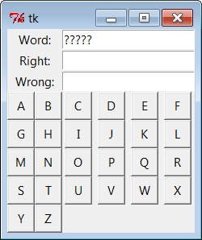 | click ‘P’ | 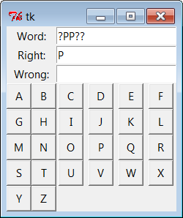 | click ‘P’ again
 | click ‘N’ | 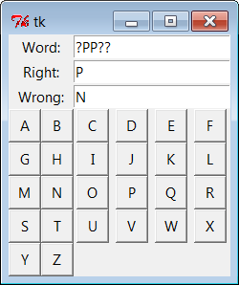 | ‘L’
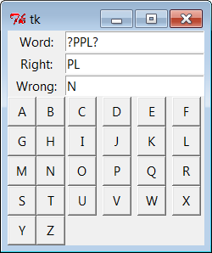 | ‘E’,then ‘A’ | 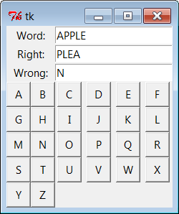 | 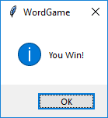  could be ‘You Lose’ if there are 6 wrong letters

================ playWordGame – for testing text based game ================

def playWordGame(word):

wg = WordGame(word)
while True:
print( "secret Word='{}', correct='{}', wrong='{}'".format( wg.getHint(), wg.getRight(), wg.getWrong() ))
letter = input('Guess a letter: ' )
wg.guess(letter)
if wg.getState()=='won':
print( 'Congratulations, you guessed it! The word is {}.'.format( wg.getSecret() ))
break
elif wg.getState()=='lost':
print( 'Sorry, you lose! The secret word is {}.'.format( wg.getSecret() ))
break

