HW5

Reading: Chapter 10
Problems:
Use the usual naming scheme. Make sure you include the name(s) of any collaborators and run the doctest on your solutions.
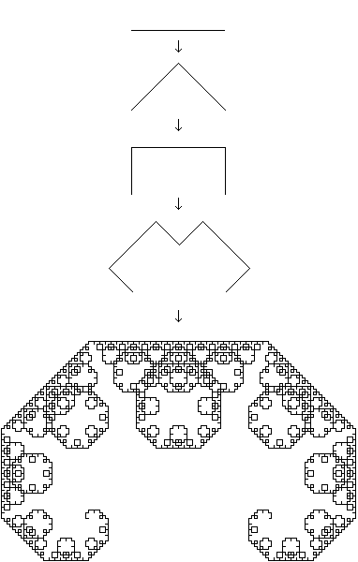
- The Levy curves, like the Koch curves, are fractal curves that can be generated recursively. Write a function levy that produces a code that can be used to draw the nth Levy curve. Each turn should be 45 degrees. You only need to generate the code, you don’t need to draw the curves (though, if you like, you can use the draw function to do so)
Sample runs:
>>> levy(0)
'F'
>>> levy(1)
'LFRRFL'
>>> levy(2)
'LLFRRFLRRLFRRFLL'
>>> levy(3)
'LLLFRRFLRRLFRRFLLRRLLFRRFLRRLFRRFLLL'
>>>

- Write a recursive function fibWord that, when give a non-negative integer n, returns the n^{th} Fibonacci word (a str). The first two Fibonacci words are ‘0’ and ‘01’, every other Fibonacci word is the concatenation of the two previous (order matters). Sample runs:
>>> fibWord(0)
'0'
>>> fibWord(1)
'01'
>>> fibWord(2)
'010'
>>> fibWord(3)
'01001'
>>> fibWord(4)
'01001010'
- Write a recursive function nested that when given n, that is a power of 2, returns a nested list with n ones in it. The list must be nested as given by the output below:
>>> nested(1)
[1]
>>> nested(2)
[[1], [1]]
>>> nested(4)
[[[1], [1]], [[1], [1]]]
>>> nested(8)
[[[[1], [1]], [[1], [1]]], [[[1], [1]], [[1], [1]]]]
>>> nested(16)

- Write a recursive function printCollatz that when given a positive integer n, prints the Collatz sequence that starts at n and ends at 1. A Collatz sequence obeys the following rules: 1) the sequence stops at 1, 2) if the current term n is even, then the next term is n divided by 2, and 3) if the current term n is odd (and not 1), the next term is 3n+1. Sample output:
>>> printCollatz(1)
1
>>> printCollatz(2)
2 1
>>> printCollatz(4)
4 2 1
>>> printCollatz(3)
3 10 5 16 8 4 2 1
>>> printCollatz(8)
8 4 2 1
>>> printCollatz(16)
16 8 4 2 1
>>> printCollatz(5)
5 16 8 4 2 1
>>> printCollatz(10)
10 5 16 8 4 2 1

