**An exploration of data: prediction, modeling and displays**

**Karsten Maurer**

**Department of Statistics**

**Miami University**

**Oxford, OH 45056**

[**maurerkt@miamioh.edu**](mailto:maurerkt@miamioh.edu)

**URL:** [**kmaurer.github.io**](http://kmaurer.github.io/)

**Department Social Media**

**Twitter: @STADeprMiamiOH @statsandstories**

**Podcast:** [**www.statsandstories.net**](http://www.statsandstories.net)

**Statistics and Prediction Example** 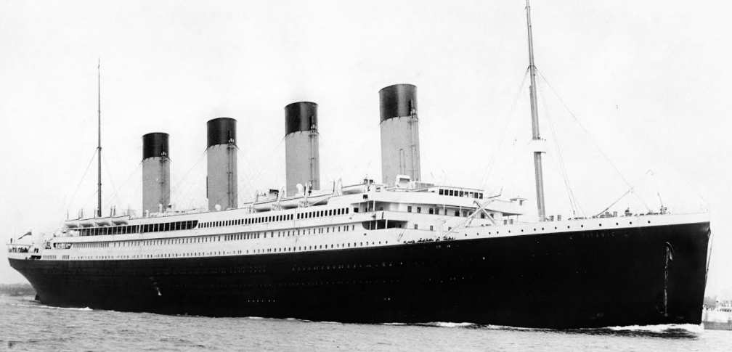

**Background:** In the early morning of April 15, 1912, the RMS Titanic sunk after colliding with an iceberg in the North Atlantic during her maiden voyage from the Samhampton, UK to New York, USA. Roughly 2/3 of the passengers and crew did not survive this accident.

**Data:** In the paper, The "Unusual Episode" Data Revisited published in the Journal of Statistics Education vol.3, no.3 (1995), records for 2201 passengers and crew were recorded with their ticket status (the Class variable), Age (categorized as Adult/Child), Gender (Female/Male) and whether they survived the sinking. 15 of the 2201 passengers/crew were randomly removed from the record and summary tables of the remaining 2186 passengers/crew is included below.

**Questions:**

1. Which variables appear to influence a person’s survival?
2. On the next page is a list of the 15 people removed from the record. Your goal is to:
   1. Predict whether each of the 15 people survived.
   2. Assign a probability/percentage on the likelihood they survived.

|  |  |  |
| --- | --- | --- |
| **Class** **Age** **Gender** **Survived**  **1st** : 324 **Adult** : 2078 **Female** : 465 **No** : 1483  **2nd** : 283 **Child** : 108 **Male** : 1721 **Yes** : 703  **3rd** : 701  **Crew** : 878 | | |
| **Survived**  **Class** **No** **Yes**  **1st** 122 202  **2nd** 167 116  **3rd** 526 175  **Crew** 668 210 | **Survived**  **Age** **No** **Yes**  **Adult** 1431 647  **Child** 52 56 | **Survived**  **Class** **Age** **Gender** **No** **Yes**  **1st** **Adult** **Female** 4 139  **Male** 118 57  **Child** **Female** 0 1  **Male** 0 5  **2nd** **Adult** **Female** 13 79  **Male** 154 14  **Child** **Female** 0 12  **Male** 0 11  **3rd** **Adult** **Female** 89 74  **Male** 385 74  **Child** **Female** 17 14  **Male** 35 13  **Crew** **Adult** **Female** 3 20  **Male** 665 190  **Child** **Female** 0 0  **Male** 0 0 |
| **Survived**  **Gender** **No** **Yes**  **Female** 126 339  **Male** 1357 364 | **Gender**  **Age** **Female** **Male**  **Adult** 421 1657  **Child** 44 64 |
| **Age**  **Class** **Adult** **Child**  **1st** 318 6  **2nd** 260 23  **3rd** 622 79  **Crew** 878 0 | **Gender**  **Class** **Female** **Male**  **1st** 144 180  **2nd** 104 179  **3rd** 194 507  **Crew** 23 855 |

|  |
| --- |
| **Person** **Class** **Age** **Gender**  219 1st Adult Female  566 2nd Adult Female  602 2nd Child Female  633 3rd Adult Male  815 3rd Adult Male  866 3rd Adult Male  1104 3rd Adult Female  1122 3rd Adult Female  1402 Crew Adult Male  1407 Crew Adult Male  1672 Crew Adult Male  1854 Crew Adult Male  2025 Crew Adult Male  2097 Crew Adult Male  2135 Crew Adult Male |

Suppose we built a statistical model … a classification tree was produced below based on a training set of 2186 passengers. (STA 333, STA 467)

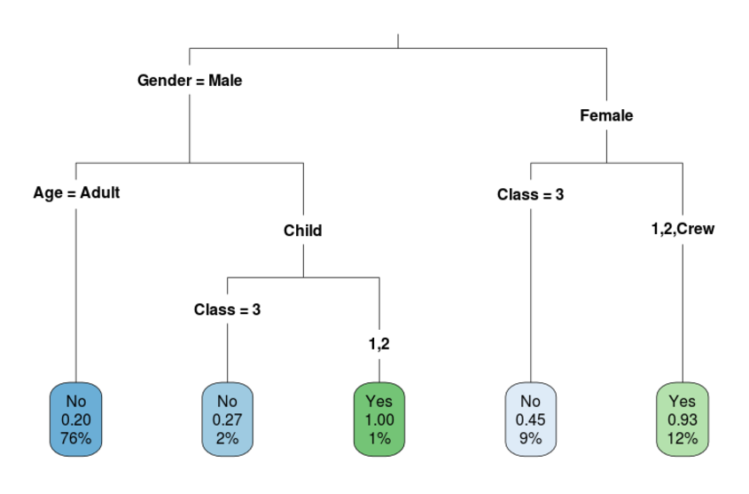

This could be applied to the test set of 15 passengers that were sampled.

Predictions based on classification tree

**Person**    **Class**   **Age**   **Gender**        **P(Not)**   **P(Survived)**  **Predict**  
   219      1st   Adult  Female    0.07380074    0.9261993       Yes  
   566      2nd   Adult  Female    0.07380074    0.9261993       Yes

   602      2nd   Child  Female    0.07380074    0.9261993       Yes

   633      3rd   Adult   Male     0.79782740    0.2021726        No  
   815      3rd   Adult   Male     0.79782740    0.2021726        No  
   866      3rd   Adult   Male     0.79782740    0.2021726        No

  1104      3rd   Adult  Female    0.54639175    0.4536082        No  
  1122      3rd   Adult  Female    0.54639175    0.4536082        No

 1402     Crew   Adult   Male     0.79782740    0.2021726        No  
  1407     Crew   Adult   Male     0.79782740    0.2021726        No  
  1672     Crew   Adult   Male     0.79782740    0.2021726        No  
  1854     Crew   Adult   Male     0.79782740    0.2021726        No  
  2025     Crew   Adult   Male     0.79782740    0.2021726        No  
  2097     Crew   Adult   Male     0.79782740    0.2021726        No  
  2135     Crew   Adult   Male     0.79782740    0.2021726        No

**Person**    **Class**   **Age**   **Gender**        **P(Not)**   **P(Survived)**  **Prediction**      **Truth**  
   219      1st   Adult  Female    0.07380074    0.9261993       Yes         **Yes**  
   566      2nd   Adult  Female    0.07380074    0.9261993       Yes         **Yes**

   602      2nd   Child  Female    0.07380074    0.9261993       Yes         **Yes**

   633      3rd   Adult   Male     0.79782740    0.2021726        No         **Yes**  
   815      3rd   Adult   Male     0.79782740    0.2021726        No          **No**  
   866      3rd   Adult   Male     0.79782740    0.2021726        No          **No**

  1104      3rd   Adult  Female    0.54639175    0.4536082        No         **Yes**  
  1122      3rd   Adult  Female    0.54639175    0.4536082        No         **Yes**

  1402     Crew   Adult   Male     0.79782740    0.2021726        No         **Yes**  
  1407     Crew   Adult   Male     0.79782740    0.2021726        No         **Yes**  
  1672     Crew   Adult   Male     0.79782740    0.2021726        No          **No**  
  1854     Crew   Adult   Male     0.79782740    0.2021726        No          **No**  
  2025     Crew   Adult   Male     0.79782740    0.2021726        No          **No**  
  2097     Crew   Adult   Male     0.79782740    0.2021726        No          **No**  
  2135     Crew   Adult   Male     0.79782740    0.2021726        No          **No**

Our predictions of the 15 passengers that were sampled wasn’t perfect (10 of 15 classified correctly).

Tables can be tough to process. Can we visualize this? (STA 404)

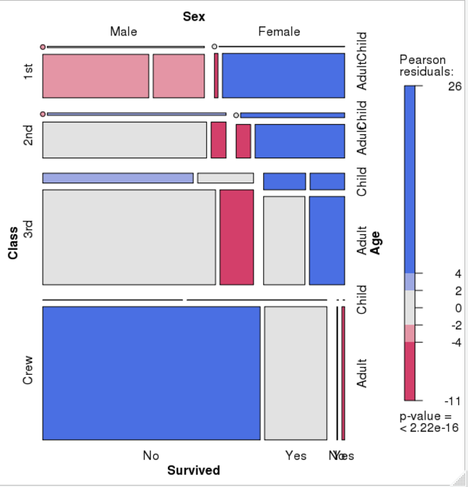

Visual cues in this Mosaic Plot?

* Size of boxes
* Color of boxes

Visualizing data …

The Joy of Statistics – Hans Rosling

<https://www.youtube.com/watch?v=jbkSRLYSojo>

As you watch this video, please record the following information:

What variables were presented?

What graphical characteristic (aesthetic trait) was mapped to each variable?

Rstudio.miamioh.edu -> exploring gapminder data

# Data-visualization-exploration-DEMO-04oct17.R

Studying at Miami University

* Math & Stat Degrees ([B.S. Math & Stat](http://bulletin.miamioh.edu/arts-science/mathematics-and-statistics-bs/), [B.S. Stat](http://bulletin.miamioh.edu/arts-science/statistics-bs/))
  + Foundation in mathematics
  + Statistical modeling
  + Data handling and visualization
* [Analytics Co-Major](http://bulletin.miamioh.edu/arts-science/analytics-comajor/)
  + Complements the B.S. Math & Statistics & B.S. Statistics very well
* [Actuarial Science Minor](http://bulletin.miamioh.edu/arts-science/actuarial-science-minor/) (actuarial science club: Dr. Miljkovic)
  + Complements B.S. degrees and satisfies related hours & thematic sequences
* [Miami University StatHawks](https://muhub.campuslabs.com/engage/organization/StatHawks) (partners with Pi Mu Epsilon for some activities)
  + Student Chapter of the American Statistical Association
  + Can join on the Hub - Events throughout the fall (movie night, trivia, speakers)
* [Center for Analytics and Data Science](http://miamioh.edu/fsb/centers/cads/) (CADS)
  + DataFest - weekend of April 6-8, 2018

THANK YOU!

Questions?