AS/400 Mid-range Operating System
The Signon Screen

The Signon Screen

The Signon Screen

The Signon Screen

•Introduction to AS/400•Definitions•Signing On•Help is available!•Lab stuff

•Introduction to AS/400•Definitions•Signing On•Help is available!•Lab stuff

Introduction to AS/400•Definitions•Signing On•Help is available!•Lab stuff

Is most often used by a company to runtheir daily business transactions•Can be used for special applications withina large organization

Κατάλογος περιεχομένων

AS/400 Mid-range Operating System 1
LECTURE AGENDA 2
What is an AS/400? 2
DEFINITIONS 2
“System” 2
OS400 2
Licensed Programs 3
System Values 3
“User” 3
“Subsystem” 3
“Job” 3
“Interactive Jobs” 3
“Batch Jobs” 3
“Subsystem” 4
Queues 4
Signing On 4
The Signon Screen 4
Main menu 5
Major menu 6
Verb menu 9
Clear commands Menu 10
Clear Physical File Command 10
'?' in Member Parameter 11
Definition of the Member Parameter (Field Level Help) 11
Definition of the CLRPFM Command (Extended Help) 12
The AS/400 is “Green Screen” 12
IBM AS/400 Help 12
A. Files 12
File Member 12
B. Database Files 13
Types of *FILES 13
Source Physical File vs Data Physical File 13
Steps to create a Physical Data File? 13
Loading data into a physical file (created) ? 13
Program described file : How to create & to put data into it 13
Externally described file : How to create & to put data into it 13
AS/400 Architecture 14
Objects 14
Object? 14
Object Types 14
How the AS/400 finds Objects 14
AS/400 commands ask for library and object names 14
Library Lists 14
LIBL vs Qualified Object Name 14
A few special objects 15
What is a Spooled File? 15
Spooled Files 15
How Do Spooled Files get Created? 15
"Work with Jobs" Command 15
WRKUSRJOB (command) 15
WRKSPLF vs WRKOUTQ 16
Lab 1 Objectives 16
“Objects” 16
“Libraries” 16
Library Lists 16
Library List Commands 17
COMMANDS 18
Commands - CL Syntax 18
Commands that do not Require the Entry of Parameters 18
Keyword vs Positional Notation 18
Questions 19
Naming of Commands 19
Some typical nouns 19
How do I find the exact syntax (including keywords) of a command? 19
AS400 Menus 20
Move a file from the AS/400 to the PC using FTP 20
Using Whildcards 20
Reference 20

LECTURE AGENDA
•Introduction to AS/400
•Definitions
•Signing On
•Help is available!
•Lab stuff

What is an AS/400?
•IBM’s “Application System”/400
•Multi-user, multi-tasking
•Is most often used by a company to runtheir daily business transactions
•Can be used for special applications withina large organization

DEFINITIONS

“System”
•The AS/400 is the “system”
– “The system is down”
– “The system is slow today”

OS400
• AS/400 Operating System
• Object-Based
• Not only does it control all the activity on the AS/400, but it also incorporates many features that would be separate software components on other systems.

Licensed Programs
•Programming Languages
– Pascal, PL/1, Basic, RPG, C, C++, Cobol, Java,SQL, etc.

System Values
•Control and Configuration attributes that allow you to customize the operating environment to suit the company.
•These values define what the default valueswill be.
•You can’t change them, but you can look atthem.

“User”
•A person who “uses” the AS/400
•A User will have unique Userid
•A Userid identifies you to the system when you signon
•Each Userid has a User Profile which describes the user and their authorities

“Subsystem”
• Jobs run in subsystems.
•An operating environment in which system resources (eg. main storage) are divided up and allocated.
•Enable better performance tuning.
•Described in subsystem descriptions.
•Most are started at IPL time.

“Job”
•A “job” is any and every piece of work on the AS/400.
•There are two types of jobs:
– Interactive jobs
– Batch jobs

“Interactive Jobs”
•A job that begins when a user signs on to the system and ends when they sign off.
•It is a job with interaction between the user and the AS/400, similar to a conversation (a polite conversation!).
•Input for the job is entered via the screen.

“Batch Jobs”
•A job that runs in the background.
•They do not require input from the screen, but would read data from files.
•They are generally jobs that use a lot of resources and are lower priority than interactive jobs.
•Usually submitted by interactive jobs e.g.a program compile

“Subsystem”
• Jobs run in subsystems.
•An operating environment in which system resources (eg. main storage) are divided up and allocated.
•Enable better performance tuning.
•Described in subsystem descriptions.
•Most are started at IPL time.

Two subsystems
• Interactive jobs run in subsystem QINTER
• Batch jobs run in subsystem QBATCH

Queues
•A queue is a line-up! A place where things wait.
•Examples of AS/400 queues:
– job queues: where batch jobs wait
– message queues: where messages wait
– output queues: where spool files wait to print

Signing On
The AS/400 is easy to use:
•Menu driven
•Lots of built-in help
•Built-in security

The Signon Screen
•The first level of security, it keeps out unauthorized people
•It requires a valid userid and password (see your sticky label)
•Always remember to signoff if you aregoing to leave your computer. If you don’t,someone could come along and clobber your work!

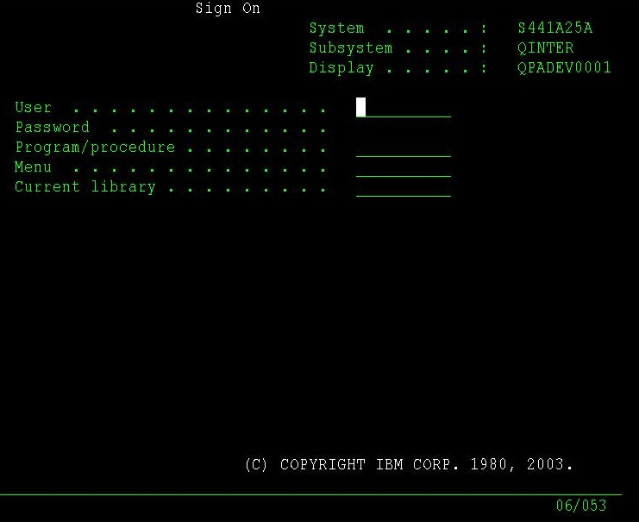

AS/400 Main menu
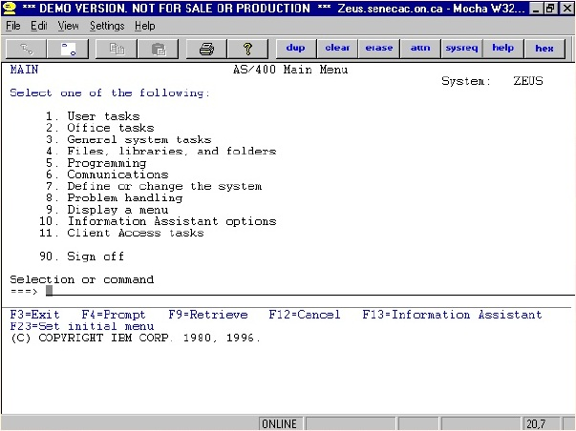

Major Commands menu
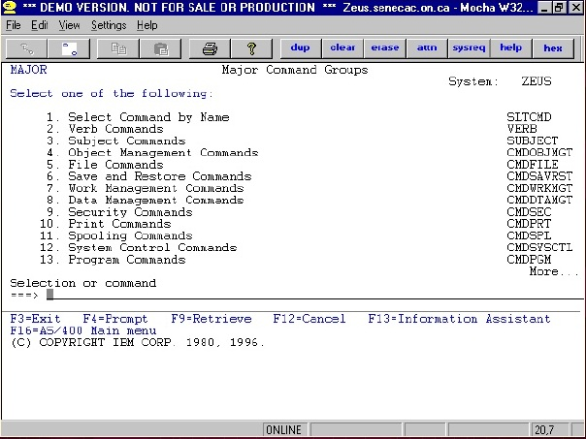

Verb Commands menu
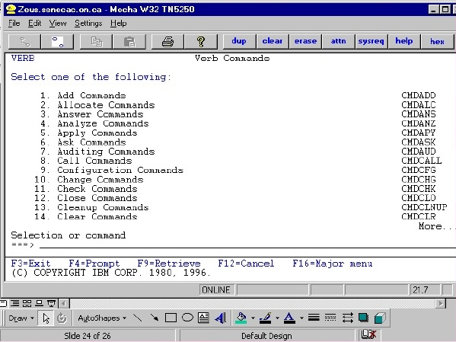

Clear commands Menu
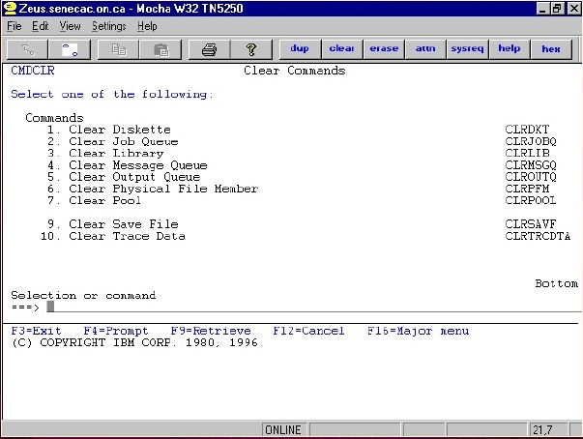

Clear Physical File Command
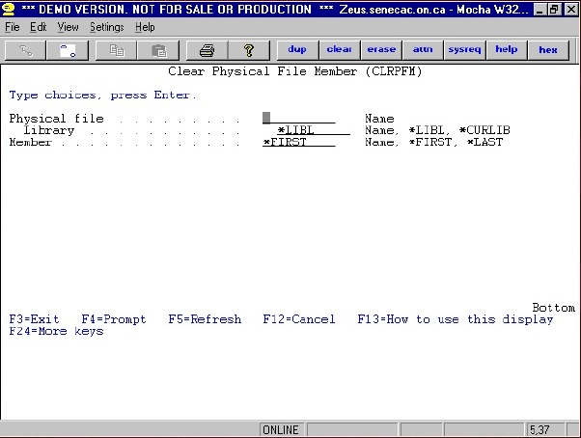

'?' in Member Parameter
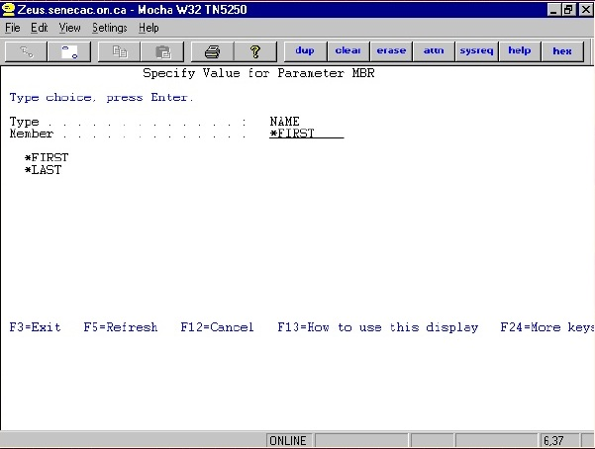

Definition of the Member Parameter (Field Level Help)
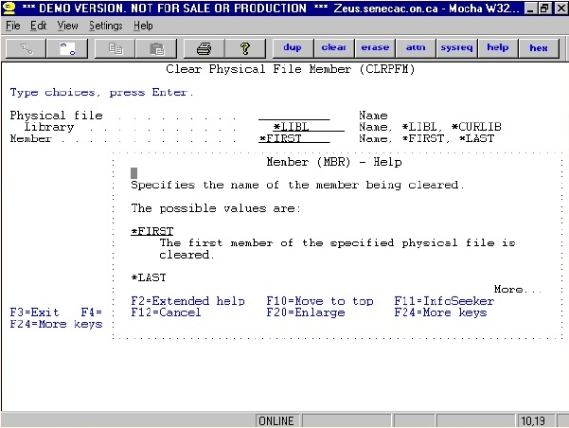

Definition of the CLRPFM Command (Extended Help)
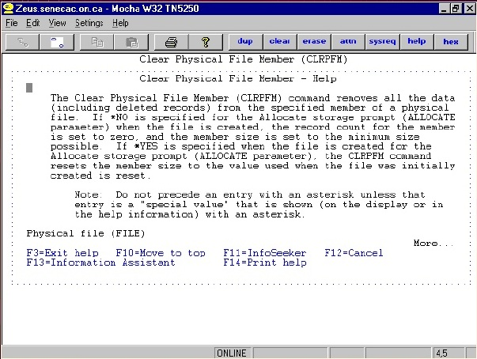

The AS/400 is “Green Screen”
•Green screen v.s. GUI (Graphical User Interface)
•You can’t point and click!
•You must use the TAB keys to go from field to field

IBM AS/400 Help
• F1 = HELP
• Field Level
• Extended Help
• Info Seeker

A. Files
- Files = objects that store data
  - ie. customer file: customer #, address, billing info etc. for each customer
- source file - special file that stores a programmer’s’source code
  - eg. Judy stores all her source code in source file Judysrc (in library Judylib)

File Member
- Source files have many ‘members’ one member for each source program
  - eg. Judysrc file has 3 members: RPGPGM1,RPGPGM2, CLPROG, each contains a different program
- PDM (Prog Dev Mgr) give easy access to a programmer’s stuff (libs/files/mbrs)

B. Database Files

Types of *FILES
- Physical File PF
  - Source
  - Data
- Logical File LF
- Printer File PRTF
- Display File DSPF

Source Physical File vs Data Physical File
- Source Physical File
  - Layout is fixed: 3 fields
- programmers can only alter the length of the textfield
  - Used to store code
- Data Physical File
  - Layout is determined by Application Design
  - Used to store data

Steps to create a Physical Data File?
- Create a Source Physical File called QDDSSRC
- Create a source member in QDDSSRC withthe name of the Data Physical File
- Type in the DDS Code
- Save the Code
- Compile the Code

Loading data into a physical file (created) ?
- DFU
- SQL
- Copy File
- Write a program

Program described file : How to create & to put data into it
- Use the CRTPF command to create the file with a specific record length
- Use a ‘Copy’ command to copy data into the file, or SQL, or write a program, or DFU.

Externally described file : How to create & to put data into it
- Create the source physical file member
- Type in the DDS code
- Use the CRTPF command to create the file with the record layout specified in the DDS Code
- Use a ‘Copy’ command to copy data into the file, or SQL, or write a program, or DFU.

AS/400 Architecture
- Software Applications do not have to be changed or recompiled with the operating system changes.
- Model Names denote the age and speed of the processor.
- Old style: B, C, D, E, F
- New style:720, 740, etc.
- Software vendors base licensing fees on Model

Objects

Object?
- takes up space on the AS400
- Has a Description
- Has an Object Type
- ... are ‘stored in’ (addressed by) libraries

Object Types
- Certain types of commands only work with certain types of Object Types
  - eg. DSPUSRPRF
- Object Type is assigned to the Object at time of creation
  - eg. CRTLIB creates objects with a type of *LIB

How the AS/400 finds Objects
- When an object is created, it is created ‘in’ a particular library.
- To access an object, the AS/400 needs to know what library the object is in.
- The library is really a directory which contains pointers to the objects in that library.

AS/400 commands ask for library and object names
- (CL) Commands prompt you for the object name and library name
  - .eg. CALL and press F4: prompts you for program tocall (the object we are accessing in this case) and the library in which that program object resides.
- We could have a program object named PROGA in two different libraries!

Library Lists
- What if we are always accessing objects in the same libraries over and over again?
- We have to tell the system again and again in which library to find the object? PAIN!
- Hence, the library list. When I go to use an object, assume it is in a library in my library list, a list of commonly used libraries.

LIBL vs Qualified Object Name
- the default for the library parameter incommands is *LIBL - Search my Library List for the object
- Library List is a convenience only, you can always access a library not on the list! (as long as your user profile has proper authority to thelibrary)
- Qualified Object Name:
  - Library/Object ie. CMOPS324/REVIEWS

A few special objects
- Stored in library QSYS:
  - Library Descriptions,
  - Device Descriptions and
  - User Profiles
- This means that you do not have to specify a library name when you access these objects.

What is a Spooled File?

Spooled Files
- When you print something, a spool file is created withthe data to be printed
- WRKSPLF shows your spooled files
- Are stored in Output Queues
- To print a Spooled File, the file must be moved to anOutput Queue attached to a printer.

How Do Spooled Files get Created?
QINTER

1. Job
Program/Command (Data *FILE, Report Layout *FILE) = Spooled file

2. Output Queue
Spooled File

"Work with Jobs" Command
- To display information about your current Interactive job, simply type: WRKJOB
- To display information about any other job, use the Work With Job (WRKUSRJOB) and enter the Job Name and User. Number is Optional.
- To display your Batch Jobs, use the Work with Submitted Jobs Commands (WRKSBMJOB)

WRKUSRJOB (command)
- Shows you a list of all of the jobs that you own on thesystem irregardless of the subsystem
Status:
  - Active = Job is currently running
  - Outq = Job is finished
  - Jobq = Job is waiting to process.
- Do delete a ‘run-away’ job, take option 4

WRKSPLF vs WRKOUTQ
- WRKSPLF groups all of YOUR spooled files together onone screen irregardless of the Output Queue
- WRKOUTQ groups together all of the spooled file in ONE output queue irregardless of the USER

WRKSPLF option 2. Change the Spooled File to OutQ (PRT01)
WRKSPLF-2(DC234X99(SPLF#1, SPLF#2))=PRT01(SPLF#3, SPLF#4)

Lab 1 Objectives
•Get you familiar with AS/400 greenscreens, using menus etc.
•Review some of the definitions covered inlecture (user profile, jobs, subsystem, screentypes, accessing help)
•Set up your stuff for later labs (a file for youto store your programs)

“Objects”
•any thing on the AS/400 that has a nameand takes up space in storage
•on Unix/Windows, everything is a file
•on AS/400, everything is an object
•on Windows, files have extensions (.txt)
•on AS/400 objects have types
•Common object types include:
– libraries, files, job queues, programs

“Libraries”
• Library: an object whose purpose is to‘store’ and index other objects. ie. objectsare ‘stored’ in libraries.
•Exactly like a directory in Unix/Windowshowever you do not have libraries withinlibraries on the AS/400.
•Example: user Deb stores all her objects in library DEBLIB

Library Lists
Each job has an attached Library List
Different Types of Libraries:
- System: IBM Supplied
- Product:Added automatically when an IBM product is used
- Current: Defined by an individual user ID
User ID’s default Library
- User: Non-IBM Supplied Libraries
Created by Business to organize programs, files,etc.
Determine where a Job finds Objects
Parts of a Library List (or the 4 library list types)
- System (SYS)
- Product (PRD)
- Current (CUR)
- User (USR)

Library List Commands
- ADDLIBLE -
  - Adds an entry to a library list to the USER portion of the library list
- RMVLIBLE -
  - Removes an entry from the USER portion of thelibrary list
- EDTLIBL -
  - Adds/Deletes/Changes entries on the USER portionof the library list
- CHGCURLIB -
  - Changes the Current Library
- CHGLIBL -
  - Changes the Current Library and allows
  - Add/Change/Delete to the USER portion of thelibrary list.

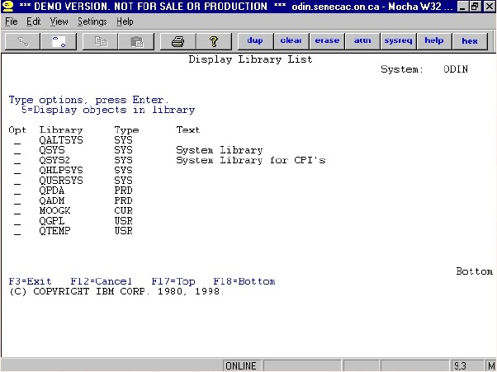

*** All Library List commands are listed on the CMDLIBL menu.
*** Don’t rename or delete your current Library!

COMMANDS

Commands - CL Syntax
> Comand-name ((space) parameter)

Commands that do not Require the Entry of Parameters
WRKJOB
WRKACTJOB
WRKSBMJOB

Keyword vs Positional Notation
Keyword
WRKOUTQ OUTQ(PRT01)
CRTLIB LIB(MOOGK10) +
TEXT(‘Cindys Library’)
Positional
WRKOUTQ
PRT01CRTLIB MOOGK10 *PROD ‘Cindys Library’

Questions
How do I know what the *&(&!! Commands are?
How do I know what the !@#!@ Keywords are?

Naming of Commands
- Based on English!
- Combination of Verb and Noun
  - e.g. CRTLIB = Create + Library
- Typically start with the following verbs:

CL Verb | English | Description
CALL | Call | Executes a program
GO | Go to | Executes a Menu
CPY | Copy | Copies a file
CRT | Create | Creates an object
DSP | Display | Displays something about an object
WRK | Works With | Works with an object

Some typical nouns
CL Noun | English | Description
LIB | Library | Object that holds Objects
LIBL | Library List | List of Libraries for a Job
OUTQ | Output Queue | Object that stores Spool Files
JOBQ | Job Queue | Object that stores Batch Jobs to be processed
FD | File Desc | Description of file
F | File | Object that stores data
USRPRF | User Profile | Object that lists attributes about a Sign On Id

How do I find the exact syntax (including keywords) of a command?
- Answer:
  - Use AS400 Menus
  - Use AS400 Prompts (F4)
    - by pressing F4 at a Command line
    - by typing command and pressing F4
- How do I find the Keywords to a command?
  - Type the command and press F4

AS400 Menus
Menu | Description
MAIN | Main Menu
PROGRAM | Programmers Menu
MAJOR | Sorts Commands
CMDCPY | Copy Commands
CMDDSP | Display Commands
CMDWRK | Work With Commands
CMDLIB | Library Commands
CMDMSG | Message Commands
CMDOUTQ | Output Queue Commands
CMDUSRPRF | User Profile Commands

Move a file from the AS/400 to the PC using FTP
- Open a DOS Window by clicking o the MS-DOS Prompt on your desk top.
- Type FTP ODIN.SENECAC.ON.CA
- Login by typing your User id (DC234 ???) - Press ENTER
- Enter your Password - Press ENTER
- Type GET LIBRARY/FILENAME.MEMBER C:\NEWFILE -Press ENTER.
  - For example, to move REVIEW file, member REVIEW1 in CMOPS324 library to a file called REVIEW1 in your C: drive, do this: GET CMOPS324/REVIEWS.REVIEW1C:\REVIEW1
- To exit type BYE - Press ENTER

Using Whildcards
- What does the ‘*’ (Asterix) denote?
  - When used before an ‘AS/400’ word, indicatesthat the word is a special value.eg. CRTLIB LIB(MOOGK1)TYPE(*TEST) TEXT(‘Cindys Library)
  - When used at the end of a word, indicates ageneric combination of alphanumerics(wildcards). eg. WRKLIB SIMON*
- Use of the ‘?’
  - Entering a command to see all possible values for aparameter.
  - F4 does the same

Reference
Based on http://www.scribd.com/doc/19245156/As-400-Admin-ppt

