Exporting Figures in R
You can save plots directly to your computer using functions such as png(), jpeg(), pdf(), and tiff(). These functions open a graphics device (AKA portal) that directs your plots to a file instead of displaying them in the RStudio Plots pane.
Steps:
- Call a graphics device function (e.g., png()) and specify the file name and any settings.
- Create your plot using plot(), ggplot(), or another plotting function or supply an object that has your plot stored in it.
- Call dev.off() to close the graphics device (AKA close the portal) and finish saving the file.

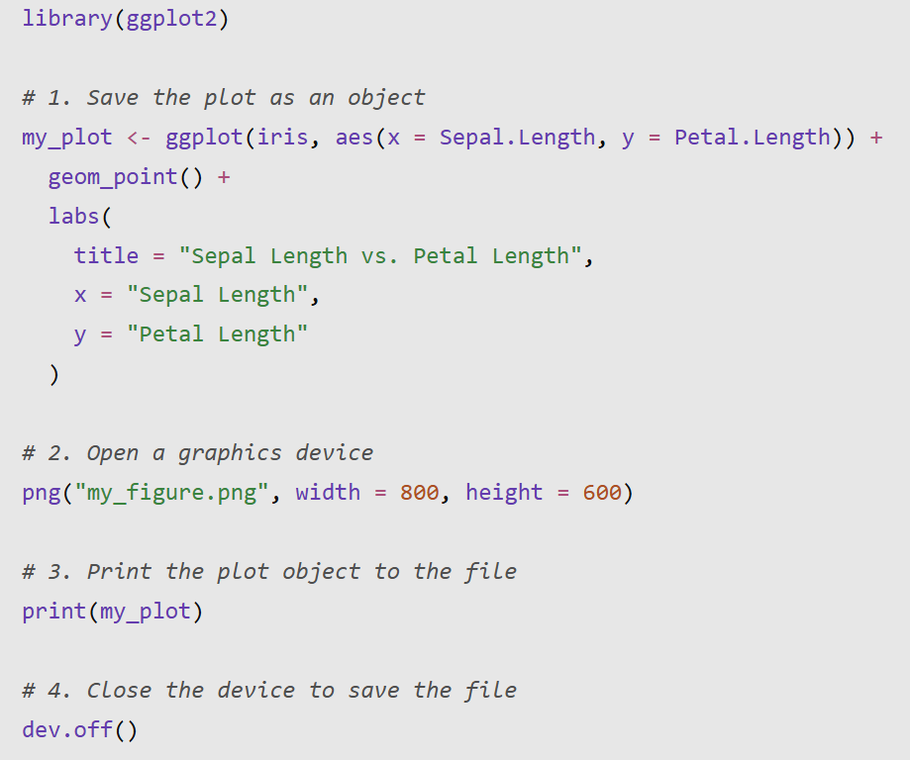

Common file formats
Function | File format | Best for
png() | PNG | Digital reports and presentations
jpeg() | JPEG/JPG | Photographs and continuous-tone images
pdf() | PDF | High-quality, scalable figures for papers and reports
tiff() | TIFF | Publications requiring high-resolution images

Important tips
- File location: Files are saved to your current working directory unless you specify a full file path. Use getwd() to check your working directory.
- Specify a path: For example, png("figures/my_figure.png") saves the file in a figures folder inside your working directory. The folder must already exist.
- Always use dev.off(): This closes the graphics device (AKA portal) and ensures the file is finalized properly.
- Set dimensions and resolution: For raster formats like PNG and JPEG, use width, height, and res to control image size and resolution. For example, png("figure.png", width = 6, height = 4, units = "in", res = 300).
- One device (AKA portal), one plot: Each graphics device generally captures the plots drawn while it is open. Close it with dev.off() before opening another device.
Remember: Open the device (AKA portal) → create the plot → close the device (AKA portal).

