Kimberly Clarisse P. Puno
2196 – 6AWEB
WD – 302 January 21, 2026
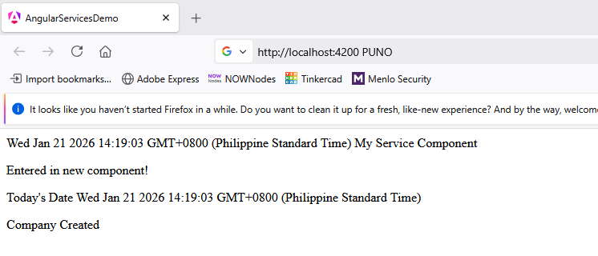

REFLECTION
Creating this Angular Services activity helped me understand how services allow data and logic to be shared across components effectively. I saw how the @Injectable decorator and service injection simplify code reuse and improve modularity. Implementing showTodayDate() and serviceproperty showed me how services can return dynamic values and static properties to multiple components. It was satisfying to see the output reflect both the date and the shared property, proving the service integration worked. This activity strengthened my confidence in using Angular services for scalable and maintainable app development.

