SALARY MANAGEMENT SOFTWARE
Complete Project Documentation
Architecture • Features • Email System • API Reference • Debugging Guide • Interview Prep
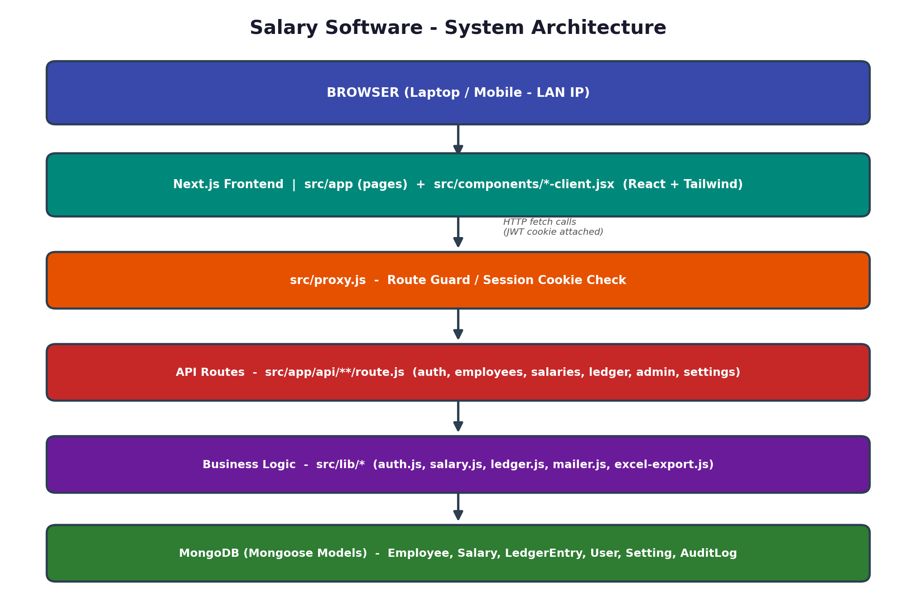
System Architecture — high level overview
Prepared as a Senior-Developer style handover document
Language: Hinglish (Hindi + English mix) for easy understanding

Table of Contents

1. Project Overview (Project Kya Hai)
Ye ek Next.js based Salary Management System hai jo school ya kisi bhi organization ke employees, unki monthly salary, ledger expenses, reports, users, backup/restore aur security sessions ko ek hi jagah manage karta hai.
Simple shabdon me samjho: is software me HR/Accountant employees ka data rakhta hai, har mahine unki attendance ke hisaab se salary calculate hoti hai, PDF slip banti hai, aur poora data safely MongoDB database me store hota hai.

Main Features
- Employee Master Data — naam, employee ID, role, department, phone, address, bank details, salary, photo, active/inactive status.
- Salary Module — monthly salary, working days, present/absent, CL, half CL, emergency leave, bonus, advance, deductions, PF, net salary.
- Bulk Salary Generation — active employees ke liye ek saath salary create karna.
- Ledger Module — expenses/advances entries maintain karna.
- Reports — salary history, filters, Excel/PDF export.
- Salary Slip — printable/PDF salary slip with branding assets.
- Admin Module — users create/update, permissions manage, account disable.
- Settings Module — school profile, email/SMTP, backup/restore, security sessions.
- Auth — JWT based secure HTTP-only cookie sessions.

Interview me kaise bolein (Elevator Pitch)
💡 Quick Answer
"Maine ek full-stack Salary Management System banaya hai using Next.js App Router, MongoDB aur JWT authentication. Isme employee management se lekar salary calculation, PDF salary slip, Excel reports, aur database backup/restore tak sab automated hai. Architecture layered hai — Frontend, Middleware guard, API routes, Business logic, aur Database — jisse code maintainable aur scalable hai."

2. Tech Stack (Technology Used)
Layer | Technology | Kaam Kya Hai
Frontend | Next.js (App Router), React, JSX | UI pages aur components render karta hai
Styling | Tailwind CSS | Utility-class based fast styling
Backend APIs | Next.js Route Handlers (src/app/api) | Server-side logic aur data operations
Database | MongoDB + Mongoose | Employee, Salary, Ledger, User data store
Auth | JWT (jose) + bcryptjs | Login session aur password hashing
Validation | zod | Input data validate karna
Export/PDF | xlsx, jspdf, html2canvas | Reports aur salary slip PDF/Excel
Email | nodemailer | SMTP se email bhejna (OTP, alerts)

3. System Architecture (Colorful Diagram)
Neeche diya diagram poore system ka data-flow dikhata hai — Browser se request start hoti hai aur layer-by-layer neeche MongoDB tak jaati hai. Ye diagram interview me architecture explain karne ke liye sabse useful hai.
🔑 Yaad Rakhne Wali Baat
Har request pehle proxy.js (middleware) se guzarti hai jo session cookie check karta hai — isliye koi bhi bina login ke protected page access nahi kar sakta.

4. Folder Structure (Root & src)

Root Folder
Path | Kya Hai
.env.example | Example environment variables
.env.local | Local secret/config file — SHARE NA KAREIN
.mongo-data/ | Local MongoDB data folder
.next/ | Next.js build/dev output (generated)
backups/ | Local backup JSON files
database_backup.json | Existing database backup file
next.config.js | Next.js config + LAN/dev origin settings
package.json | Scripts aur dependencies
public/ | Static images/logos/assets
scripts/ | Utility scripts (backup/profile switch)
src/ | Main application source code
⚠️ Important Warning
.env.local, .mongo-data, backups, aur database_backup.json me sensitive/real business data hota hai. Client delivery ya public GitHub upload se pehle inhe carefully exclude/handle karein.

src/ Folder Map — Visual Diagram
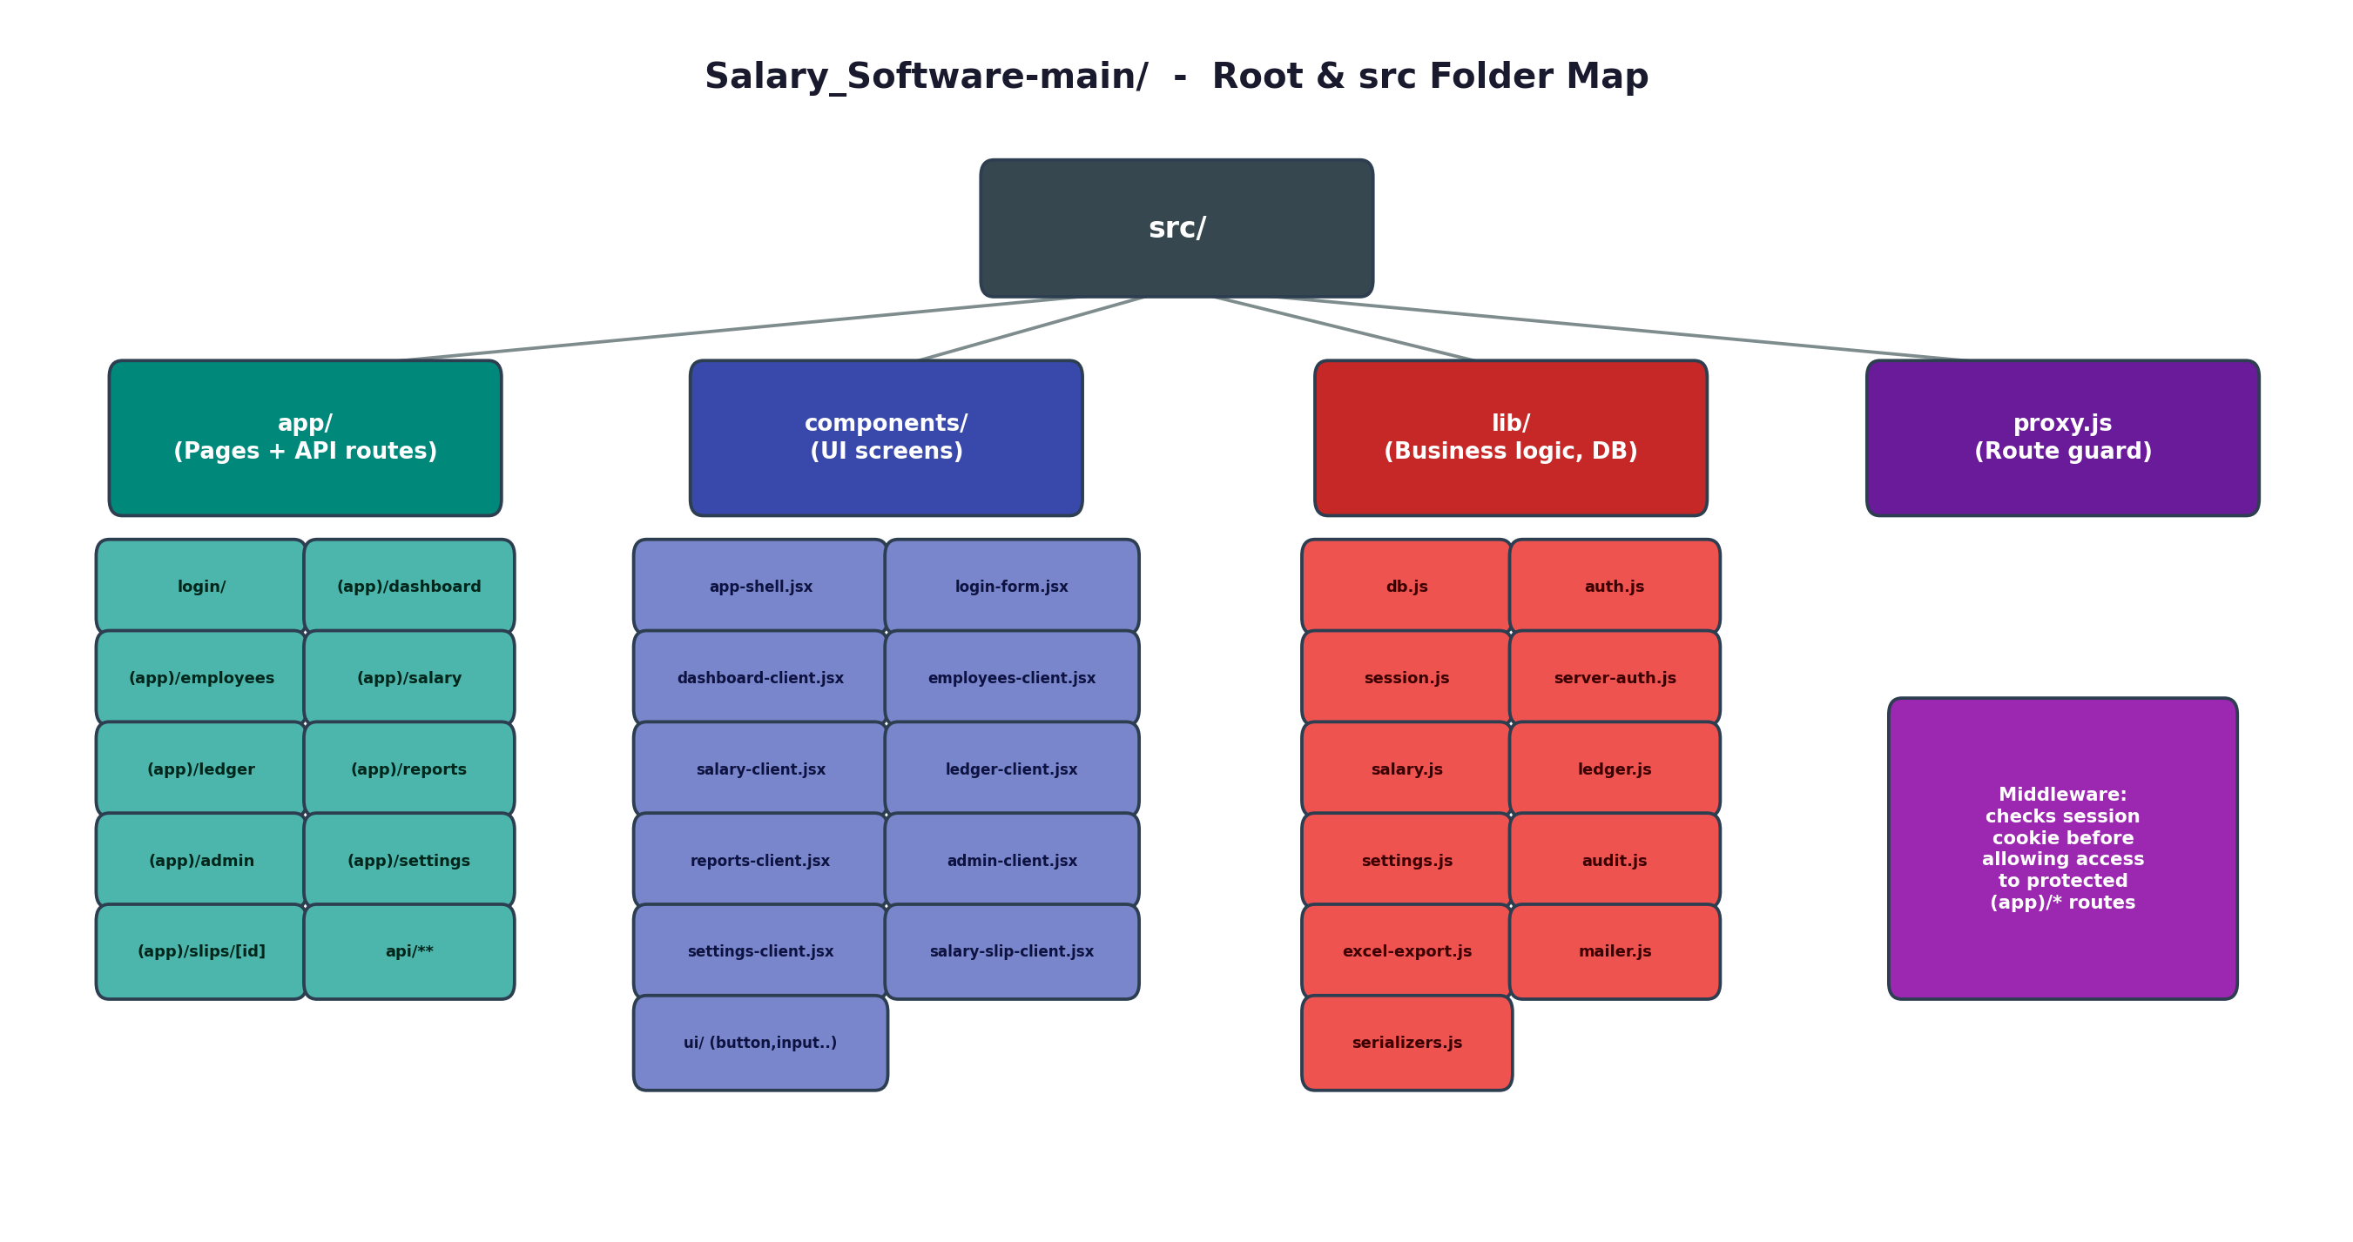

5. App Routes (Pages)
Route File | Description
src/app/page.jsx | Home route — dashboard par redirect karta hai
src/app/login/page.jsx | Login screen
src/app/layout.jsx | Root layout aur global providers
src/app/globals.css | Global styles aur Tailwind classes
src/app/(app)/layout.jsx | Protected app shell wrapper
src/app/(app)/dashboard/page.jsx | Dashboard page
src/app/(app)/employees/page.jsx | Employees page
src/app/(app)/salary/page.jsx | Salary generation page
src/app/(app)/ledger/page.jsx | Ledger page
src/app/(app)/reports/page.jsx | Reports page
src/app/(app)/admin/page.jsx | Admin users page
src/app/(app)/settings/page.jsx | Settings page
src/app/(app)/slips/[id]/page.jsx | Salary slip detail page
Protected routes src/proxy.js ke through guard hoti hain. Agar cookie/session valid nahi hai to user /login par automatically redirect ho jaata hai.

6. API Routes (Backend Endpoints)

Auth APIs
Endpoint File | Kaam
api/auth/login/route.js | Login, JWT session cookie set
api/auth/logout/route.js | Logout, session revoke/cookie delete
api/auth/me/route.js | Current logged-in user details
api/auth/profile/route.js | Profile related update/read
api/auth/forgot-password/* | OTP based password reset flow

Employee APIs
Endpoint File | Kaam
api/employees/route.js | Employee list and create
api/employees/[id]/route.js | Employee detail, update, delete/inactive
api/employees/import/route.js | Excel import

Salary APIs
Endpoint File | Kaam
api/salaries/route.js | Salary list and create
api/salaries/[id]/route.js | Salary detail, update, delete
api/salaries/bulk/route.js | Bulk salary generation
api/salaries/advance-pending/route.js | Previous pending advance calculation

Admin APIs
Endpoint File | Kaam
api/admin/users/route.js | Admin user list/create
api/admin/users/[email]/route.js | Update/delete user
api/admin/password/route.js | Current user profile/password update

Settings APIs
Endpoint File | Kaam
api/settings/route.js | School and SMTP settings
api/settings/email/test/route.js | SMTP test mail
api/settings/backup/download/route.js | Complete DB backup download
api/settings/restore/route.js | Backup restore — current DB replace karta hai
api/settings/security/* | Sessions aur logout-all features

Ledger APIs
Endpoint File | Kaam
api/ledger/route.js | Ledger list/create
api/ledger/[id]/route.js | Ledger update/delete

7. Components Guide (Frontend Screens)

Main Screen Components
Component File | Kaam
app-shell.jsx | Sidebar, topbar, footer, auth user load, permission based navigation
login-form.jsx | Login, forgot password, OTP verify, reset password
dashboard-client.jsx | Dashboard UI aur summary cards
employees-client.jsx | Employee CRUD, import, salary history, ledger export
salary-client.jsx | Salary form, calculation inputs, bulk generation
ledger-client.jsx | Ledger entry workflow
reports-client.jsx | Reporting, filtering, Excel/PDF export
admin-client.jsx | User aur permission management
settings-client.jsx | Settings, SMTP, backup/restore, security sessions
salary-slip-client.jsx | Salary slip UI aur PDF generation

Reusable UI Components
- ui/button.jsx
- ui/input.jsx
- ui/card.jsx
- ui/modal.jsx
- ui/toast.jsx
- ui/badge.jsx

8. Library and Business Logic (src/lib)
File | Kaam
db.js | MongoDB connection. MONGODB_URI missing ho to error throw karega
auth.js | Credentials validation, JWT sign/verify, permissions
session.js | Session cookie name, JWT secret, shared cookie options
server-auth.js | API routes ke liye current user, role and permission guard
salary.js | Core salary calculation logic — formula change yahi se karo
ledger.js | Ledger related helper logic
settings.js | School/SMTP settings read/write
secure-settings.js | Sensitive settings handling
audit.js | Audit log create/serialize
excel-export.js | Reports and employee ledger Excel export
excel-import-template.js | Employee import template generation
mailer.js | Email sending through SMTP
utils.js | Formatting and small UI helpers
serializers.js | MongoDB documents ko frontend-safe JSON me convert karna
🛠️ Debug Tip
Salary calculation me koi bug ho to sabse pehle src/lib/salary.js check karo — puri formula wahi centralize hai.

9. Database Models (MongoDB Collections)
Model | Kya Store Karta Hai
Employee | Employee profile, salary base, bank details, active/inactive status
Salary | Monthly salary record, attendance, leave, advance, deductions, net salary
LedgerEntry | Expense/advance ledger entries
User | Admin/accountant users, hashed password, role, permissions, status
ActiveSession | Logged-in browser/device session tracking
AuditLog | Login, backup, restore, password aur important activity logs
Setting | School profile, SMTP config, profile photo aur app settings
PasswordResetOtp | Forgot password OTP records

10. Authentication Flow
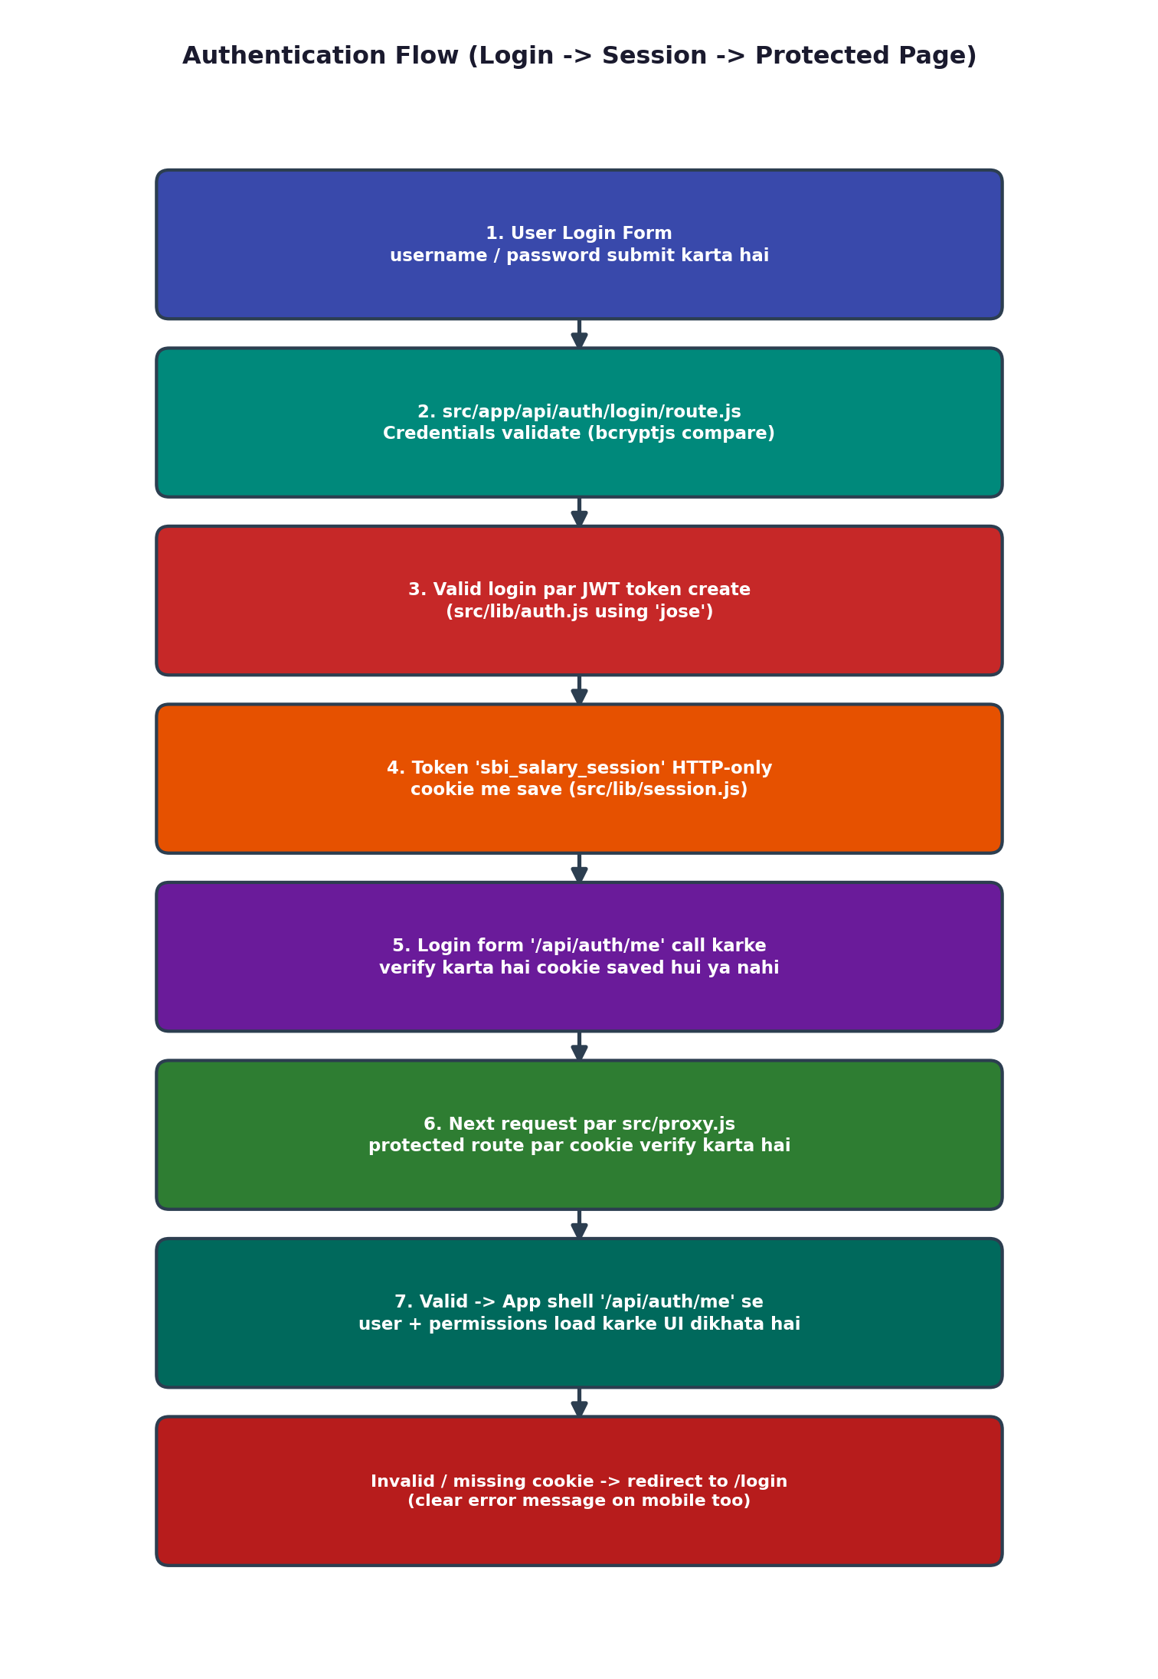

Mobile/LAN Login Fix
- Session cookie options ab src/lib/session.js me centralize hain.
- Login form ab login ke baad /api/auth/me se verify karta hai ki browser ne session cookie save ki ya nahi.
- Agar mobile browser cookie save nahi karta ya user localhost aur IP mix karta hai, ab clear error message dikhega instead of silent same-page loop.

LAN Usage — Commands
npm run dev

Laptop ka IP find karke mobile me same Wi-Fi par open karein:
http://LAPTOP-IP:3000

Example:
http://192.168.31.134:3000
📱 Important
Mobile me localhost use mat karein. Mobile ka localhost mobile device khud hota hai, laptop nahi. Hamesha laptop ka Wi-Fi IP use karein.

11. New Feature Add Karne Ka Standard Process
Feature add karte waqt is recommended flow ko follow karein:
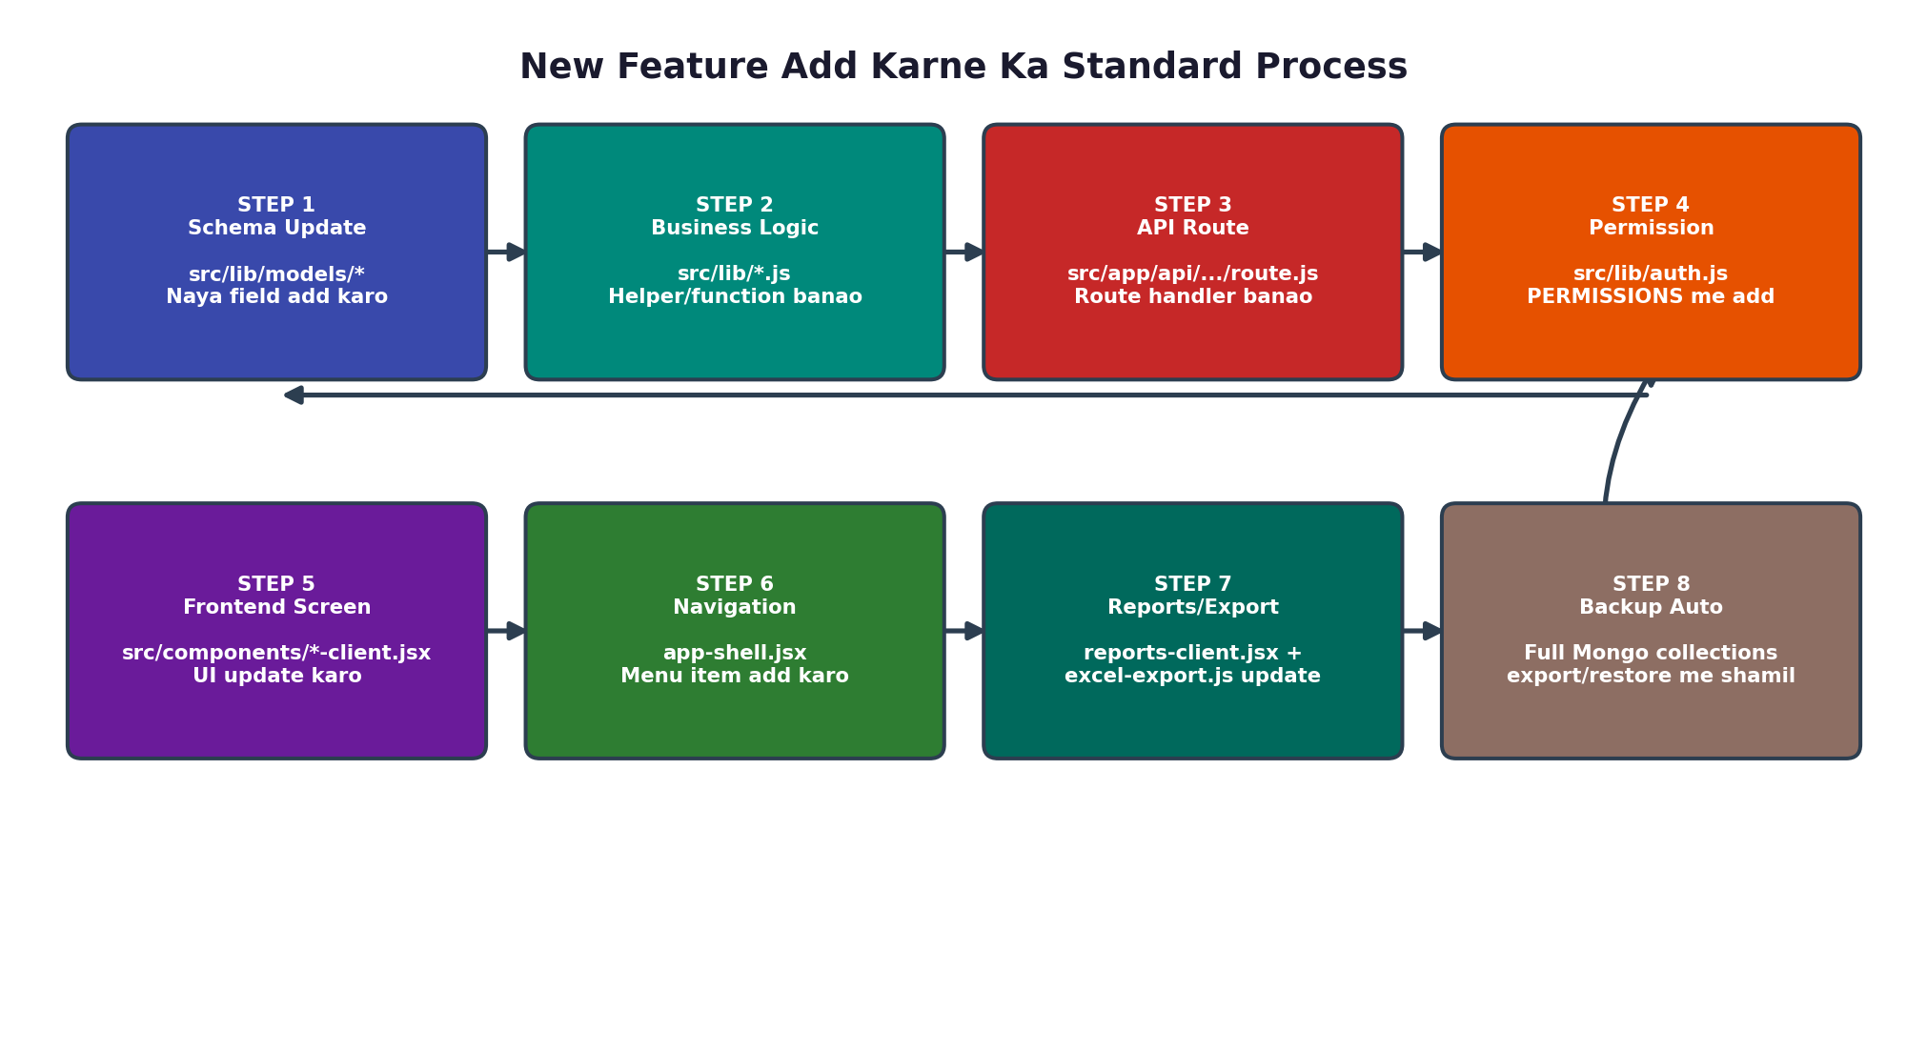

Example: "Department wise report" add karna ho
- Salary/Employee data already models me hai.
- API route ya existing reports API me department filter add karo.
- reports-client.jsx me filter dropdown aur table/chart update karo.
- Excel export me department column include karo.

12. Data Safety Notes

✅ Safe Points
- Employee delete flow password confirmation ke saath protected hai.
- Salary duplicate month/year/employee avoid karne ke liye unique index hai.
- Restore endpoint valid backup format check karta hai.
- Restore action admin permission ke behind hai.
- Audit logs important actions record karte hain.
- Backup download complete database export karta hai.

⚠️ Risk Points (Client Delivery Se Pehle Dhyan Rakhein)
- src/app/api/settings/restore/route.js current database collections replace karta hai — restore se pehle backup lena mandatory process hona chahiye.
- .env.local me plain admin password nahi rakhna chahiye production me — bcrypt hash use karein.
- Local .mongo-data folder client machine specific hota hai — deployment ke liye managed MongoDB recommended hai.
- database_backup.json aur backups/ me real data ho sakta hai — public GitHub/re-sale ZIP me include na karein unless client ko wahi data transfer karna hai.

Production Recommendation
- Strong JWT_SECRET set karein.
- ADMIN_PASSWORD_HASH aur ACCOUNTANT_PASSWORD_HASH use karein.
- MongoDB Atlas ya secured MongoDB server use karein.
- Regular backup policy define karein.
- Client handover se pehle demo data aur real data separate rakhein.

13. Common Commands
npm install
cp .env.example .env.local
npm run db:start
npm run dev
npm run lint
npm run build
npm run backup

Local only:
npm run dev:local

LAN/mobile testing:
npm run dev

Production build:
npm run build
npm run start

14. Client Handover Checklist
- .env.local client ke production values ke saath configure.
- Strong admin password/hash set.
- MongoDB URI production database par point.
- Test login on laptop and mobile using laptop IP.
- Employee create/edit tested.
- Salary generate and salary slip PDF tested.
- Reports export tested.
- Backup download tested.
- Restore only demo/test DB par verify.
- node_modules, .next, .mongo-data, aur private backups ko public code package me include na karein.

15. Quick Debug Guide

Mobile login same page par aa raha ho
- App mobile me http://LAPTOP-IP:3000 se open karein, localhost se nahi.
- Laptop and mobile same Wi-Fi par hone chahiye.
- Server npm run dev se start hona chahiye kyunki ye 0.0.0.0 bind karta hai.
- Browser cache/cookies clear karke retry karein.
- Login ke baad agar session save nahi hota, login form ab clear message show karega.

Database unavailable
- Local DB ke liye npm run db:start run karein.
- .env.local me MONGODB_URI aur MONGODB_DB check karein.

Duplicate salary error
- Same employee/month/year salary already exist ho sakti hai.
- Existing salary edit karein ya purani record delete karke recreate karein.

16. Files Most Important For Future Development
Change Type | Files To Touch
Auth/session change | src/lib/auth.js, src/lib/session.js, src/proxy.js
Salary formula change | src/lib/salary.js
Employee form/list change | src/components/employees-client.jsx, src/app/api/employees/*
Salary screen change | src/components/salary-client.jsx, src/app/api/salaries/*
Reports/export change | src/components/reports-client.jsx, src/lib/excel-export.js
Admin permissions change | src/lib/auth.js, src/components/admin-client.jsx
Settings/backup change | src/components/settings-client.jsx, src/app/api/settings/*

17. New Feature: Email System & Automated Notifications
Ye naya feature Salary Software me automated email notifications add karta hai — jab bhi salary generate hoti hai, employee ko automatically confirmation email chala jaata hai.

17.1 Automated Email Dispatch on Salary Generation
- Jab bhi kisi employee ki salary create hoti hai (POST /api/salaries), system automatically us employee ke email address par confirmation email bhejta hai jisme salary slip URL bhi included hota hai.
- Bulk salary generation (/api/salaries/bulk) ke case me bhi har employee ko individually email jaata hai.
- Email trigger src/lib/mailer.js ke through hota hai, jo SMTP settings (src/lib/settings.js) se configuration leta hai.

17.2 Employee Email Persistence & Sanitization
- Employee Master Data me email field properly validate, sanitize aur MongoDB me persist hota hai (validation zod se hoti hai).
- Form open karne par existing email address auto-fill hota hai.
- Employees Table me employee ID ke saath email address bhi display hota hai — jaise SBI-2026-014 • employee@gmail.com

17.3 Reports Table — Email Status & Actions
Status / Button | Meaning
Email Already Sent | Green status badge — salary email dispatch ho chuka hai
Send Again — Click Now | Direct action button — already-sent email ko dobara resend karne ke liye
Send Email | Primary action button — unsent email ko first time send karne ke liye

17.4 SMTP Email Configuration & Security
- Gmail SMTP integration — smtp.gmail.com on Port 465 (SSL).
- AES-256-GCM Encryption se SMTP passwords securely MongoDB Setting collection me store hote hain (plain text me kabhi nahi).
- Settings UI me Direct Test Email Dispatch feature — admin ek click me test mail bhej kar SMTP config verify kar sakta hai (existing api/settings/email/test/route.js endpoint isi kaam ke liye use hota hai).

17.5 Email Flow Diagram
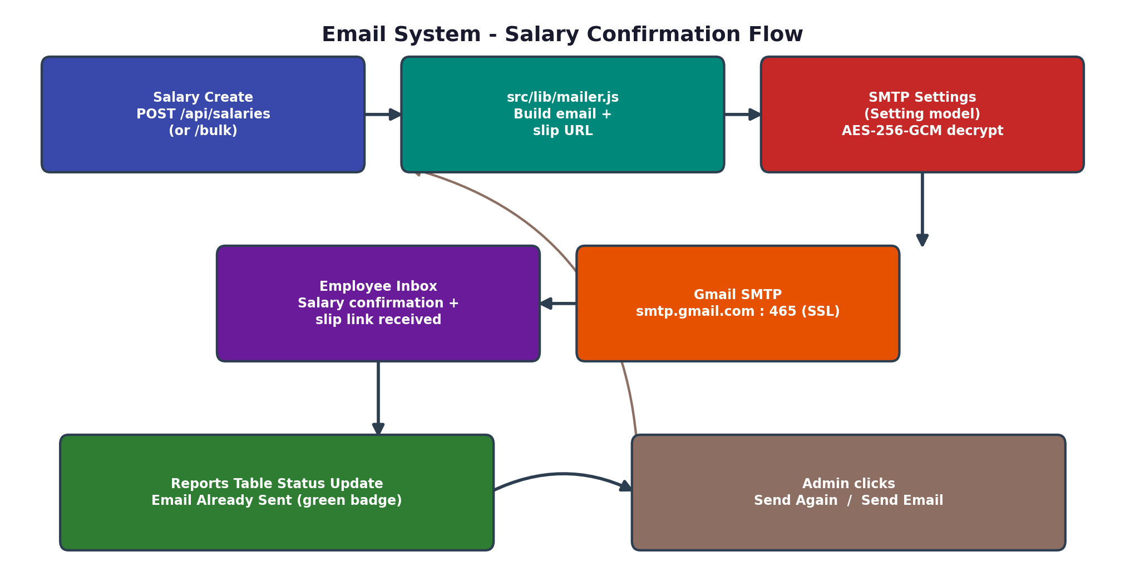

17.6 Implementation Checklist (New Feature Process ke hisaab se)
- Schema Update — Employee model me email field add/validate karo (src/lib/models/*).
- Business Logic — src/lib/mailer.js me salary-confirmation email template aur send function banao.
- API Route — src/app/api/salaries/route.js aur bulk/route.js me salary create hone ke baad mail-trigger call add karo; email resend ke liye ek naya action endpoint banao.
- Permission — src/lib/auth.js ke PERMISSIONS me email-send/resend permission add karo agar role-restricted rakhna ho.
- Frontend Screen — employees-client.jsx me email field + auto-fill; reports-client.jsx me status badge aur action buttons.
- Security — SMTP password AES-256-GCM se encrypt/decrypt karne ka helper src/lib/secure-settings.js me add karo.
- Settings UI — settings-client.jsx me "Send Test Email" button wire karo.
🛠️ Debug Tip — Email Feature
Agar email nahi ja raha, sabse pehle Settings → SMTP test mail try karo. Agar wahi fail ho raha hai to problem SMTP credentials/Port 465 SSL config me hai, code me nahi.

🎯 Interview Ke Liye Last Tip
Agar interviewer poochein 'sabse tricky part kya tha', to Mobile/LAN login cookie issue aur Bulk Salary Generation ke duplicate-month handling ka example dena best rahega — dono real production problems hain jo tumne already solve kiye hain.

