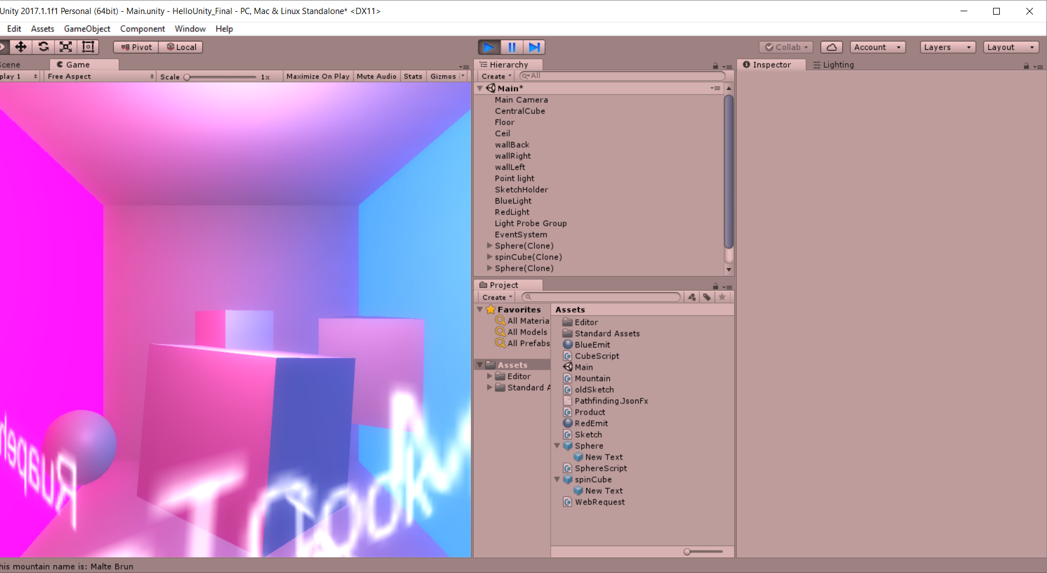Github link: https://github.com/kmcc063/HelloUnity_Final---Products

Breakpoints

