# Innovation

### Functionality Added:

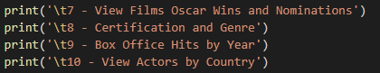

### View Films Oscar Wins and Nominations

The user is shown a list of films, their Oscar wins and Oscar nominations in alphabetical order, split into groups of ten.

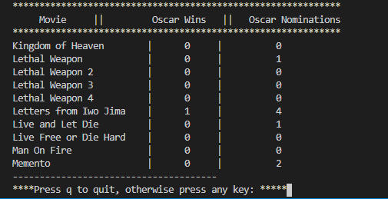

The list continues until it reaches the end, or the user enters ‘q’ and is returned to the title menu.

External library needed for this functionality is pandas. To install enter the below from the command line. $ pip install pandas

I retuned the SQL query as a dataframe as I could not figure out how to return in groups otherwise. This is the solution I produced. Also used in **Title Menu C*hoice 1 - View Films***

### Certification and Genre

The user is asked to enter a certification



If U, PG, 12, 12A, 15 or 18 is not entered the user is prompted again. When a certificate is entered a list of films with the corresponding certification are returned showing the genre, film name and synopsis of the film.

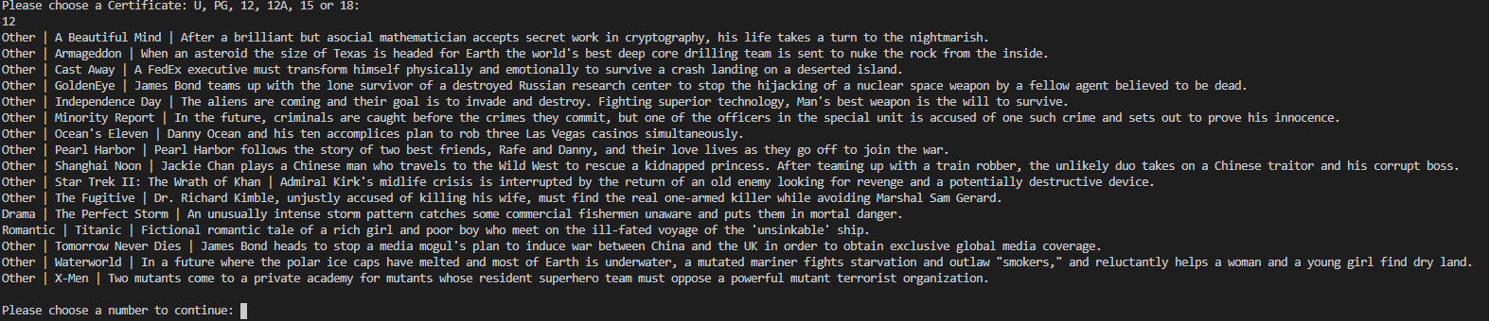

### Box Office Hits by Year

The user is asked to input a year. If an invalid year I.e., not an integer the user is repromoted to enter a year.



When the user enters a valid year a list of films, their director and box office takings are returned in order of highest box office takings to lowest.

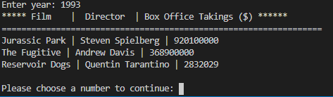

### View Actors by Country

The user is asked to enter a country.



if the country entered has actors attached to it in the database a list of Actors and their DOB is returned. If the user enters ‘q’ they are returned to the title menu.

