Discussion
We can see that understanding the domain of our data is very important. Since this data was generated in the polar domain, training in the cartesian domain results in models that have a poorer fit. Moreso, even if we had a large enough model to overfit to the existing training data in the cartesian domain, it would not generalize well since it doesn’t have an understanding for the circular nature of the polar domain. On the other hand the models trained in the polar domain generalize much better as they are well defined to the simply solving the predefined problem of the domain. Also Normalization was beneficial to the model fitting which makes sense.

Trained in Polar Coordinates & Normalized
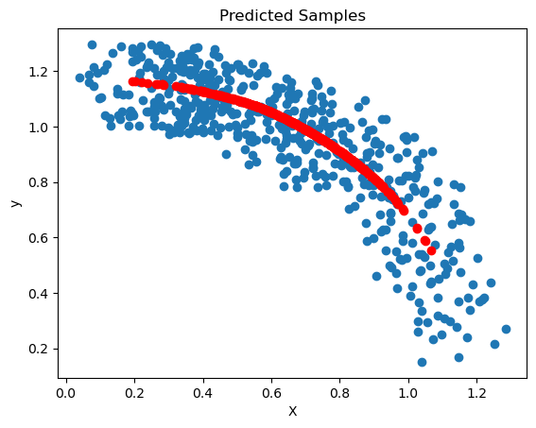

Trained in Polar Coordinates & Normalized - Extrapolation
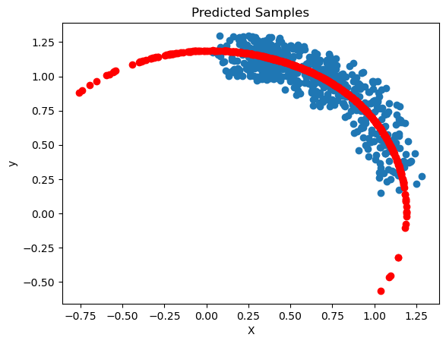

Trained in Polar Coordinates & Not Normalized
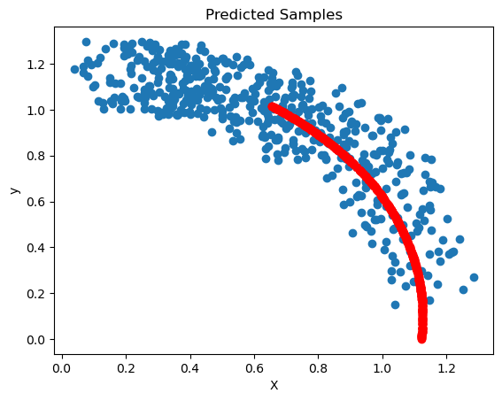

Trained in Polar Coordinates & Not Normalized - Extrapolation
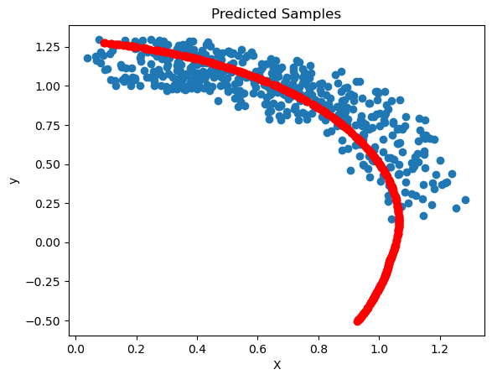

Trained in Cartesian Coordinates & Normalized
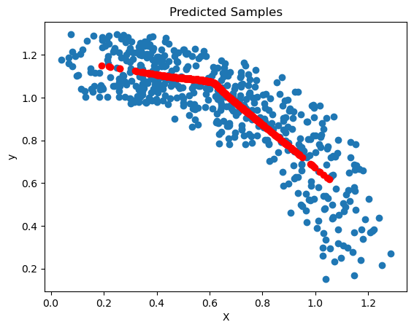

Trained in Cartesian Coordinates & Normalized - Extrapolation
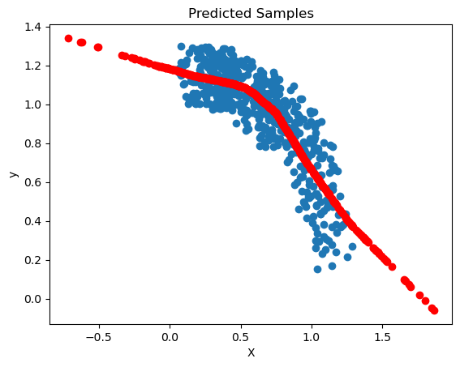

Trained in Cartesian Coordinates & Not Normalized
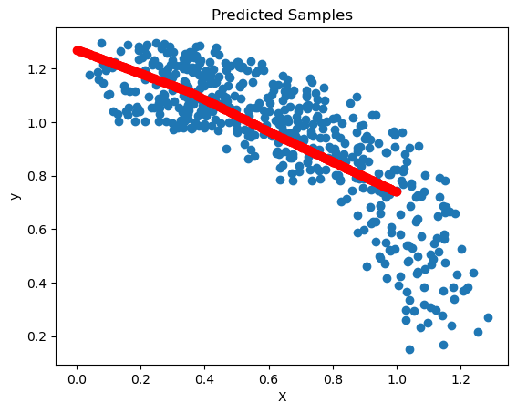

Trained in Cartesian Coordinates & Not Normalized - Extrapolation
