**User Instructions for the use of the BioMet Shiny Visualization App**

Kelsey McGuire ([kmcgu@student.ubc.ca](mailto:kmcgu@student.ubc.ca))

Date Last Updated: August 25, 2023

1. Download the `app_BioMet.R` file onto your local server.
2. Open the script, if in RStudio, it should open in a similar fashion to this:

1. Install any packages that are missing, and then Run the App. It will either open in Viewer, or you can select to have it open in a window by clicking on the drop-down beside the `Run App` button. The app will then be rendered, and should look like the image on the right.

1. Once the app is running, you can begin uploading your data by either dragging the files to the file upload button or by selecting `Browse…`. Once uploaded the `App Description` section of the app should look like this:

1. The user is then able to navigate to whichever visualization method they would like, the various pages are shown below. More thorough comments on the processing and variable functions can be found within the `app_BioMet.R` script. A basic rundown of each tab’s function can be found below.
   1. Time Series – The default page for the app
      1. The user must choose their variable of interest, and if they would like to plot a third stage variable (if present), they must click on the `Plot Third Stage Variable` box.

* 1. Diurnal Cycle
     1. This is stage-dependent, so if a user would like to see third-stage data they must have it uploaded, and change the selection. The default is the second stage data variables, and all that the user must do is change the inputs to have the data displayed to what they would like.

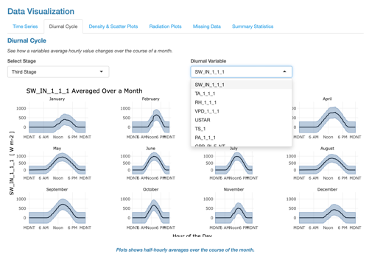

* 1. Density & Scatter Plots
     1. Default is a variable-variable comparison, but if both stages are uploaded, then you may do a stage-stage comparison. Similar to previous tabs, the variables are drop-down menus that the user may choose from. Variables are given notation based on which dataset they come from, where `2s` is the second stage, and `3s` is the third.

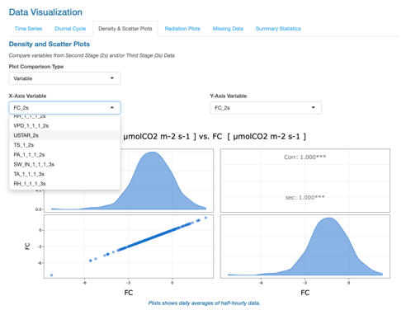 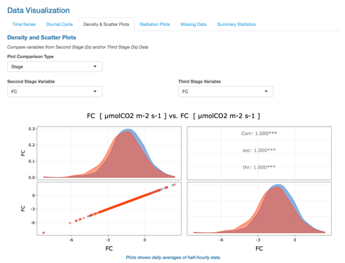

* 1. Radiation Plots - *this specific tab is still a work-in-progress so some plotting may be incorrect.*
     1. This tab has the most amount of user inputs, where they must input their site’s location details including its closest Standard Meridian, Latitude, and Longitude (used for calculations surrounding potential radiation). As always, the user is able to select what stage, and variables are displayed, yet within this tab, they are also able to choose how to compare the specific radiation variable to either the calculated Potential Radiation or if the dataset includes it, Net Radiation. The time scale options will dictate the plot created, defaulted is `All Time` which displays daily averaged values over the entirety of the dataset.

* + 1. Other options include `All Months` which displays a grid of monthly, hourly averages from the variable.

* + 1. Finally, there are separate month-specific plots, which are dictated by the dates given.

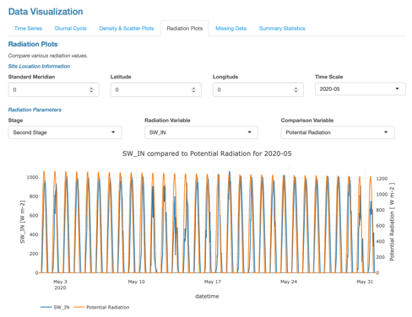

* 1. Missing & Summary Statistics
     1. These two tabs are fairly straightforward with no inputs needed from the user, where the Missing tab displays the amount of missing data for each variable from each dataset.

* + 1. The summary statistics tab will include a table of statistics for each individual variable.

If there are any questions/concerns, please reach out to me [kmcgu@student.ubc.ca](mailto:kmcgu@student.ubc.ca), or a member of the [UBC Micrometeorology Lab](https://ubc-micromet.github.io/).