HW4:

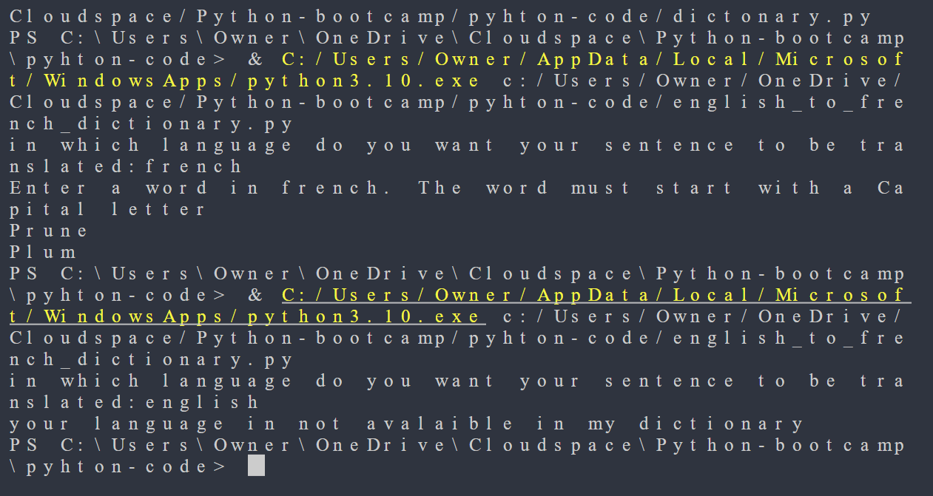

HW5:

