Goto Dashboard folder through terminal and run the following command:

Pip install gradio

python heartdisease.py # the purpose of this is to save the model which is used by dashboard.py. I have already saved the model in the file, therefore no need to run this.

python dashboard.py # directly run this one

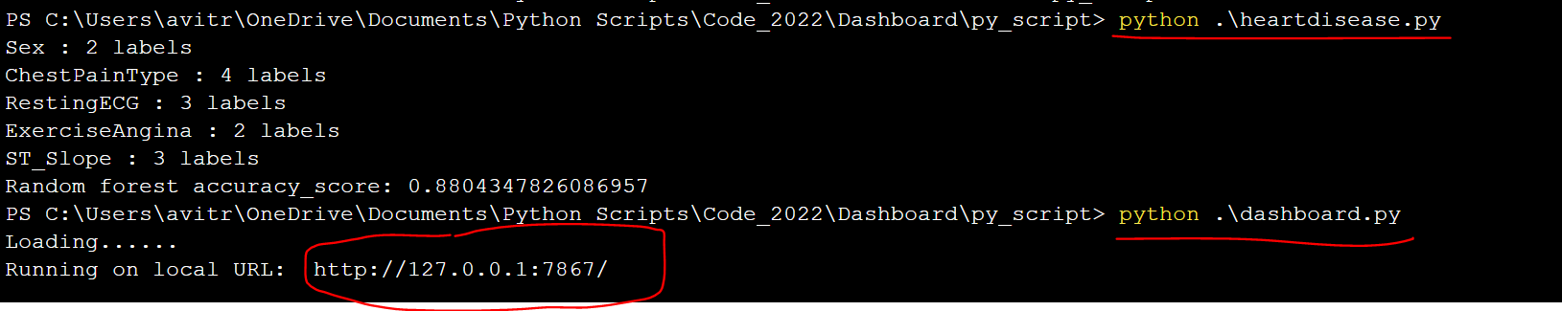

Open http://127.0.0.1:7867/ in browser

