JavaLife:
Karyn Drombosky
CS 1632 - DELIVERABLE 5: Performance Testing Conway's Game of Life
https://github.com/kmdrombosky/JavaLife
I began profiling this application by running it with 30,000 iterations and looking at the sampling section of VisualVM. I noticed from this application that the getNumNeighbors method in the World class was using most of the CPU. I then looked at the code for the World class and noticed that, in the getNumNeighnors method, there is a section of code that is arbitrarily looped over 10,000 times. There is no need for this to occur, and this is where the performance issues stem from. I commented out the loop and reran the program with the same parameters as before, this time using VisualVM to verify that the getNumNeighbors method was no longer utilizing 90%+ CPU.
Before:
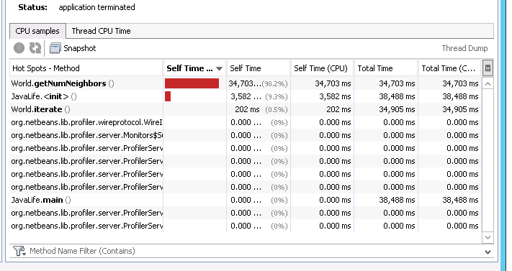

After: 