We first started with Neo4j graph database and tried to convert a RDMS database into a graph database. Neo4J allows tables of an RDBMS database to be loaded as graphs where each row of the table takes the form of a node.

The following diagram shows the relationship between tables in the RDBMS database:

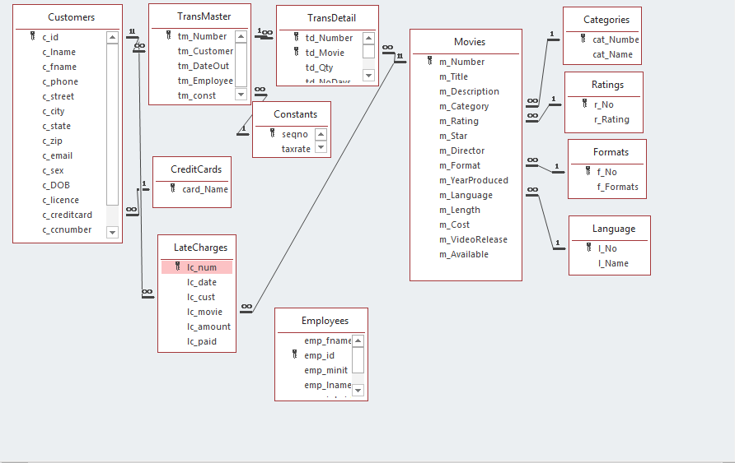

In order to load these tables into Neo4J each of the tables were exported in CSV files and stored in a GitHub repository. While in theory all tables could be loaded from a local drive it was decided to access the CSV files through an URL so that some complexity and possible errors could be avoided, which was the reason for storing all those data in GitHub.

There are certain rules that need to be followed to transfer the RDBMS relationships into Neo4J as the data models for relational versus graph are very different. This would require more time to explore and learn and did not seem to be possible to do within the timeframe allowed for this assignment.

Therefore we decided to use Networkx and a different dataset for the assignment.