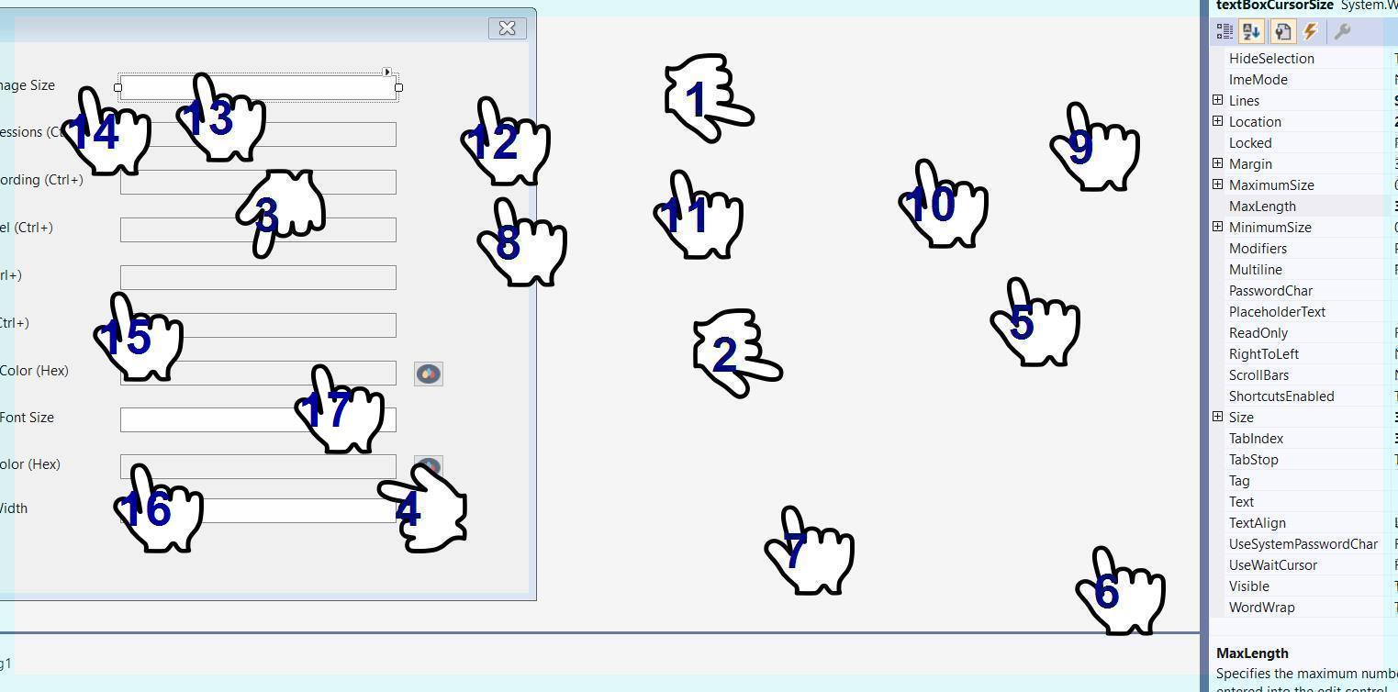

I have that I have to inform you have to have anoff-road andhavegrown from:sent fromfifthto