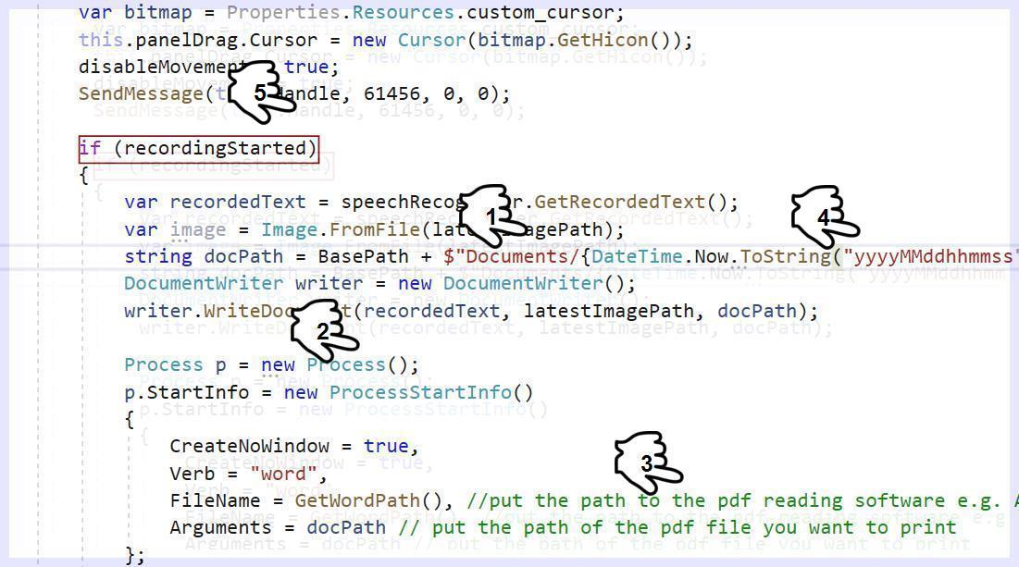

That'san unknownworkloads 20andarmor