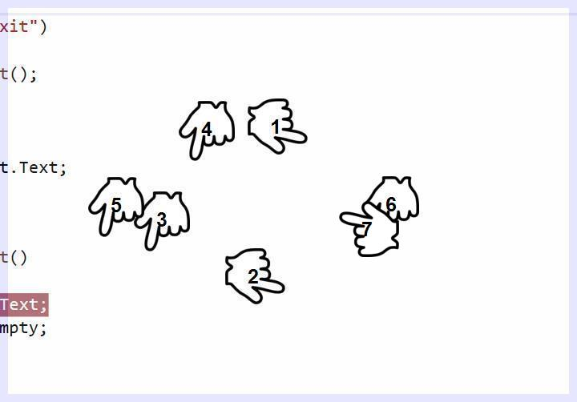

Andwhat every single zerowith 37,001of her when