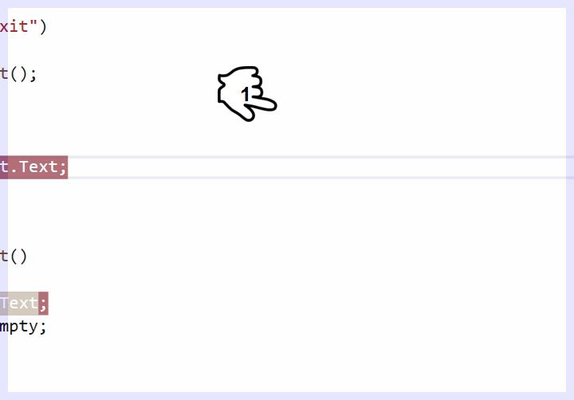

It'sno need for sixand ID 86 at thissometimes we cannot guarantee the workand it's always better trained & support foritsminimumability to a certain age it worksand a teacher from nine to produce results