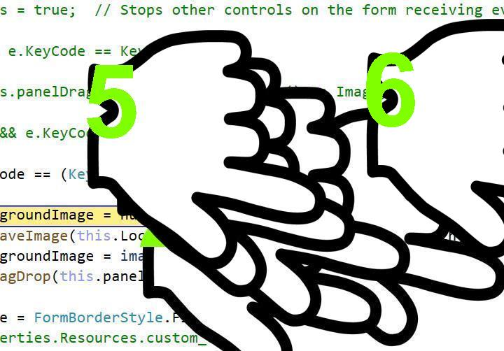

I never will be met with was Khan your name from 1982 when one of the mother, or at am an